Investigating the Effect of Crystallizability and Glass Transition Temperature of Supporting Materials for Preparing High Enthalpy Electrospun Poly(lactic acid)/Poly(ethylene glycol) Phase Change Fibers

Yifan Jia^{a,#}, Guoxing Liao^{a,b,#}, Yang Wuª, Oleksandr Mykhaylyk^{b}, Paul D. Topham^{c}, Xuehui Dongª, Changzhong Chen^{d,*}, Qianqian Yu^{a,*}, LinGe Wang^{a,*}

ª South China Advanced Institute for Soft Matter Science and Technology, School of Emergent Soft Matter, Guangdong Provincial Key Laboratory of Functional and Intelligent Hybrid Materials and Devices, South China University of Technology, Guangzhou 510640, China.
^{b} Department of Chemistry, University of Sheffield, Brook Hill, Sheffield, South Yorkshire S3 7HF, UK.
^{c} Chemical Engineering and Applied Chemistry, School of Infrastructure and Sustainable Engineering, College of Engineering and Physical Sciences, Aston University, Birmingham, B4 7ET, UK.
^{d} School of Chemistry and Environmental Science, Xiangnan University, Chenzhou 423000, China.

# Y. Jia and G. Liao contributed equally to this work.
* Corresponding authors: czchen@xnu.edu.cn (C. Z. Chen), yuqianqian@scut.edu.cn (Q. Yu), lingewang@scut.edu.cn (L. G. Wang).

Abstract
Form-stable phase change fibers (PCFs) that are composed of stable supporting material (as polymer matrix) and phase change material (PCM, as working ingredient) have become novel smart materials, being widely applied in energy storage, thermal regulation and the biomedical field. However, the inherent limitation of PCFs is the restriction of the supporting material on the crystallization of the PCM, which results in low phase change enthalpy (ΔH). Here, six different types of PCF comprised of poly(lactic acid) (PLA, as supporting material) and poly(ethylene glycol) (PEG, as PCM) have been fabricated. Their morphology, phase change performance and structural transitions during phase change have been extensively studied. We reveal that the crystallizability and glass transition temperature of PLA have a dominating influence on ΔH. In the optimum system, PLA/PEG PCFs can achieve up to 104 J/g ΔH which is close to the theoretical value of pristine PEG. This high-performance PCF also exhibits only 2.5% ΔH loss after 100 thermal cycles and good ability in thermal energy storage and thermal regulation. This work provides a promising form-stable PCF and introduces a new strategy towards developing high ΔH PCFs by selecting suitable supporting materials.

Keywords
Phase change fibers, High phase change enthalpy, Structural transition, Thermal energy storage, Thermal regulation

1. Introduction
Over the last two decades, phase change fibers (PCFs) have been extensively studied as smart materials, since they not only inherit the thermoactive properties of phase change materials (PCMs) but also endow the PCM with stable form, flexibility and controllable micro-to-nanoscale fibrous structures [1-4]. They have been applied in general thermal storage and regulation (such as thermal regulating textiles [5-8] and electronic device protection [9], such as battery protection [10]), and even in the biomedical field (controlled drug delivery systems [11-13] and cancer therapy [14]).
As a convenient and versatile method, electrospinning techniques have been extensively developed for this field [4, 15-17], since form-stable PCFs can be readily fabricated from a solution containing solid-liquid PCMs and supporting materials [18-21]. During electrospinning, supporting materials can form a three-dimensional fibrous cage (or matrix) to “support and restrict” the melted PCM from flow loss, which would eventually lead to leakage. Therefore, the entire PCF can be rendered stable (no leakage) when phase changing. Many researchers have fabricated advanced form-stable PCFs using electrospinning [22, 23]. The influence of PCF composition, PCM type and ratio [24, 25], additives [26, 27], post treatment (annealing [28], crosslinking [29]) and consequent structures [30] (fiber structure, domain distribution) on electrospun PCF performance (such as phase change enthalpy, ΔH [24-31], mechanical properties [29], thermal conductivity [26, 27] and stability [26, 27, 32]) have been studied. 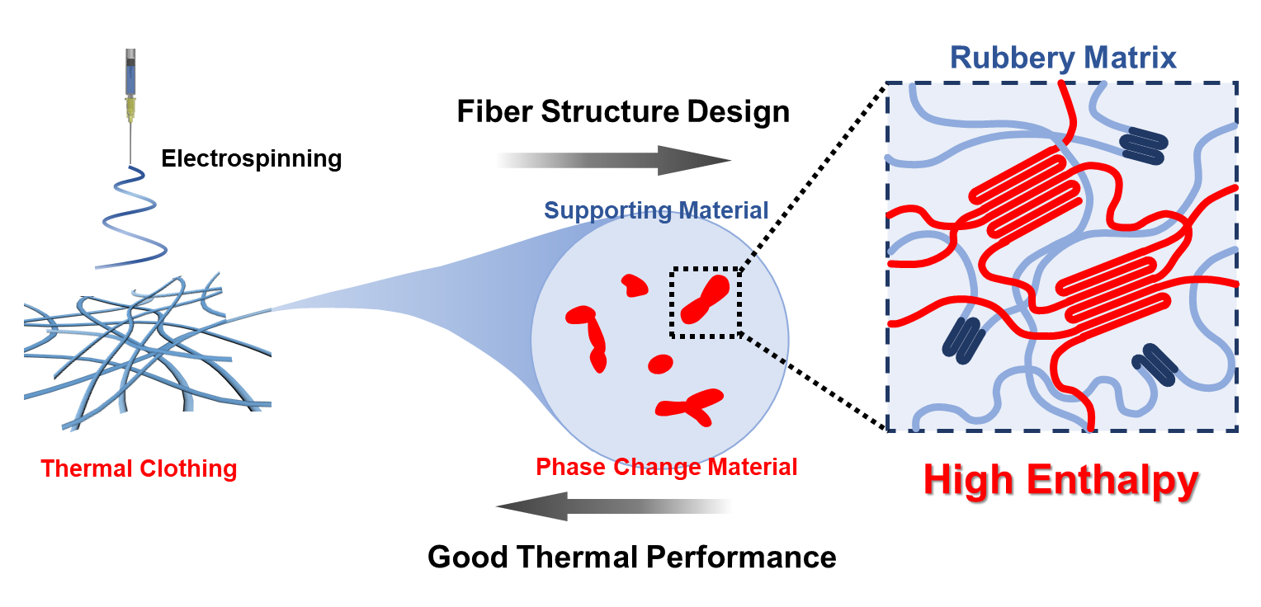
Figure 1. Using a rubbery polymer as supporting material to enhance the enthalpy of electrospun PCFs.

Among the various features of PCFs, ΔH is one of the most important parameters that influences their properties [33]. However, the introduction of supporting materials can limit the crystallization of PCMs and cause a decrease in ΔH. The interaction between the PCM and supporting material (such as hydrogen bonding [34]) can restrict the molecular motion of the PCM. Supporting materials can also act as a diluent and hinder the chain folding of the PCM during crystallization [35]. As Table 1 shows, the experimental phase change enthalpy (ΔH) of encapsulated PCM is typically lower than the theoretical phase change enthalpy (ΔH_{T}) of bulk PCM. This phenomenon is called confined crystallization [28, 36, 37]. Different types of supporting material exhibit varying degrees of confinement on PCM crystallization. For example, as seen in Table 1, CA, PAN and nylon-6,6 were all used as supporting materials to encapsulate poly(ethylene glycol) (PEG) resulting in a varied effect on the crystallization, with a nylon-6,6 fibrous matrix exhibiting the lowest confinement on PEG crystallization (${\text{Δ}\text{H}}_{\text{c}}$/${\text{Δ}\text{H}}_{\text{c-T}}$ = 95%). Looking at previously reported PCFs [4] we observe that, in many cases, PCFs made up of semi-crystalline supporting materials with lower glass transition temperature (T_{g}) than the melting temperature (T_{m}) of the PCM usually exhibited a high ΔH value, close to ΔH_{T}, although this was not explicitly stated nor explored. Based on this finding, we propose two hypotheses to significantly advance the field of PCFs: (1) Will a supporting material with a lower T_{g} than the T_{m} of encapsulated PCM (i.e., rubbery state supporting material) be beneficial for obtaining high ${\text{Δ}\text{H}}_{\text{c}}$ PCFs? (2) Will a semi-crystalline supporting material induce the crystallization of PCM? [38]

Table 1. Experimental crystallization (ΔH_{c}) and melting (ΔH_{m}) enthalpies, and theoretical crystallization (ΔH_{c-T}) and melting (ΔH_{m-T}) enthalpies of reported PCFs.
No. | Supporting material/ PCM | $${\text{Δ}\text{H}}_{\text{c}}$$ | $${\text{Δ}\text{H}}_{\text{c-T}}$$ | % | $${\text{Δ}\text{H}}_{\text{m}}$$ | $${\text{Δ}\text{H}}_{\text{m-T}}$$ | % | Ref.
1 | CA/PEG | 65.8 | 83.9 | 78 | 86.0 | 88.7 | 97 | [39]
2 | PAN/PEG | 52.4 | 73.45 | 71 | 44.0 | 82.0 | 54 | [40]
3 | PAN/LA-SA | / | / | / | 53.1 | 67.6 | 79 | [41]
4 | CA/PEG | 46.8 | 73.5 | 64 | 39.5 | 82.0 | 48 | [42]
5 | PA6/LA | 57.1 | 86.6 | 66 | 70.4 | 86.1 | 81 | [43]
6 | PET/LA | 81.1 | 90.1 | 90 | 87.5 | 92.4 | 95 | [44]
7 | PET/GMS | 53.2 | 57.4 | 93 | 57.1 | 57.6 | 99 | [45]
8 | PS/LA | 143.0 | 144.2 | 99 | 141.3 | 148.2 | 95 | [46]
9 | Nylon-6,6/PEG | 86.0 | 91.0 | 95 | 85.4 | 106.8 | 80 | [47]
10 | PVA/Erythritol | 151.4 | 151.4 | 100 | 196.7 | 204.4 | 96 | [48]
Definition of theoretical phase change enthalpy (J/g):
${\text{Δ}\text{H}}_{\text{c-T}}$ (of PCF) = ${\text{Δ}\text{H}}_{\text{c}}$ (of PCM) × PCM weight ratio (within PCFs)
${\text{Δ}\text{H}}_{\text{m-T}}$ (of PCF) = ${\text{Δ}\text{H}}_{\text{m}}$ (of PCM) × PCM weight ratio (within PCFs)
CA - cellulose acetate; PEG - poly(ethylene glycol); PAN - polyacrylonitrile; LA - lauric acid; SA - stearic acid; PA6 - polyamide-6; PET - poly(ethylene terephthalate); GMS - glyceryl monostearate; PS - polystyrene; PVA - poly(vinyl alcohol)

Therefore, in this work, six PCFs consisting of poly(lactic acid) (PLA, as supporting material) and PEG (as PCM) were prepared to thoroughly explore our hypotheses. Fiber morphology, phase change performance, crystal structure, shape stability and thermal regulating ability were assessed. The results indicated that both the crystallizability and T_{g} of PLA (${\text{T}}_{\text{g}}^{\text{PLA}}$) dramatically influenced the phase change performance of PEG. ΔH could be promoted by selecting a suitable supporting material. The most promising support matrix was shown to be semi-crystalline PLA with flexible, or rubbery, amorphous regions (${\text{T}}_{\text{g}}^{\text{PLA}}$ < operating temperature of PCM) as it provided structural integrity, whilst having weaker confinement on PEG crystallization, resulting in higher ΔH.

2. Materials and methods

2.1 Materials
The following chemicals were used as supplied without further purification. Three forms of PLA: poly(L-lactic acid) (L-PLA), poly(D-lactic acid) (D-PLA), and random copolymer of L-lactic acid and D-lactic acid (D,L-PLA) were obtained from Jinan Daigang Bio-engineering Co., Ltd. China (see PLA type and weight-average molecular weight (M_{w}) in Supporting Information (SI), Table S1). PEG of varying M_{w} (6k, 1k and 0.6k g/mol) were bought from Petroliam National Berhad, Malaysia. Dichloromethane (DCM) was analytical grade and purchased from Aladdin.

2.2 Fibers Preparation

2.2.1 PLA solutions
8 wt% PLA solutions (SI, Table S1) were prepared by dissolving PLA (L-PLA, D-PLA or D,L-PLA) in DCM (stirred for 24 h at room temperature).

2.2.2 PLA/PEG solutions
PLA was firstly dissolved in DCM to form the primary PLA solution (see PLA wt.% in Table S1) as described above. An equal weight of PEG (M_{w} = 6k, 1k or 0.6k g/mol) was added into the PLA solution to form PLA/PEG (1:1 wt./wt.) solution, which was stirred for 24 h at room temperature.

2.2.3 Electrospinning
The prepared solution (PLA or PLA/PEG) was loaded into a syringe to fabricate the corresponding electrospun fibers. Fibers were collected on an aluminum plate at room temperature and humidity ~65%. The needle and collector were connected with positive and negative voltages, respectively. The solution supply rates and applied voltages are listed in the Supporting Information, Table S1. Electrospun fibers were dried in the air at room temperature for 48 hours to remove residual solvent for the further use.

2.3 Characterization
Scanning electron microscopy (SEM) was performed on a Phenom Pro G3 (Phenom, Holland). Samples were sputtered with a layer of platinum for 120 seconds (Q150T ES PLUS, Quorum, U.K.).
Differential scanning calorimetry (DSC) was performed on a DSC 2500 (TA Instruments, USA). A hole was stabbed in the aluminum sample pan to balance pressure during heating. To assess phase change performance, samples were firstly maintained at 100 °C for 5 minutes to eliminate thermal and processing history. Subsequently, they were cooled down to -20 °C before being heated to 100 °C. All temperature ramps were performed at 10 °C/min. Samples were held for 5 minutes between each temperature ramp to establish thermal equilibrium. ${\text{T}}_{\text{g}}^{\text{PLA}}$ values were obtained by heating PLA powder to melt (200 °C for L-PLA, D-PLA and 100 °C for D,L-PLA), cooling to -20 °C and heating back to 100 °C at a rate of 20 °C/min. The ${\text{T}}_{\text{g}}^{\text{PLA}}$ values were recorded during the final heating ramp.
The thermal cycling test was performed by heating and cooling PCFs for 100 cycles. PCFs were firstly heated to 100 °C, held for 10 min to establish equilibrium, then thermally cycled between -20 to 100 °C at 10 °C/min in the DSC.
Time-resolved wide-angle X-ray scattering (WAXS) was undertaken on a HomeLab instrument (Rigaku, Japan) with a copper target K_{α} X-ray with 0.154 nm wavelength. Sample-to-detector distance was approximately 70 mm and calibrated with the diffraction pattern of silicon powder. The pixel size of the detector (Hypix-6000) was 100 μm × 100 μm. Fibers were packed between two pieces of aluminum foil and then placed on the hot stage (LTSE420, Linkam, U.K.). The applied temperature program was identical to the DSC tests. 2D WAXS patterns were collected every 15 seconds with 10 seconds exposure time.
Thermal regulating tests were performed on a hot stage (LTSE420, Linkam, U.K.). Approximately 0.5 g of the fibers were wrapped in 20 × 15 mm aluminum foil and pressed against the hot stage for full surface contact. Thermocouples were respectively wrapped within aluminum foil to measure the temperature of the environment and the fibers. The temperature was collected every second by a digital thermometer (TA612C, Suzhou TeAnSi Electronics Co., Ltd, China). Hot stage and fibers were cooled down and heated up at a rate of 20 °C/min around the phase change temperature (namely, working temperature) of PCFs to measure the fiber capability for stabilizing temperature during the rapid fluctuation of temperature.
PEG leakage tests were performed on a hot stage (LTSE420, Linkam, U.K.) based on protocols reported elsewhere [33, 34, 49]. Approximately 0.1 g of sample (pristine PEG, PLA fibers and PLA/PEG PCFs) was placed on filter paper and heated from 25 °C to 100 °C at a rate of 10 °C/min, and then maintained at 100 °C for 10 minutes. Digital photographic images of the samples were recorded before and after heating.

3. Results and discussion
Six different PLA/PEG PCFs (illustrated in Table 2) were prepared. The effect of T_{g} and crystallizability of the supporting material (PLA) on the phase change performance of PCM (PEG) are studied in Sections 3.1 and 3.2, respectively. The PEG used in this study are named as PEG0.6k, PEG1k and PEG6k according to their M_{w}.

Table 2. Electrospun PLA and PLA/PEG (1:1 wt.) fibers created in this study.
No. | PCFs | PLA type |  | PEG type
1 | L-PLA/PEG6k | Semi-crystalline | Rubbery stateª | PEG T_{m} > PLA T_{g}
2 | L-PLA/PEG1k | Semi-crystalline | Glassy state^{b} | PEG T_{m} < PLA T_{g}
3 | D-PLA/PEG6k | Semi-crystalline | Rubbery state | PEG T_{m} > PLA T_{g}
4 | D-PLA/PEG1k | Semi-crystalline | Glassy state | PEG T_{m} < PLA T_{g}
5 | D,L-PLA/PEG6k | Amorphous | Rubbery state | PEG T_{m} > PLA T_{g}
6 | D,L-PLA/PEG0.6k | Amorphous | Glassy state | PEG T_{m} < PLA T_{g}
ª Glassy-to-rubbery transition of the PLA matrix occurs during PEG phase changing when PEG T_{m} > PLA T_{g}
^{b} PEG phase changes within glassy PLA matrix when PEG T_{m} < PLA T_{g}

3.1 Effect of supporting material T_{g}
T_{g} is the macro-manifestation of segmental chain motion in the polymer chain i.e. the flexibility of the macromolecules in the amorphous phase [50]. Ke et al. [45], Emilija et al. [51] and Samanta et al. [28, 52] all reported that within electrospun PCFs, a PCM-rich domain formed within a matrix of supporting material (see fiber structure in Figure 1). Based on these studies, we propose that a flexible matrix formed by rubbery polymer chains (T_{g} < PCM T_{m}) may confer reduced confinement on PCM crystallization, resulting in higher ΔH. Therefore, we designed two types of PCF consisting of the same supporting material, but encapsulating two different types of PCM; one with high phase change temperature (PCM1) and one with low phase change temperature (PCM2) (see Figure 2a). During the phase change of the PCM in PCM1, a glassy-to-rubbery transition of the supporting material would concomitantly occur. In contrast, the supporting material in PCM2 would remain glassy and encapsulate the PCM component throughout the phase change. Consequently, the effect of the T_{g} of the supporting material can be probed in these two systems.
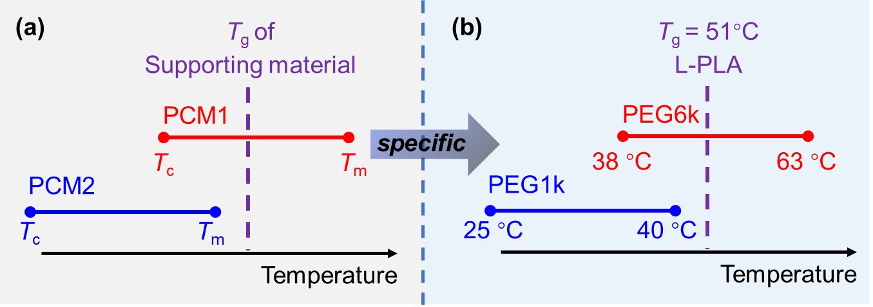
Figure 2. (a) The PCFs designed for evaluating the effect of the T_{g} value of the supporting material on PCM phase change performance and (b) the specific properties of selected supporting material (L-PLA) and phase change materials (PEG6k and PEG1k). T_{g} – glass transition temperature, T_{m} – melting temperature, T_{c} – crystallization temperature.

PLA is a biodegradable, environmentally friendly polymer that has been exploited in many systems [53-55]. In this part of our study, semi-crystalline L-PLA was selected as supporting material. PEG is a widely used PCM with controllable phase change temperature by adjusting PEG M_{w} [25]. Therefore, PEG1k and PEG6k were selected to meet the T_{c} and T_{m} requirements of the PCM (see Figure 2b). The measured ${\text{T}}_{\text{g}}^{\text{PLA}}$ values can be found in the SI, Figure S2. A relatively high ratio (50 wt.%) of PEG was loaded into PLA fibers to avoid frustrated crystallization, which was reported in systems with low PCM ratio (≤ 20%) and shown to dramatically decrease the ΔH value in PCFs [28].

3.1.1 Fiber morphology
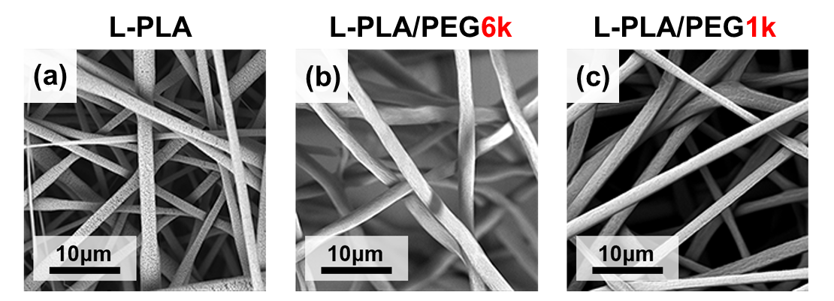
Figure 3. SEM images of electrospun L-PLA (a), L-PLA/PEG6k (b) and L-PLA/PEG1k (c). L-PLA, where PLA M_{w} = 120 kg/mol and the PLA:PEG ratio was 50/50 (w/w) in the PCF blends.

Numerous researchers have shown that the morphology of electrospun fibers is influenced by polymer molecular weight [56, 57]. Thus, L-PLA with varying molecular weight (M_{w} = 115, 120 and 315 kg/mol) were used (see SEM images in SI, Figure S1 and corresponding description on selecting suitable PLA M_{w}). Considering fiber morphology and electrospinnability, L-PLA M_{w} = 120 kg/mol was selected for further studies. As shown in Figure 3, continuous cylindrical L-PLA, L-PLA/PEG6k and L-PLA/PEG1k non-oriented fibers with similar diameter and morphology were successfully electrospun to avoid the potential impact of fiber morphology on PEG phase change performance.

3.1.2 Phase change performance
ΔH and phase change temperature are key performance parameters of PCMs. Thus, DSC measurements were performed and results are shown in Figure 4 and Table 3. The T_{c} and T_{m} values were derived from the peaks of the DSC thermograms and the ΔH_{c} and ΔH_{m} values were obtained by integrating the corresponding peak areas. Since PEG6k and PEG1k have different ΔH values, to directly compare the ΔH loss of PEG after being loaded into the PLA matrix, the normalized parameter χ was introduced according to Equation 1:
${\text{χ}}_{\text{c/m}}^{\text{PEG}}\text{= }\frac{{\text{Δ}\text{H}}_{\text{c}\text{/m}}^{\text{PLA/PEG fiber}}}{{\text{Δ}\text{H}}_{\text{c}\text{/m}\text{-T}}^{\text{PLA/PEG fiber}}}\text{ = }\frac{{\text{Δ}\text{H}}_{\text{c}\text{/m}}^{\text{PLA/PEG fiber}}}{{\text{Δ}\text{H}}_{\text{c}\text{/m}}^{\text{PEG}}\text{ * }{\text{ω}}_{\text{PEG}}}\text{×100\%}$ (Eq. 1)
Where c and m represent crystallizing and melting, ${\text{Δ}\text{H}}_{\text{c}\text{/m}}^{\text{PLA/PEG fibers}}$ is the experimental phase change enthalpy of PLA/PEG fibers, ${\text{Δ}\text{H}}_{\text{c}\text{/m}\text{-T}}^{\text{PLA/PEG fiber}\text{s}}$ is the theoretical phase change enthalpy of PLA/PEG fibers, ${\text{Δ}\text{H}}_{\text{c}\text{/m}}^{\text{PEG}}$ is the experimental phase change enthalpy of PEG, and ${\text{ω}}_{\text{PEG}}$ is the mass ratio of PEG within PLA/PEG fibers (wt.%). As aforementioned, ${\text{ω}}_{\text{PEG}}$ was kept at 50% in this study. According to the definition, ${\text{χ}}_{\text{c/m}}^{\text{PEG}}$ actually represents the relative crystallinity of PEG encapsulated within the fibers, compared to its bulk state. Higher χ values (closer to 100%) indicate a lower degree of confined crystallization in the PCFs.
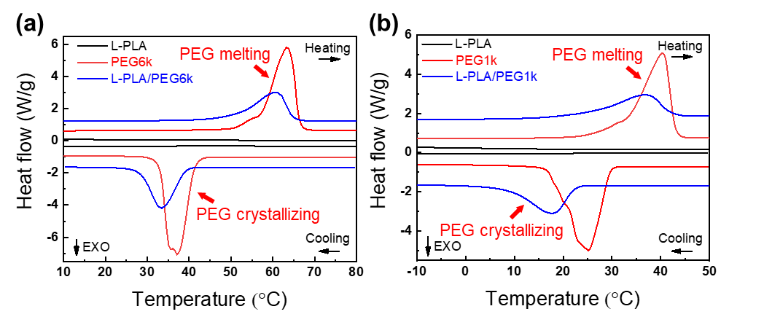
Figure 4. DSC thermograms of pristine PEG (red lines), L-PLA fibers (black lines) and PLA/PEG PCFs (blue lines): (a) PEG6k and L-PLA/PEG6k; (b) PEG1k and L-PLA/PEG1k.

Table 3. Phase change performance of pristine PEG6k, PEG1k and L-PLA/PEG6k, L-PLA/PEG1k fibers.
Sample | T_{c} (°C) | ΔH_{c} (J/g) | ${\text{χ}}_{\text{c}}^{\text{PEG}}$ (%) | T_{m} (°C) | ΔH_{m} (J/g) | ${\text{χ}}_{m}^{\text{PEG}}$ (%)
PEG6k | 37.6 | -208.9 | 100.0 | 63.3 | 201.2 | 100.0
L-PLA/PEG6k | 33.5 | -104.2 | 99.8 | 61.1 | 99.2 | 98.6
PEG1k | 25.1 | -189.6 | 100.0 | 40.5 | 190.1 | 100.0
L-PLA/PEG1k | 18.2 | -70.9 | 74.8 | 36.6 | 75.4 | 79.4

As shown in Figure 4, L-PLA fibers showed no phase change (black lines) over the temperature range studied and all PCF ΔH values were contributed to by PEG. After being encapsulated within the L-PLA matrix, the T_{c} and T_{m} values of PEG1k and PEG6k were both slightly lower than those of the corresponding bulk polymers. Excitingly, L-PLA/PEG6k fibers exhibited higher ${\text{χ}}_{\text{c}}^{\text{PEG}}$ (99.8%) than that of L-PLA/PEG1k (74.8%) demonstrating that, as predicted, rubbery L-PLA chains have weaker confinement on PEG crystallization.

3.1.3 Structural transition
To study the crystalline structure of L-PLA, L-PLA/PEG6k and L-PLA/PEG1k fibers during operation, time-resolved WAXS were undertaken. The WAXS data for the cooling (crystallizing) process of the fibers are illustrated in Figure 5 and the heating (melting) process data are provided in SI, Figure S3.
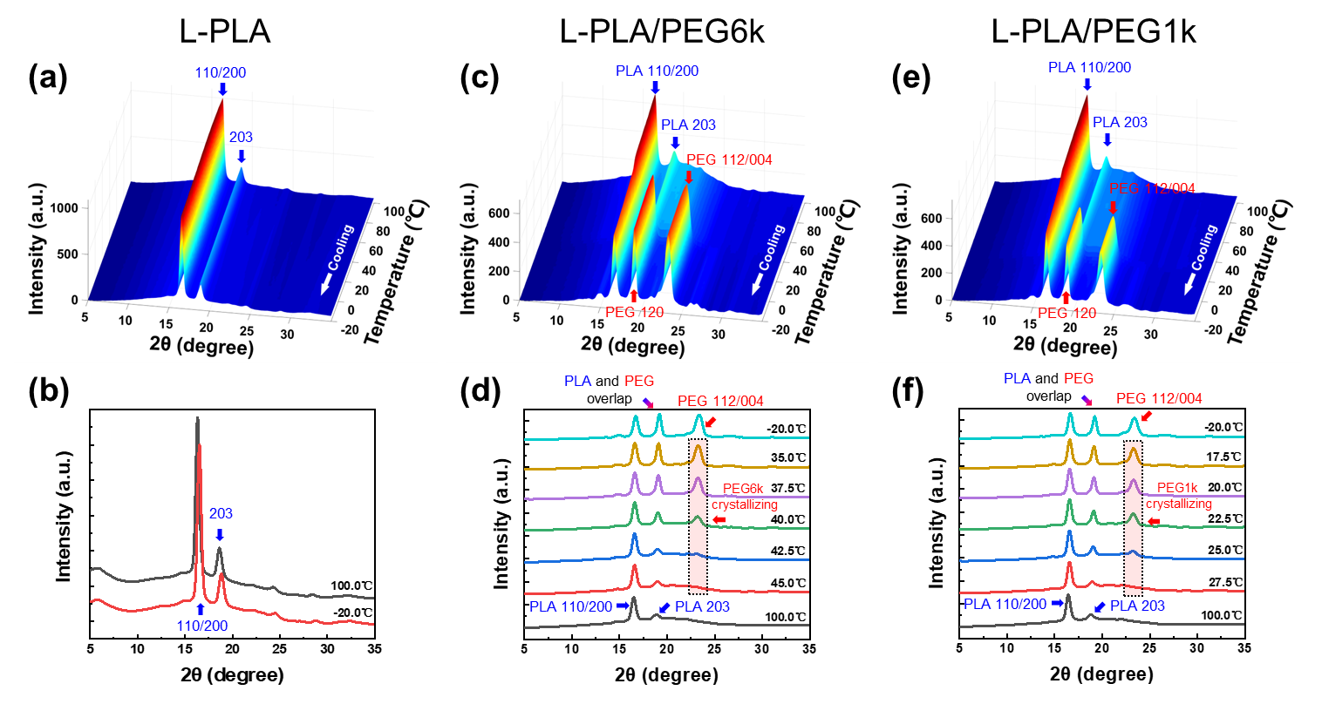
Figure 5. Time-resolved WAXS data of L-PLA (a), L-PLA/PEG6k (c) and L-PLA/PEG1k (e) fibers during cooling. The 1D integrated WAXS profiles of the fibers at 100 °C, -20°C and critical phase change temperatures are illustrated in (b), (d) and (f).

As shown in Figure 5a, the 110/200 and 203 crystalline peaks of PLA [58, 59] at 2θ = 16.3° and 18.8° were observed. During cooling (Figure 5b) and heating (SI, Figure S3a and b) no more peaks were observed and no peaks disappeared, indicating that L-PLA was stable across the entire temperature range of -20 to 100 °C. For the L-PLA/PEG6k fibers, the same PLA crystalline peaks were found and remained unchanged during heating and cooling cycles, again demonstrating the stable crystalline structure of L-PLA as a supporting material for the PCM. The crystallization of PEG6k was identified during cooling (Figure 5c) as the PEG 112/004 crystalline peaks (2θ = 23.3°) [60] appeared when cooled down to 42.5 °C and increased in intensity with further cooling. PEG6k melting can also be observed, as shown by the disappearance of the WAXS peaks in the SI, Figure S3c and d. The onset temperatures of crystallization (42.5 °C) and melting (55 °C) of PEG6k match those derived from DSC. L-PLA/PEG1k exhibited the same structural transition as L-PLA/PEG6k, except for a decrease in phase transition temperature (i.e. lower ${\text{T}}_{\text{c}}^{\text{PEG1k}}$ and ${\text{T}}_{\text{m}}^{\text{PEG}\text{1}\text{k}}$). The visual appearance of L-PLA, L-PLA/PEG6k and L-PLA/PEG1k fibers before and after time-resolved WAXS was recorded (Figure 6). Digital photographs show an unchanged fibrous structure after thermal cycles for both of the PCFs. PEG leakage test results reveal that there was no PEG leakage from L-PLA/PEG6k and L-PLA/PEG1k fibers (SI, Figure S7).
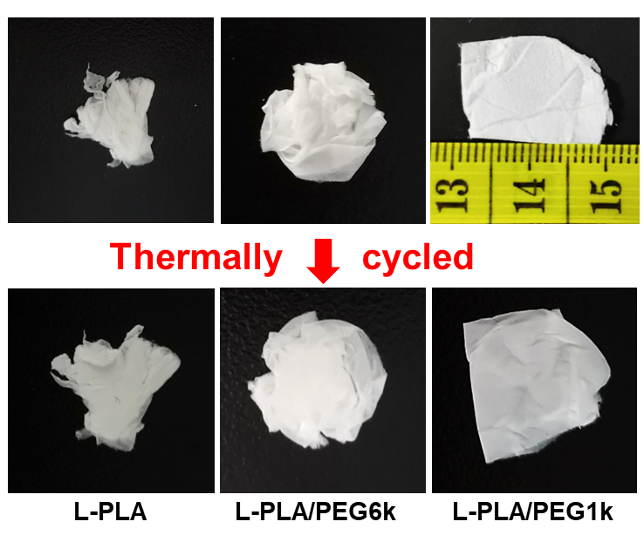
Figure 6. Digital camera images of as spun (first row) and thermally cycled (second row) L-PLA, L-PLA/PEG6k and L-PLA/PEG1k fibers. The units of the scale bar are centimeters. All samples were prepared in close size.

3.1.4 Thermal cycling test
The DSC and WAXS experiments showed that L-PLA was a stable supporting material during the temperature range of the PEG phase change. Furthermore, L-PLA/PEG6k and L-PLA/PEG1k fibers exhibited considerable potential for further application. Therefore, the phase change stability of L-PLA/PEG6k and L-PLA/PEG1k fibers was measured by being thermally cycled 100 times in DSC. The DSC thermograms are shown in Figure 7a and c. Accordingly, the T_{c}, T_{m}, ΔH_{c} and ΔH_{m} values were obtained and are provided in the SI, Figure S4. It can be seen that during cycling, ${\text{T}}_{\text{c}}^{\text{L-PLA/PEG6k}}$ decreased slightly from 38.0 °C to 34.5 °C, whereas ${\text{T}}_{\text{m}}^{\text{L-PLA/PEG6k}}$ remained consistent at approximately 62.5 °C. ${ΔH}_{\text{c}}^{\text{L-PLA/PEG6k}}$ and ${ΔH}_{\text{m}}^{\text{L-PLA/PEG6k}}$ decreased by only approximately 2.5% from 101.60 J/g and 99.16 J/g to 100.76 J/g and 98.21 J/g, respectively, after 100 cycles. This ΔH loss is attributed to leakage of PEG6k that was distributed on the surface of PCFs, which is supported by the SEM image of L-PLA/PEG6k fibers after 100 cycles (Figure 7b) that shows surface fusion at fiber contact points. In contrast to L-PLA/PEG6k fibers, during thermal cycling, ${\text{T}}_{\text{c}}^{\text{L-PLA/PEG1k}}$ (17.8 to 22.7 °C) and ${\text{T}}_{\text{m}}^{\text{L-PLA/PEG1k}}$ (36.8 to 42.0 °C) both increased during the first 10 cycles and then remained constant thereafter. Moreover, ${\text{Δ}\text{H}}_{\text{c}}^{\text{L-PLA/PEG1k}}$ and ${\text{Δ}\text{H}}_{\text{m}}^{\text{L-PLA/PEG1k}}$ also increased by 5.4 and 3.0 J/g from 64.6 and 68.0 J/g, respectively. These results suggest that there could be PLA and PEG domain rearrangement due to thermal annealing, which results in enhanced crystallization and higher ΔH. Generally speaking, L-PLA is an ideal supporting material for encapsulating PEG1k and PEG6k and successfully protects PEG from flow loss, with 97.5% ΔH remaining after 100 cycles of phase changing.
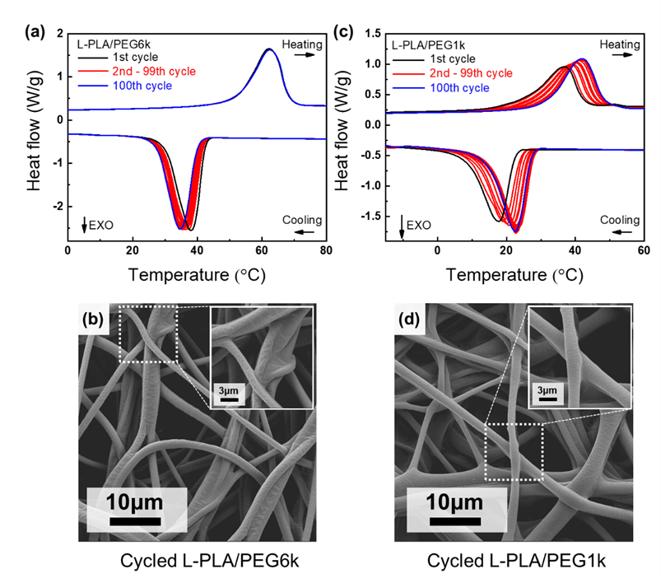
Figure 7. DSC thermograms (a and c) and SEM images (b and d) of thermally cycled (100 times) L-PLA/PEG6k (a and b) and L-PLA/PEG1k fibers (c and d).

3.1.5 Thermal regulating ability
Thermal energy storage and release is one of the most attractive abilities of PCFs on regulating heat. One particular application of note for PCFs is their use in the stabilization of intra-fibrous temperature [61, 62]. Based on the intended application, the thermal regulating ability can be exploited to serve a specific function, such as buffering intra-fibrous temperature under rapid environmental temperature fluctuations [39, 63] and increasing intra-fibrous temperature hysteresis against ambient temperature change. [64, 65]. Here, a hot stage was used to simulate rapid environmental temperature fluctuations. L-PLA, L-PLA/PEG6k and L-PLA/PEG1k fibers were tested on the hot stage within the PEG6k and PEG1k phase change temperature range, where L-PLA fibers were used as a control.
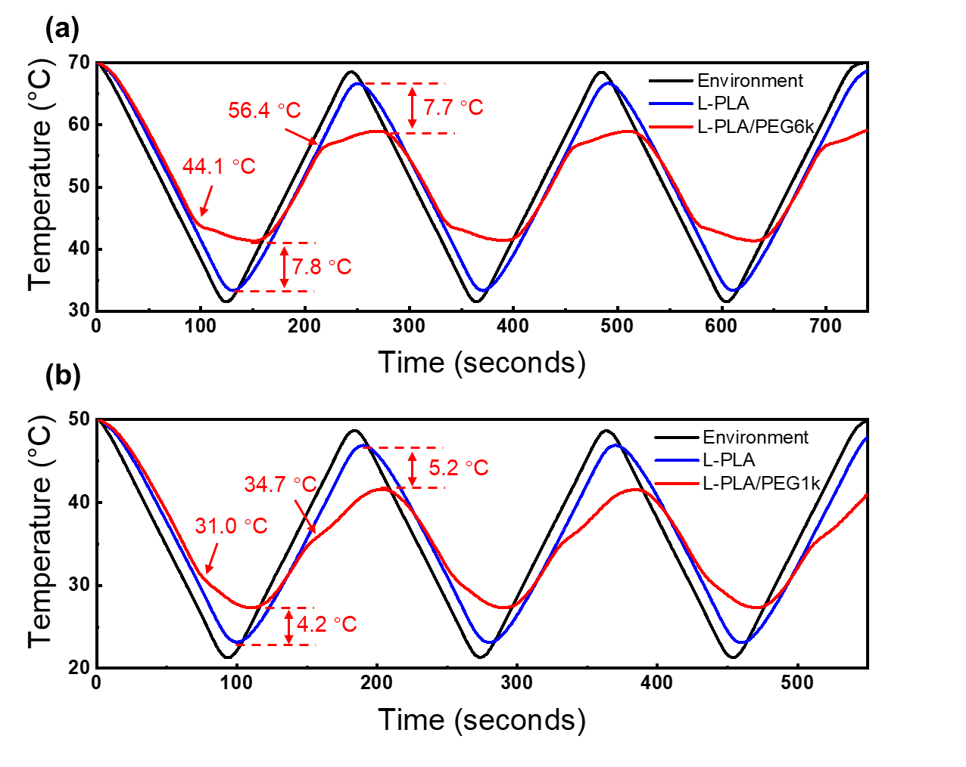
Figure 8. Thermal regulation test results of (a) L-PLA/PEG6k and (b) L-PLA/PEG1k fibers (red lines) compared with the temperature of environment (black lines) and pristine L-PLA fibers (blue lines).

As Figure 8 shows, compared with the environmental temperature (that was cycled rapidly over the phase change range, i.e. between room temperature and 50 °C or 70 °C for PEG1k and PEG6k, respectively), L-PLA fibers exhibited thermal hysteresis only (due to the low thermal conductivity of polymers). In contrast, L-PLA/PEG6k and L-PLA/PEG1k exhibited both thermal hysteresis and obvious temperature stabilizing effect due to the phase changing of PEG. The critical temperature points have been marked in Figure 8 and they match the onset temperature of the phase change of L-PLA/PEG PCFs from the DSC studies. It can be seen that due to the thermal energy storage and release of PEG, L-PLA/PEG6k fibers achieved 7.7 °C (heating) and 7.8 °C (cooling) maximum temperature difference against environmental temperature fluctuation. L-PLA/PEG1k fibers only achieved 5.2 °C (heating) and 4.2 °C (cooling) maximum temperature difference due to lower ΔH. Li et al. [63] reported a coaxial PCF consisting of paraffin wax (PW, as PCM) and polyurethane (PU, as supporting material) which exhibited ΔH ~ 90 J/g, which is superior to L-PLA/PEG1k fibers (approximately 90 J/g ΔH) and inferior to D-PLA/PEG1k fibers (approximately 100 J/g ΔH). The PW/PU PCF exhibited 5.8 °C (heating) and 4.7 °C (cooling) maximum temperature difference. This again indicates that a higher ΔH value is the key for better thermal regulating performance.

3.2 Effect of supporting material crystallizability
The results discussed in Section 3.1 using L-PLA/PEG1k and L-PLA/PEG6k fibers show the effect of glass transition temperature control, demonstrating that a supporting matrix comprising flexible PLA chains (T_{g} below operating temperature) promotes an increase in the ΔH value of the PCF. In this section, the effect of the crystallizability of the supporting material on ΔH is studied. For this study, PLA is an ideal candidate for the supporting material due to the two optical isomers of lactic acid, namely Levo- (L-) and Dextro (D-). As a consequence of this chirality, three types of PLA with different crystallizability can be obtained: L-PLA, D-PLA (both semi-crystalline) and D,L-PLA (amorphous). In the work presented in Section 3.1, semi-crystalline L-PLA was used as the supporting material. As shown in Figure 9a, semi-crystalline D-PLA and amorphous D,L-PLA were also used to encapsulate PEG and the corresponding PCF phase change performance and structure were studied and compare to the L-PLA-based system.
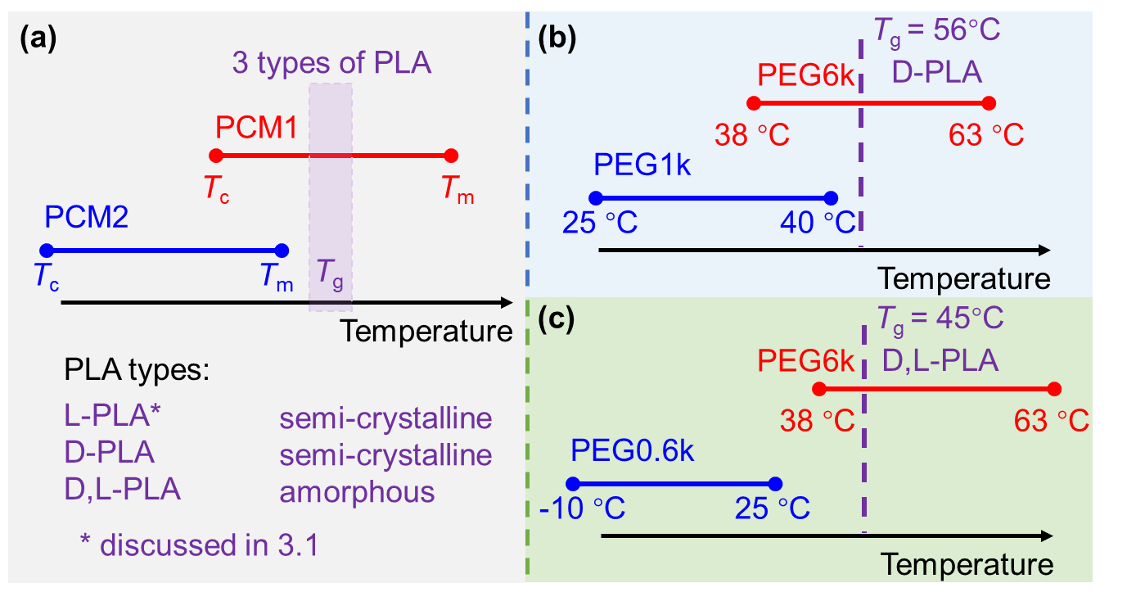
Figure 9. PLA/PEG PCFs designed to evaluate the effect of PLA crystallizability on PCF ΔH value (a). The specific properties of selected supporting material for (b) D-PLA and (c) D,L-PLA) with their corresponding phase change materials (PEG6k, PEG1k and PEG0.6k). T_{g} – glass transition temperature, T_{m} – melting temperature, T_{c} – crystallization temperature.

It should be noted that PEG6k and PEG1k were chosen as PCM1 and PCM2 to fabricate D-PLA/PEG1k and D-PLA/PEG6k fibers (Table 2 and Figure 9b). However, due to the molecular irregularity of D,L-PLA, ${\text{T}}_{\text{g}}^{\text{D,L-PLA}}$ (45.1 °C) is lower than ${\text{T}}_{\text{g}}^{\text{D-PLA}}$ (56.3 °C). The offset melting temperature of PEG1k (44.7 °C) is too close to ${\text{T}}_{\text{g}}^{\text{D,L-PLA}}$ and ${\text{T}}_{\text{m}}^{\text{PEG1k}}$ is too high, therefore PEG1k is not a suitable PCM2 candidate to be encapsulated within a D,L-PLA matrix. Consequently, PEG0.6k (with lower phase change temperature) was selected as PCM2 to prepare D,L-PLA/PEG0.6k fibers for further study (Figure 9c).

3.2.1 Fiber morphology

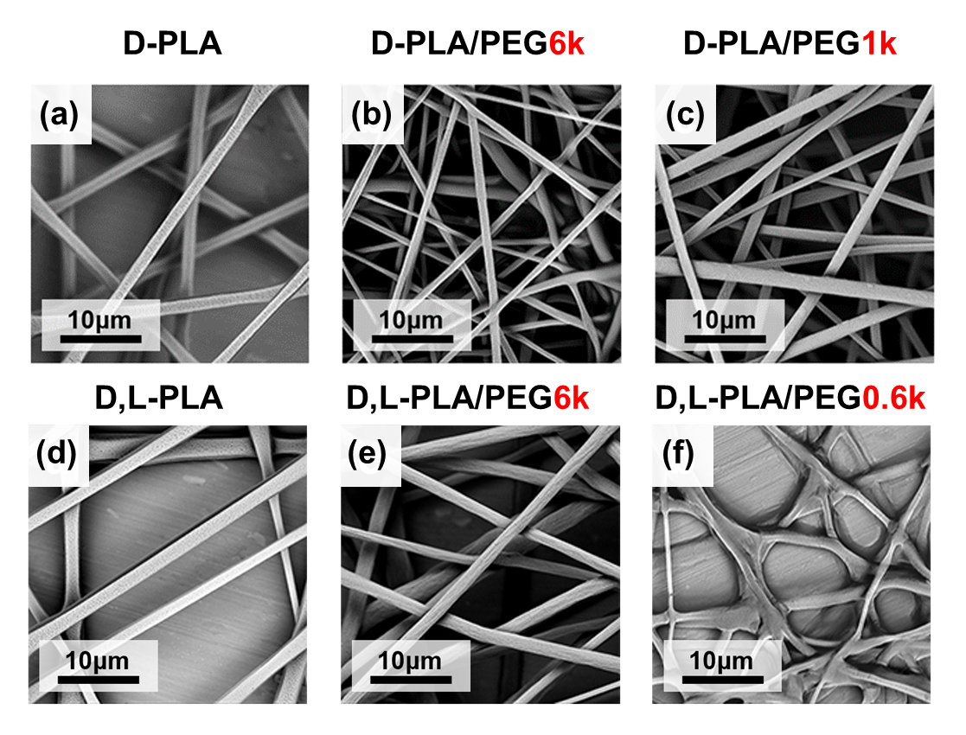
Figure 10. SEM images of electrospun D-PLA (a), D-PLA/PEG6k (b), D-PLA/PEG1k (c), D,L-PLA (d), D,L -PLA/PEG6k (e) and D,L -PLA/PEG0.6k (f) fibers. D-PLA M_{w} = 100 kg/mol. D,L-PLA M_{w} = 100 kg/mol and the PLA:PEG ratio was 50/50 (w/w) in the PCF blends.

Figure 10 shows that D-PLA, D,L-PLA and corresponding PCFs have a similar morphology to L-PLA/PEG6k and L-PLA/PEG1k PCFs. However, the melted structure shown in Figure 10f is attributed to a heating effect of the electron radiation source in SEM, as ${\text{T}}_{\text{g}}^{\text{D,L-PLA}}$ (45.1 °C) and the melting temperature of PEG0.6k (about 15 °C) are low.

3.2.2 Phase change performance
Thermal behavior of the prepared fibers was measured by DSC as shown in Figure 11 and the key parameters are listed in Table 4.
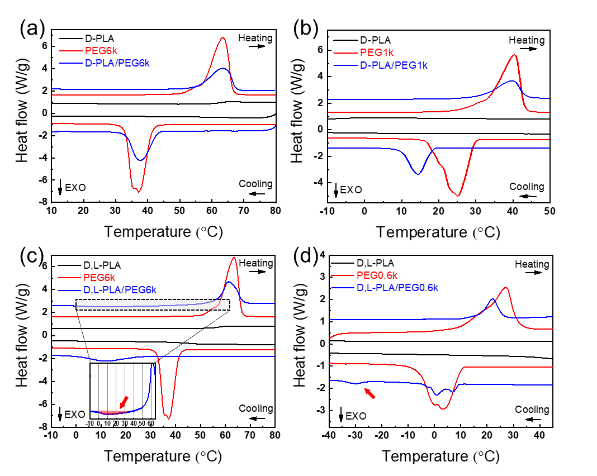
Figure 11. DSC thermograms of pristine PEG (red lines), PLA fibers (black lines) and PLA/PEG PCFs (blue lines): (a) D-PLA/PEG6k; (b) D-PLA/PEG1k; (c) D,L-PLA/PEG6k; (d) D,L-PLA/PEG0.6k.

As shown in Figure 11, D-PLA and D,L-PLA fibers showed no phase change (black lines) across the temperature range studied. After being encapsulated within a D-PLA matrix, the T_{c} and T_{m} values of PEG1k and PEG6k were close to those of the corresponding bulk polymers. D-PLA/PEG6k fibers exhibited higher ${\text{χ}}_{\text{c}}^{\text{PEG}}$ (95.1%) than D-PLA/PEG1k (66.9%). This result was similar to the PCFs composed of L-PLA (see Section 3.1.2). All findings herein demonstrate that flexible, or rubbery PLA chains (T_{g} < ${\text{T}}_{\text{m}}^{\text{PEG}}$) inferred less confinement on PEG crystallization.

Table 4. Phase change performance of pristine PEG6k, PEG1k, PEG0.6k and D-PLA/PEG6k, D-PLA/PEG1k, D,L-PLA/PEG6k D,L-PLA/PEG0.6k fibers.
Sample | T_{c} (°C) | ΔH_{c} (J/g) | χ_{c} (%) | T_{m} (°C) | ΔH_{m} (J/g) | χ_{m} (%)
PEG6k | 37.6 | -208.9 | 100.0 | 63.3 | 201.2 | 100.0
D-PLA/PEG6k | 37.5 | -99.3 | 95.1 | 63.2 | 100.3 | 99.7
D,L-PLA/PEG6k | 11.2 | -44.7 | 42.8 | 61.4 | 84.6 | 84.1
 | 13.7ª | -9.8ª | 9.7ª
PEG1k | 25.1 | -189.6 | 100.0 | 40.5 | 190.1 | 100.0
D-PLA/PEG1k | 14.5 | -63.4 | 66.9 | 39.6 | 64.1 | 67.4
PEG0.6k | 3.0 | -132.6 | 100.0 | 27.2 | 146.7 | 100.0
D,L-PLA/PEG0.6k | 0.7 | -23.8 | 42.7 | 22.1 | 36.1 | 49.3
 | -30.3 | -4.5
ª Cold crystallization during heating

D,L-PLA/PEG6k and D,L-PLA/PEG0.6k exhibited completely different phase change performance. The crystallization peak of PEG6k within D,L-PLA/PEG6k fibers was much broader than that of pristine PEG6k (Figure 11c) and ${\text{χ}}_{\text{c}}^{\text{PEG6k}}$ decreased to only 42.8%. Moreover, cold crystallization of PEG6k was observed at about 15 °C during heating (enlarged area in Figure 11c), implying that the crystallization of PEG6k was severely confined by the D,L-PLA matrix. The phase change performance of D,L-PLA/PEG0.6k fibers was also significantly different from that of the PEG0.6k polymer. Within D,L-PLA/PEG0.6k fibers, the crystallization behavior of PEG0.6k can be divided into two parts. One part is at approximately 0 °C (close to its bulk state), and the other at -30 °C (red arrow in Figure 11d), which was reported to be caused by PEG homogeneous nucleation [52]. Furthermore, ${\text{χ}}_{\text{c}}^{\text{PEG}\text{0.}\text{6k}}$ of D,L-PLA/PEG0.6k fibers was only 42.7%. Comparing the phase change performance of PCFs consisting of semi-crystalline L-PLA (discussed in Section 3.1.2), semi-crystalline D-PLA and amorphous D,L-PLA, it can be seen that amorphous D,L-PLA is not a suitable supporting material, as it largely confines PEG crystallization.
PEG0.6k exhibited low ${\text{χ}}_{\text{c}}^{\text{PEG0.6k}}$ within the D,L-PLA matrix (i.e. D,L-PLA/PEG0.6k PCFs). In an attempt to verify the effect of the crystallizability of PLA, PEG0.6k was also encapsulated within L-PLA and D-PLA matrices to form L-PLA/PEG0.6k and D-PLA/PEG0.6k PCFs as control groups. Their DSC thermograms are shown in the Supporting Information, Figure S9 with key parameters listed in Table S2. The results suggest that the low ${\text{χ}}_{\text{c}}^{\text{PEG0.6k}}$ value of D,L-PLA/PEG0.6k PCFs could be caused by the melting of the D,L-PLA matrix (see detailed discussion in SI).

3.2.3 Structural transition
From the results obtained thus far, it appears that the significant differences in phase change performance of D-PLA/PEG and D,L-PLA/PEG PCFs is due to the crystallizability of PLA and its impact on PEG crystallization. Therefore, time-resolved WAXS studies were undertaken to probe the crystalline structure in the PCFs. D-PLA fibers and D-PLA/PEG PCFs had similar structural transition to L-PLA fibers and L-PLA/PEG PCFs (see the SI, Figures S5 and S6 and associated discussion). The WAXS data of D,L-PLA fibers and D,L-PLA/PEG PCFs are shown in Figure 12 (cooling) and SI, Figure S7 (heating).
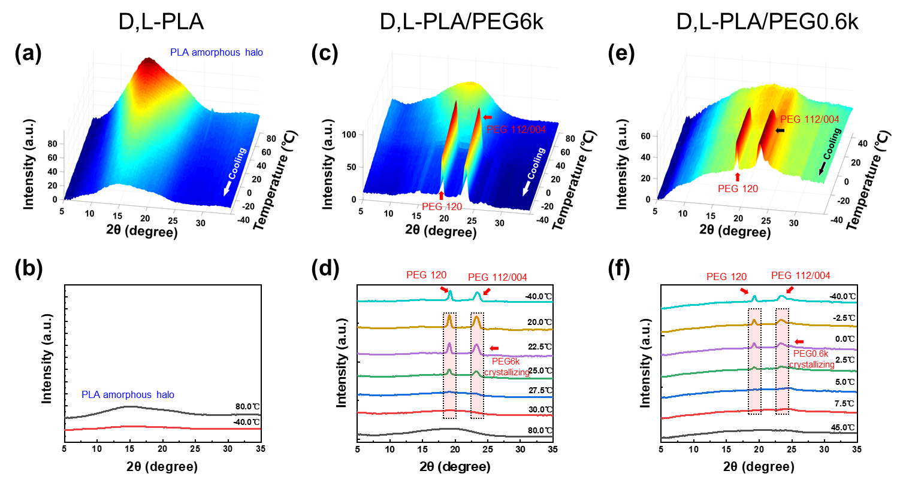
Figure 12. Time-resolved WAXS data of D,L-PLA (a), D,L -PLA/PEG6k (c) and D,L -PLA/PEG0.6k (e) fibers during cooling and associated 1D integrated WAXS profiles at critical phase change temperatures in (b), (d) and (f), respectively.

D,L-PLA is an amorphous polymer. Thus, Figure 12a and SI, Figure S7a show an amorphous halo of D,L-PLA. It can be seen that the shape of this halo changed with temperature indicating a structural change within the amorphous D,L-PLA during heating and cooling. The WAXS data of D,L-PLA/PEG6k and D,L-PLA/PEG0.6k PCFs also showed that there was no PLA crystalline peak. Within the D,L-PLA matrix, the crystallization and melting of PEG6k and PEG0.6k can be followed by tracking the appearance and disappearance of PEG 120 and 112/004 crystalline peaks. The T_{c} and T_{m} values of PEG6k and PEG0.6k match those measured from DSC.
The visual appearance of D-PLA, L-PLA fibers and corresponding PCFs were recorded both before and after time-resolved WAXS during the thermal sweeps (Figure 13). It can be seen that a PLA matrix formed from semi-crystalline D-PLA remained stable, while the D,L-PLA fibrous matrix melted and fused into a transparent film. This fusion is attributed to the lack of PLA crystals in D,L-PLA. In contrast, L-PLA and D-PLA are semi-crystalline polymers and when heated over T_{g} (but lower than T_{m}, 179 °C [66]), the PLA crystals could act as physical crosslinks to encapsulate and stabilize the highly mobile amorphous phase. As Figure 11c and d shows, the fused D,L-PLA matrix dramatically confines the crystallization of PEG and results in low ΔH_{c}.
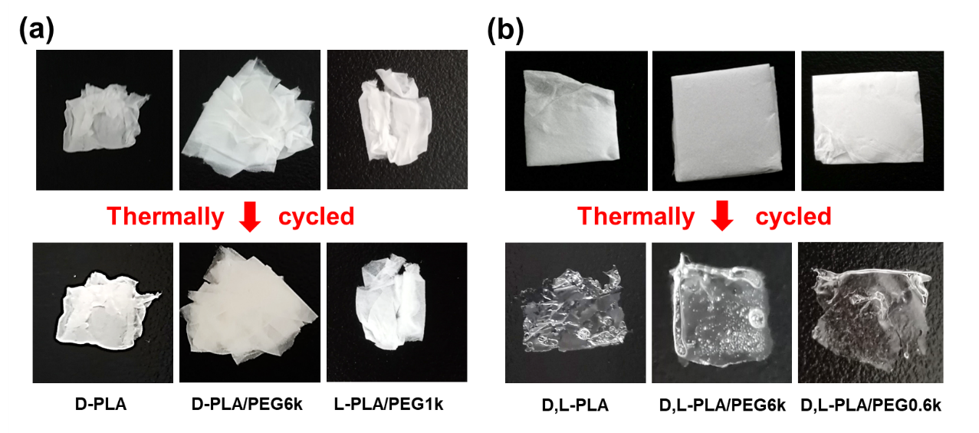
Figure 13. Digital camera images of as spun (first row) and thermally cycled (second row) (a) D-PLA, D-PLA/PEG6k, D-PLA/PEG1k fibers and (b) D,L-PLA, D,L-PLA/PEG6k, D,L-PLA/PEG0.6k fibers.

3.3 Mechanism hypothesis
In this study, in order to verify our two hypotheses, six PLA/PEG PCFs were fabricated by selecting various PEG M_{w} and PLA types. We investigated the relative crystallinity, ${\text{χ}}_{\text{c}}^{\text{PEG}}$, when PEG was encapsulated within rubbery, glassy, semi-crystalline and amorphous PLA fibrous matrices, as summarized in Figure 14a.
As proposed, a rubbery fibrous PLA matrix (where ${\text{T}}_{\text{g}}^{\text{PLA}}$ < ${\text{T}}_{\text{m}}^{\text{PEG}}$) conferred weaker confinement than a glassy matrix (${\text{T}}_{\text{g}}^{\text{PLA}}$ > ${\text{T}}_{\text{m}}^{\text{PEG}}$) on PEG crystallization (Figure 14a). This is attributed to the glassy PLA chains forming a rigid network with interpenetrating PEG chains within the PLA/PEG fibers, hindering the chain folding of PEG and confining PEG crystallization (Figure 14b) [67]. Samanta et al. [28] studied an electrospun PCF and discovered that microphase separation occurred by annealing PCF over ${\text{T}}_{\text{g}}^{\text{PS}}$ due to incompatibility between supporting material (polystyrene, PS) and PCM (PEG). The system formed by PLA and PEG in our study have also been shown to be physically incompatible [68]. Therefore, to some extent, the chain entanglement of rubbery PLA and PEG may be minimized due to the enthalpic driving force of their physical incompatibility and, thus, result in better PEG crystallization (Figure 14c).
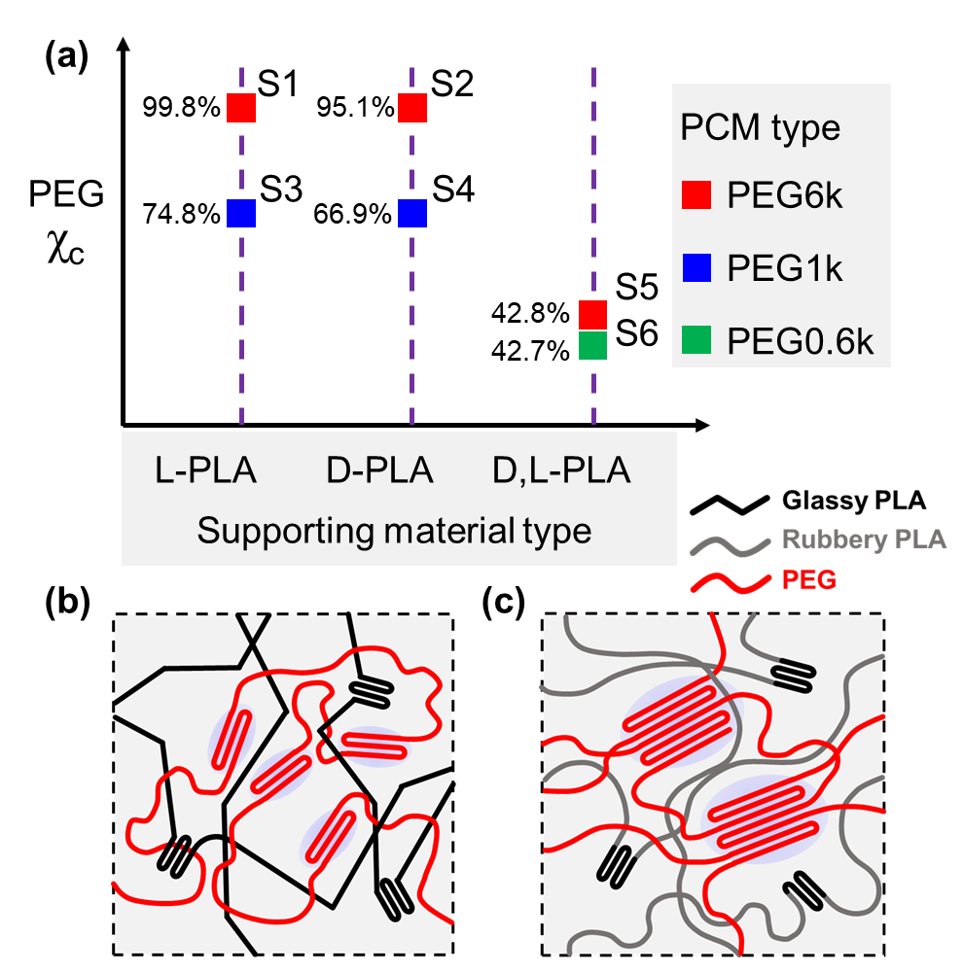
Figure 14. (a) The relative crystallinity (χ_{c}) of various M_{w} PEG encapsulated in different PLA matrices: S1, S2 for semi-crystalline and rubbery PLA matrix; S3, S4 for semi-crystalline and glassy PLA matrix; S5 for amorphous and rubbery PLA matrix; S6 for amorphous and glassy PLA matrix. (b) Glassy PLA matrix showed stronger confinement than rubbery matrix (c) on PEG crystallization.

Initially, it was believed that semi-crystalline supporting materials may induce the crystallization of PCM, but our experimental findings did not support this concept. Surprisingly, it was shown that PLA crystallinity was the key to stabilize the fibrous structure. PLA crystals appear to provide physical crosslinks within the fibers and prevent the macroscopic motion of amorphous PLA chains when PLA/PEG PCFs are operating above the ${\text{T}}_{\text{g}}^{\text{PLA}}$. In contrast, as Figure 13b and Figure 11c and d show, a physically fused PLA fibrous matrix (observed in the non-crystalline D,L-PLA-containing systems) severely confines the crystallization of PEG.
Chen et al. [34] attempted to enhance ΔH by increasing PEG content. An enthalpy of 107.6 J/g was successfully obtained at 80 wt.% PEG ratio by introducing stronger hydrogen bonding in supporting material. While, in this study, by controlling the molecular arrangement of supporting material, a ΔH value of 104.2 J/g can also be achieved (Table 5, L-PLA/PEG6k). This value is comparably superior among reported PCFs at 50 wt.% PCM ratio.

Table 5. Crystallization (ΔH_{c}) and melting (ΔH_{m}) enthalpies of some reported PCFs with approximately 50% PCM ratio.
No. | Supporting material/ PCM | ${\text{Δ}\text{H}}_{\text{c}}$ (J/g) | ${\text{Δ}\text{H}}_{\text{m}}$ (J/g) | PCM (wt.%) | Ref.
1 | PAN/paraffin | 57.42 | 58.74 | 50 | [35]
2 | PAN/MP-LA | 84.50 | 88.51 | 50 | [69]
3 | PET/MES | 88.03 | 90.43 | 50 | [70]
4 | PA6/PEG | / | ~95 | 50 | [71]
5 | PVA/PEG | 70.50 | 72.30 | 50 | [62]
6 | PAN/ butyl stearate | 55.10 | 55.10 | 45 | [72]
7 | PAN/ ethyl palmitate | 95.37 | 95.37 | 55 | [72]
8 | PVA/PEG | 73.43 | 59.31 | 50 | [73]
9 | PVP/PEG | 51.0 | 101.1 | 50 | [74]
10 | Copolyamide/ionic liquid | 57.60 | 67.67 | 47.5 | [75]
11 | L-PLA/PEG6k | 104.2 | 100.6 | 50 | This work
12 | L-PLA/PEG1k | 70.91 | 75.44 | 50 | This work
PAN - polyacrylonitrile; MP - methyl palmitate; LA - lauric acid; PET - poly(ethylene terephthalate); MES - methyl stearate; PA6 - polyamide-6; PVA - poly(vinyl alcohol); PVP - polyvinylpyrrolidone.

Semi-crystalline polymers with rubbery amorphous regions (T_{g} < operating temperature) appear to provide an ideal supporting material for preparing high ΔH PCFs. On one hand, the crystalline regions of the supporting material stabilize the fibrous structure of the PCFs, whilst on the other hand, the rubbery amorphous domains bring about higher ΔH.

4. Conclusions
As one of the most important parameters of PCFs, the phase change enthalpy (ΔH) of encapsulated PCMs have been reported to be significantly influenced by the supporting materials in which they are housed. Therefore, the present study was designed to investigate the effects of crystallizability and T_{g} of supporting materials to enhance the ΔH value of PCFs. Six different PLA/PEG PCFs were successfully electrospun for our in-depth study. PLA and PEG were selected for their biocompatibility and biodegradability. PEG was encapsulated within rubbery or glassy, and semi-crystalline or amorphous PLA fibrous matrices. The findings of this study indicate that semi-crystalline PLA with rubbery amorphous regions (T_{g} < operating temperature) could help to promote the crystallization of encapsulated PEG. Among all PCFs prepared, the representative L-PLA/PEG6k fibers showed a very high ΔH (~100 J/g) at 50 wt.% PCM and 97.5% ΔH remained after 100 thermal cycles. L-PLA/PEG6k fibers can stabilize their intra-fibrous temperature and achieve a maximum of 7.8 ℃ temperature difference against environmental temperature fluctuations. These novel L-PLA/PEG6k fibers can be considered as promising form-stable PCFs for application in many fields, such as thermal energy storage, thermal regulation, smart textiles, controlled drug delivery and cancer thermal therapy. We believe that the strategy of selecting semi-crystalline polymers with flexible amorphous regions may inspire researchers to find suitable supporting materials and undertake further studies to fully exploit this strategy for advancing PCF technology.

Data Availability
Data will be made available on request.

Declaration of competing interest
The authors declare that they have no known competing financial interests or personal relationships that could have appeared to influence the work reported in this paper.

Acknowledgement
The authors thank the financial support from the National Key R&D Program of China (No. 2021YFB3802700), National Natural Science Foundation of China (No. U22A20316 and 51890871), Guangdong Project (No. 2016ZT06C322), Overseas Expertise Introduction Center for Discipline Innovation (“111 Center”) and Guangdong University Student Science and Technology Innovation Cultivation Special Fund Project (No. pdjh2023b0038).

References
[1] P. Zhang, X. Xiao, Z.W. Ma, A review of the composite phase change materials: Fabrication, characterization, mathematical modeling and application to performance enhancement, Appl. Energy 165 (2016) 472-510. https://doi.org/10.1016/j.apenergy.2015.12.043
[2] M.M. Umair, Y. Zhang, K. Iqbal, S.F. Zhang, B.T. Tang, Novel strategies and supporting materials applied to shape-stabilize organic phase change materials for thermal energy storage-A review, Appl. Energy 235 (2019) 846-873. https://doi.org/10.1016/j.apenergy.2018.11.017
[3] H. Liu, X. Wang, D. Wu, Innovative design of microencapsulated phase change materials for thermal energy storage and versatile applications: A review, Sustainable Energy Fuels 3 (2019) 1091-1149. https://doi.org/10.1039/c9se00019d
[4] Y. Wu, C. Chen, Y. Jia, J. Wu, Y. Huang, L. Wang, Review on electrospun ultrafine phase change fibers (PCFs) for thermal energy storage, Appl. Energy 210 (2018) 167-181. https://doi.org/10.1016/j.apenergy.2017.11.001
[5] T. Gao, Z. Yang, C. Chen, Y. Li, K. Fu, J. Dai, E.M. Hitz, H. Xie, B. Liu, J. Song, Three-Dimensional Printed Thermal Regulation Textiles, ACS Nano 11 (2017) 11513–11520. https://doi.org/10.1021/acsnano.7b06295
[6] L. Civan, S. Kurama, A review: preparation of functionalised materials/smart fabrics that exhibit thermochromic behaviour, Mater. Sci. Technol. 37 (2021) 1405-1420. https://doi.org/10.1080/02670836.2021.2015844
[7] Y. Lu, X. Xiao, J. Fu, C. Huan, S. Qi, Y. Zhan, Y. Zhu, G. Xu, Novel smart textile with phase change materials encapsulated core-sheath structure fabricated by coaxial electrospinning, Chem. Eng. J. 355 (2019) 532-539. https://doi.org/10.1016/j.cej.2018.08.189
[8] J. Wang, J. Xu, Y. He, Novel smart textile with ultraviolet shielding and thermo-regulation fabricated via electrospinning, J. Energy Storage 42 (2021) 103094. https://doi.org/10.1016/j.est.2021.103094
[9] R. Shen, M. Weng, L. Zhang, J. Huang, X. Sheng, Biomass-based carbon aerogel/Fe3O4@PEG phase change composites with satisfactory electromagnetic interference shielding and multi-source driven thermal management in thermal energy storage, Composites Part A: Applied Science and Manufacturing 163 (2022) 107248. https://doi.org/10.1016/j.compositesa.2022.107248
[10] Y. Sun, R. Wang, X. Liu, S. Fang, B. Li, Design of a novel multilayer low-temperature protection composite based on phase change microcapsules, J. Appl. Polym. Sci. 136 (2019) 47534. https://doi.org/10.1002/app.47534
[11] Y.-J. Kim, M. Ebara, T. Aoyagi, A Smart Hyperthermia Nanofiber with Switchable Drug Release for Inducing Cancer Apoptosis, Adv. Funct. Mater. 23 (2013) 5753-5761. https://doi.org/10.1002/adfm.201300746
[12] L. Chen, Q.Q. Yu, K. Cheng, P.D. Topham, M.M. Xu, X.Q. Sun, Y.M. Pan, Y.F. Jia, S. Wang, L.G. Wang, Can Photothermal Post-Operative Cancer Treatment Be Induced by a Thermal Trigger?, ACS Appl. Mater. Interfaces 13 (2021) 60837-60851. https://doi.org/10.1021/acsami.1c16283
[13] K.Y. Zhang, H.J. Lv, Y.Q. Zheng, Y.M. Yao, X.R. Li, J.Y. Yu, B. Ding, Nanofibrous hydrogels embedded with phase-change materials: Temperature-responsive dressings for accelerating skin wound healing, Compos. Commun. 25 (2021) 100752. https://doi.org/10.1016/j.coco.2021.100752
[14] L. Chen, X. Sun, K. Cheng, P.D. Topham, M. Xu, Y. Jia, D. Dong, S. Wang, Y. Liu, L. Wang, Q. Yu, Temperature-Regulating Phase Change Fiber Scaffold Toward Mild Photothermal–Chemotherapy, Adv. Fiber Mater. 4 (2022) 1669-1684. https://doi.org/10.1007/s42765-022-00199-8
[15] X.F. Song, Y.B. Cai, W.W. Wang, X.L. Sun, Y. Wu, Q.F. Wei, Y. Hu, Thermal behavior and shape-stabilization of fatty acid eutectics/electrospun carbon nano-felts composite phase change materials enhanced by reduced graphene oxide, Sol. Energy Mater. Sol. Cells 191 (2019) 306-315. https://doi.org/10.1016/j.solmat.2018.11.042
[16] Y. Jia, W. Yuan, M. Xu, C. Yang, L. Chen, S. Wang, P.D. Topham, G. Luo, M. Wang, Y. Zhang, G. Jiang, Q. Yu, L. Wang, One-step Method to Fabricate Poly(ethylene terephthalate)/Gd(OH)3 Magnetic Nanofibers Towards MRI-active Materials with High T1 Relaxivity and Long-term Visibility, Giant 12 (2022) 100121. https://doi.org/10.1016/j.giant.2022.100121
[17] Y.B. Cai, X.B. Hou, W.W. Wang, M.M. Liu, J.H. Zhang, H. Qiao, F.L. Huang, Q.F. Wei, Effects of SiO2 nanoparticles on structure and property of form-stable phase change materials made of cellulose acetate phase inversion membrane absorbed with capric-myristic-stearic acid ternary eutectic mixture, Thermochim. Acta 653 (2017) 49-58. https://doi.org/10.1016/j.tca.2017.03.027
[18] G. Chen, T.T. Shi, X.G. Zhang, F. Cheng, X.W. Wu, G.Q. Leng, Y.G. Liu, M.H. Fang, X. Min, Z.H. Huang, Polyacrylonitrile/polyethylene glycol phase-change material fibres prepared with hybrid polymer blends and nano-SiC fillers via centrifugal spinning, Polymer 186 (2020) 122012. https://doi.org/10.1016/j.polymer.2019.122012
[19] J.T. McCann, M. Marquez, Y.N. Xia, Melt coaxial electrospinning: A versatile method for the encapsulation of solid materials and fabrication of phase change nanofibers, Nano Lett. 6 (2006) 2868-2872. https://doi.org/10.1021/nl0620839
[20] E. Pakdel, M. Naebe, L. Sun, X.G. Wang, Advanced Functional Fibrous Materials for Enhanced Thermoregulating Performance, ACS Appl. Mater. Interfaces 11 (2019) 13039-13057. https://doi.org/10.1021/acsami.8b19067
[21] C.Z. Chen, J. Chen, Y.F. Jia, P.D. Topham, L.G. Wang, Binary shape-stabilized phase change materials based on poly(ethylene glycol)/polyurethane composite with dual-phase transition, J. Mater. Sci. 53 (2018) 16539-16556. https://doi.org/10.1007/s10853-018-2806-2
[22] C. Cardenas-Ramirez, F. Jaramillo, M. Gomez, Systematic review of encapsulation and shape-stabilization of phase change materials, J. Energy Storage 30 (2020) 101495. https://doi.org/10.1016/j.est.2020.101495
[23] A. Liguori, S. Pandini, C. Rinoldi, N. Zaccheroni, F. Pierini, M.L. Focarete, C. Gualandi, Thermoactive Smart Electrospun Nanofibers, Macromol. Rapid Commun. 43 (2022) 2100694. https://doi.org/10.1002/marc.202100694
[24] C.Z. Chen, L.G. Wang, Y. Huang, Ultrafine electrospun fibers based on stearyl stearate/polyethylene terephthalate composite as form stable phase change materials, Chem. Eng. J. 150 (2009) 269-274. https://doi.org/10.1016/j.cej.2009.03.007
[25] C.Z. Chen, L.G. Wang, Y. Huang, Role of M-n of PEG in the Morphology and Properties of Electrospun PEG/CA Composite Fibers for Thermal Energy Storage, AlChE J. 55 (2009) 820-827. https://doi.org/10.1002/aic.11708
[26] N. Xie, J.Y. Niu, X.N. Gao, Y.T. Fang, Z.G. Zhang, Fabrication and characterization of electrospun fatty acid form-stable phase change materials in the presence of copper nanoparticles, Int. J. Energy Res. 44 (2020) 8567-8577. https://doi.org/10.1002/er.5543
[27] R. Ji, Q.F. Zhang, F.X. Zhou, F. Xu, X.D. Wang, C.W. Huang, Y.C. Zhu, H.Z. Zhang, L.X. Sun, Y.P. Xia, X.C. Lin, H.L. Peng, Y.J. Zou, H.L. Chu, Electrospinning fabricated novel poly (ethylene glycol)/graphene oxide composite phase-change nano-fibers with good shape stability for thermal regulation, J. Energy Storage 40 (2021) 102687. https://doi.org/10.1016/j.est.2021.102687
[28] P. Samanta, V. Thangapandian, S. Singh, R. Srivastava, B. Nandan, C.-L. Liu, H.-L. Chen, Crystallization behaviour of poly(ethylene oxide) under confinement in the electrospun nanofibers of polystyrene/poly(ethylene oxide) blends, Soft Matter 12 (2016) 5110-5120. https://doi.org/10.1039/c6sm00648e
[29] G. Fredi, P. Kianfar, S. Dalle Vacche, A. Pegoretti, A. Vitale, Electrospun Shape-Stabilized Phase Change Materials Based on Photo-Crosslinked Polyethylene Oxide, Polymers 13 (2021) 2979. https://doi.org/10.3390/polym13172979
[30] V. Kupka, E. Dvorakova, A. Manakhov, M. Michlicek, J. Petrus, L. Vojtova, L. Zajickova, Well-Blended PCL/PEO Electrospun Nanofibers with Functional Properties Enhanced by Plasma Processing, Polymers 12 (2020) 1403. https://doi.org/10.3390/polym12061403
[31] C.Z. Chen, L.G. Wang, Y. Huang, Crosslinking of the electrospun polyethylene glycol/cellulose acetate composite fibers as shape-stabilized phase change materials, Mater. Lett. 63 (2009) 569-571. https://doi.org/10.1016/j.matlet.2008.11.033
[32] Y. Cao, M.M. Weng, M.H.H. Mahmoud, A.Y. Elnaggar, L. Zhang, I.H. El Azab, Y. Chen, M.N. Huang, J.T. Huang, X.X. Sheng, Flame-retardant and leakage-proof phase change composites based on MXene/polyimide aerogels toward solar thermal energy harvesting, Advanced Composites and Hybrid Materials 5 (2022) 1253-1267. https://doi.org/10.1007/s42114-022-00504-4
[33] J. Huang, J. Su, W. Xu, J. Lin, M. Weng, Y. Liu, Y. Min, High enthalpy efficiency lignin-polyimide porous hybrid aerogel composite phase change material with flame retardancy for superior solar-to-thermal energy conversion and storage, Sol. Energy Mater. Sol. Cells 248 (2022) 112036. https://doi.org/10.1016/j.solmat.2022.112036
[34] C.Z. Chen, R. Chen, T.Y. Zhao, L.G. Wang, A comparative study of linear polyurea and crosslinked polyurea as supports to stabilize polyethylene glycol for thermal energy storage, Renewable Energy 183 (2022) 535-547. https://doi.org/10.1016/j.renene.2021.10.078
[35] N. Kizildag, Smart composite nanofiber mats with thermal management functionality, Sci. Rep. 11 (2021) 4256. https://doi.org/10.1038/s41598-021-83799-5
[36] Y. Xu, C.-G. Liu, H.-R. Nie, A.-H. He, Fractionated and Confined Crystallization of Polybutene-1 in Immiscible Polypropylene/Polybutene-1 Blends, Chin. J. Polym. Sci. 36 (2018) 859-865. https://doi.org/10.1007/s10118-018-2103-1
[37] L. Zhu, S.Z.D. Cheng, B.H. Calhoun, Q. Ge, R.P. Quirk, B.S. Hsiao, F. Yeh, Molecular and supramolecular ordering in confined environments, Chin. J. Polym. Sci., 2000, pp. 287-300.
[38] Z.L. Zheng, W.J. Sun, X.X. Zhang, Z.Y.T. Liu, W.B. Wang, M.H. Bai, H.R. Yang, G.J. Zhong, J.Z. Xu, Z.M. Li, Interfacial Banded Transcrystallization of Polyoxymethylene/Poly(butylene succinate) Blends Induced by the Polyamide 6 Fiber, Chin. J. Polym. Sci. 40 (2022) 394-402. https://doi.org/10.1007/s10118-022-2684-6
[39] C. Chen, L. Wang, Y. Huang, Electrospun phase change fibers based on polyethylene glycol/cellulose acetate blends, Appl. Energy 88 (2011) 3133-3139. https://doi.org/10.1016/j.apenergy.2011.02.026
[40] Z. Esmaeilzadeh, B. Rezaei, A.M. Shoushtari, M.R.M. Mojtahedi, Enhancing the Thermal Characteristics of Shape-Stabilized Phase Change Nanocomposite Nanofibers by Incorporation of Multiwalled Carbon Nanotubes within the Nanofibrous Structure, Adv. Polym. Technol. 37 (2018) 21655. https://doi.org/10.1002/adv.21655
[41] G. Ke, X. Wang, J. Pei, Fabrication and Properties of Electrospun PAN/LA-SA/TiO2 Composite Phase Change Fiber, Polym.-Plast. Technol. Eng. 57 (2018) 958-964. https://doi.org/10.1080/03602559.2017.1370101
[42] B. Rezaei, M. Askari, A.M. Shoushtari, R.A.M. Malek, The effect of diameter on the thermal properties of the modeled shape-stabilized phase change nanofibers (PCNs), J. Therm. Anal. Calorim. 118 (2014) 1619-1629. https://doi.org/10.1007/s10973-014-4025-7
[43] Y. Cai, C. Gao, X. Xu, Z. Fu, X. Fei, Y. Zhao, Q. Chen, X. Liu, Q. Wei, G. He, H. Fong, Electrospun ultrafine composite fibers consisting of lauric acid and polyamide 6 as form-stable phase change materials for storage and retrieval of solar thermal energy, Sol. Energy Mater. Sol. Cells 103 (2012) 53-61. https://doi.org/10.1016/j.solmat.2012.04.031
[44] C. Chen, L. Wang, Y. Huang, Morphology and thermal properties of electrospun fatty acids/polyethylene terephthalate composite fibers as novel form-stable phase change materials, Sol. Energy Mater. Sol. Cells 92 (2008) 1382-1387. https://doi.org/10.1016/j.solmat.2008.05.013
[45] H.Z. Ke, D.W. Li, X.L. Wang, H. Wang, Y.B. Cai, Y. Xu, F.L. Huang, Q.F. Wei, Thermal and mechanical properties of nanofibers-based form-stable PCMs consisting of glycerol monostearate and polyethylene terephthalate, J. Therm. Anal. Calorim. 114 (2013) 101-111. https://doi.org/10.1007/s10973-012-2856-7
[46] P. Lu, W. Chen, M. Zhu, S. Murray, Embedding Lauric Acid into Polystyrene Nanofibers To Make High-Capacity Membranes for Efficient Thermal Energy Storage, ACS Sustainable Chem. Eng. 5 (2017) 7249-7259. https://doi.org/10.1021/acssuschemeng.7b01476
[47] M. Seifpoor, M. Nouri, J. Mokhtari, Thermo-regulating Nanofibers Based on Nylon 6,6/Polyethylene Glycol Blend, Fibers Polym. 12 (2011) 706-714. https://doi.org/10.1007/s12221-011-0706-z
[48] H. Che, Q. Chen, Q. Zhong, S. He, The effects of nanoparticles on morphology and thermal properties of erythritol/polyvinyl alcohol phase change composite fibers, E-Polymers 18 (2018) 321-329. https://doi.org/10.1515/epoly-2017-0176
[49] S. Salimian, M. Montazer, A.S. Rashidi, N. Soleimani, A. Bashiri Rezaie, PCM nanofibrous composites based on PEG/PVA incorporated by TiO2/Ag nanoparticles for thermal energy management, J. Appl. Polym. Sci. 138 (2021) 51357. https://doi.org/10.1002/app.51357
[50] R.-M. Wang, S.-R. Zheng, Y.-P. Zheng, 1 - Introduction to polymer matrix composites, Polymer Matrix Composites and Technology, Woodhead Publishing, Beijing, 2011, pp. 1-548.
[51] E. Zdraveva, J. Fang, B. Mijovic, T. Lin, Electrospun Poly(vinyl alcohol)/Phase Change Material Fibers: Morphology, Heat Properties, and Stability, Ind. Eng. Chem. Res. 54 (2015) 8706-8712. https://doi.org/10.1021/acs.iecr.5b01822
[52] P. Samanta, V. Thangapandian, R. Srivastava, B. Nandan, Frustrated Crystallization behavior of Poly(ethylene oxide) in Electrospun Core-Shell Nanofibers and Beads, Fibers Polym. 22 (2021) 2750-2761. https://doi.org/10.1007/s12221-021-1221-5
[53] A. Kongprayoon, G. Ross, N. Limpeanchob, S. Mahasaranon, W. Punyodom, P.D. Topham, S. Ross, Bio-derived and biocompatible poly(lactic acid)/silk sericin nanogels and their incorporation within poly(lactide-co-glycolide) electrospun nanofibers, Polym. Chem. 13 (2022) 3343-3357. https://doi.org/10.1039/D2PY00330A
[54] J.-W. Park, J.-H. Shin, G.-S. Shim, K.-B. Sim, S.-W. Jang, H.-J. Kim, Mechanical Strength Enhancement of Polylactic Acid Hybrid Composites, Polymers 11 (2019) 349. https://doi.org/10.3390/polym11020349
[55] N. Tuancharoensri, G.M. Ross, S. Mahasaranon, P.D. Topham, S. Ross, Ternary blend nanofibres of poly(lactic acid), polycaprolactone and cellulose acetate butyrate for skin tissue scaffolds: influence of blend ratio and polycaprolactone molecular mass on miscibility, morphology, crystallinity and thermal properties, Polym. Int. 66 (2017) 1463-1472. https://doi.org/10.1002/pi.5393
[56] P. Taepaiboon, U. Rungsardthong, P. Supaphol, Drug-loaded electrospun mats of poly(vinyl alcohol) fibres and their release characteristics of four model drugs, Nanotechnology 17 (2006) 2317-2329. https://doi.org/10.1088/0957-4484/17/9/041
[57] S.A. Theron, E. Zussman, A.L. Yarin, Experimental investigation of the governing parameters in the electrospinning of polymer solutions, Polymer 45 (2004) 2017-2030. https://doi.org/10.1016/j.polymer.2004.01.024
[58] C. Echeverría, I. Limón, A. Muñoz-Bonilla, M. Fernández-García, D. López, Development of Highly Crystalline Polylactic Acid with β-Crystalline Phase from the Induced Alignment of Electrospun Fibers, Polymers 13 (2021) 2860. https://doi.org/10.3390/polym13172860
[59] J. Sun, H. Yu, X. Zhuang, X. Chen, X. Jing, Crystallization Behavior of Asymmetric PLLA/PDLA Blends, J. Phys. Chem. B 115 (2011) 2864-2869. https://doi.org/10.1021/jp111894m
[60] C. Slusarczyk, Crystallization and melting behavior of poly(ethylene oxide) and its blend with styrene-based ionomer using time-resolved SAXS/WAXS experiments, Radiat. Phys. Chem. 80 (2011) 1078-1083. https://doi.org/10.1016/j.radphyschem.2011.02.023
[61] K.-J. Chang, H.-R. Chen, H.-H. Hsu, T.-H. Kao, T.-Y. Lo, H.-W. Lin, J.-T. Chen, Electrospun PMMA fibers blended with core-shell PCM/PS microspheres for thermal regulating applications, J. Chin. Chem. Soc. 69 (2022) 1519-1524. https://doi.org/10.1002/jccs.202200192
[62] W. Zhu, Y. Wang, S. Song, H. Ai, F. Qiu, D. Li, L. Dong, Environmental-friendly electrospun phase change fiber with exceptional thermal energy storage performance, Sol. Energy Mater. Sol. Cells 222 (2021) 110939. https://doi.org/10.1016/j.solmat.2020.110939
[63] X. Li, Q. Li, J. Hu, R. Li, J. Lin, Y. Liu, Core-sheath phase change fibers via coaxial wet spinning for solar energy active storage, Composites Part B: Engineering 247 (2022) 110346. https://doi.org/10.1016/j.compositesb.2022.110346
[64] F. Haghighat, S.A. Hosseini Ravandi, M.N. Esfahany, A. Valipouri, Z. Zarezade, Thermal performance of electrospun core-shell phase change fibrous layers at simulated body conditions, Appl. Therm. Eng. 161 (2019) 113924. https://doi.org/10.1016/j.applthermaleng.2019.113924
[65] Y. Qian, N. Han, X. Gao, X. Gao, W. Li, X. Zhang, Cellulose-based phase change fibres for thermal energy storage and management applications, Chem. Eng. J. 412 (2021) 128596. https://doi.org/10.1016/j.cej.2021.128596
[66] N. Chaiya, D. Daranarong, P. Worajittiphon, R. Somsunan, P. Meepowpan, A. Tuantranont, N. Rakbamrung, P.D. Topham, B.J. Tighe, A. Mahomed, W. Punyodom, 3D-printed PLA/PEO blend as biodegradable substrate coating with CoCl2 for colorimetric humidity detection, Food Packag. Shelf Life 32 (2022) 100829. https://doi.org/10.1016/j.fpsl.2022.100829
[67] M.C. Ma, Y.L. Guo, Physical Properties of Polymers Under Soft and Hard Nanoconfinement: A Review, Chin. J. Polym. Sci. 38 (2020) 565-578. https://doi.org/10.1007/s10118-020-2380-3
[68] A. Takhulee, Y. Takahashi, V. Vao-soongnern, Molecular simulation and experimental studies of the miscibility of polylactic acid/polyethylene glycol blends, J. Polym. Res. 24 (2016) 8. https://doi.org/10.1007/s10965-016-1174-3
[69] N. Xie, J. Niu, X. Gao, Y. Fang, Z. Zhang, Fabrication and characterization of electrospun fatty acid form-stable phase change materials in the presence of copper nanoparticles, Int. J. Energy Res. 44 (2020) 8567-8577. https://doi.org/10.1002/er.5543
[70] H. Ke, Electrospun methyl stearate/PET form-stable phase change composite nanofibres for storage and retrieval of thermal energy, Mater. Res. Innovations 22 (2018) 150-158. https://doi.org/10.1080/14328917.2016.1266203
[71] A. Babapoor, G. Karimi, S.I. Golestaneh, M.A. Mezjin, Coaxial electro-spun PEG/PA6 composite fibers: Fabrication and characterization, Appl. Therm. Eng. 118 (2017) 398-407. https://doi.org/10.1016/j.applthermaleng.2017.02.119
[72] H. Ke, Y. Li, A series of electrospun fatty acid ester/polyacrylonitrile phase change composite nanofibers as novel form-stable phase change materials for storage and retrieval of thermal energy, Text. Res. J. 87 (2016) 2314-2322. https://doi.org/10.1177/0040517516669078
[73] J.W. Huang, H.Y. Yu, S.Y.H. Abdalkarim, J. Marek, J. Militky, Y.Z. Li, J.M. Yao, Electrospun Polyethylene Glycol/Polyvinyl Alcohol Composite Nanofibrous Membranes as Shape-Stabilized Solid-Solid Phase Change Materials, Adv. Fiber Mater. 2 (2020) 167-177. https://doi.org/10.1007/s42765-020-00038-8
[74] W. Zhang, X. Zhang, Y. Xu, Y. Xu, J. Qiao, T. Shi, Z. Huang, Y.g. Liu, M. Fang, X. Min, X. Wu, Flexible polyethylene glycol/polyvinylpyrrolidone composite phase change fibres: Preparation, characterization, and thermal conductivity enhancement, Polymer 214 (2021) 123258. https://doi.org/10.1016/j.polymer.2020.123258
[75] C. Lin, W. Li, Y. Yan, H. Ke, Z. Liu, L. Deng, Z. Qiu, Ultrafine electrospun fiber based on ionic liquid/AlN/copolyamide composite as novel form-stable phase change material for thermal energy storage, Sol. Energy Mater. Sol. Cells 223 (2021) 110953. https://doi.org/10.1016/j.solmat.2020.110953

