Sources and Mechanisms of Modality-Specific Distraction in Visual Short-Term Memory

Tom Mercer¹, Raegan Shaw¹, and Luke Fisher²
¹ School of Psychology, University of Wolverhampton
² School of Psychology, Aston University

WORD COUNT: 11,927 words (excluding title page, references, tables, figures and abstract)

RUNNING HEAD: Distraction in Visual Memory

CONTACT: Correspondence concerning this article should be addressed to Tom Mercer, Centre for Psychological Research, School of Psychology, University of Wolverhampton, Wolverhampton, UK, WV1 1LY. Email: t.mercer2@wlv.ac.uk. Telephone: +44(0)1902 321368. ORCID: 0000-0001-8402-1762

DATA AVAILABILITY STATEMENT: The data that support the findings of this study are openly available in the Open Science Framework project “Sources and Mechanisms of Modality-Specific Distraction in Visual Short-Term Memory” at https://doi.org/10.17605/OSF.IO/CA7U6.
Abstract

Visual short-term and working memory can be disrupted by irrelevant, distracting input occurring after encoding. Distractors similar to the original memory are known to be interfering, but it is unclear whether dissimilar distractors have the same disruptive effect. The presence of dissimilar distraction would be problematic for views of similarity-based interference, hence the present study investigated modality-specific distraction using a procedure that required participants to compare single target and probe objects over a delay. An irrelevant distractor could be presented during the delay separating the target and probe, but it varied in its similarity to the target. In four experiments, recognition was disrupted by the presence of a distractor, even when the distractors were highly dissimilar to the target. Furthermore, the interference effect was not reduced when the same distractors were repeatedly used throughout the experiment, and interference from dissimilar distractors was only lessened when it was extremely predictable. These findings indicate that susceptibility to dissimilar distraction is a persistent limitation in visual short-term memory.

KEY WORDS: Retroactive interference, distraction, visual memory, forgetting.

Once they have been formed, memories can still be disrupted by subsequently encountered information. Classic work by Loftus and colleagues has shown that memories for specific events can be changed and modified via ensuing misinformation (see Loftus & Loftus, 1980), with Loftus and Greene (1980) highlighting the impact on retention of faces. Memory for a target individual, presented under a variety of different scenarios, was sensitive to misleading information, with some participants incorporating incorrect details (heard from another source) into their description. This also affected recognition performance, and misleading information presented via leading questions could be incorporated into the memory of the person too.
The notion that information or events occurring after the formation of a memory damages retrieval is known as retroactive interference (RI). The work of Loftus and colleagues examined interference effects in long-term memory, but it can affect memory over briefer periods too, including visual short-term memory (VSTM). VSTM is the system responsible for maintaining visual information over brief delays and is crucial to daily activities. Understanding how visual memory responds to interference has therefore become an important area of research, but RI can occur in different ways. This includes interruptions (interference produced by an attention-demanding secondary task) and distraction (interference produced by passive exposure to irrelevant and ignorable stimuli; Clapp et al., 2010). The latter effect may also be referred to as perceptual interference (Makovski & Pertzov, 2015) or delay-period perceptual distraction (Lorenc et al., 2021).
Attentionally-demanding interruptions tend to be more damaging than passive distraction (e.g., Clapp et al., 2010; Makovski et al., 2006; Makovski & Pertzov, 2015), yet modality-specific distraction is still a significant source of RI in VSTM (e.g., Della Sala et al., 1999; Fallon et al., 2018; Hecht et al., 2016; Klauer & Zhao, 2004; Logie & Marchetti, 1991; Makovski et al., 2006; Makovski & Jiang, 2007; McNab & Dolan, 2014; Mercer, 2018). Indeed, distraction effects have been reported in memory for simple visual features, such as orientation (e.g., Lorenc et al., 2018; Rademaker et al., 2015), spatial frequency (e.g., Magnussen et al., 1991) and color (e.g., Nemes et al., 2012), as well as more complex objects, such as faces (e.g., Dolcos et al., 2007).
Even though distractors are irrelevant and do not require a response, they may have a detrimental effect because they capture attention. This has been demonstrated by studies on the visual suffix effect, which require participants to remember a set of targets that is immediately followed by an irrelevant distractor (the suffix; see Hitch et al., 2020, for a review). While participants are explicitly instructed to ignore this suffix, it disrupts both recognition (Ueno, Allen, et al., 2011) and cued recall (Ueno, Mate, et al., 2011). The suffix effect has also been reported with sequentially presented stimuli (Hu et al., 2014) and under different stimulus prioritization instructions (Hitch et al., 2018), and may be a consequence of automatically encoding the distractor, or unsuccessfully attempting to prevent such encoding (Ueno, Allen, et al., 2011).
Distraction-based RI therefore plays a role in the loss of VSTM and may be an important forgetting mechanism. However, it remains poorly understood. Studies investigating distraction-based RI tend to be dispersed across the perception, attention, and memory literature, and utilize diverse methodologies and stimuli. Nonetheless, most studies require participants to remember an array of targets over an unfilled interval or a delay containing distractors, with the latter producing a mild but detectable disruption to behavioral performance (see Lorenc et al., 2021, for a review).
There is some evidence that distraction-based interference may be selective. Logie et al. (1990) showed that performance in a visual span test was more strongly affected by a visual imagery task, rather than mental arithmetic. Similarly, van der Meulen et al. (2009) found that retention of visually presented letters, which may be verbally encoded, was not affected by the presentation of irrelevant pictures. In terms of RI, some studies have found that distractors similar to the target memory are especially disruptive (e.g., Blalock, 2013; Borst et al., 2012; Nicholls et al., 2005), which has been termed the similarity assumption (see Sun et al., 2017) or, more broadly, the congruency effect (Lorenc et al., 2021).
A clear demonstration of similarity-based RI in visual memory was reported by Burin et al. (2007), who showed that retention of polygons was not affected by articulatory suppression or dynamic visual noise (DVN; a rapidly flickering matrix of black and white squares), but a complex, moving shape – similar to the polygons – did damage performance. Other studies have also shown that DVN – very dissimilar to the targets – does not act as a source of distraction when presented during the retention interval (e.g., Andrade et al., 2002; Avons & Sestieri, 2005; Quinn & McConnell, 2006) and categorical overlap between the target object and distractor may be important. For instance, Dolcos et al. (2007) reported that memory for three faces was hindered by exposure to other faces during the retention interval, but not by scrambled face images (see also Kim et al., 2015). Yoon et al. (2006) had even greater categorical incongruence and showed that memory for faces was disrupted by exposure to another face, but not a natural outdoor scene (though memory for scenes was not disrupted by either a distractor scene or a distractor face). Other findings are consistent with these effects (e.g., Clapp et al., 2010; Derrfuss et al., 2017) and additional demonstrations of similarity-based distraction have been documented (e.g., Fallon et al., 2018; Schroeder et al., 2018).
It is therefore possible that VSTM is most strongly disrupted by distractors similar to the to-be-remembered target. This effect is predicted by certain models, including Johnson, Spencer, and Schöner’s (2009) dynamic field theory, which explains visual memory through inhibitory and excitatory processes (see also Johnson, Spencer, Luck, & Schöner, 2009). A visual event is represented through an inhibitory response, and any new visual information highly similar to the current contents of memory will be inhibited. More dissimilar input leads to an excitatory response and the creation of a new representation. Whether this new input damages the existing content of the memory buffer depends on similarity – if the new input is very different to an existing memory, both can exist simultaneously as they take up different positions in the excitatory field. But if the items share some overlap, the original representation may be deleted by new input. Correspondingly, sensory recruitment models also predict similarity-dependent RI, as the target memory and the distractor may compete for shared neural resources when they overlap (see Lorenc et al., 2021).
Yet similarity can have complex effects on visual memory that are not always detrimental. For instance, Lin and Luck (2009) showed that performance in a color change detection task was enhanced when target objects were similar to each other, rather than dissimilar. Furthermore, there are some issues with the way in which target-distractor similarity has been manipulated in previous research, which may have underestimated the role of RI from distractors dissimilar to the target memory. Some studies have used the same stimuli as targets and distractors while varying them on one specific feature (e.g., Rademaker et al., 2015; Sun et al., 2017). For example, targets and distractors may differ in color, but be identical in other ways (e.g., type of object and shape). In this scenario, a dissimilar distractor can still have a great deal of overlap with the target. The other approach uses radically different targets and distractors, such as stimuli from different semantic categories (e.g., faces and houses; Feredoes et al., 2011) or DVN (e.g., Burin et al., 2007). However, use of familiar objects, such as images of houses, may introduce long-term memory processes – an issue that has not been extensively explored within the context of interference in VSTM – whereas faces are a more specialized stimulus with dedicated underpinning neural systems (Evans & Baddeley, 2018). The other common distractor, DVN, may not be perceived as a single type of distracting event as it is the visual equivalent of white noise.
Despite these issues, there is some evidence that dissimilar distractors can still be interfering. Feredoes et al.’s (2011) participants remembered three targets (either faces or houses) and distraction was introduced by inserting another three stimuli into the retention interval. Distractors were from the opposite category to the target, yet results revealed a trend towards poorer performance when distractors were present rather than absent. Additionally, Dent (2010) and Vasques et al. (2016) showed that DVN is capable of disrupting memory for visual stimuli. Hakun and Ravizza’s (2016) behavioral data also confirmed that RI can occur when there is less overlap between targets and distractors, as did Sun et al. (2017) and Mercer (2018). In Sun et al.’s experiments, participants had to recall the color of a single target (a real-world object) over a delay containing five distractors. The color of the distractors was manipulated and could be either similar to the target, or dissimilar. It was the distractors with very different colors that were most detrimental, increasing the probability of guess responses, whereas interference from distractors with similar colors was less pronounced and could generally be resisted. Mercer (2018) found that a dissimilar distractor was more detrimental to recognition performance than a similar distractor (but see Mercer & Barker, 2020, Experiment 2), though the latter distractor was still noticeably different to the target.
Distractors dissimilar to the target memory may therefore still be disruptive, but this may not be attributed to the processes that produce similarity-based distraction. Indeed, there is theoretical uncertainty about the RI produced by dissimilar distractors, but in long-term memory, demonstrations of this form of RI have been linked to disrupted consolidation (e.g., Dewar et al., 2007; Wixted, 2004, 2005). In this explanation, any distractor can produce interference if it occurs before the completion of consolidation (after consolidation, the memory will be resilient to RI). However, in VSTM, consolidation occurs rapidly (Vogel et al., 2006), yet there are demonstrations of distractors having a more detrimental impact when they occurred later in the retention interval (i.e., after the consolidation period; Mercer, 2018).
An alternative approach to understanding the impact of dissimilar distractors concerns novelty and surprise. In the updating and feature overwriting model (UFO), which was originally developed as a model of auditory memory for timbre (McKeown et al., 2011; McKeown & Wellsted, 2009; Mercer & McKeown, 2010a, 2010b), distraction is produced by two processes: a highly selective form of feature overwriting (which accounts for RI from similar distractors) and more general updating (which accounts for RI from dissimilar distractors). The latter occurs when any new events happen, creating another representation that forces the contents of the memory buffer to be updated. This updating process makes it difficult to retrieve elements of previously encountered objects. This notion that new items are given preference has some overlap with a mechanism outlined by Hitch et al. (2020), in which the most recently encountered stimulus is given special preference, perhaps by being held in the focus of attention.
Related to this point, distractors dissimilar to the existing content of memory may be perceived as novel or surprising, “standing out” from previous input and capturing attention (see Theeuwes, 2019). Evidence for surprising stimuli capturing visual attention was reported by Horstmann and Herwig (2015), who presented an array of eight discs, each containing a letter. The task was to detect specific letters within the array. Initially, all discs were presented in the same color, but this was followed by a critical trial, in which the target was shown in a different color to the distractors. This surprising event appeared to capture attention through attracting and binding eye gaze, suggested that a novel, surprising event allows rapid reorientation of attention. Other evidence is consistent with this interpretation (e.g., Horstmann, 2005, 2006; Horstmann & Becker, 2008, 2011).
Demonstrations of surprise-induced blindness also highlight the role that unexpected events can have on visual attention. For example, Asplund et al. (2010) used a rapid serial visual presentation task, displaying stimuli in a rapid sequence, with the task being to identify whether a target had been presented. On rare occasions, a surprising stimulus was shown in the sequence (this would be selected from a different semantic category to the other stimuli, such as a face presented in a sequence of letters, or vice versa). The surprising stimulus had a strong, detrimental effect on target detection, at least at short stimulus onset asynchronies.
Surprising events can capture attention, and within the context of RI, distractors dissimilar to the target may capture attention and lead to inadvertent encoding – i.e., the distractor type may be important. This would add a new representation to the memory buffer (an updating process), and this may disrupt the existing contents of that buffer (memory for target stimuli), but further testing of this account is needed.
In summary, there are some plausible explanations for RI produced by distractors dissimilar to target memories, but these need further testing. The issue has been further complicated by empirical uncertainty about the robustness of dissimilar RI, given contradictory findings concerning its effects. It is therefore necessary to gain a better understanding of both the magnitude of this source of interference and its underlying mechanisms, which was the aim of the present study. The first experiment aimed to measure the impact of dissimilar RI and assess its limits, measuring whether “extreme” dissimilarity would lessen any impact of the distractor (Burin et al., 2007; Feredoes et al., 2011). Experiments 2-4 then assessed possible mechanisms of dissimilar RI, focusing on the role of novelty and expectations.

Experiment 1

The first experiment modified a procedure used by Mercer (2018) and required participants to compare single target and probe objects over a brief retention interval. All targets and probes were selected from the set of objects known as Fribbles (stimulus images courtesy of Michael J. Tarr, Center for the Neural Basis of Cognition and Department of Psychology, Carnegie Mellon University, http://www.tarrlab.org), which are complex shapes consisting of a central body with four appendages. They are organized into three different families, each of which have completely different bodies and appendages. Within each family are four species that all share the same body, but have very different appendages (e.g., in location, shape, color, etc.). Finally, each species has 81 exemplars, all of which have slightly differing appendages, but these are similar in their position on the central body.
Single items were used as targets to minimize concurrent interference and allow RI effects to be isolated. While most previous studies use several objects, other distraction studies have used individual items (e.g., Rademaker et al., 2015). However, the objects used here still contained several components (the four appendages), meaning that concurrent RI could be lessened while simultaneously ensuring the stimuli were complex enough to place demands on memory.
To manipulate RI, the interval separating the target and probe sometimes contained a single, irrelevant distractor (in the control condition, the distractor was removed). When a distractor was present, it occurred 1.5 s after the target offset (see Figure 1 for a diagram of the procedure). Four different distractor types were created for this experiment and the intention was to assess the “limits” of dissimilar RI. One distractor was designed to be highly similar to the target and came from the same family and species as the target, though its four appendages were unique. This was named the high similarity condition. Another distractor was also chosen from the Fribbles set, but it came from a different family and species. This was named the low similarity distractor condition and matched an equivalent condition in Mercer (2018).

Figure 1
Diagram Depicting an Example Distractor Trial
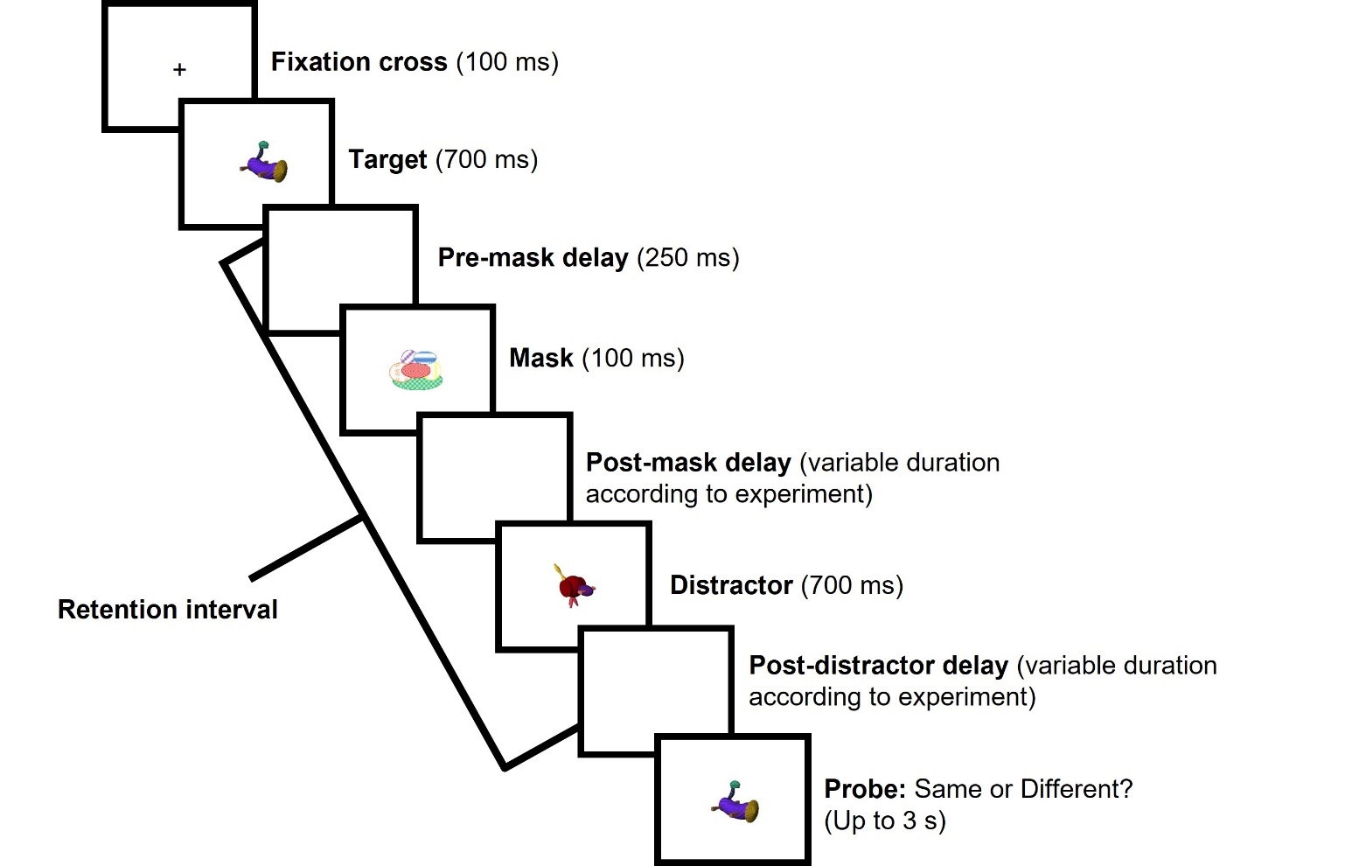
Note. On distractor-free trials, the retention was unfilled except for the mask. In this example, the target and probe are the same and the distractor is selected from the low similarity condition.

The low similarity distractor still had a degree of structural overlap with the target, belonging to the same stimulus set. To assess more “extreme” dissimilarity, two further distractor conditions were added that were even more distinct from the target. These two distractor types were also used to assess the role of distractor familiarity in dissimilar RI. Past work has suggested that semantic incongruence between the target and distractor eliminates interference (e.g., Yoon et al., 2006), yet some prior studies investigating highly dissimilar distractors have used familiar stimuli. Distractors that have no prior familiarity (i.e., they have never been encountered before, either within or outside the experimental context) may be particularly disruptive, whereas distractors with broader, prior familiarity may have less impact. To assess this, the low familiarity distractor used images of real-world stimuli that were unfamiliar and not commonly encountered. Conversely, the high familiarity distractor included images of easily identifiable real-world objects, such as highly recognizable gadgets, tools, and appliances. Both these distractors were highly dissimilar to the target yet differed in their prior familiarity. Examples of the different distractor types are shown in Figure 2.
If interference can be produced by any type of dissimilar distractor, low similarity, low familiarity, and high familiarity conditions should all impair recognition when compared with the distractor-free control. But if prior familiarity with a distractor reduces interference, the high familiarity distractor may have little impact in comparison to the distractor-free control condition. The strongest distraction may be produced by the high similarity distractor, in line with the similarity assumption and the congruency effect.

Method

Participants. A power analysis was performed with 95% power to detect an effect at an alpha of 0.05 based on a one-way repeated measures ANOVA design. The effect size was estimated from a similar study (Mercer, 2018, Experiment 1, η_{p}² = 0.17) and 25 participants were required (or 17 for 80% power). Twenty-eight participants were tested, but data from four individuals were lost because 15%+ of their responses were missing or invalid. The final sample included 24 psychology students (16 female, six male and two unrecorded) from the University of Wolverhampton. Participants were aged between 18 and 52 (M = 25.23, SD = 8.24, two ages unrecorded) and they provided written informed consent before undertaking the procedure.

Figure 2
Diagram Showing Four Major Distractor Types
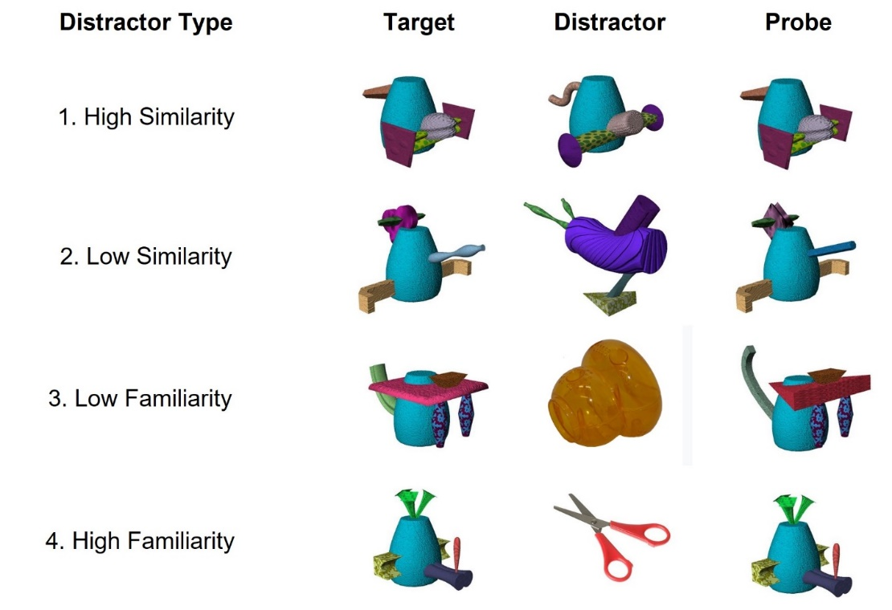

Materials. Fribbles served as the targets, probes, and high and low similarity distractors. The three major Fribble families were equally represented and when the target and probe differed, they came from the same family/species but varied in two of their four appendages. This approach has been used in previous experiments and allows the task to be difficult, while avoiding floor and ceiling effects (Mercer, 2014, 2018). As each Fribble has four appendages, changing two appendages on Different trials meant there were six possible permutations, and each occurred three times in a condition. A mask stimulus from Mercer (2014) and a black fixation cross (Tahoma size 48) were also used and stimuli were presented in the center of a white background (see Figure 1).
To create the high similarity distractor condition, the distractor was from the same family and species as the target, but its four appendages were unique. To create the low similarity distractor condition, the target and distractor came from a different Fribble family and species. The low familiarity distractors were selected from Horst and Hout’s (2016) Novel Object and Noun database (NOUN; http://www.sussex.ac.uk/wordlab/noun). This includes novel images of unfamiliar real objects (e.g., unusual toys) and 36 images were randomly selected. The high familiarity distractor condition featured images of common and easily recognizable objects, which were found online.
The experiment was designed and run on a PC using SuperLab 4.5 software (Cedrus, https://www.cedrus.com/superlab/), and displayed on a HannsG HP191 19” LCD monitor (Hannspree Europe Holdings B. V.; https://www.hannspree.eu). Participants were seated approximately 60 cm from the screen and responded using a keyboard.
Design and Procedure. The main manipulation was the type of distractor, which was a within-groups variable. Each trial began with a fixation cross (for 100 ms) followed by the target (for 700 ms). The mask was presented 250 ms after target offset for 100 ms. The timings for the mask matched those used by Ricker and Cowan (2010) and it was designed to eliminate any sensory memory (see Saults & Cowan, 2007). After a further 3.75 s delay, the probe was presented and remained on screen for 3 s or until the participant made a response on the keyboard (“S” for Same and “D” for Different). Participants were encouraged to respond quickly and within 3 s, but without sacrificing accuracy. Once they responded, the next trial began after a 3 s delay.
On no distractor trials, the retention interval was empty apart from the mask, whereas on distractor trials another object was presented 1.5 s after the target offset, for 700 ms. Participants were instructed to ignore the distractor but requested to look at the screen throughout the entire trial and not close their eyes, ensuring that the distractor was perceived (see Ueno, Allen, et al., 2011). They were also told that the distractor would vary in its similarity to the target but were not offered any further information about this manipulation.
Each condition had 36 trials (18 Same and 18 Different). Trials were arranged into three blocks and those with a distractor were completed separately to those without a distractor, so that participants could differentiate the distractor and probe. Two of the blocks included 72 distractor trials, with all different distractor types being present. There were six different block combinations and participants were pseudo-randomly allocated to one order, with the requirement that each combination would be undertaken by at least four individuals. Trials within the blocks were fully randomized and the procedure lasted approximately 35 minutes. Optional breaks were provided, and no feedback was given on performance. Participants were tested individually within an experimental room and began the procedure with six practice trials. Response times and task accuracy were recorded on each trial.

Results

Missing responses (M = 1.74%) and invalid responses (M = 0.3%) were removed, though these were relatively rare. The proportion of hits (correctly responding “Same” on Same trials) and false alarms (incorrectly responding “Same” on Different trials) were then used to calculate A’. This was calculated using Mueller and Zhang’s (2006) technique and offers a bias-free index of sensitivity (values of 0.5 and 1 denote chance and perfect performance, respectively). A’ is preferable to the more common d’ when the number of trials may be relatively low or where there are cases of perfect performance (e.g., a hit rate of 1 or a false alarm rate of 0). An overall A’ – based on average performance – was created and used to assess for outliers, but none were detected.
A’ data, along with hits and false alarms, are shown in Figure 3. Generally, all distractors lowered A’ scores in relation to the distractor-free control and increased false alarms. To assess this distractor effect, a one-way repeated measures ANOVA, which met the sphericity requirement, was performed. This was supplemented with a Bayesian ANOVA performed using JASP (JASP Team, 2018; Wagenmakers et al., 2018), plus Bayesian pairwise comparisons based on Dienes (2014, 2019). Bayes factors (BF¹⁰) above 1 indicate support for the alternative over the null hypothesis, but a BF¹⁰ of 3 is often used to denote clearer evidence for the alternative hypothesis (and values below 0.33 support the null hypothesis; see Dienes, 2014, for a discussion).
The ANOVAs found a significant effect of distractor type, with extreme support for the alternative hypothesis, F(4, 92) = 4.39, p = .003, η_{p}² = 0.16, BF¹⁰ = 1.30 x 10¹⁵. Simple planned contrasts were then used to compare each distractor condition against the control, to assess RI (see Table 1). Only unfamiliar dissimilar distractors – low similarity and low familiarity – produced significant disruption and for these comparisons there was convincing evidence for the alternative hypothesis. The high similarity and high familiarity RI effects were non-significant, but close to the .05 threshold. The Bayesian analysis showed support for the alternative hypothesis for both remaining comparisons, though this was insensitive for the high similarity distractor.

Figure 3
Mean A’, Hits and False Alarms According to Distractor Type in Experiment 1
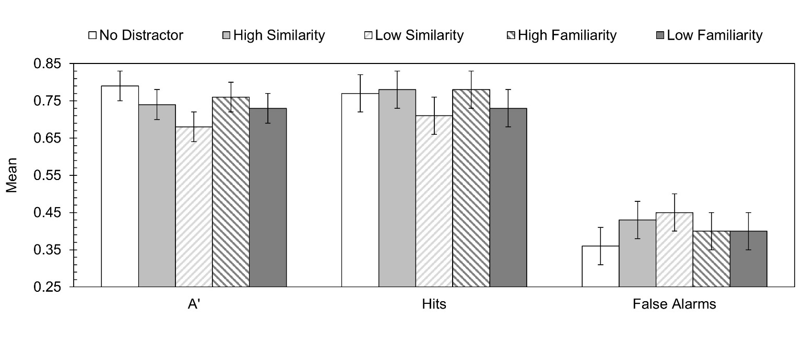
Note. Error bars show 95% CIs calculated using the approach outlined by Jarmasz and Hollands (2009).

Table 1
Simple Planned Contrasts Comparing A’ for Each Distractor Type Against the No Distractor Control Condition in Experiment 1
Comparison | F | p | η_{p}² | BF¹⁰
No Distractor vs. High similarity | 3.46 | .076 | 0.13 | 2.23
No Distractor vs. Low similarity | 16.66 | <.001 | 0.42 | 254.60
No Distractor vs. Low familiarity | 5.55 | .027 | 0.19 | 7.53
No Distractor vs. High familiarity | 3.65 | .069 | 0.14 | 3.10

Lastly, the impact of distractor type on hits and false alarms was explored, but this yielded no effects (False alarms: F[4, 92] = 1.80, p = .136, η_{p}² = 0.07, BF¹⁰ = 0.36; Hits: F[4, 92] = 1.48, p = .213, η_{p}² = 0.06, BF¹⁰ = 0.23).

Discussion

Overall, a damaging effect of distraction-based RI in relation to the control condition was uncovered. All distractors lowered task accuracy in comparison to the distractor-free control, though this was significant for only two of the distractors (low similarity and low familiarity). However, the Bayesian analysis indicated an RI effect from the high familiarity distractor too. Generally, then, dissimilar distractors were harming VSTM.
The discovery that distractors highly dissimilar to the target can impair recognition performance supported some previous findings (e.g., Dent, 2010; Hakun & Ravizza, 2016; Sun et al., 2017; Vasques et al., 2016). In a related study (Mercer, 2018), dissimilar RI was reported, but all stimuli were drawn from the same set of items (Fribbles), meaning that the distractor still had structural overlap with the target. Here, the low familiarity distractor was an entirely different type of object to the target stimulus, but it was still capable of impairing recognition performance. Dissimilar RI appears to generalize beyond the category of stimuli used to create the targets/probes.
The impact of the high familiarity distractor – also extremely dissimilar to the target – was more ambiguous, and the evidence for similarity-based RI, as produced by the high similarity distractor, was relatively limited. This finding challenged the similarity assumption and congruency effect, but some previous studies have also failed to document similarity-based RI (e.g., Mercer 2018; Sun et al., 2017) and in some situations similarity can be beneficial for VSTM (e.g., Lin & Luck, 2009). However, these effects should be treated with some caution, given the relatively modest sample size.
Overall, Experiment 1 documented distraction from stimuli that had no overlap with the target memory, highlighting a form of “extreme” dissimilar RI. Experiments 2-4 then aimed to investigate the potential mechanisms underlying this form of distraction, assessing the role of expectations and novelty.

Experiment 2

Experiment 1 uncovered a dissimilar RI effect, but the mechanism underlying this effect remains unclear. As noted above, dissimilar RI is congruent with consolidation theory, but the target-distractor window used here allowed ample time for the rapid consolidation process (Vogel et al., 2006). The role of novelty and surprise may therefore offer a better explanation of the dissimilar RI found here, but there are different ways of conceptualizing these variables, and different terminology is used within the literature. Quent et al. (2021) have usefully differentiated competing forms of novelty and surprise, which exist at both an item and context level. Item novelty refers to stimuli that have never been encountered before, and context novelty refers to an unfamiliar context where there is uncertainty about what to expect. In Experiment 1, context novelty was high, given the parameters of the task and the unpredictability of the distractors, which varied from trial to trial. Item novelty was also generally high, and none of the distractors had been encountered in the experiment before. Conversely, item surprise refers to previously familiar items presented with unexpected features, and context surprise occurs when familiar items occur in an unexpected context (Quent et al., 2021).
In Experiment 1, each type of distractor occurred on 25% of distractor trials, in a random fashion. Distractors were consistently novel – i.e., they were never repeated – and context novelty was high. Difficulties in anticipating the type of distractor may be important, as demonstrations of surprise-induced blindness (e.g., Asplund et al., 2010) show that unexpected events are particularly effective at capturing attention (see also Horstmann, 2015, for discussion).
Experiment 2 aimed to assess whether unexpected distractor types influenced RI. This was achieved by manipulating the rarity of dissimilar distractors in an online experiment. Participants once again compared a single target and probe over a short retention interval and the delay separating these stimuli was either empty or included a single distractor. The critical manipulation concerned the frequency of dissimilar distractors (which matched the low similarity condition of Experiment 1). In the common condition, the distractor was consistently dissimilar to the target, whereas in the rare condition the distractor was usually similar to the target, and it was only dissimilar on 20% of distractor trials. If dissimilar RI is influenced by expectations, a stronger RI effect should emerge in the rare compared to common condition and would be manifested in an interaction.

Method

Participants. Effort was made to recruit a sample size at least twice as large as Experiment 1, due to the addition of a between-groups variable (common vs. rare conditions). Recruitment continued for a period of three and a half months and participants were University of Wolverhampton psychology students recruited to an online experiment via an internal participant pool scheme. In total, 90 participants completed the experimental procedure, but responses from 13 individuals could not be used due to incomplete responses (15% or more trials were missing a response). The final valid sample included 77 individuals (69 females, seven males and one non-binary) aged between 18 and 54 (M = 24.96, SD = 9.10). There were 38 participants in the common condition and 39 in the rare condition. Participants consented to the experiment and the study was approved by a Faculty Ethics Committee.
Materials. The Fribble stimulus set was again used to create the targets, probes, and distractors. In the common condition, targets and probes were all selected from the “B” family, whereas the distractor came from the “C” family. The distractor was therefore always dissimilar to the target, matching the low similarity condition of Experiment 1. In the rare condition, targets, probes, and most distractors were from the “B” family. Distractors were usually similar to the target and probe, being derived from the same family but different species. Occasionally, however, a dissimilar distractor from the “C” family was presented.
Due to reliance on the “B” family, a few repetitions of specific Fribbles were necessary, but this only applied to distractors. Individual Fribbles used as targets and probes were not employed on more than one trial. The four different species within a family were also equally represented. The approach to manipulating Fribbles on “Different” trials matched Experiment 1, with the different permutations to the appendages occurring on a similar number of trials, and there was an equal mixture of Same and Different trials.
The study was built and conducted using the online Gorilla Experiment Builder (www.gorilla.sc; Anwyl-Irvine et al., 2020). Participants still responded via a keyboard, using the “S” (Same) and “D” (Different) buttons. The experiment was completed outside the laboratory but had to be undertaken on a computer or laptop.
Design and Procedure. This experiment used a mixed design, manipulating the type of trial (whether a distractor was present or absent) as a within-groups variable and the rarity of dissimilar distractors as a between-groups variable. In the common condition, the distractor was always dissimilar to the target and probe (making the dissimilar distractor a regular occurrence). In the rare condition, the distractor was similar to the target and probe on 80% of trials. On the remaining 20% of trials the distractor was dissimilar to the target and probe, and therefore rare. These rare dissimilar distractor trials were of primary interest, and termed critical trials. In the common condition, the critical trials acted as a comparison for the rare condition, but the dissimilar distractor should have been expected. Critical trials in the two conditions used exactly the same stimuli as targets, probes and distractors, but they differed in terms of the rarity of the dissimilar distractor within the broader experimental context. There were 24 critical distractor trials as well as an equivalent number of trials without a distractor. The remaining 96 distractor trials served as fillers.
The trial structure was similar to Experiment 1, except the retention interval and inter-trial interval were shortened to 3.35 s and 2 s, respectively. Participants were given up to 5 s to respond to the probe, however, and the phrase “Same or different?” was displayed underneath the probe to prompt a response.
Participants completed the experiment in two blocks – one with a distractor and one without. The order of trials within a block, and the order of blocks, was randomized. Prior to beginning the main experimental trials, participants were given text-based instructions about the procedure, interspersed with practice trials. At the end of the procedure, participants were asked if they wanted to submit their responses for analysis or withdraw them. The experiment lasted approximately 25-30 minutes.

Results

Data were scored and screened following the approach outlined in Experiment 1. Missing and invalid trials were removed, but these comprised fewer than 1.5% of trials. No outliers were identified, and the homogeneity of variance assumption was met.
The critical distractor trials were of most interest, and these were compared across conditions and against the distractor-free trials. Performance on filler trials was also calculated and all A’ scores, hits and false alarms are shown in Figure 4. A modest distractor effect was revealed, though this was clearer in the false alarm rate. However, the distraction did not seem to be dependent on the condition.

Figure 4
Mean A’, Hits and False Alarms According to Distractor Type and Condition in Experiment 2
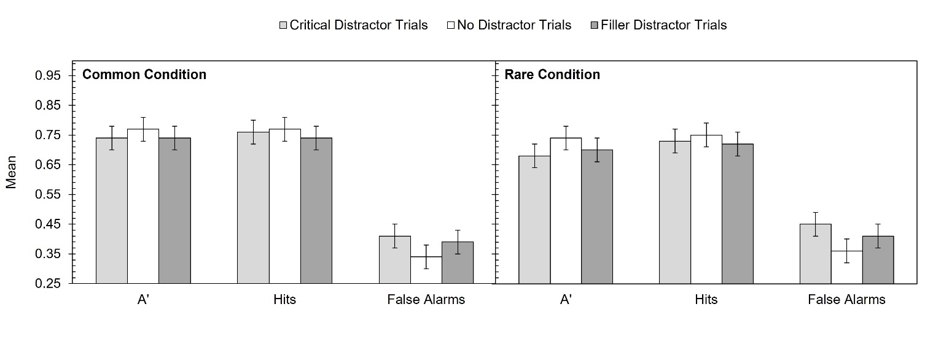
Note. Error bars show 95% CIs (Jarmasz & Hollands, 2009), calculated for the interaction between distractor type and condition.

A 2 (condition: common vs. rare) x 2 (trial type: distractor vs. no distractor) mixed ANOVA, supplemented with the equivalent Bayesian ANOVA, was then performed. The effect of trial type was just above the significance threshold, F(1, 75) = 3.89, p = .052, η_{p}² = 0.05, BF¹⁰ = 1.09, with performance on no distractor trials (M = 0.76) being better than distractor trials (M = 0.71). However, this effect was only 1.09 times more likely under the alternative than null hypothesis, offering very little differentiation between the two predictions.
Participants were less accurate in the rare (M = 0.71) than common (M = 0.75) condition overall, but this effect was non-significant, F(1, 75) = 1.61, p = .209, η_{p}² = 0.02, BF¹⁰ = 0.47, and more compatible with the null, rather than the alternative, hypothesis (though insensitive). Of most importance, there was no interaction between condition and trial type, F(1, 75) = 0.43, p = .513, η_{p}² = 0.01, BF¹⁰ = 0.31, and this effect supported the null hypothesis.
To delve further into this effect, separate ANOVAs were conducted on the hits and false alarms. For hits, there were no significant effects and more support for the null rather than alternative hypothesis (trial type: F[1, 75] = 0.51, p = .479, η_{p}² = 0.01, BF¹⁰ = 0.22; condition: F[1, 75] = 0.62, p = .434, η_{p}² = 0.01, BF¹⁰ = 0.35; trial type x condition: F[1, 75] = 0.003, p = .960, η_{p}² = 0, BF¹⁰ = 0.26). Conversely, for false alarms, there was a strong and significant effect of trial type, F(1, 75) = 9.34, p = .003, η_{p}² = 0.11, BF¹⁰ = 15.65, with more false alarms on distractor (M = 0.43) than no distractor (M = 0.35) trials. The effect of condition, F(1, 75) = 1.02, p = .317, η_{p}² = 0.01, BF¹⁰ = 0.31, and the interaction, F(1, 75) = 0.33, p = .567, η_{p}² = 0.004, BF¹⁰ = 0.06, remained non-significant and compatible with the null hypothesis.

Discussion

Experiment 2 manipulated the rarity of dissimilar distractors. Rare dissimilar distractors were expected to be particularly detrimental to performance, as they were unexpected and could better capture attention beyond expected distractor types. This was not supported, with the interaction being in line with the null hypothesis.
It should be acknowledged that the distraction effect reported here was more modest than Experiment 1. This may have been due to the online nature of the experiment, where control over the environment was lessened, though performance on the task remained generally high (mean A’ = 0.73, compared to a mean A’ of 0.74 in Experiment 1). Furthermore, a distractor effect was manifested on the false alarms (on “Different” trials, participants were more likely to incorrectly indicate that the probe matched the target when a distractor was present). This suggests that distractors made it more difficult to detect subtle changes within the stimuli, but there was no convincing evidence that unexpected dissimilar distractors produced more disruption than commonly encountered dissimilar distractors. Even when dissimilar distractors could be anticipated, they continued to heighten false alarms.

Experiment 3

Introduction

Experiment 2 found little evidence that the rarity of dissimilar distractors underpinned RI. It was assumed that unexpected distractor types would be surprising in the rare condition and would therefore be better at capturing attention and leading to distractor encoding, in comparison with the common condition. This was not supported, but as trials were randomly ordered, participants may have had difficulty establishing reliable expectations about the trial structure. In addition, several dissimilar distractors may have occurred in close proximity in the rare condition, potentially increasing expectations about their occurrence.
Experiment 3 therefore aimed to improve control over the occurrence of specific distractors. This was achieved by arranging trials into quintets – a decision inspired by the study of Vachon et al. (2012). Their participants encoded a series of visually presented digits for subsequent serial recall. During encoding, letter names were presented auditorily in a male or female voice and after every five trials the voice was changed (e.g., switching from female to male). The first encounter with a new voice did not impair serial recall performance, but the first encounter with a violation to expectations did. A second experiment further supported a role for expectations – at the point that a full sequence of the female voice was expected, there was a reversal to the male voice, and this greatly disrupted task performance.
The study of Vachon et al. (2012) is noticeably different to the design employed here, as it focused on serial recall with distraction produced by auditory events during encoding. Nonetheless, it highlights the need to consider expectations. Matching Experiment 2, the present study again manipulated the rarity of dissimilar distractors using the common and rare conditions. In the former condition, all five trials within the quintet used a distractor that was dissimilar to the target, whereas in the latter condition, only the fifth and final trial used a dissimilar distractor (the remaining four trials used a similar distractor) – see Figure 5. The fifth trial was therefore of most theoretical interest. In addition, the sample size was more than doubled compared to Experiment 2, allowing a greater opportunity to detect an effect, and the number of critical trials was increased from 24 to 36.
If dissimilar RI is influenced by expectations, specifically where expectations are violated by a distractor, a stronger form of RI should be manifested on the fifth trial of the quintets in the rare compared to the common condition. This was again expected to be manifested in an interaction between trial type and condition.

Figure 5
Quintet Trial Structure According to Condition in Experiment 3
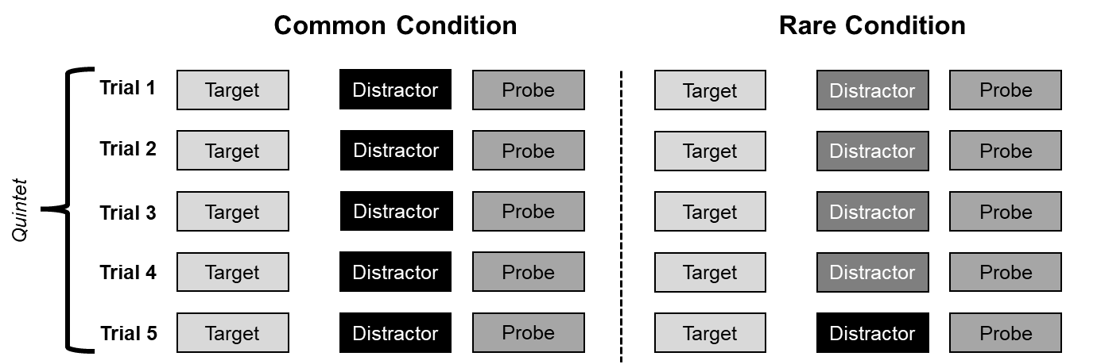
Note. In the common condition, the distractor was always dissimilar to the target. In the rare condition, the distractor was usually similar to the target, and only differed on the fifth and final trial. The arrangements for trial 5 were otherwise identical in the two conditions.

Method

Participants. Recruitment proceeded in two phases. Initially, the study was advertised via an internal University of Wolverhampton participant pool scheme, the website “Psychological Research on the Net” (https://psych.hanover.edu/research/exponnet.html) and social media. As recruitment was challenging, the second phase used Aston University’s Prolific Academic account to advertise the experiment. Here participants were paid £10.19 per hour (average £5.98 at 35 minutes) to complete the study, which had received ethical approval and participants provided informed consent.
Based on Experiment 2’s smaller interference effect, an apriori power analysis for a 2 x 2 ANOVA required 154 participants to detect the effect with 80% power. An 80% power level was considered suitable given the timeframe and resources available for recruitment. In total, 171 participants completed the study, but two asked to withdraw their data. A further four participants were removed for having 15%+ of their responses missing, leaving 165 participants (110 females, 52 males and 3 non-binary/third gender) aged between 18 and 59 (M = 29.29, SD = 9.07, one missing).
Materials. The experiment was designed and run using the online Gorilla Experiment Builder. Arrangements largely matched Experiment 2, except all three Fribble families were used in the present experiment and every family/species was equally represented. Within a quintet the targets, probes and distractors were consistently selected from a specific family and species (except for the distractor on the critical fifth trial in the rare condition). This meant the stimuli within a quintet were predictable and made the change in the rare condition more noticeable.
Design and Procedure. The experiment employed a 2 (condition: common vs. rare) x 2 (trial type: distractor vs. no distractor) mixed experimental design, like Experiment 2, but the major new feature was the quintet trial structure. The five trials of each quintet were identical in the common and rare conditions, except the common condition always used a distractor dissimilar to the target (being selected from a different family), whereas in the rare condition, the distractor was similar to the target on the first four trials (being selected from the same family but different species, as in Experiment 2). On the critical fifth trial, it was dissimilar to the target – see Figure 5. Dissimilar distractors were again present on 20% of distractor trials in the rare condition, but there was much greater control over their occurrence.
The order of trials in a quintet were fixed, but quintets themselves were randomly organized, and participants were randomly allocated to either the common or rare condition. The experimental trials were organized into four blocks, with block order being randomly determined. Three of the blocks included a distractor, arranged into 12 quintets and yielding 180 distractor trials in total, 36 of which were the critical fifth trial (a 50% increase compared with Experiment 2). The remaining block removed the distractor and acted as the distractor-free control, comprising 60 trials arranged into 12 quintets. While there were fewer distractor-free trials, quintet positions 3-5 were merged to create a comparison for the critical fifth distractor trial (see the Results section for more information). This was justifiable as distractor expectations were irrelevant when the distractor was removed.
Other arrangements matched Experiment 2, except the retention interval and inter-trial interval were shortened to 3 s and 1 s, respectively. Additionally, participants were given “Match” and “Mismatch” buttons underneath the probe and clicked the one corresponding to their answer, rather than responding via a keypress. This was intended to make it clearer when a response was needed, and a countdown display began at the probe onset (with a maximum time of 3 s). Participants were also shown an instructional video and given 10 practice trials before commencing the main experiment, which lasted approximately 35 minutes.

Results

The approach to data scoring and screening matched Experiments 1 and 2, and two outliers were identified. These individuals performed below chance and since they did not appear capable of differentiating the stimuli, they were removed. This left 163 participants (86 in the rare condition and 77 in the common condition), and their missing and invalid trials were removed (comprising 2.15% of all trials).
To create a distractor-free condition based on 36 trials, the no distractor trials from positions 3-5 in the quintets were averaged. This was justifiable as 2 (condition: common vs. rare) x 3 (position: trial 3 vs. trial 4 vs. trial 5) frequentist and Bayesian mixed ANOVAs revealed no effect of trial position, F(2, 322) = 0.33, p = .178, η_{p}² = 0.002, BF¹⁰ = 0.03, with very similar mean performance across the last three trials (trial 3: M = 0.80; trial 4: M = 0.80; trial 5: M = 0.79). There was also strong evidence for the null hypothesis. There was no effect of condition, F(1, 161) = 0.21, p = .646, η_{p}² = 0.001, BF¹⁰ = 0.16, and no interaction, F(2, 322) = 2.25, p = .109, η_{p}² = 0.01, BF¹⁰ = 0.31. By averaging these three positions, data from 36 trials was available, which was equivalent to the critical fifth distractor trial. Results are shown in Figure 6.
Next, a 2 (condition: common vs. rare) x 2 (trial type: distractor vs. no distractor) mixed ANOVA, supplemented with the equivalent Bayesian ANOVA, was conducted. This found a significant main effect of trial type and extremely strong support for the alternative hypothesis, F(1, 161) = 19.80, p < .001, η_{p}² = 0.11, BF¹⁰ = 1,289.31, with performance on no distractor trials (M = 0.80) being better than distractor trials (M = 0.75). The effect of condition was non-significant and compatible with the null hypothesis, F(1, 161) = 1.12, p = .292, η_{p}² = 0.01, BF¹⁰ = 0.29, reflecting similar overall performance in the common (M = 0.78) and rare (M = 0.77) conditions. However, the interaction was significant and there was support for the alternative hypothesis, F(1, 161) = 6.42, p = .012, η_{p}² = 0.04, BF¹⁰ = 3.30.
To explore this interaction, three Holm-Šidàk corrected t-tests were performed and supplemented with a Bayesian comparison based on Dienes (2014, 2019). The first tests compared the two trial trials separately in the rare and common conditions, which revealed a distractor effect in the rare condition, t(85) = 4.75, p < .001, d = 0.56, BF¹⁰ > 1,000,000, but not in the common condition, t(76) = 1.44, p = .154, d = 0.17, BF¹⁰ = 1.74, though this latter comparison was insensitive. For the final test, performance on trials with a distractor were subtracted from those without a distractor to give a measure of RI (where a positive value indicated the presence of RI). The common and rare conditions were then compared on this new measure of distraction, which confirmed that RI was stronger in the rare (M = 0.07) than common (M = 0.02) condition, t(161) = -2.53, p = .024, d = 0.40, BF¹⁰ = 9.12.

Figure 6
Mean A’, Hits and False Alarms According to Distractor Type and Condition in Experiment 3
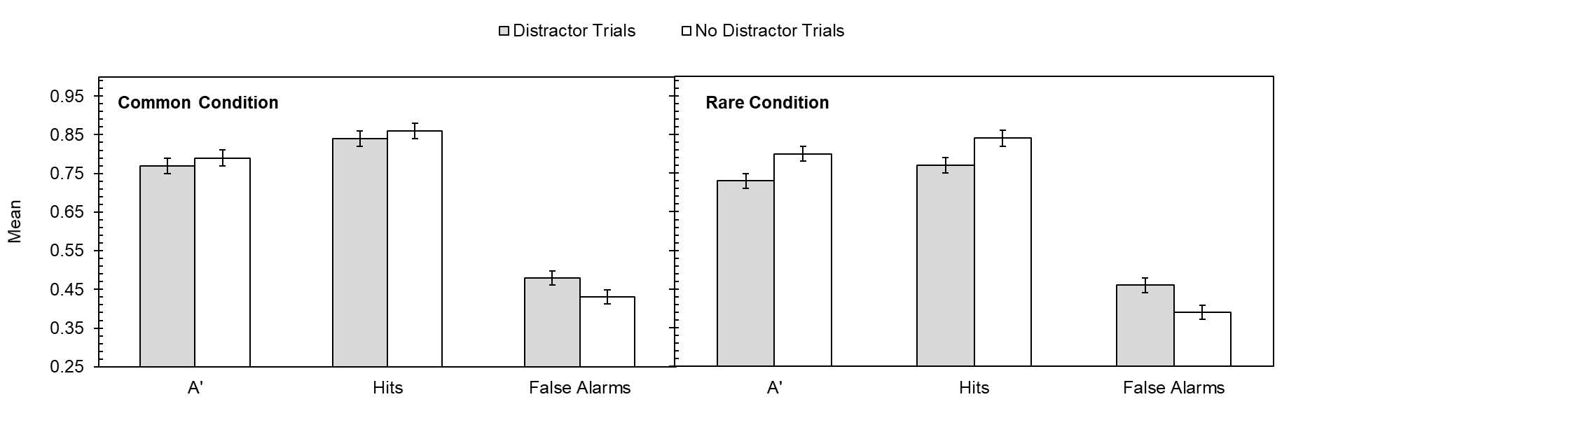
Note. Distractor trial performance was based on the fifth trial of the quintets, whereas no distractor performance was collapsed across quintent positions 3-5. Error bars show 95% CIs (Jarmasz & Hollands, 2009). These were calculated based on the interaction for A’ and for the main effect of distractor type for hits and false alarms.

Finally, separate 2 x 2 ANOVAs were performed on hits and false alarms, with data shown in Figure 6. Once again, performance on no distractor trials was averaged across quintet positions 3-5 and contrasted against the critical fifth distractor trial. For hits, there was a significant effect of trial type and strong support for the alternative hypothesis, F(1, 161) = 12.64, p < .001, η_{p}² = 0.07, BF¹⁰ = 55.79. This was due to fewer hits on distractor (M = 0.81) than no distractor (M = 0.85) trials. Condition was also significant, F(1, 161) = 4.17, p = .043, η_{p}² = 0.03, BF¹⁰ = 1.20, with fewer hits in the rare (M = 0.81) than common (M = 0.85) condition, though this was insensitive. The interaction was non-significant but insensitive, F(1, 161) = 3.19, p = .076, η_{p}² = 0.02, BF¹⁰ = 0.79.
For false alarms, there was also an effect of trial type, F(1, 161) = 16.01, p < .001, η_{p}² = 0.09, BF¹⁰ = 222.87, caused by higher false alarms when a distractor was present (M = 0.47) than absent (M = 0.41). However, the effect of condition, F(1, 161) = 1.37, p = .243, η_{p}² = 0.01, BF¹⁰ = 0.34, and the interaction, F(1, 161) = 0.50, p = .481, η_{p}² = 0.003, BF¹⁰ = 0.22, were both non-significant and compatible with the null hypothesis (though the main effect of condition was insensitive).

Discussion

Experiment 3 aimed to influence expectations by making the type of distractor highly predictable. Those expectations were then violated by occasionally presenting a dissimilar distractor in the rare condition. While the idea was similar to Experiment 2, a series of methodological improvements were made, and the sample size increased.
A dissimilar RI effect was found on all three performance measures (A’, hits and false alarms), but on the A’ measure this was influenced by distractor rarity on the critical fifth trial. In the common condition, the RI effect was far less pronounced than the rare condition. In that latter condition, dissimilar distractors violated expectations within the quintet trial structure, and a stronger RI effect emerged.
These findings are broadly compatible with previous discoveries that expectations do influence RI (e.g., Vachon et al., 2012), but the impact of the dissimilar distractor in the rare condition was not unusually high. Indeed, the overall RI effect was lower than that recorded in Experiment 1, so these findings indicate better management of RI when the distractor type was predictable and in line with expectations.
The presence of the interaction also lessens concerns that participants in the rare condition began to predict the occurrence of the dissimilar distractor in position 5 of the quintet. If this had happened, the interaction should have been absent, and changing the type of Fribble after each quintet may have helped hide the critical manipulation on the fifth trial.

Experiment 4

Introduction

The final experiment continued investigating the mechanisms of dissimilar RI but placed more emphasis on novelty. In Experiment 1, the low similarity and low familiarity distractors were both strong on item novelty, as they had not been encountered before and were only presented on one occasion throughout the experiment (the same applied to the dissimilar distractors in Experiments 2-3, especially in the rare condition). Experiment 1’s high familiarity distractor arguably had lower item novelty, as these stimuli possessed prior familiarity and could be identified from past experience, but they were still novel in the experimental context, as they had not been presented before.
Item and context novelty may both be important in the dissimilar RI effect, and Experiment 3 showed that reducing context novelty in the common condition (through making distractor arrangements highly predictable) lessened interference. Item novelty can be lessened through repetition (see Ranganath & Rainer, 2003), which was manipulated in the present experiment via the stimulus pool, where distractors were either repeated frequently throughout the experiment (repeated condition) or were unique (changing condition). Over the course of the experiment, those in the repeating condition experienced multiple repetitions of the same distractors, which should reduce item novelty, but in the changing condition item novelty was constantly high. Contextual novelty was examined by looking at the time course of distraction over the course of the experiment. The distractor trials were arranged into four different blocks, so the distraction effect could be tracked throughout the procedure. Any evidence for increasing resistance to RI could then be assessed.
The dissimilar distractor types from Experiment 1 were re-employed here. The basic experimental task remained the same, though the total number of trials was increased, and this design allowed the effects of the different distractors to be measured alongside the impact of item and contextual novelty. Following Experiment 1, all three dissimilar distractor types were expected to lower task performance in relation to the distractor-free control condition. If item novelty is important, however, distraction should be stronger in the changing rather than repeating condition. If contextual novelty is important, distraction should be most powerful earlier in the experimental task, where expectations may have been very low. However, over the course of the procedure, as participants experienced multiple trials, context novelty should decline and greater resistance to distraction may occur. This was also predicted to interact with item novelty, particularly in the repeating condition: by the final block of the experiment, the distractors should be highly familiar and item novelty very low. If so, distraction in that condition should be particularly weak by the end of the procedure.

Method

Participants. Effort was made to recruit a sample size similar to Experiment 2. The study was advertised on an internal participant pool, the website “Psychological Research on the Net” and shared via social media. Ninety-one participants completed the procedure, but three asked for their data to be removed and responses from two participants could not be used due to the large number of missing/invalid answers. The remaining 84 participants (58 female, 25 male and one non-binary/third gender) were aged between 18 and 51 (M = 24.40, SD = 8.66). There were 48 participants in the repeating condition and 36 in the changing condition. Participants provided informed consent and the study was approved by a Faculty Ethics Committee.
Materials. The experiment was designed and run using the online Gorilla Experiment Builder adopting arrangements similar to previous experiments. Stimuli used as targets, probes and distractors followed Experiment 1, except the high similarity distractor conditions was removed and more stimuli were required due to the increased number of trials (256 experimental trials in total, compared to 180 in Experiment 1). To create the high familiarity condition, images were selected from Brady et al.’s (2008) image database (https://bradylab.ucsd.edu/stimuli.html), and then chosen based on their ease of identification (e.g., a clock, a belt, a book, etc.).
In the changing condition, 64 stimuli were used for each distractor type and the repeating condition randomly chose three of those stimuli for each distractor type, ensuring that participants in that condition were exposed to a very limited number of distractors over the experiment. A specific distractor image was also always paired with a specific Fribble family (e.g., in the high familiarity condition, when the target was selected from family “A”, the distractor was always an image of a clothes peg).
Design and procedure. This experiment employed a 2 (condition: repeating vs. changing) x 4 (block: 1 vs. 2 vs. 3 vs. 4) x 4 (distractor: low similarity vs. high familiarity vs. low familiarity vs. no distractor) mixed design. Condition was a between-groups variable, with participants being randomly allocated to one of the two conditions, whereas block and distractor were manipulated within groups. The basic trial structure closely resembled the previous experiments but used a 3 s retention interval and 1 s inter-trial interval, like Experiment 3. Arrangements for responding to the probe were also the same as Experiment 3.
Each distractor condition had 64 trials split into four blocks of 16 trials. The order of blocks was randomized, but this allowed participant’s susceptibility to RI over the course of the task to be assessed. Furthermore, in the repeating condition, the same three distractor images were used repeatedly across the four blocks, whereas in the changing condition the distractor on each trial was unique. The order of the four distractor conditions was randomized.
Instructions for the task were provided via video and participants completed 10 practice trials before beginning the main procedure. The entire experiment lasted approximately 30 minutes.

Results

Data were again scored and screened, with rare missing and invalid trials being removed. One outlier was detected in the changing condition – an individual performing below chance overall and over 2.5 SDs below the mean – and data from this individual were removed, leaving 83 participants in the final analysis.
Data were converted into A’, which are displayed in Figure 7. Overall, the various distractors lowered A’ in comparison to the control, and in most cases, this seemed consistent for each block. The condition had little impact too, but these effects were assessed using a 2 (condition: repeating vs. changing) x 4 (block: 1 vs. 2 vs. 3 vs. 4) x 4 (distractor: low similarity vs. high familiarity vs. low familiarity vs. no distractor) mixed ANOVA, supplemented with the equivalent Bayesian ANOVA. As this design had multiple variables, the Bayesian ANOVA was based on an analysis of effects, which generates a BF_{Inclusion} score. The BF_{Inclusion} quantifies the level of support for retaining a particular main effect or interaction within the model. This is a useful way of assessing interactions in more complex experimental designs and BF_{Inclusion} indicates the plausibility of data under a particular model (e.g., a BF_{Inclusion} of 3 for a main effect would indicate the data are 3 times more likely under models including that main effect; van den Bergh et al., 2020). For this analysis, a matched models approach was used to examine interactions, meaning models with an interaction were contrasted against those without the interaction effect (van den Bergh et al., 2020).
The only significant effect was the distractor, F(3, 243) = 6.67, p < .001, η_{p}² = 0.08, and there was convincing evidence for retaining this effect within the model (BF_{Inclusion} = 295.16). Post-hoc Šidàk tests and Bayesian pairwise comparisons found that compared to the control condition, both low similarity (p < .001, d = 0.39, BF¹⁰ > 50,000) and low familiarity distractors (p = .001, d = 0.38, BF¹⁰ > 50,000) reduced task performance, with extreme evidence for the alternative hypothesis. The RI effect for the high familiarity distractor was above the significance threshold (p = .057, d = 0.26, BF¹⁰ = 20.81), but there was still good evidence for the alternative hypothesis. No other comparisons were significant, and the difference between low similarity and low familiarity was consistent with the null hypothesis (BF¹⁰ = 0.15). The difference between high familiarity and the two other distractor types was insensitive (BF¹⁰ = 1.74).
The other main effects of block, F(3, 243) = 0.46, p = .709, η_{p}² = 0.01, BF_{Inclusion} = 0.003, and condition, F(1, 81) = 0.11, p = .745, η_{p}² = 0.001, BF_{Inclusion} = 0.18, were non-significant and had no support for retention within the model.
Likewise, no interactions were significant or supported: Distractor x condition: F(3, 243) = 0.49, p = .687, η_{p}² = 0.01, BF_{Inclusion} = 0.01; block x condition, F(3, 243) = 0.79, p = .500, η_{p}² = 0.01, BF_{Inclusion} = 0.02; distractor x block: F(9, 729) = 0.43, p = .922, η_{p}² = 0.01, BF_{Inclusion} < 0.001; distractor x block x condition: F(9, 729) = 0.62, p = .784, η_{p}² = 0.01, BF¹⁰ = 0.01.

Figure 7
Mean A’ According to Distractor Type, Block and Condition in Experiment 4
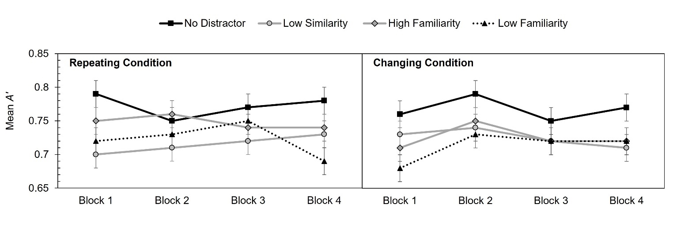
Note. Error bars show 95% CIs (Jarmasz & Hollands, 2009), calculated for the main effect of distractor type (computed separately for each condition).

Hits and false alarms were separately assessed, using further 2 x 4 x 4 ANOVAs. The analysis on hits again yielded no significant or supported effects, but there was an effect on false alarms (see Figure 8). Specifically, there was a significant effect of distractor, F(3, 243) = 8.86, p < .001, η_{p}² = 0.10, and extreme support for retaining this variable within the model (BF_{Inclusion} = 119,560.01). Šidàk post-hoc tests confirmed that all distractors increased false alarms compared to the distractor-free control, and follow-up Bayesian tests (estimating a maximum difference of 0.08 following the false alarm difference in Experiment 2) revealed consistent support for the alternative hypothesis (low similarity: p < .001, d = 0.49, BF¹⁰ = 903.16; high familiarity: p < .001, d = 0.37, BF¹⁰ > 1,000,0000; low familiarity: p = .010, d = 0.32, BF¹⁰ = 33.45). Comparisons between the three distractor types revealed non-significant effects and no further support for the alternative hypothesis.

Figure 8
Mean False Alarm Rate According to Distractor Type, Block and Condition in Experiment 4
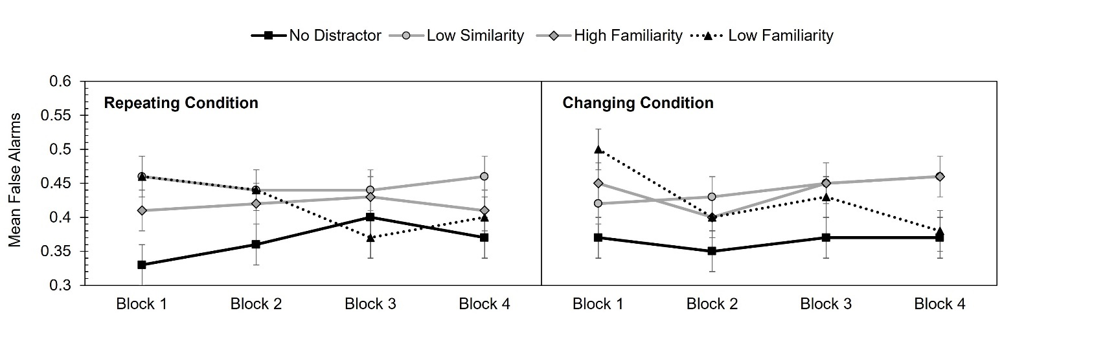
Note. Error bars show 95% CIs (Jarmasz & Hollands, 2009), calculated for the main effect of distractor type (computed separately for each condition).

Other effects were non-significant and unsupported (block: F[3, 243] = 0.81, p = .491, η_{p}² = 0.01, BF_{Inclusion} = 0.01; condition: F[1, 81] = 0.03, p = .867, η_{p}² = 0, BF_{Inclusion} = 0.19; distractor x condition: F[3, 243] = 0.36, p = .780, η_{p}² = 0.004, BF_{Inclusion} = 0.01; block x condition: F[3, 243] = 0.75, p = .524, η_{p}² = 0.01, BF_{Inclusion} = 0.02; distractor x block x condition: F[9, 729] = 0.91, p = .520, η_{p}² = 0.01, BF_{Inclusion} = 0.01). While the interaction between block and distractor was marginally significant, F(9, 729) = 1.86, p = .054, η_{p}² = 0.02, the Bayesian analysis revealed very little support for retaining this interaction within the model (BF_{Inclusion} = 0.03) and it was not examined further.

Discussion

Another dissimilar distraction effect was reported here, supporting the previous experiments, and showing that distractors highly different to the target impair recognition. This happens even when distractors are from a different semantic category to the target. The low similarity and low familiarity distractors reduced A’ scores and heightened false alarms. The high familiarity distractor did not significantly lower A’, but there was support for the alternative hypothesis from the Bayesian perspective. Like the other distractors, high familiarity increased false alarms in relation to the control.
Generally, VSTM was disrupted by various dissimilar distractors, and, of most importance, this effect did not diminish either with item repetition or familiarity with the procedure. The distractor effect in the repeating condition was similar to that in the changing condition, despite repeated exposure to the same few distractors. The distractor effect also did not diminish over the course of the experiment, with it remaining a persistent source of disruption.

General Discussion

Visual memory can be disrupted by distracting events (e.g., Clapp et al., 2010; Della Sala et al., 1999; Fallon et al., 2018; Hecht et al., 2016; Hitch et al., 2020; Klauer & Zhao, 2004; Logie & Marchetti, 1991; Makovski & Jiang, 2007; McNab & Dolan, 2014; Rademaker et al., 2015; Sun et al., 2017), but there is doubt as to whether distractors highly dissimilar to the to-be-remembered item can produce RI, with mixed findings in the literature and theoretical uncertainty concerning explanations for dissimilar RI. The present experiment aimed to address these issues.
The experiments reported here did show that a dissimilar distractor produced RI and it was present in some form in all four experiments. This discovery is consistent with some previous empirical work (e.g., Dent, 2010; Feredoes et al., 2011; Hakun & Ravizza, 2016; Mercer, 2018; Vasques et al., 2016), but the present findings demonstrated a form of dissimilar RI that was more wide-ranging than previously reported. For example, Sun et al. (2017) found that dissimilar RI was most detrimental to recall and could eliminate the target representation, but in their second experiment they also varied distractor identity. Distractors following the target were either the same object (but varying in color) or a different object entirely. While the color manipulation affected recall, distractor identity had no effect. Similarly, in the visual suffix effect, the detrimental impact of the suffix tends to be strongest when it is “plausible” – i.e., drawn from the pool of stimuli forming the experimental set – rather than implausible (items that were never part of the experimental set; Ueno, Allen, et al., 2011; Ueno, Mate, et al., 2011).
In the present study, a more pervasive form of dissimilar RI was highlighted, where a distractor dissimilar in identity to the target still impaired recognition. This form of distraction was reported even when the distractor shared no structural similarity with the target (e.g., low familiarity distractors), indicating that semantic incongruence between the target and distraction does not necessarily allow RI to be resisted. The high familiarity distractor was also greatly dissimilar to the target yet could be more easily identified than other distractor types. In both experiments where this distractor was used, it reduced A’ scores in relation to the control condition, but this was not conventionally significant. However, from the Bayesian perspective, this distractor type did produce RI, and in Experiment 4 it significantly increased false alarms in comparison to the distractor-free control.
The discovery of this nonspecific dissimilar RI has important theoretical implications. It cannot be easily reconciled with the similarity assumption or the congruency effect, and it highlights a form of interference not anticipated by dynamic field theory (e.g., Johnson, Spencer, and Schöner, 2009) or sensory recruitment models (see Lorenc et al., 2021). As a result, the present study explored other mechanisms that could explain dissimilar RI.
Experiments 2 and 3 considered the role of expectations as factors influencing RI. In Experiment 2, dissimilar distractors were manipulated so that they were either very common or rare. This manipulation did not affect performance on the task (though this experiment found limited RI on the A’ measure overall). The assumption was that rare dissimilar distractors would be harder to anticipate, but rarity in itself seemed to have minimal impact. Experiment 3 then made some methodological improvements and employed a quintet trial structure to establish expectations more carefully. In the rare condition, the first four trials used targets, probes and distractors that were all closely related, whereas the critical fifth trial employed a dissimilar distractor for the first time. This resulted in stronger RI in comparison to the common condition, where dissimilar distractors were used on all trials.
As noted above, however, this finding is best understood as a diminishment in RI when the distractor did meet highly specific expectations. That is, easily predictable distractor types were less damaging, but distractors violating expectations produced an RI effect no more pronounced than previously reported (e.g., Mercer, 2018).
Furthermore, dissimilar RI only appeared manageable when extremely predictable. It was present throughout Experiment 4, even when the same distractors were recycled throughout the task. One condition used a small set of distractors across the entire experiment, whereas another condition selected distractors from a wider stimulus pool (ensuring they were unique on each trial). A finer-grained analysis of distractor repetition was achieved by segmenting the procedure into different blocks to determine whether RI declined through repeated exposure to the distractors. Neither of these manipulations affected RI, which remained a constant presence throughout the experiment, even when the same distractors were used repeatedly.
As Experiment 4 employed a random trial structure, the specific stimuli employed could not be anticipated from one trial to the next. As such, participants may not have been able to learn the exact arrangements for distraction, and this is supported by Shimi and Logie (2019), who reported very slow learning in a change detection task, despite repeated exposure to an identical set of stimuli. It may only be with a much more predictable trial structure, like that of Experiment 3’s common condition, where the impact of RI can be lessened.
Given the present findings, the perceived discrepancy between the target and distractor at the level of individual trials may in itself be sufficient to produce disruption, even if that distractor has been encountered before. In this view, it is simply the detection of a difference between the target and distractor which drives distraction (except where the distractor type is extremely predictable). Horstmann (2015) has outlined an automatic process that compares new input against existing input, with particular attention given to change. Events dissimilar to previous events may be classed as inconsistent and attract attentional resources. This notion is also compatible with the UFO model’s updating process, in which distractors that are very different to previously encountered items lead to an updating of the memory buffer and a loss of older representations. There is further overlap with the classic Von Restorff effect, in which stimuli that are distinctive, or “stand out”, are more likely to be remembered (see Hunt, 1995, for a discussion). Distinctive items are effective at capturing attention (see Theeuwes, 2019), and this may allow distinct distractors to be unintentionally encoded and enter VSTM.
If distractors were encoded, this must have happened despite the instructions given to ignore the distractor, and despite attempts to prioritize the target. Indeed, Hitch et al. (2018) have shown that attempts to prioritize a particular item in visual memory may make that item more vulnerable to interference (see also McKeown et al., 2014, for arguments that active attempts to maintain visual stimuli increases their susceptibility to loss). In the present study, participants’ efforts to maintain the target within the focus of attention may have made distraction more likely, and efforts to resist the distractor were not always successful (except when the type of distractor was extremely predictable).
While an understanding of dissimilar RI is forming, more work is needed to further understand this source of distraction. Additional mechanisms influencing dissimilar RI may include capacity limitations, sudden death, and retrieval failure, as well as trace blurring (see Sun et al., 2017). While capacity limitations seem less plausible, as only one target had to be retained here, it is possible that the target memory is lost completely following distraction (i.e., sudden death) or is unavailable during retrieval. It is equally plausible that the distractor made the target representation less precise, without fully eradicating it. For example, specific appendages may be forgotten, but broader object-level information retained. It is difficult to differentiate these possibilities based on the paradigm used here (responding to a single probe), but the distractor consistently increased false alarms (albeit not significantly in Experiment 1). The distractor may have increased the difficulty of retaining the fine features needed to differentiate the target and probe objects, and so may be better understood as a form of trace blurring, rather than complete loss. Exploring the memory representations through recall paradigms may help to differentiate these possibilities.
Additionally, more directly comparing RI for different types of visual stimuli could be useful. As noted above, some studies are based on memory for individual visual features, whereas others use more complex objects, and this may influence distraction (see also Bancroft et al., 2016). Some of the more robust demonstrations of similarity-based RI concern memory for very specific features, like spatial frequency (e.g., Magnussen et al., 1991). For these stimuli, interference seems to depend on a critical relationship between the target and distractor. In contrast, the target/probe stimuli used here were three-dimensional, multi-component objects, which may react differently to distraction. However, this possibility needs to be more directly explored.
There are also limitations with the present study that could be addressed in future research, including the set size. Participants only needed to retain a single object on each trial, which was intended to avoid concurrent interference from other to-be-remembered targets. It is possible that distraction effects would be different if multiple objects had to be remembered. Some evidence indicates that single items can be stored preferentially (e.g., Pertzov et al., 2017) and distraction may be more modest in this situation. The distractor was also placed in the same location as the target, but spatial position may play a role in distractor effects (e.g., Allen et al., 2015). If participants can differentiate the target from the distractor using spatial location, RI may be less pronounced. Finally, the age range in the present studies was quite wide, although correlations between age and averaged A’ revealed consistent non-significant relationships. In three of the experiments the direction was towards older participants scoring more highly on the task.
In conclusion, the present study found distraction-based RI in VSTM and distractors dissimilar to the to-be-remembered target damaged recognition. This effect was not influenced by distractor novelty and RI did not decline throughout the experimental procedure. Making the occurrence of specific distractors highly predictable did reduce interference, but dissimilar RI was a constant presence in some form in all four experiments. These findings indicate that susceptibility to dissimilar distraction is a persistent limitation in VSTM.

Acknowledgements

The Fribble stimuli used in these experiments were provided courtesy of Michael J. Tarr, Center for the Neural Basis of Cognition and Department of Psychology, Carnegie Mellon University, http://www.tarrlab.org. A number of undergraduate students have supported this project at different stages as part of the Research Opportunity Network. We would like to thank Bonnie Garner for her help with Experiment 1, particularly in sourcing the high familiarity distractors, as well as Ellie Batham, Lyndsey Howells and Dionne Wallace for support with participant testing. We are also grateful to Professor John Krantz for hosting Experiments 3 and 4 on the website “Psychological Research on the Net” (https://psych.hanover.edu/research/exponnet.html)

Declaration of Interest Statement

The Authors declares that there is no conflict of interest.

References

Allen, R. J., Castellá, J., Ueno, T., Hitch, G. J., & Baddeley, A. D. (2015). What does visual suffix interference tell us about spatial location in working memory? Memory & Cognition, 43(1), 133-142. https://doi.org/10.3758/s13421-014-0448-4
Andrade, J., Kemps, E., Werniers, Y., May, J., & Szmalec, A. (2002). Insensitivity of visual short-term memory to irrelevant visual information. Quarterly Journal of Experimental Psychology, 55(3), 753-774. https://doi.org/10.1080/02724980143000541
Anwyl-Irvine, A. L., Massonnié, J., Flitton, A., Kirkham, N., & Evershed, J. K. (2020). Gorilla in our midst: An online behavioral experiment builder. Behavior Research Methods, 52, 388-407. https://doi.org/10.3758/s13428-019-01237-x
Asplund, C. L., Todd, J. J., Snyder, A. P., Gilbert, C. M., & Marois, R. (2010). Surprise-induced blindness: a stimulus-driven attentional limit to conscious perception. Journal of Experimental Psychology. Human Perception and Performance, 36(6), 1372-1381. https://doi.org/10.1037/a0020551
Avons, S. E., & Sestieri, C. (2005). Dynamic visual noise: No interference with visual short-term memory or the construction of visual images. European Journal of Cognitive Psychology, 17(3), 405-424. https://doi.org/10.1080/09541440440000104
Bancroft, T. D., Jones, J. A., Ensor, T. M., Hockley, W. E., & Servos, P. (2016). Overwriting and intrusion in short-term memory. Memory & Cognition, 44, 435-443. https://doi.org/10.3758/s13421-015-0570-y
Blalock, L. D. (2013). Mask similarity impacts short-term consolidation in visual working memory. Psychonomic Bulletin & Review, 20(6), 1290-1295. https://doi.org/10.3758/s13423-013-0461-9
Borst, G., Ganis, G., Thompson, W. L., Kosslyn, S. M. (2012). Representations in mental imagery and working memory: Evidence from different types of visual masks. Memory & Cognition, 40(2), 204-217. https://doi.org/10.3758/s13421-011-0143-7
Brady, T. F., Konkle, T., Alvarez, G. A., & Oliva, A. (2008). Visual long-term memory has a massive storage capacity for object details. PNAS, 105, 14325-14329. https://doi.org/10.1073/pnas.0803390105
Burin, D. I., Irrazabal, N., & Quinn, J. G. (2007). Maintenance in visuo-spatial working memory. Psychologia, 50(2), 90-101. https://doi.org/10.2117/psysoc.2007.90
Clapp, W. C., Rubens, M. T., & Gazzaley, A. (2010). Mechanisms of working memory disruption by external interference. Cerebral Cortex, 20(4), 859-872. https://doi.org/10.1093/cercor/bhp150
Della Sala, S., Gray, C., Baddeley, A., Allamano, N., & Wilson, L. (1999). Pattern span: A tool for unwelding visuo-spatial memory. Neuropsychologia, 37(10), 1189-1199. https://doi.org/10.1016/S0028-3932(98)00159-6
Dent, K. (2010). Dynamic visual noise affects visual short-term memory for surface colour, but not spatial location. Experimental Psychology, 57(1), 17-26. https://doi.org/10.1027/1618-3169/a000003
Derrfuss, J., Ekman, M., Hanke, M., Tittgemeyer, M., & Fiebach, C. J. (2017). Distractor resistant short-term memory is supported by transient changes in neural stimulus representations. Journal of Cognitive Neuroscience, 29(9), 1547-1565. https://doi.org/10.1162/jocn_a_01141
Dewar, M. T., Cowan, N., & Della Sala, S. (2007). Forgetting due to retroactive interference: A fusion of Müller and Pilzecker's (1900) early insights into everyday forgetting and recent research on anterograde amnesia. Cortex, 43(5), 616-634. https://doi.org/10.1016/S0010-9452(08)70492-1
Dienes, Z. (2014). Using Bayes to get the most out of non-significant results. Frontiers in Psychology, 5, 781. https://doi.org/10.3389/fpsyg.2014.00781
Dienes, Z. (2019). How do I know what my theory predicts? Advances in Methods and Practices in Psychological Science, 2(4), 364-377. https://doi.org/10.1177/2515245919876960
Dolcos, F., Miller, B., Kragel, P., Jha, A., & McCarthy, G. (2007). Regional brain differences in the effect of distraction during the delay interval of a working memory task. Brain Research, 1152, 171-181. https://doi.org/10.1016/j.brainres.2007.03.059
Evans, K. K., & Baddeley, A. (2018). Intention, attention and long-term memory for visual scenes: It all depends on the scenes. Cognition, 180, 24-37. https://doi.org/10.1016/j.cognition.2018.06.022
Fallon, S. J., Mattiesing, R. M., Dolfen, N., Manohar, S. G., & Husain, M. (2018). Ignoring versus updating in working memory reveal differential roles of attention and feature binding. Cortex, 107, 50-63. https://doi.org/10.1016/j.cortex.2017.12.016
Feredoes, E., Heinen, K., Weiskopf, N., Ruff, C., & Driver, J. (2011). Causal evidence for frontal involvement in memory target maintenance by posterior brain areas during distracter interference of visual working memory. PNAS, 108(42), 17510-17515. https://doi.org/10.1073/pnas.1106439108
Hakun, J. G., & Ravizza, S. M. (2016). Ventral fronto-parietal contributions to the disruption of visual working memory storage. NeuroImage, 124, 783-793. https://doi.org/10.1016/j.neuroimage.2015.09.056
Hecht, M., Thiemann, U., Freitag, C. M., & Bender, S. (2016). Time-resolved neuroimaging of visual short-term memory consolidation by post-perceptual attention shifts. NeuroImage, 125, 964-977. https://doi.org/10.1016/j.neuroimage.2015.11.013
Hitch, G. J., Allen, R. J., & Baddeley, A. D. (2020). Attention and binding in visual working memory: Two forms of attention and two kinds of buffer storage. Attention, Perception, & Psychophysics, 82(1), 280-293. https://doi.org/10.3758/s13414-019-01837-x
Hitch, G. J., Hu, Y., Allen, R. J., & Baddeley, A. D. (2018). Competition for the focus of attention in visual working memory: Perceptual recency versus executive control. Annals of the New York Academy of Sciences, 1424(1), 64-75. https://doi.org/10.1111/nyas.13631
Horst, J. S., & Hout, M. C. (2016). The Novel Object and Unusual Name (NOUN) Database: A collection of novel images for use in experimental research. Behavior Research Methods, 48(4), 1393-1409. https://doi.org/10.3758/s13428-015-0647-3
Horstmann, G. (2005). Attentional capture by an unannounced color singleton depends on expectation discrepancy. Journal of Experimental Psychology: Human Perception and Performance, 31(5), 1039-1060. https://doi.org/10.1037/0096-1523.31.5.1039
Horstmann, G. (2006). Time course of intended and unintended orienting of attention. Psychological Research, 70(1), 13-25. https://doi.org/10.1007/s00426-004-0184-7
Horstmann, G. (2015). The surprise-attention link: A review. Annals of the New York Academy of Sciences, 1339(1), 106-115. https://doi.org/10.1111/nyas.12679
Horstmann, G., & Becker, S. (2008). Effects of stimulus onset asynchrony and display duration on implicit and explicit measures of attentional capture by a surprising singleton. Visual Cognition, 16(2-3), 290-306. https://doi.org/10.1080/13506280701461725
Horstmann, G., & Becker, S. I. (2011). Evidence for goal-independent attentional capture from validity effects with unexpected novel color cues - a response to Burnham (2007). Psychonomic Bulletin & Review, 18(3), 512-517. https://doi.org/10.3758/s13423-011-0080-2
Horstmann, G., & Herwig, A. (2015). Surprise attracts the eyes and binds the gaze. Psychonomic Bulletin & Review, 22(X), 743-749. https://doi.org/10.3758/s13423-014-0723-1
Hu, Y., Hitch, G. J., Baddeley, A. D., Zhang, M., & Allen, R. J. (2014). Executive and perceptual attention play different roles in visual working memory: evidence from suffix and strategy effects. Journal of Experimental Psychology. Human Perception & Performance, 40(4), 1665-1678. https://doi.org/10.1037/a0037163
Hunt, R. R. (1995). The subtlety of distinctiveness: What von Restorff really did. Psychonomic Bulletin & Review, 2(1), 105-112. https://doi.org/10.3758/BF03214414
Jarmasz, J., & Hollands, J. G. (2009). Confidence intervals in repeated-measures designs: The number of observations principle. Canadian Journal of Experimental Psychology, 63(2), 124-138. https://doi.org/10.1037/a0014164
JASP Team (2018). JASP (Version 0.9.0.1) [Computer software]. Retrieved from https://jasp-stats.org/
Johnson, J. S., Spencer, J. P., Luck, S. J., & Schöner, G. (2009). A dynamic field model of visual working memory and change detection. Psychological Science, 20(5), 568-577. https://doi.org/10.1111/j.1467-9280.2009.02329.x
Johnson, J. S., Spencer, J. P., & Schöner, G. (2009). A layered neural architecture for the consolidation, maintenance, and updating of representations in visual working memory. Brain Research, 1299, 17-32. https://doi.org/10.1016/j.brainres.2009.07.008
Kim, G.-W., Chung, Y.-C., Yang, J.-C., Chung, G.-H., Park, T.-J., & Jeong, G.-W. (2015). Neuroanatomical mechanism on the effect of distraction in working memory maintenance in patients with schizophrenia. Journal of Neuropsychiatry and Clinical Neurosciences, 27(1), 1-9. https://doi.org/10.1176/appi.neuropsych.13080177
Klauer, K. C., & Zhao, Z. (2004). Double dissociations in visual and spatial short-term memory. Journal of Experimental Psychology: General, 133(3), 355-381. https://doi.org/10.1037/0096-3445.133.3.355
Lin, P.-H., & Luck, S. J. (2009). The influence of similarity on visual working memory representations. Visual Cognition, 17(3), 356-372. https://doi.org/10.1080/13506280701766313
Loftus, E. F., & Greene, E. (1980). Warning: Even memory for faces may be contagious. Law and Human Behavior, 4(4), 323-334. https://doi.org/10.1007/BF01040624
Loftus, E. F., & Loftus, G. R. (1980). On the permanence of stored information in the human brain. American Psychologist, 35(5), 409-420. https://doi.org/10.1037//0003-066x.35.5.409
Logie, R. H. & Marchetti, C. (1991). Visuo-spatial working memory: Visual, spatial or central executive? In R. H. Logie & M. Denis (Eds.), Mental images in human cognition (pp. 105-115). Elsevier. http://dx.doi.org/10.1016/S0166-4115(08)60507-5
Logie, R. H., Zucco, G. M., & Baddeley, A. (1990). Interference with visual short-term memory. Acta Psychologica, 75(1), 55-74. https://doi.org/10.1016/0001-6918(90)90066-o
Lorenc, E. S., Sreenivasan, K. K., Nee, D. E., Vandenbroucke, A. R. E., & D’Esposito, M. (2018). Flexible coding of visual working memory representations during distraction. Journal of Neuroscience, 38(23), 5267-5276. https://doi.org/10.1523/JNEUROSCI.3061-17.2018
Lorenc, E. S., Mallett, R., & Lewis-Peacock, J. A. (2021). Distraction in visual working memory: Resistance is not futile. Trends in Cognitive Sciences, 25(3), 228-239. https://doi.org/10.1016/j.tics.2020.12.004
Magnussen, S., Greenlee, M. W., Asplund, R., & Dyrnes, S. (1991). Stimulus-specific mechanisms of visual short-term memory. Vision Research, 31(7/8), 1213-1219. https://doi.org/10.1016/0042-6989(91)90046-8
Makovski, T., & Jiang, Y. V. (2007). Distributing versus focusing attention in visual short-term memory. Psychonomic Bulletin & Review, 14(6), 1072-1078. https://doi.org/10.3758/BF03193093
Makovski, T., & Pertzov, Y. (2015). Attention and memory protection: Interactions between retrospective attention cueing and interference. Quarterly Journal of Experimental Psychology, 68(9), 1735-1743. https://doi.org/10.1080/17470218.2015.1049623
Makovski, T., Shim, W. M., & Jiang, Y. V. (2006). Interference from filled delays on visual change detection. Journal of Vision, 6(12), 1459-1470. https://doi.org/10.1167/6.12.11
McKeown, D., Holt, J., Delvenne, J. F., Smith, A., & Griffiths, B. (2014). Active versus passive maintenance of visual nonverbal memory. Psychonomic Bulletin & Review, 21(4), 1041-1047. https://doi.org/10.3758/s13423-013-0574-1
McKeown, D., Mills, R., & Mercer, T. (2011). Comparisons of complex sounds across extended retention intervals survives reading aloud. Perception, 40(10), 1193-1205. https://doi.org/10.1068/p6988
McKeown, D., & Wellsted, D. (2009). Auditory memory for timbre. Journal of Experimental Psychology: Human Perception and Performance, 35(3), 855-875. https://doi.org/10.1037/a0013708
McNab, F., & Dolan, R. J. (2014). Dissociating distractor-filtering at encoding and during maintenance. Journal of Experimental Psychology: Human Perception and Performance, 40(3), 960-967. https://doi.org/10.1037/a0036013
Mercer, T. (2014). The loss of short-term visual representations over time: Decay or temporal distinctiveness? Journal of Experimental Psychology: Human Perception and Performance, 40(6), 2281-2288. http://dx.doi.org/10.1037/a0038141
Mercer, T. (2018). Retroactive interference in visual short-term memory. Experimental Psychology, 65(3), 139-148. https://doi.org/10.1027/1618-3169/a000401
Mercer, T., & Barker, E. (2020). Time-dependent forgetting in visual short-term memory. Journal of Cognitive Psychology, 32(4), 391-408. https://doi.org/10.1080/20445911.2020.1767627
Mercer, T., & McKeown, D. (2010a). Interference in short-term auditory memory. Quarterly Journal of Experimental Psychology, 63(7), 1256-1265. https://doi.org/10.1080/17470211003802467
Mercer, T., & McKeown, D. (2010b). Updating and feature overwriting in short-term memory for timbre. Attention, Perception, & Psychophysics, 72(8), 2289-2303. https://doi.org/10.3758/BF03196702
Mueller, S. T., & Zhang, J. (2006). Upper and lower bounds of area under ROC curves and index of discriminability of classifier performance. Proceedings of the ICML 2006 workshop on ROC Analysis in Machine Learning (pp. 41-46). Association for Computing Machinery.
Nemes, V. A., Parry, N. R. A., Whitaker, D., & McKeefry, D. J. (2012). The retention and disruption of colour information in human short-term visual memory. Journal of Vision, 12(1), 1-14. https://doi.org/10.1167/12.1.26
Nicholls, A. P., Parmentier, F. B. R., Jones, D. M., & Tremblay, S. (2005). Visual distraction and visuo-spatial memory: A sandwich effect. Memory, 13(3-4), 357-363. https://doi.org/10.1080/09658210344000422
Pertzov, Y., Manohar, S., & Husain, M. (2017). Rapid forgetting results from competition over time between items in visual working memory. Journal of Experimental Psychology: Learning, Memory, & Cognition, 43(4), 528-536. https://doi.org/10.1037/xlm0000328
Quent, J. A., Henson, R. N., & Greve, A. (2021). A predictive account of how novelty influences declarative memory. Neurobiology of Learning and Memory, 179, 107382. https://doi.org/10.1016/j.nlm.2021.107382
Quinn, J. G., & McConnell, J. (2006). The interval for interference in conscious visual imagery. Memory, 14(2), 241-252. https://doi.org/10.1080/09658210500210019
Rademaker, R. L., Bloem, I. M., De Weerd, P., & Sack, A. T. (2015). The impact of interference on short-term memory for orientation. Journal of Experimental Psychology: Human Perception and Performance, 41(6), 1650-1665. http://dx.doi.org/10.1037/xhp0000110
Ranganath, C., & Rainer, G. (2003). Neural mechanisms for detecting and remembering novel events. Nature Reviews Neuroscience, 4(3), 193-202. https://doi.org/10.1038/nrn1052
Ricker, T. J., & Cowan, N. (2010). Loss of visual working memory within seconds: the combined use of refreshable and non-refreshable features. Journal of Experimental Psychology: Learning, Memory, and Cognition, 36(6), 1355-1368. https://doi.org/10.1037/a0020356
Saults, J. S., & Cowan, N. (2007). A central capacity limit to the simultaneous storage of visual and auditory arrays in working memory. Journal of Experimental Psychology: General, 136(4), 663-684. https://doi.org/10.1037/0096-3445.136.4.663
Schroeder, S. C. Y., Ball, F., & Busch, N. A. (2018). The role of alpha oscillations in distractor inhibition during memory retention. European Journal of Neuroscience, 48(7), 2516-2526. https://doi.org/10.1111/ejn.13852
Shimi, A., & Logie, R. H. (2019). Feature binding in short-term memory and long-term learning. Quarterly Journal of Experimental Psychology, 72(6), 1387-1400. https://doi.org/10.1177/1747021818807718
Sun, S. Z., Fidalgo, C., Barense, M. D., Lee, A. C. H., Cant, J. S., & Ferber, S. (2017). Erasing and blurring memories: The differential impact of interference on separate aspects of forgetting. Journal of Experimental Psychology: General, 146(11), 1606-1630. http://dx.doi.org/10.1037/xge0000359
Theeuwes, J. (2019). Goal-driven, stimulus-driven, and history-driven selection. Current Opinion in Psychology, 29, 97-101. https://doi.org/10.1016/j.copsyc.2018.12.024
Ueno, T., Allen, R. J., Baddeley, A. D., Hitch, G. J., & Saito, S. (2011). Disruption of visual feature binding in working memory. Memory & Cognition, 39(1), 12-23. https://doi.org/10.3758/s13421-010-0013-8
Ueno, T., Mate, J., Allen, R. J., Hitch, G. J., & Baddeley, A. D. (2011). What goes through the gate? Exploring interference with visual feature binding. Neuropsychologia, 49(6), 1597-1604. https://doi.org/10.1016/j.neuropsychologia.2010.11.030
Vachon, F., Hughes, R. W., & Jones, D. M. (2012). Broken expectations: Violation of expectancies, not novelty, captures auditory attention. Journal of Experimental Psychology: Learning, Memory, and Cognition, 38(1), 164-177. https://doi.org/10.1037/a0025054
van den Bergh, D., van Doorn, J., Marsman, M., Draws, T., van Kesteren, E., Derks, K., & Wagenmakers, E. (2020). A tutorial on conducting and interpreting a Bayesian ANOVA in JASP. L’Année Psychologique, 120, 73-96. https://doi.org/10.3917/anpsy1.201.0073
van der Meulen, M., Logie, R. H., & Della Sala, S. (2009). Selective interference with image retention and generation: Evidence for the workspace model. Quarterly Journal of Experimental Psychology, 62(8), 1568-1580. https://doi.org/10.1080/17470210802483800
Vasques, R., Garcia, R. B., & Galera, C. (2016). Short-term memory recall of visual patterns under static and dynamic visual noise. Psychology & Neuroscience, 9(1), 46-53. https://doi.org/10.1037/pne0000039
Vogel, E. K., Woodman, G. F., & Luck, S. J. (2006). The time course of consolidation in visual working memory. Journal of Experimental Psychology: Human Perception and Performance, 32(6), 1436-1451. https://doi.org/10.1037/0096-1523.32.6.1436
Wagenmakers, E.-J., Love, J., Marsman, M., Jamil, T., Ly, A., Verhagen, J., Selker, R., Gronau, Q. F., Dropmann, D., Boutin, B., Meerhoff, F., Knight, P., Raj, A., van Kesteren, E.-J., van Doorn, J., Šmíra, M., Epskamp, S., Etz, A., Matzke, D., … Morey, R. D. (2018). Bayesian inference for psychology. Part II: Example applications with JASP. Psychonomic Bulletin & Review, 25(1), 58-76. https://doi.org/10.3758/s13423-017-1323-7
Wixted, J. T. (2004). The psychology and neuroscience of forgetting. Annual Review of Psychology, 55, 235-269. https://doi.org/10.1146/annurev.psych.55.090902.141555
Wixted, J. T. (2005). A theory about why we forget what we once knew. Current Directions in Psychological Science, 14(1), 6-9. https://doi.org/10.1111/j.0963-7214.2005.00324.x
Yoon, J. H., Curtis, C. E., & D’Esposito, M. (2006). Differential effects of distraction during working memory on delay-period activity in the prefrontal cortex and the visual association cortex. NeuroImage, 29(4), 1117-1126. https://doi.org/10.1016/j.neuroimage.2005.08.024

Tables

Table 1
Simple Planned Contrasts Comparing A’ for Each Distractor Type Against the No Distractor Control Condition in Experiment 1
Comparison | F | p | η_{p}² | BF¹⁰
No Distractor vs. High similarity | 3.46 | .076 | 0.13 | 2.23
No Distractor vs. Low similarity | 16.66 | <.001 | 0.42 | 254.60
No Distractor vs. Low familiarity | 5.55 | .027 | 0.19 | 7.53
No Distractor vs. High familiarity | 3.65 | .069 | 0.14 | 3.10

As the paradigm used here involves passive maintenance of visual representations, without any need for manipulating that information, the phrase “short-term memory” is used instead of “working memory”.
The full set of these distractors included images of a washing machine (practice trial), a toaster, toothpaste, sunglasses, a bicycle, a kettle, a coat hanger, an axe, a bed, a hairdryer, a car, a power drill, a hairbrush, a chair, a bus, an iron, a laptop, a toothbrush, a lamp, keys, a teapot, kitchen knives, a light switch, a pen, a tea cup, scissors, a fork, a tape measure, a tap, an umbrella, a light bulb, a lawn mower, a pan, a hammer, a smart phone, a game controller and a bar of soap.
To make specific comparisons, a half-normal distribution was assumed as an estimated RI effect could be obtained from Mercer (2018), which also used the Fribble stimulus set. In that study, the largest RI effect – based on subtracting performance in a distractor condition against the no distractor control – was 0.08. This occurred for a dissimilar distractor presented 1.5 s after the target. This difference was then used to calculate the Bayes factor (BF¹⁰), employing the calculator available at http://www.lifesci.sussex.ac.uk/home/Zoltan_Dienes/inference/bayes_factor.swf.
Here “surprise” is referred to within the context of distractor type, rather than its occurrence or position, which could be anticipated.
The approach to calculating the Bayes factor for these pairwise comparisons matched Experiment 1, anticipating an RI effect of 0.08 based on a half-normal distribution.
Although Gorilla software randomly allocated participants to each condition, such that group sizes should be equivalent, the higher drop-out rate in the changing condition led to an imbalance in group size.
Correlations between age and averaged A’ in each experiment were as follows: Experiment 1 – r(20) = 0.36, p = .099; Experiment 2 – r(75) = -0.11, p = .352; Experiment 3 – r(162) = 0.10, p = .206; Experiment 4 – r(80) = 0.11, p = .328.

