Theorizing the path dependencies and hierarchical structure of the multidimensional risks in green building projects

Abstract
Green buildings are designed, constructed, and operated to reduce the consumption of energy, electricity, water, materials, and natural resources over the whole lifecycle. However, the added sustainability objectives expose green building (GB) projects to additional uncertainties and unpredictable risks. This paper conducted a systematic literature review to identify, categorize, and theorize the chain reactions of various risks in GB projects. Results revealed ninety-six (96) critical risk factors (CRFs) for GB projects. The study derived nine (9) broad taxonomies of the CRFs, including financial, material and equipment, design, technical, stakeholder, management, environmental, legal, and regulatory risks. These taxonomies parade different levels of criticalities based on mean citation scores. The five most persistent taxonomies include design, regulatory, material and equipment, financial, and technical risks. A Pareto analysis revealed sixty (60) vital CRFs for green building projects. The study developed a hierarchical structural model explaining how the various risks influence each other in GB projects. Therefore, this study not only provides a comprehensive list of CRFs, as frame of reference, for researchers and practitioners, but also can inform more efficient resource allocation and introduce novel perspectives for managerial practices in GB projects.

Keywords: critical risk factors; green building; green construction; risks; sustainable construction; systematic literature review

Abbreviations: GBs – Green buildings; CO₂ – Carbon dioxide; CRFs – Critical risk factors; SLR – Systematic literature review; PRISMA – Preferred Reporting Items for Systematic Reviews and Meta-Analyses; FRs – Financial risks; MERs – Material and equipment risks; DRs – Design risks; TRs – Technical risks; SRs – Stakeholder risks; MRs – Management risks; ERs – Environmental risks; LRs – Legal risks; RRs – Regulatory risks.
Introduction
The design, construction, operation, and demolition of buildings significantly influence ecological balance parameters, social values, and economic objectives [1]. It is well-established that the lifecycle of conventional buildings interacts adversely with the natural environment, society, and economic growth [2]. Various negative impacts arising from buildings, such as extraction of non-renewable resources, energy consumption, embodied and operational CO₂ emissions, climate change, water stress and solid waste generation are extensively documented in the literature [3,4].
Green buildings (GBs) are widely promoted as a promising solution to minimizing the adverse environmental footprints of buildings over their lifecycles [5,6]. GBs emerged from the environmental movements in the 1970 – 80s to meet building demand while reducing energy consumption in the construction industry [2]. GBs are designed, constructed, and operated to reduce the consumption of energy, electricity, water, materials, and natural resources over the whole lifecycle [1,7]. GBs aim to achieve optimum energy efficiency with a priority on natural, reclaimed, and recycled materials during construction.
There are several benefits of GBs, including operational cost savings [8], lower insurance cost, improved corporate image [9], reduced waste generation, improved wellbeing, and better productivity of occupants [10], natural resource conservation, reduced CO₂ emissions, and climate change mitigation [11]. These benefits and performance improvements are documented in the promissory notes of GBs, culminating in a strong business case for incorporating green ideas into building projects [12].
However, GBs together with associated sustainability technologies constitute innovations, requiring process, organizational, industry, and policy level changes, entailing risks and unforeseen costs [13]. GB projects reinvent the decision-making phases, design strategies, procurement systems, tasks, actors, roles, team cultures, and competencies required to deliver building projects [14]. These changes and requirements expose adopters to complex organizational requirements and procedural difficulties associated with adopting new technologies, cultivating multidimensional risks that can thwart the objectives of GB projects [15,16]. The design, construction, and management of GB projects are more challenging due to the extra sustainability objectives needed to be achieved [17]. The additional sustainability objective of GB projects imposes the adoption of a new spectrum of construction technologies, design strategies, materials, and procurement systems, generating additional layers of considerable uncertainties and unpredictable risks [15].
Consequently, GB projects suffer more uncertainties and risks than traditional building projects [14]. The success of GB projects can hardly be decoupled from effective risk management. However, the critical risk factors (CRFs) for GB projects fragmented and scattered in the corpus of literature. Thus, industry practitioners, stakeholders, and policymakers have been deprived of a holistic understanding of various risks associated with GB projects. Despite studies, GB projects also continue to suffer unprecedented challenges and mixed outcomes, with some failing to achieve desired objectives [18]. This has been linked to the lack of in-depth understanding of the chain reactions, path dependencies, and hierarchical structure of risks in GB projects [19].
Consequently, important questions such as what are the key dimensions of risks in GB projects and how are the various risks interlinked remain unanswered. Therefore, this study aims to review and theorize the multiple possible interactions among various dimensions of risks in GB projects. There are three concomitant objectives: (i) to identify and harmonize the CRFs for GB projects, (ii) to categorize the CRFs for GB projects, and (iii) to develop a hierarchical theoretical model explaining path dependencies, driving powers, and push effects of risks in GB projects. The novelty of this study lies in consolidating and developing an interpretive theoretical structural model that explain the interdependencies among risks in GB projects.
Methods and Material
Research strategy
The study implemented a systematic literature review (SLR) to identify, harmonize, and theorize the vital risks in GB projects. SLR as the best-known type of literature review, provides a sound methodological lens to synthesize and compare findings from existing studies and answer specific research questions [20]. It constitutes transparent, rigorous, and detailed methodology used to consolidate compatible information from several sources [21,22]. SLR can produce new knowledge through accumulating knowledge and evidence from a large corpus of comparable studies. The study implemented the SLR with a strict adherence to the Preferred Reporting Items for Systematic Reviews and Meta-Analyses (PRISMA) Statement Protocol to minimize the risk of bias, ensure the necessary rigor, and guarantee the reliability of the findings. The SLR protocol comprised a formulation of a research question, selection of keywords, database selection and literature search, inclusion and exclusion of studies, evaluation of included studies, extraction of relevant metadata, and data analysis [23].
Literature search strategy
The literature search was conducted in Elsevier’s Scopus, which is considered the most comprehensive database indexing the widest range of articles on GBs [2]. Two sets of keywords were developed to search and retrieve studies specifically addressing CRFs for GB projects. The full Scopus search string is given below.
(TITLE ("green building" OR "sustainable building" OR "green construction" OR "sustainable construction" OR "sustainable projects" OR "green projects" OR "high performance buildings" OR "energy-efficient buildings" OR "zero energy buildings" OR "sustainable housing" OR "green housing" OR "green retrofit" OR "building retrofit" OR "greening building" OR "building retrofitting" OR "green retrofitting") AND TITLE (risk)) AND (LIMIT-TO (DOCTYPE, "ar") OR LIMIT-TO (DOCTYPE, "re")) AND (LIMIT-TO (LANGUAGE, "English")) AND (LIMIT-TO (SRCTYPE, "j"))

The search was limited to the titles of the articles to avoid retrieving studies that only mentioned relevant search terms in the abstract and keywords but failed to address the CRFs for GB projects. Three filters were applied, including document type (i.e., article and review only), language (i.e., English Language publications only), and source type (i.e., Journals only). The search string generated fifty-two (52) studies (As of 4 November 2022). However, the filtered results still contained irrelevant studies. Given the small number, the Titles/Abstract/Keywords of the retrieved studies were thoroughly screened. The rapid screening revealed forty-five (45) potentially relevant studies, which were downloaded for full-text evaluation. Fig. 1 shows the literature sampling procedure.
Fig. 1. A flowchart of the literature sampling procedure
The full-text evaluation revealed forty (40) articles, which specifically addressed the risks of GB projects. The study further conducted a snowballing search (chain referral method) to identify other relevant articles. The snowballing strategy comprised backward snowballing (searching the reference lists of the included studies) and forward snowballing (searching articles citing the included studies) to increase the sample size [24]. The additional articles identified became samples for a snowballing search, until no new articles were identified. The snowballing search revealed twenty (20) additional relevant studies, which were evaluated and included in the final sample. Thus, sixty (60) relevant articles were included in the study. Table 1 summarizes the references to the included studies.
Table 1. Reviewed articles
ID | Study | ID | Study
1 | Zerkin [25] | 31 | Aktas and Ozorhon [9]
2 | Pitt et al. [26] | 32 | Hwang et al.[15]
3 | Ranaweera and Crawford [8] | 33 | An and Pivo [27]
4 | Häkkinen and Belloni [13] | 34 | Guan et al. [19]
5 | Hwang and Tan [28] | 35 | Qazi et al.[14]
6 | Zou and Couani [29] | 36 | El-Sayegh et al.[30]
7 | Shi et al. [31] | 37 | Adabre et al.[32]
8 | Kasai and Jabbour [33] | 38 | Liu et al.[34]
9 | Hwang et al. [35] | 39 | Love et al.[36]
10 | Gan et al.[37] | 40 | Dewlaney et al.[38]
11 | Yang et al. [39] | 41 | Del Puerto and Crowson [40]
12 | Azeem et al.[41] | 42 | Hwang and Ng [42]
13 | Nguyen et al.[43] | 43 | Shen et al.[44]
14 | Hwang et al.[45] | 44 | Hwang et al.[46]
15 | Chan et al.[47] | 45 | Polat et al.[48]
16 | Ismael and Shealy [49] | 46 | Alamdari et al.[50]
17 | Ranawaka and Mallawaarachchi [51] | 47 | Othman and Abdelwahab [52]
18 | Javed et al.[53] | 48 | Zhang et al.[54]
19 | Andal and Juanzon [55] | 49 | Xiao et al. [56]
20 | Zou et al.[57] | 50 | Assaad et al.[58]
21 | Qin et al.[16] | 51 | Mohammadi and Birgonul [59]
22 | Zhao et al.[17] | 52 | Tollin [60]
23 | Ghazvini et al.[61] | 53 | Górecki and Díaz-Madroñero [62]
24 | Alattyih et al. [63] | 54 | Wadu Mesthrige and Kwong [64]
25 | Nguyen et al.[65] | 55 | Karakhan and Gambatese [66]
26 | Mirhosseini et al. [67] | 56 | Fortunato et al.[68]
27 | El-Sayegh [69] | 57 | Rosa et al.[70]
28 | Winston [71] | 58 | Zhang and Mohandes [72]
29 | Rafindadi et al. [73] | 59 | González-Gaya et al.[74]
30 | Yang and Zou [75] | 60 | Mohandes and Zhang [76]

Metadata extraction and analysis
The included articles were critically reviewed to extract the relevant metadata. Each study was reviewed to extract the year of publication, journal, context (country), data collection method, data analysis technique, risk factors, and documented evidence of the interlinkages between various risk factors. As a thumb rule [77], A CRF was only included if at least two articles cited it. The number of times the various CRFs were cited in the included studies was recorded in a data summary sheet in Excel. The study further derived dimensions (i.e., taxonomies or categories) of the CRFs for GB projects. The mean citation scores of the taxonomies of the CRFs for GB projects were computed using equation (1).
$Mean Citation Score (μ_{j})=\frac{\sum_{j=1}^{n}{({CRF}_{j})}}{n}$ (1)
Where µ_{j} denotes the mean citation score of a taxonomy of the CRFs; CRF_{j} represents the citation frequency of a CRF in each taxonomy, and n denotes the number of CRFs in a taxonomy. The mean citation scores were used as surrogate indicators to rank the taxonomies of the CRFs for GB projects.
The study also conducted a Pareto analysis to prioritize the vital few CRFs in various taxonomies. A Pareto analysis is a quality control technique conducted based on the heuristic of the “80/20” principle, which postulates that a small proportion (i.e., 20%) of the risks account for a large proportion (i.e., 80%) of the impact of a defined set of risks on the objectives of GB projects [78]. It is conducted based on frequency of occurrence and argues that the impact of risks can be minimized and control if project teams can identify and mitigate the “vital few” risks (i.e., 20%) accounting for a large proportion (i.e., 80%) of the impact of risks in GB projects. A Pareto analysis ranks data classifications, in descending order, from the highest to the lowest citation frequencies [79] based on the heuristic of the “80/20” rule. In a Pareto chart, the total (cumulative) frequency is equated to 100%, such that the “vital few” CRFs occupy a substantial amount (80%) of the cumulative citation frequencies and the “trivial many” occupy the remaining 20% of the cumulative citation frequencies. A Pareto analysis was appropriate for the study because the main data was a frequency of citations (i.e., occurrence) in the reviewed literature. The citation frequency was used as a proxy measure to prioritize the identified risks to inform resource allocation. Pareto analyses have been used to prioritize benefits [78], barriers [80], and critical success factors [77] for circular construction based on citation frequencies. Based on precedents [77,78,80], this study used Pareto charts to prioritize the vital CRFs for GB projects. Finally, the study extracted and documented the relationships between the identified risks in the literature to build a theory to explain the interdependencies among the various risk constructs in GB projects. Based on the total interpretive structural modelling (TISM) framework [81], the study constructed a theoretical model explaining the relationships and hierarchies among the taxonomies of the risks in GB projects.
TISM is a system-thinking technique that can decompose a complex problem and explain how the components are interlinked to explain the dynamic behavior of the system [81]. It can capture the causal relationships and transitive links among constructs of a complex system. TISM uses nodes to represent the constructs and lines to depict the links or relationship between two constructs in a hierarchical model based on driving powers and dependencies [81]. The typical procedures for constructing an accurate and reliable TISM model of risks for GB projects include: (i) identifying, defining, and verifying various risks, (ii) determining the relationships between the various risk constructs, (iii) generating interpretive logic of pairwise comparison, (iv) developing an agency matrix, (v) developing the final reachability matrix, (vi) developing a binary interaction matrix, (vii) hierarchical partitioning the reachability matrix intro different levels, (viii) drawing a directed graph (i.e., diagraph), (ix) developing a direct interaction matrix, and (x) constructing and interpreting a TISM model. A detailed description of the TISM techniques and these procedures would unnecessarily lengthen the paper and should be referred elsewhere [81]. The biggest challenge of constructing a TISM model is establishing the relationships between the risk constructs, which are already established in the literature. Wuni [77] leveraged the theoretical positions of established relationships in the literature to construct a TISM model of the critical success factors for circular construction. This study adopted a similar approach to develop a TISM model of the risks in GB projects.

Results
Characteristics of the included studies
The study included sixty (60) relevant articles published in thirty-five (35) reputable journals between 2006 and November 2022. Fig. 2 shows the annual distribution of the included studies. The period between 2006 and 2009 witnessed an annual output of only one (1) article. It was the early stages when researchers started to focus on exploring the barriers and drivers of the GBs [2]. Interests in the CRFs for GB projects gained traction and sustained from 2012 and reached the highest annual output of 10 articles in 2021. The trend line shows a rising interest in the CRFs for GB projects, providing additional justification for consolidating and itemizing the vital CRFs for GB projects.

Fig. 2. Temporal distribution of the included studies
The included studies used various data collection instruments to investigate the CRFs for GB projects, including questionnaire survey (39), case study (19), interviews (9), focused group workshops (3), project-based data (1), text mining (1), and plenary session (1). The included studies also used nineteen (19) analytical techniques to assess and quantify the CRFs for GB projects.
Fig. 3 summarizes the frequency distribution of the analytical techniques. It shows that deterministic, probabilistic, and network modelling techniques have been used to analyze the CRFs for GB projects. The top five most frequently used techniques, comprising thematic content analysis (n=17), mean score analysis (n=13), risk significance index (n=7), factor analysis (n=5), and relative importance index (n=4) are deterministic risk assessment tools [82]. While useful and acceptable, deterministic techniques have inherent limitations in risk prioritization and resource allocation, including inability to capture and retain the distributions and profiles of various risks, negligence of the significance of tail risks, inability to incorporate varied risk tolerance levels of decision-makers, and inability to proportionally allocate risk management resources based on the relative importance of various risks [14].

Fig. 3. Frequency distribution of analytical techniques in the included studies
While various network modeling techniques, including structural equation modelling (n=2), interpretive structural modeling (n=2), analytic hierarchy process (n=2), social network analysis (n=2), meta-network modeling (n=1), fuzzy analytic network process (n=1), and artificial neural network (n=1) can capture the interdependencies among various risk factors, they also suffer the limitations of the deterministic techniques in risk prioritization and resource allocation [14]. Probabilistic techniques such as Monte Carlo simulation (n=3) can address the inherent shortcomings of the deterministic techniques, but cannot capture the interdependences among various risks [82]. Though the probabilistic techniques are considered as the most advanced risk assessment and prioritization techniques, they have been rarely used in the included studies. Thus, the existing assessment and prioritization schemes for the CRFs for GB projects may have generated suboptimal outcomes to inform risk management.
Ranking of the critical risk factors for green building projects
The metadata synthesis and analysis revealed ninety-six (96) CRFs for GB projects in the literature. Table 2 summarizes the citation frequencies and ranking of the identified CRFs for GB projects. It presents the identified risks, number of studies (i.e., Freq) in the reviewed literature citing each risk, and ranks each risk based on the citation frequency. The top five most-cited CRFs for GB projects include (i) shortage of funding and resources (FR1), (ii) unavailability and shortage of approved green materials and technologies (MER1), (iii) poor communication, cooperation, and information sharing between the project team members (SR1), (iv) inadequate professional knowledge and expertise in efficient green building methods, technologies, and eco-products (TR1), and (v) inflation and changes in prices of green construction materials (FR2).
Table 2. Citation frequency ranking of the critical risk factors for green building projects
ID | Critical risk factor | Freq | Rank
 | Financial risks (FRs)
FR1 | Shortage of funding and resources | 28 | 1
FR2 | Inflation and changes in prices of green construction materials | 22 | 4
FR3 | Higher capital costs | 19 | 9
FR4 | Long and uncertain payback period | 14 | 16
FR5 | Uncertain market demand and value of green buildings | 13 | 23
FR6 | Additional design and construction costs of green buildings | 13 | 23
FR7 | Currency and interest rates fluctuation | 11 | 33
FR8 | Inaccurate estimate of the return on investment | 8 | 45
FR9 | Delayed payments to the specialist contractor | 7 | 57
FR10 | High cost of green material and equipment | 7 | 57
FR11 | Split incentives for developers | 6 | 63
FR12 | Extra cost of certification and re-testing of products and materials | 6 | 63
FR13 | Energy saving uncertainty | 6 | 63
FR14 | Prevalence of significant hidden, unknown, and soft costs of green buildings | 5 | 72
FR15 | Higher cost premium of green building projects | 3 | 88
 | Material and Equipment Risks (MERs)
MER1 | Unavailability and shortage of approved green materials and technologies | 25 | 2
MER2 | Unproven quality of new green products, materials, equipment, and technologies | 17 | 12
MER3 | Inadequate information of green building products, materials, systems, and performance | 14 | 16
MER4 | Unclear information and uncertainty in the performance of green materials, products, and equipment | 11 | 33
MER5 | Inadequate pool of suppliers of green materials and products | 10 | 37
MER6 | Delay and late delivery of green building materials | 8 | 45
MER7 | Poor quality of green building materials and products | 8 | 45
MER8 | Unavailability and shortage of relevant equipment | 8 | 45
MER9 | Inadequate support of manufacturers and suppliers | 3 | 88
 | Design risks (DRs)
DR1 | Poor detailed design with deficiencies in drawings and unclear specifications | 20 | 6
DR2 | Inaccurate specification of green construction materials and technologies | 20 | 6
DR3 | Frequent design changes and variations | 16 | 13
DR4 | Inadequate integration of sustainability into the design and supply chain of green buildings | 13 | 23
DR5 | Poor definition of design requirements, procurement criteria, and targets of the client | 7 | 57
DR6 | Inaccurate and insufficient design information | 6 | 63
 | Technical risks (TRs)
TR1 | Inadequate professional knowledge and expertise in efficient green building methods, technologies, and eco-products | 22 | 4
TR2 | Lack of competent and experienced green building project team | 19 | 9
TR3 | Unavailability of skilled and experienced manpower | 14 | 16
TR4 | Unfamiliarity with green building techniques and technologies | 14 | 16
TR5 | Lack of quantitative tools and models to evaluate cost, benefits, and certification of green building | 13 | 23
TR6 | Longer planning, design and procurement time required to incorporate green objectives | 12 | 29
TR7 | Long lead times for green products and materials | 11 | 33
TR8 | Improper feasibility, planning and scheduling for green buildings | 10 | 37
TR9 | Low labor and equipment productivity | 8 | 45
TR10 | Incompetent design team with limited experience | 8 | 45
TR11 | Inadequate knowledge of green building options | 5 | 72
TR12 | Uncertainty over green building performance | 4 | 80
TR13 | Technical complexity of design and construction of green buildings | 4 | 80
TR14 | Inadequate experience and expertise in integrated design, procurement, and construction methods | 4 | 80
TR15 | Unpredicted technical problems in green construction | 3 | 88
 | Stakeholder risks (SRs)
SR1 | Poor communication, cooperation, and information sharing between the project team members | 24 | 3
SR2 | Frequent change orders and intervention of client | 12 | 29
SR3 | Lack of a common understanding of sustainability and shared vision of green buildings | 11 | 33
SR4 | Injuries and accidents during construction | 8 | 45
SR5 | Delays in resolving contractual issues, problems, disputes, and conflicts in green buildings | 8 | 45
SR6 | Lack of expressed interest from client and project team members | 7 | 57
SR7 | Poor interrelationships between the client, project team and supply chain partners | 7 | 57
SR8 | Poor commitment of the consultant | 7 | 57
SR9 | Resistance and inadequate commitment of the owner to green materials and technologies | 6 | 63
SR10 | Unavailability at the outset and late involvement of relevant actors in the green building projects | 4 | 80
SR11 | Complex stakeholder composition and requirements | 3 | 88
SR12 | Conflicting objectives and concerns of multiple stakeholders in green building projects | 3 | 88
 | Management risks (MRs)
MR1 | Inadequate supervision of a project manager with limited technical expertise and skills in green buildings | 14 | 16
MR2 | Improper quality control, defective work, and reworks | 14 | 16
MR3 | Inaccurate cost estimation of green buildings | 13 | 23
MR4 | Inaccurate quotation, project budgeting, and poor management of the contractor | 13 | 23
MR5 | Unreasonably tight project schedule for green construction practices | 10 | 37
MR6 | Unclear assignment of roles to the project team members | 10 | 37
MR7 | Organizational and procedural difficulties | 9 | 41
MR8 | Lack of support from senior management | 9 | 41
MR9 | Strict health and safety regulations | 9 | 41
MR10 | Lack of proper project management framework and staff for green buildings | 8 | 45
MR11 | Inappropriate procurement systems discouraging supply chain integration | 6 | 63
MR12 | Frequent meetings with green specialists | 6 | 63
MR13 | Poorly defined scope of green building works | 5 | 72
MR14 | Failure to adopt integrated design methods in green buildings | 5 | 72
MR15 | Poor management of green information in the design, procurement, and construction | 5 | 72
MR16 | Inappropriate green construction products, materials, and technologies | 5 | 72
MR17 | Delayed issuance of drawings and documents | 4 | 80
MR18 | Delay in approving major changes in the scope of works | 4 | 80
MR19 | Additional testing and inspection in green construction | 3 | 88
MR20 | Disruptions in the supply chain of green buildings | 2 | 94
 | Environmental risks (ERs)
ER1 | Inadequate site information | 8 | 45
ER2 | Variation in adverse weather conditions | 8 | 45
ER3 | Insufficient construction site investigation and unforeseen adverse site conditions | 6 | 63
ER4 | Excessive pollution from green construction | 5 | 72
ER5 | War threats and political instability | 2 | 94
 | Legal risks (LRs)
LR1 | Breach of contracts and disputes | 12 | 29
LR2 | Unclear contract clauses and conditions for green building | 9 | 41
LR3 | Inadequate long-term warranties and insurances for green materials and equipment | 8 | 45
LR4 | Litigation, legal actions, and prosecutions during construction | 5 | 72
LR5 | Corruption and bribes | 4 | 80
 | Regulatory risks (RRs)
RR1 | Complex and complicated approval procedures, codes, and regulations for green buildings | 20 | 6
RR2 | Changes in government regulations, taxes, incentives, and policies | 19 | 9
RR3 | Difficulty in obtaining green certification and documentation upon completion | 16 | 13
RR4 | Lack of government support and incentives | 15 | 15
RR5 | Uncertainty and delays in obtaining approval and permitting for green buildings | 14 | 16
RR6 | Inadequate green building code and regulations | 12 | 29
RR7 | Restrictive building codes and zoning regulations | 6 | 63
RR8 | Violation of existing building regulations | 4 | 80
RR9 | Unclear technical guidelines and standards for green buildings | 2 | 94

These highly cited CRFs could reflect the adverse implications of financial requirements and constraints, stakeholder complexities, regulatory hurdles, extended design requirements, and technical complexities on the performance of GB projects. Table 2 offers the most comprehensive and consolidated frameworks of various risks and provides stakeholders with an all-inclusive understanding of the nature of risks in GB projects. Detailed description and implications of the various risks in Table 2 are provided in the next section.
Taxonomies of the critical risk factors for green building projects
Based on some existing classifications [14,17], the study derived nine taxonomies (i.e., categories) of the identified risks in GB projects, including financial, material and equipment, design, technical, stakeholder, management, environmental, legal, and regulatory risks. Table 2 shows that the number (n) of CRFs and total citation counts (Σ) of the taxonomies include financial risks (n=15, Σ=168), material and equipment risks (n= 9, Σ=104), design risks (n= 6, Σ= 82), technical risks (n= 15, Σ= 151), stakeholder risks (n= 12, Σ= 100), management risks (n= 20, Σ= 154), environmental risks (n= 5, Σ= 29), legal risks (n= 5, Σ= 38), and regulatory risks (n= 9, Σ= 108). The number (n) of CRFs and total citation counts (Σ) formed the basis for computing the mean scores and Pareto analysis of the taxonomies of the CRFs for GB projects.
Mean scores of the taxonomies of critical risk factors for building projects
Fig. 4 shows the number of CRFs, total citation counts, and mean scores of the taxonomies of the CRFs for GB projects. The mean scores indicate that the five most-cited taxonomies of the CRFs for GB projects include design (µ = 13.67), regulatory (µ = 12.00), material and equipment (µ = 11.56), financial (µ = 11.20), and technical (µ = 10.07) risks.

Fig. 4. Number of critical risk factors, total citations, and mean scores of the taxonomies
The results underscore the need to identify, assess, prioritize, theorize, and develop robust strategies to manage various design, regulatory, material and equipment, financial, and technical risks associated with GB projects.

Pareto analysis of the critical risk factors for green building projects
Financial risks: Fig. 5 (a) shows fifteen (15) financial risks of GB projects. The vital critical financial risk factors include shortage of funding and resources (FR1), inflation and changes in prices of green construction materials (FR2), higher capital costs (FR3), long and uncertain payback period (FR4), uncertain market demand and value of green buildings (FR5), additional design and construction costs of green buildings (FR6), currency and interest rates fluctuation (FR7), inaccurate estimate of the return on investment (FR8), and delayed payments to the specialist contractor (FR9).
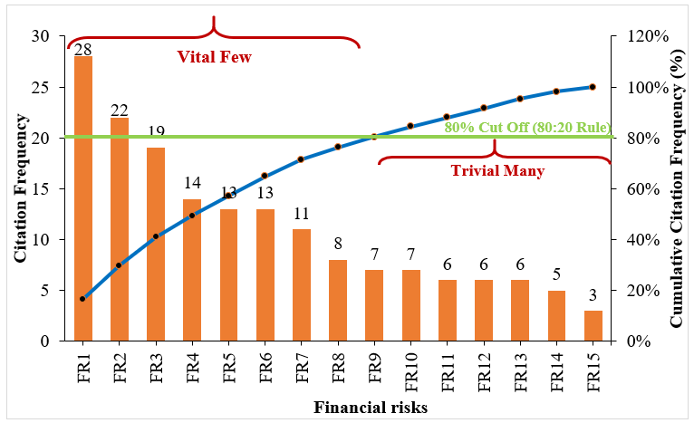  - Financial risks of green building projects | 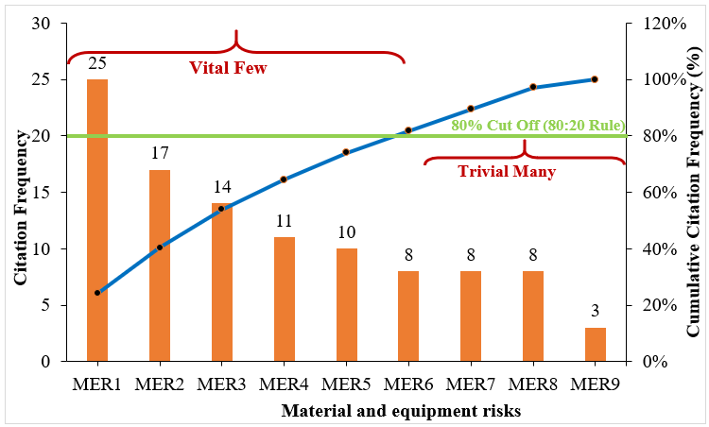  - Material - equipment risks of GB projects
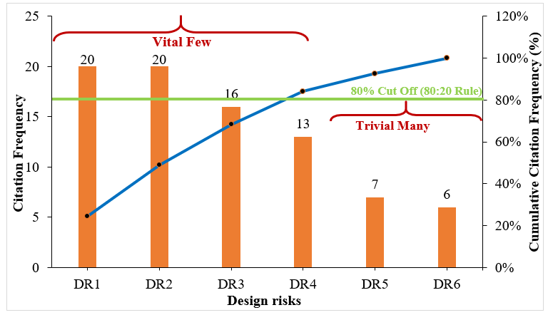  - Design risks of green building projects | 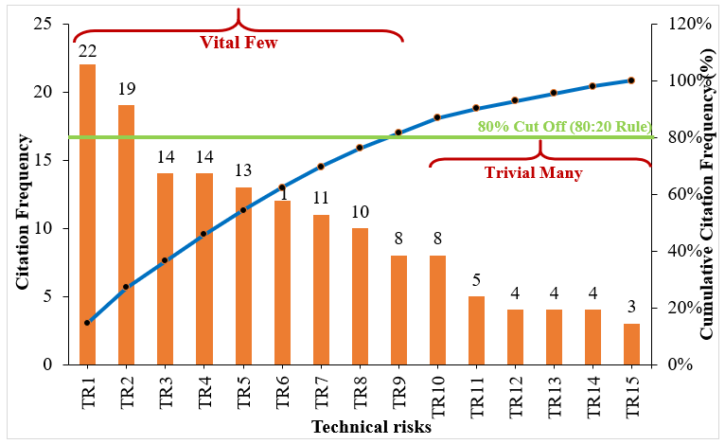  - Technical risks of green building projects
Fig. 5. Pareto charts of financial, material and equipment, design, and technical risks of GB projects

The financial capacity of the client or developer of GB projects is essential to avoid disruptions [57]. A shortage of funding and resources can halt the construction of GB projects at any point, resulting in extended schedules, disputes, and increased cost of capital [25]. GB projects can encounter funding shortages because of the initial higher capital investment required to accomplish the green objectives in the project [46].
The higher capital costs of GB projects result from complex design solutions, modeling costs required to integrate green practices into the project, and higher costs of green materials, technologies, equipment, processes, and decisions [42]. The funding shortages may also arise from financial incapacitation or a sudden bankruptcy of the owners [69]. While it is rare, clients and owners can cancel GB projects or breach their contracts due to bankruptcy. The funding challenges and disputes in GB projects may arise from the split incentive, where the developer or contractor bearing the higher design and construction costs do not benefit directly from the long-term benefits and operational cost savings, especially when cost-plus contracts are not used [13]. The split incentive problem arises because the stakeholder making the investment decisions is not a direct beneficiary of the long-term benefits [25].
Additionally, delayed payments to the specialist contractor due to project funding problems can result in dysfunctional disputes [57]. It places financial hardship on contractors, which could constrain their ability to pay subcontractors and labor, resulting in conflicts [69]. Contractors need to assess the financial capacity of clients and obtain relevant statements that guarantee the progress of payments. It is also essential for the specialist contractor to assign the responsibilities in strict adherence to the contractual agreements and establish a good working relationship with the client to avoid uncooperative attitudes [57].
Moreover, inflation and changes in prices of green construction materials can significantly influence the delivery of GB projects. The prices of green construction materials change in tandem with inflation and the relationships between supply and demand in the market. The volatilities of currency and interest rate may incur an increase in the price of imported green construction materials and equipment, translating into cost overruns in GB projects [15]. Inflation can also generate significant deviation in cost estimate for GB projects, especially where the bill of quantities and estimates are based on the rigid quotation method, without referring to the volatile market conditions [57]. Also, the inaccurate estimate of the long-term return on investment (ROI) is due to the unapparent short-term economic returns of GB projects [19]. Given the uncertainty compassing the market value of sustainability, an inaccurate estimate of the long-term ROI can result in suboptimal investment decision-making in GB projects [19].
Material and equipment risks: Fig. 5 (b) shows nine (9) material and equipment risks of GB projects. The vital critical material and equipment risk factors include unavailability and shortage of approved green materials and technologies (MER1), unproven quality of new green products, materials, equipment, and technologies (MER2), inadequate information of green building products, materials, systems, and performance (MER3), unclear information and uncertainty in the performance of green materials, products, and equipment (MER4), inadequate pool of suppliers of green materials and products (MER5), and delay and late delivery of green building materials (MER6).
Given the prevailing immaturity of the green market in some countries, unavailability and shortage of approved green materials, products, and technologies present serious risks in GB projects [13]. Green materials and products are sometimes only available at a cost premium unless they are specified and contracted in the early design process, and even then there may be delays in actually getting them delivered [25]. Shortages in the supply of green materials may arise from poor forecasting, planning, low inventory levels, poor communication of information, and dependence on a single supplier [15].
Despite the substantial progress in GBs, there exist inadequate information on green building products, materials, systems, and performance in some contexts. The quality of new green materials, products, equipment, and technologies does not have a proven track record [26,42]. The relevant project parties may lack awareness of, and access to information about, green materials, technologies, equipment, and options during the delivery of GB projects. Similarly, an inadequate pool of suppliers of green materials and products influences the availability and costs of high-performance materials and products. In a case where green materials and products have to be procured from overseas due to the inadequate pool of local suppliers, it can result in a long lead time, international transportation costs, complex logistical challenges, and longer supply cycles [57].
Design risks: Fig. 5 (c) shows six (6) design risks of GB projects. The vital critical design risk factors include poor detailed design with deficiencies in drawings and unclear specifications (DR1), inaccurate specifications of green construction materials and technologies (DR2), frequent design changes and variations (DR3), and inadequate integration of sustainability into the design and supply chain of green buildings (DR4).
The design plays a key role in affecting the quality of a GB project. Poor detailed design with deficiencies in drawings and unclear specifications, arising from incomplete design, rushed design freezing, and excessive changes can compromise the objectives of GB projects [69]. The specification of appropriate green construction materials and products during the design stage has the greatest influence on the outcomes of GB projects [26]. Thus, inaccurate specifications of green construction materials and technologies can lead to poor financial, environmental, and social outcomes of GB projects [8].
Typically, frequent design changes and variations arise from defective designs and change orders of the client [57]. Defective designs result from a poor understanding of the client’s needs in the project brief, late involvement of specialist contractors, inadequate planning, poor site investigation to obtain reliable design data, and limited communication and information sharing among the design team members [69]. Frequent design variations can cause a significant delay in the project schedule, incurring extra costs in GB projects [30,83]. Green objectives must be explicitly specified and incorporated throughout the construction cycle to achieve desired outcomes in GB projects. Thus, inadequate integration of sustainability into the design and supply chain can lead to poor financial outcomes of GB projects [8].
Technical risks: Fig. 5 (d) shows fifteen (15) technical risks of GB projects. The vital critical technical risk factors include inadequate professional knowledge and expertise in efficient green building methods, technologies, and eco-products (TR1), lack of competent and experienced green building project team (TR2), unavailability of skilled and experienced manpower (TR3), unfamiliarity with green building techniques and technologies (TR4), lack of quantitative tools and models to evaluate cost, benefits, and certification of green building (TR5), longer planning, design and procurement time required to incorporate green objectives (TR6), long lead times for green products and materials (TR7), improper feasibility, planning and scheduling for green buildings (TR8), and low labor and equipment productivity (TR9).
The inadequate professional knowledge and expertise of the core project team members in GB tools, technologies, methods, and products can fail GB projects [84]. Designers with insufficient knowledge of and unfamiliarity with high-performance options, products, and design solutions to produce robust specifications for contractors can generate significant inefficiencies and compromise the objectives of GB projects [25]. The inexperienced designers may invest considerable time researching alternative sources of high-performance materials and equipment, resulting in a longer design time and extended project duration. Senior management and core project team members without considerable knowledge may fail to make optimal decisions that consider the impact of external and internal conditions, thus influencing the performance of GB projects [84].
Similarly, a lack of competent and experienced GB project team presents serious risks because successful installation and maintenance of high-performance systems depend on the availability of specialized knowledgeable players. For most countries, the special bespoke skills and system knowledge required for the design, construction, maintenance, and operation of GBs are in short supply, and training in relevant high-performance technologies and building practices is not readily accessible for the trades, contractors, operation staff and managers [25]. Government imposition of strict quotas for the importation of skilled manpower from specific nations generates an added risk of recruiting relevant skilled labor for GB projects [69]. The unavailability of skilled and experienced manpower presents serious risks because it can result in an acute shortage and a high cost of the limited skilled labor to deliver GB projects. Poor competency of the manpower can result in quality and safety problems in GB projects [57].
Despite the development of international and national GB rating and certification systems, there remain inaccessible quantitative tools and models to evaluate the cost, benefits, and certification of GB projects [13]. Additionally, most green materials and products are imported, resulting in uncertain and long lead times [69]. The uncertainties and custom complexities associated with importing green materials and products present additional layers of risks in GB projects. The prevailing constraints associated with green construction materials, building codes, supply chains, skilled labor, and management mean that GB projects are not usually physically supported, financially prudent, technically possible, and legally advised. As such, improper feasibility, planning and scheduling can result in unforeseeable challenges, complexities, and abortive costs in GB projects [8].
Stakeholder risks: Fig. 6 (a) shows twelve (12) stakeholder risks of GB projects. The vital critical stakeholder risk factors include poor communication, cooperation, and networking between the project team members (SR1), frequent change orders and intervention of client (SR2), lack of a common understanding of sustainability and shared vision of green buildings (SR3), injuries and accidents during construction (SR4), delays in resolving contractual issues, problems, disputes, and conflicts in green buildings (SR5), lack of expressed interest from client and project team members (SR6), poor interrelationships between the client, project team and supply chain partners (SR7), and poor commitment of the consultant (SR8).
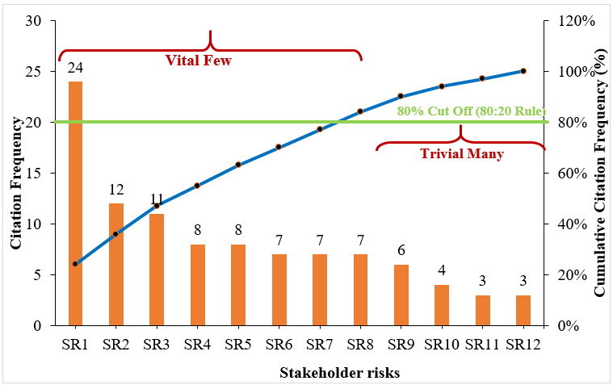  - Stakeholder risks of GB projects | 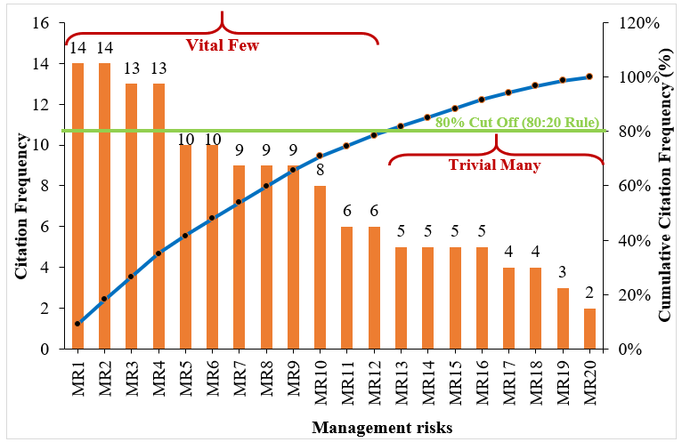  - Management risks of GB projects
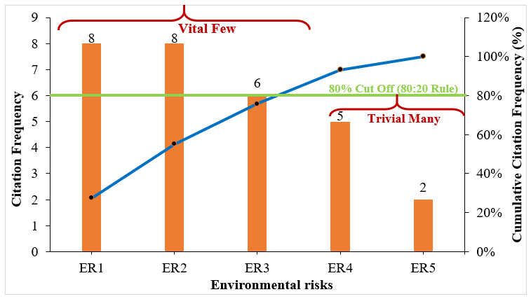  - Environmental risks of GB projects | 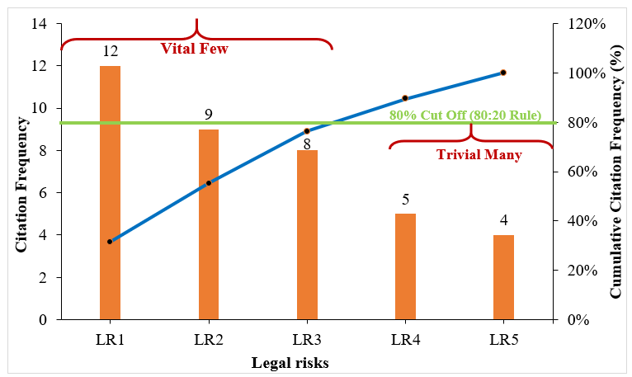  - Legal risks of green building projects
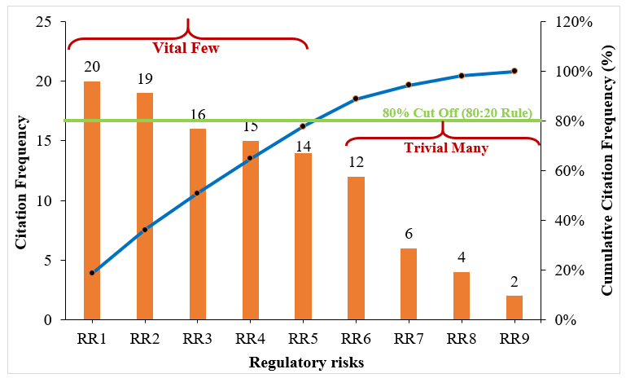
- Regulatory risks of green building projects
Fig. 6. Pareto charts of stakeholder, management, environmental, legal, and regulatory risks of GB projects

GB projects are designed and constructed by multiple project participants, institutions, and organizations [85]. These various players have varied objectives, value systems, goals, understanding, and levels of knowledge of high-performance buildings [25]. The key decisions (e.g., specification and selection of building materials) significantly affecting the outcomes of GB projects are usually made early in the project lifecycle, without the involvement of key players such as contractors [26].
Yet, the decisions and roles of various stakeholders have a complementary and cumulative impact on the outcomes of GB projects. Thus, inconsistencies and discrepancies of decisions between downstream and upstream stages of the delivery chain can compromise the success of GB projects. Thus, poor communication, cooperation, and networking between the project team members can generate inefficiencies and complications in GB projects [86,87]. Similarly, a lack of a common understanding of sustainability and a shared vision of green buildings can compromise and defeat the collaborative commitment and effort required to achieve success in GB projects.
Additionally, the efficient use of all necessary information and the effective cooperation of all actors call for methods that enable the management and sharing of information among the client, project team, and supply chain partners in GB projects [13]. Thus, poor interrelationships between various stakeholders present acute risks of poor communication and information sharing to achieve the objectives of GB projects. Similarly, early commitment and interests of the client and project team members are required to achieve desired outcomes in GB projects. For instance, the interested client and project players would commit to green objectives early upfront, plan extensively, and adopt an integrated delivery method to integrate the key players at the outset of GB projects, where decisions about green objectives matter most [88]. Thus, a lack of expressed interest from client and project team members constitutes a recipe for poor commitment to and outcomes of GB projects [29]. Similarly, a poor commitment of consultants can result in poor decisions at early stages, limited access to reliable data and information on green solutions, inefficiencies during the construction phase, and risk of losing green certification or additional costs to correct products and systems with a lack of green standards [29,83].
Moreover, frequent change orders and the intervention of clients can significantly alter the time and cost of planning, design, and construction of GB projects [57]. While the client is responsible for changes due to change of mind and additional requirements, change orders arising from the misinterpretation of the client’s needs in the project brief can result in dysfunctional conflicts in GB projects. Lastly, labor injuries and accidents caused by overexertion, exposure to hazardous materials, malfunction of equipment, and electrical shocks can significantly result in decreased morale of workers, low productivity, and statutory claims in GB projects [19]. Injuries and accidents during construction have adverse implications on the objectives of GB projects, including cost overruns, delays, loss of productivity, and loss of morale.
Management risks: Fig. 6 (b) shows twenty (20) management risks of GB projects. The vital critical management risk factors include inadequate supervision of a project manager with limited technical expertise and skills in green buildings (MR1), improper quality control, defective work, and reworks (MR2), inaccurate cost estimation of green buildings (MR3), inaccurate quotation, project budgeting, and poor management of the contractor (MR4), unreasonably tight project schedule for green construction practices (MR5), unclear assignment of roles to the project team members (MR6), organizational and procedural difficulties (MR7), lack of support from senior management (MR8), strict health and safety regulations (MR9), lack of proper project management framework and staff for green buildings (MR10), inappropriate procurement systems discouraging supply chain integration (MR11), and frequent meeting with green specialists (MR12).
The unreasonably tight project schedule for green construction practices puts project team members under pressure, resulting in detrimental mistakes and practices [57]. Excessively tight GB project schedules can be difficult and impractical to achieve [69]. Inaccurate cost estimates for GB projects can arise from several factors, including limited consultation of local subcontractors, fluctuation of market prices, rigid cost estimation methods, inexperienced cost estimator, and volatility of exchange rate, especially when green materials and products are imported [29]. Inaccurate cost estimation is a major cause of funding shortages and financial disputes between clients and contractors in GB projects [13].
A closely related risk factor is an inaccurate quotation, project budgeting, and poor management of the contractor. Most GB contractors are previously general contractors, lacking managerial skills to contract GB projects. Though contractors typically rely on specialist subcontractors to deliver GB projects, their limited specialist knowledge generates significant challenges and lapses in developing clear pro-GB contractual terms with subcontractors and overseeing the project delivery to achieve the green objectives [57].
Compared to conventional building projects, GB projects require additional design time, planning, approval procedures, and organizations. The organizational and procedural difficulties prolong the construction time and costs of GB projects. Typically, senior management approves and develops strategies to implement sustainable solutions in construction projects and organizations [13]. Thus, a lack of support from senior management can translate into inadequate funding allocation for, commitment to, and governance of GB projects [8]. It could fuel an improper project management framework and inadequate staffing of GB projects [19]. The stricter health and safety regulations in GB projects increase the investment and funding allocation to deploy safety programs and strategies. The use of inappropriate procurement systems discouraging supply chain integration can limit collaborative working relationships, frequent communication, and information sharing in GB projects.
Environmental risks: Fig. 6 (c) shows five (5) environmental risks of GB projects. The vital critical environmental risk factors for GB projects include inadequate site information (ER1), variation in adverse weather conditions (ER2), and insufficient construction site investigation and unforeseen adverse site conditions (ER3).
Inadequate site information resulting from inaccurate soil tests and surveys presents serious environmental risks in GB projects. Insufficient data and knowledge of site conditions can lead to uninformative design and detrimental cascading effect on the progress of excavation, foundation, and footing construction in GB projects [57]. Variations in weather conditions can also generate additional uncertainties, delays in schedule, and extra costs in GB projects [19]. Extreme weather events (e.g., typhoons, hurricanes, floods) in today’s rising climatic impacts can destroy and halt onsite green construction activities and potentially contaminate green materials and products with weather-driven pollutants.
Legal risks: Fig. 6 (d) shows five (5) legal risks of GB projects. The vital critical legal risk factors for GB projects include breach of contracts and disputes (LR1), unclear contract clauses and conditions for green building (LR2), inadequate long-term warranties and insurances for green materials and equipment (LR3), and litigation, legal actions, and prosecutions during construction (LR4).
Breach of contracts and disputes arising from the failure of relevant parties to discharge and fulfill contractual obligations can cause significant delay in the project schedule, generate dissatisfaction, additional legal costs of dispute resolutions, and even possible termination of the project [83]. While contractual breaches could arise from the bankruptcy of a client or other reasons, disputes usually arise from unclear contract clauses and conditions for GB projects. Contract documents for GB projects usually specify the roles, responsibilities, rights, and rewards of various parties to the contract, different types of materials and equipment to be used, minimize standards required, and necessary mechanisms to address potential disputes [83]. Thus, unclear contract clauses and conditions are sources of dysfunctional litigations and associated costs.
Inadequate long-term warranties and insurances for green materials and equipment fail to provide financial protection against the unproven quality of new green materials and equipment. Litigation, legal actions, and prosecutions during construction can halt progress and significantly extend the schedule of GB projects, thus incurring additional costs [15].
Regulatory risks: Fig. 6 (e) shows nine (9) regulatory risks in GB projects. The vital regulatory risk factors for GB projects include complex and complicated approval procedures, codes, and regulations for green buildings (RR1), changes in government regulations, taxes, incentives, and policies (RR2), difficulty in obtaining green certification and documentation upon completion (RR3), lack of government support and incentives (RR4), and uncertainty and delays in obtaining approval and permitting for green buildings (RR5).
While building regulations can be drivers of GB projects, they can also create significant disincentives, difficulties, and risks [25]. It is common for existing building codes to preclude high-performance materials and green technologies. Consequently, there are complex and complicated approval procedures, codes, and regulations for green buildings [29]. Local building authorities can be skeptical and resistant to the use of high-performance technologies and innovative design elements associated with GB projects. Typically, green technologies, materials, and products must undergo rigorous testing before being approved for high-rise GB projects. The lengthy approval processes for new green technologies and recycled materials require additional time and capital resources, leading to the overall higher costs and schedule of GB projects [42].
Similarly, changes in government regulations, taxes, incentives, and policies can adversely affect the requirements, continuity, and costs of GB projects as well [69]. For instance, laws that stop general construction works in the summer due to heat strokes can significantly affect the schedules of GB projects. There is no certain time required to obtain approval and permits for green buildings in some countries. These uncertainties arise from limited recognition of GBs in building codes and long-standing reluctance to approve some green materials due to unproven quality and unfamiliarity to relevant building authorities, limiting accurate scheduling of GB projects at early stages. There is also a difficulty in obtaining green certification and documentation upon completion in some contexts, depriving stakeholders of financial savings and added market value of GB projects [13].
Lastly, government commitment through appropriate steering mechanisms, such as normative regulatory instruments (e.g., GB building codes), informative regulatory instruments (e.g., mandatory labeling), economic and market-based instruments (e.g., certificate schemes), fiscal instruments, and incentives (e.g., tax relief and financial support) can improve the economic viability of GB projects [13]. A lack of government support and incentives creates additional layers of regulatory uncertainties, complexities, and challenges for GB projects.
Conceptual map of the vital critical risk factors for green building projects
Fig. 7 shows a conceptual map of various vital CRFs subordinate to different categories for GB projects, providing a more structured framework to examine various risks in GB projects. The Pareto analysis has revealed sixty vital CRFs for GB projects, comprising 4 design, 6 material and equipment, 9 financial, 9 technical, 12 management, 8 stakeholder, 3 environmental, 4 legal, and 5 regulatory risks. The framework shows that material and equipment, management, stakeholder, financial, technical, and regulatory risks constitute the dominant categories of risks in GB projects.

Fig. 7. Conceptual map of the vital critical risk factors for green building projects
Theorizing the path dependencies of risks in green building projects
The review studies established that probability of occurrence and severity of impact of the various risks are dynamic, dependent, and interlinked [19]. The theoretical positions of the chain reactions and path dependencies of various risks in GB projects have been well-established in the literature. For instance, Guan et al. [19] established that lack of competent and experienced GB project team (technical risk) can reinforce the probability and impact of management risks, such as inadequate supervision of a project manager with limited technical expertise and skills in GB. Mohammadi and Birgonul [59] showed that unclear contract clauses and conditions for GBs (legal risk) can reinforce the adverse impact of management risks, such as unclear assignment of roles to the project team members in GB projects. Also, the complex and complicated approval procedures, codes, and regulations for GBs (regulatory risk) can amplify probability and adverse impact of management risks, such as organizational and procedural difficulties in GB projects ([45].
Understanding these chain reactions and push effects of the various can form a basis for developing targeted response mechanisms and strategies to break the chain and minimize the systematic impact of various risks in GB projects. However, there is no successful attempt at theorizing the path dependencies, chain reactions and hierarchical structure of the various taxonomies of risks in GB projects. This study compiled the documented evidences of the various multiple reactions among the risk factors to generate an interpretive logic knowledge-base [81], providing adequate information to theorize the multidimensional risk factors in GB projects. Fig. 8 shows a theoretical model of the risks in GB projects.
The theoretical model has four levels. Level 1 comprises financial and material & equipment risks. Level 2 comprises stakeholder, design, and management risks. Level 3 includes legal risks. Level 4 comprises environmental, technical, and regulatory risks. The model contains two types of lines used to indicate the direction of influence between two dimensions of the risk factors. The regular line depicts the direction of influence of one risk factor on probability of occurrence and severity of impact of another risk factors at the same level or two successive levels (e.g., levels 1 and 2, levels 2 and 3). The dotted line depicts the direction of influence between two risk factors at extended levels (e.g., levels 1 and 3).
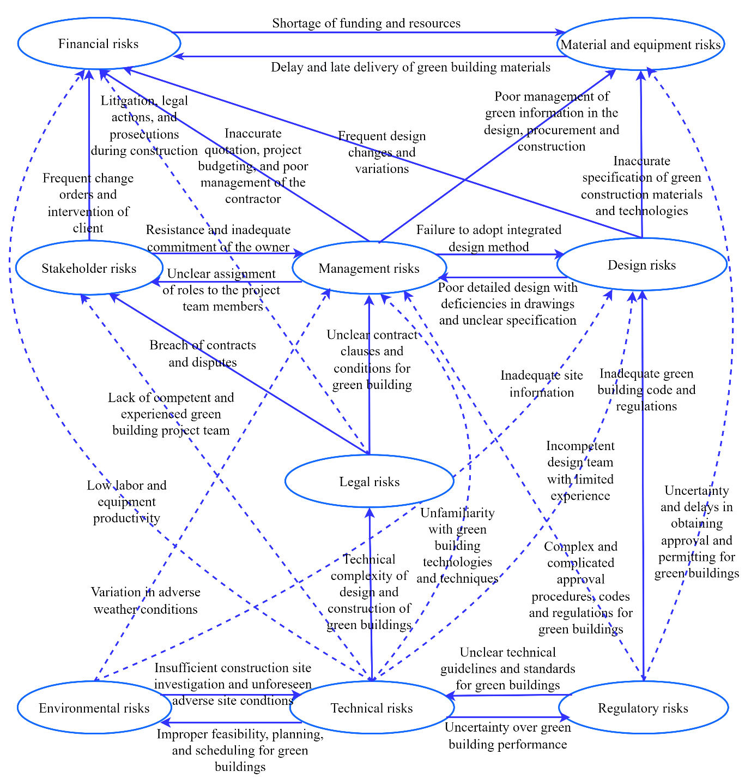
Fig. 8. Path dependencies and hierarchical structure of risks in green building projects
The text on each line explains how a dimension influences another dimension. In order, it explains the source of the influence. For instance, regulatory risks such as inadequate GB code and regulations can induce and influence the probability of occurrence and impact of design risks such as inadequate specification of green construction materials and technologies.
The constructs of the model at level 1 (financial and material & equipment risks) are considered dependent variables. These constructs have the highest dependencies and the lowest driving powers. The associated risks influence each other and dependent on other risks, but do not significant drive or influence the probability of occurrence of risks in the lower levels. They are most likely present in any GB project because several risks can trigger them.
The constructs at levels 2 (stakeholder, design, and management risks) and 3 (legal risks) of the model are considered linkage variables. These constructs have both strong dependencies and strong driving powers. They influence each, influence other risks, and are influenced by other risks. They mediate the influence between the lowest (4) and highest (1) construct. The linkage risk constructs are extremely sensitive and can significantly influence the performance of GB projects.
The constructs at level 4 (environmental, technical, and regulatory risks) of the model are considered independent variables, containing strong driving power but weak dependence power. Risk factors at this level influence each other and strongly influence other risks, but are not influenced by other risks. These constructs have extremely high reachability in the model because they can influence risks at all other levels, translating them into a major concern in risk management. Thus, project managers can regulate the cumulative probabilities and impacts of risks in GB projects, if they can control and mitigate the independent and linkage risk constructs.
Discussions
The review established multidimensional risks in GB projects, including design, material and equipment, financial, technical, management, stakeholder, environmental, legal, and regulatory risks. This classification framework extends the risk constructs established in previous studies [17,30]. The findings reveal the inadequacy of relying on a single published study to spot the dimensions of risks in GB projects. For instance, the dimensions of GB risks in Zhao et al. [17] failed to acknowledge legal and regulatory risks. Though El-Sayegh et al. [30] and Qazi et al. [14] offer a comprehensive framework, these studies excluded environmental risks in GB projects. While the stakeholder-oriented classifications of GB risks in Zou and Couani [29] facilitates risk allocation, it discourages integrated risk management in GB projects. Thus, this study offers the most comprehensive dimensions of risks in GB projects. The clustering and labels of the risk dimensions can be treated as discrete categories instead of mere conceptual guides because they were informed by existing typologies.
Moreover, the review exposed the inadequacy of previous attempts to model the interdependencies among the various risks. The structural risk-path model for sustainable housing in Adabre et al.[32] attempted to explore the causal relationships of design, construction, financial, procurement, political, operational, and maintenance risks in sustainable housing. While relevant, the model was based on a small sample size and also failed to consider the hierarchical structure of risks in GB projects. The interpretive structural model of risks in GB projects in [19] addressed hierarchical limitations of the structural model of Adabre et al.[32], but considered fewer unit risks and failed to theorize the relationships at the construct level. The social network model of stakeholder risks in GB projects in Yang et al. [75] and Yang et al. [89] failed to capture the multidimensional risks in GB projects. The theoretical model developed in this study addressed the documented limitations of the existing studies. The theoretical model explaining the path dependencies, chain reactions, and hierarchical structure of the various risks in GB projects offers important theoretical, managerial, and policy implications.
Theoretically, the study identified, harmonized, and consolidated the CRFs for GB projects. Thus, it contributes to the theoretical checklist of risk factors associated with green and sustainable construction projects. The study further developed and documented the chain reactions and push effects among the discrete taxonomies of the CRFs for GB projects. The developed theoretical model captures the “what”, “how”, and “why” aspects of theory building in terms of highlighting the interactions and influence among the various risks in GB projects. The hierarchical structure embodied in the theoretical model established the leading and lagging relationships between different constructs of risks in GB projects and provides a deeper theoretical understanding of the various risks.
For project managers, the study established a more relevant checklists for a risk register in GB projects. The prioritized and vital CRFs can inform project managers of resource allocation for risk management in GB projects. The practical relevance of the hierarchical model for developing targeted risk management strategies cannot be overemphasized. Specifically, the model informs project managers that environmental, technical, regulatory, legal, stakeholder, management, and design risks have the greatest negative push effects on performance of GB projects. For instance, design risks can propagate throughout the delivery chain and compromise the success of subsequent lifecycle stages of GB projects. For example, a poor design can hatch expensive reworks, dysfunctional defects, and inefficiencies in the construction phase. Decisions and specifications at the design stage have the greatest influence on the lifecycle impacts of construction materials and products in GB projects.
It is evident that vital CRFs can be allocated across various lifecycle stages of GB projects. Thus, more effective management of risks would be possible if the risks are managed from the perspective of a project lifecycle. Hence, identifying the possible occurrence of risks in each stage and making appropriate arrangements to cope with various significant risks are recommended. Noticeably, many identified risks may occur in more than one phase and hence they need to be considered at multiple phases.
For policy implications, the findings established consolidated the regulatory risks in GB projects. It demonstrates the roles of the government, building authorities, and regulation-making departments in mitigating the risks of GB projects. The study showed that government support and simplified approval procedures can minimize the regulatory risks of GB projects.

Conclusion
Green buildings reinvent the relationships between construction methods and associated risks. The added sustainability objectives expose GB projects to enormous risks, challenges, and requirements. Managing risks in GB projects has been recognized as a very important process to more feasibly achieve the objectives of GB projects in terms of energy efficiency, minimal environmental impact, time, cost, quality, productivity, and safety performance. This paper conducted a systematic literature review to identify, consolidate, prioritize, categorize and theorize the CRFs for GB projects. The analysis revealed a growing scholarly interest in the management risks in GB projects from 2006 to 2022. The review further established most of the existing studies largely favored deterministic and network techniques rather than probabilistic techniques in the assessment of risks in GB projects. This outcome suggests existing studies have mostly failed to consider the distributions and profiles of various risks and the significance of tail risks in GB projects, resulting in suboptimal decision support for risk management in GB projects. Of ninety-six (96) CRFs for GB projects extracted from the reviewed literature, the top five most-cited CRFs for GB projects are linked to shortage of funding and resources; unavailability and shortage of approved green materials and technologies; poor communication and information sharing between the project team members; inadequate professional knowledge and expertise in efficient green building methods, technologies, and eco-products; and inflation and changes in prices of green construction materials. The review derived nine (9) broad constructs of the identified risks for GB projects, including financial, material and equipment, design, technical, stakeholder, management, environmental, legal, and regulatory risks. Of these, the most persistent risk constructs for GB projects, in terms of citation frequencies include design, regulatory, material and equipment, financial, and technical risks. A Pareto analysis revealed a total of sixty (60) risk factors considered the “vital few” within the heuristic of the “80/20” principle.
Therefore, this study developed the most comprehensive register of a diverse range of CRFs for GB projects. The prioritized checklist of the CRFs can inform more targeted resource allocation for risk management in GB projects. The study categorized and theorized the chain reactions of the CRFs, explaining the various relationships among the risks of GB projects. The findings further established that legal advice and government support can be of great help to reduce the impact of legal and regulatory risks of GB projects.
Despite the accomplishment of the objectives in the study, there are three noteworthy limitations, demanding further improvements in future studies. First, the review was limited to articles and reviews only. By excluding other document types, the study might have missed other relevant studies addressing the risks of GB projects. Consequently, the identified sets of CRFs for GB projects may not be exhaustive. Second, the CRFs for GB projects were prioritized and ranked using citation frequencies. Therefore, their criticalities may vary based on project contexts. Nonetheless, the identified CRFs offer a guiding frame for critical risk identification in GB projects in future research. Third, the taxonomies of the CRFs were derived intuitively using a cluster analysis. Consequently, there could be overlapping and inappropriate assignments of the CRFs in various taxonomies. Future studies would focus on developing risk management strategies and best practices for implementing GB projects.

References
[1] World Green Building Council, The Business Case for Green Building: A Review of the Costs and Benefits for Developers Investors and Occupants, United States, 2013. http://www.worldgbc.org/sites/default/files/Business_Case_For_Green_Building_Report_WEB_2013-04-11-2.pdf.
[2] I.Y. Wuni, G.Q. Shen, R. Osei-Kyei, Scientometric review of global research trends on green buildings in construction journals from 1992 to 2018, Energy Build. 190 (2019) 69–85. https://doi.org/10.1016/j.enbuild.2019.02.010.
[3] X. Cao, X. Li, Y. Zhu, Z. Zhang, A comparative study of environmental performance between prefabricated and traditional residential buildings in China, J. Clean. Prod. 109 (2015) 131–143. https://doi.org/10.1016/j.jclepro.2015.04.120.
[4] J. Monahan, J.C. Powell, An embodied carbon and energy analysis of modern methods of construction in housing: A case study using a lifecycle assessment framework, Energy Build. 43 (2011) 179–188. https://doi.org/10.1016/j.enbuild.2010.09.005.
[5] M. Glaumann, T. Malm, J. Larsson, Evaluation of green buildings in Sweden, Build. Res. Inf. 27 (1999) 276–285. https://doi.org/10.1080/096132199369381.
[6] J. Zuo, S. Pullen, R. Rameezdeen, H. Bennetts, Y. Wang, G. Mao, Z. Zhou, H. Du, H. Duan, Green building evaluation from a life-cycle perspective in Australia: A critical review, Renew. Sustain. Energy Rev. 70 (2017) 358–368. https://doi.org/10.1016/j.rser.2016.11.251.
[7] Office of the Federal Environmental Executive, The Federal Commitment to Green Building: Experiences and Expectations, CreateSpace Publishing, Washington, DC, 2014. https://www.barnesandnoble.com/w/the-federal-commitment-to-green-building-the-office-of-the-federal-environmental/1120789211.
[8] R. Ranaweera, R.H. Crawford, Using early-stage assessment to reduce the financial risks and perceived barriers of sustainable buildings, J. Green Build. 5 (2010) 129–146. https://doi.org/10.3992/jgb.5.2.129.
[9] B. Aktas, B. Ozorhon, Green Building Certification Process of Existing Buildings in Developing Countries: Cases from Turkey, J. Manag. Eng. 31 (2015) 05015002. https://doi.org/10.1061/(asce)me.1943-5479.0000358.
[10] D.W. McNamara, B. Birkenfeld, P. Brown, N. Kresse, J. Sullivan, P. Thiam, Quantifying the Hidden Benefits of High-Performance Building, Washington, D.C., 2011.
[11] W. Eisenstein, G. Fuertes, S. Kaam, K. Seigel, E. Arens, L. Mozingo, Climate co-benefits of green building standards: water, waste and transportation, Build. Res. Inf. 45 (2017) 828–844. https://doi.org/10.1080/09613218.2016.1204519.
[12] C. Kreiss, N. Nasr, R. Kashmanian, Making the Business Case for Sustainability: How to Account for Intangible Benefits—A Case Study Approach, Environ. Qual. Manag. 26 (2016) 5–24. https://doi.org/10.1002/tqem.21478.
[13] T. Häkkinen, K. Belloni, Barriers and drivers for sustainable building, Build. Res. Inf. 39 (2011) 239–255. https://doi.org/10.1080/09613218.2011.561948.
[14] A. Qazi, A. Shamayleh, S. El-Sayegh, S. Formaneck, Prioritizing risks in sustainable construction projects using a risk matrix-based Monte Carlo Simulation approach, Sustain. Cities Soc. 65 (2021) 102576. https://doi.org/10.1016/j.scs.2020.102576.
[15] B. gang Hwang, M. Shan, N.N.B. Supa’at, Green commercial building projects in Singapore: Critical risk factors and mitigation measures, Sustain. Cities Soc. 30 (2017) 237–247. https://doi.org/10.1016/j.scs.2017.01.020.
[16] X. Qin, Y. Mo, L. Jing, Risk perceptions of the life-cycle of green buildings in China, J. Clean. Prod. 126 (2016) 148–158. https://doi.org/10.1016/j.jclepro.2016.03.103.
[17] X. Zhao, B.G. Hwang, Y. Gao, A fuzzy synthetic evaluation approach for risk assessment: A case of Singapore’s green projects, J. Clean. Prod. 115 (2016) 203–213. https://doi.org/10.1016/j.jclepro.2015.11.042.
[18] L. Chen, A.P.C. Chan, E.K. Owusu, A. Darko, X. Gao, Critical success factors for green building promotion: A systematic review and meta-analysis, Build. Environ. 207 (2022) 108452. https://doi.org/10.1016/j.buildenv.2021.108452.
[19] L. Guan, A. Abbasi, M.J. Ryan, Analyzing green building project risk interdependencies using Interpretive Structural Modeling, J. Clean. Prod. 256 (2020) 120372. https://doi.org/10.1016/j.jclepro.2020.120372.
[20] M.J. Grant, A. Booth, A typology of reviews: an analysis of 14 review types and associated methodologies, Health Info. Libr. J. 26 (2009) 91–108. https://doi.org/10.1111/j.1471-1842.2009.00848.x.
[21] D. Tranfield, D. Denyer, P. Smart, Towards a Methodology for Developing Evidence-Informed Management Knowledge by Means of Systematic Review, Br. J. Manag. 14 (2003) 207–222. https://doi.org/10.1111/1467-8551.00375.
[22] E. Papadonikolaki, I. Krystallis, B. Morgan, Digital Technologies in Built Environment Projects: Review and Future Directions, Proj. Manag. J. (2022) 1–19. https://doi.org/10.1177/87569728211070225.
[23] J.P.T. Higgins, J. Thomas, J. Chandler, M. Cumpston, T. Li, M.J. Page, V.A. Welch, Cochrane Handbook for Systematic Reviews of Interventions, Second Edi, The Cochrane Collaboration and John Wiley & Sons Ltd, 2019.
[24] C. Wohlin, Guidelines for snowballing in systematic literature studies and a replication in software engineering, in: Proc. 18th Int. Conf. Eval. Assess. Softw. Eng. - EASE ’14, Association for Computing Machinery (ACM), London, England, United Kingdom, 2014: pp. 1–10. https://doi.org/10.1145/2601248.2601268.
[25] A.J. Zerkin, Mainstreaming high performance building in New York City: A comprehensive roadmap for removing the barriers, Technol. Soc. 28 (2006) 137–155. https://doi.org/10.1016/j.techsoc.2005.10.017.
[26] M. Pitt, M. Tucker, M. Riley, J. Longden, Towards sustainable construction: Promotion and best practices, Constr. Innov. 9 (2009) 201–224. https://doi.org/10.1108/14714170910950830.
[27] X. An, G. Pivo, Green Buildings in Commercial Mortgage-Backed Securities: The Effects of LEED and Energy Star Certification on Default Risk and Loan Terms, Real Estate Econ. 48 (2020) 7–42. https://doi.org/10.1111/1540-6229.12228.
[28] B. Hwang, J.S. Tan, Green Building Project Management: Obstacles and Solutions for Sustainable Development, Sustain. Dev. 349 (2012) 335–349. https://doi.org/10.1002/sd.492.
[29] P.X.W. Zou, P. Couani, Managing risks in green building supply chain, Archit. Eng. Des. Manag. 8 (2012) 143–158. https://doi.org/10.1080/17452007.2012.659507.
[30] S.M. El-Sayegh, S. Manjikian, A. Ibrahim, A. Abouelyousr, R. Jabbour, Risk identification and assessment in sustainable construction projects in the UAE, Int. J. Constr. Manag. 21 (2021) 327–336. https://doi.org/10.1080/15623599.2018.1536963.
[31] Q. Shi, J. Zuo, R. Huang, J. Huang, S. Pullen, Identifying the critical factors for green construction - An empirical study in China, Habitat Int. 40 (2013) 1–8. https://doi.org/10.1016/j.habitatint.2013.01.003.
[32] M.A. Adabre, A.P.C. Chan, D.J. Edwards, E. Adinyira, Assessing critical risk factors (CRFs) to sustainable housing: The perspective of a sub-Saharan African country, J. Build. Eng. 41 (2021) 102385. https://doi.org/10.1016/j.jobe.2021.102385.
[33] N. Kasai, C.J.C. Jabbour, Barriers to green buildings at two Brazilian Engineering Schools, Int. J. Sustain. Built Environ. 3 (2014) 87–95. https://doi.org/10.1016/j.ijsbe.2014.05.004.
[34] M. Liu, H.-Y. Chong, P.-C. Liao, T. Ganbat, Risk-Based Metanetwork Modeling for Sustainable Project Performance in International Construction, J. Infrastruct. Syst. 27 (2021) 04021020. https://doi.org/10.1061/(asce)is.1943-555x.0000617.
[35] B.G. Hwang, X. Zhao, Y.L. See, Y. Zhong, Addressing Risks in Green Retrofit Projects: The Case of Singapore, Proj. Manag. J. 46 (2015) 76–89. https://doi.org/10.1002/pmj.21512.
[36] P.E.D. Love, M. Niedzweicki, P.A. Bullen, D.J. Edwards, Achieving the Green Building Council of Australia’s World Leadership Rating in an Office Building in Perth, J. Constr. Eng. Manag. 138 (2012) 652–660. https://doi.org/10.1061/(asce)co.1943-7862.0000461.
[37] X. Gan, J. Zuo, K. Ye, M. Skitmore, B. Xiong, Why sustainable construction? Why not? An owner’s perspective, Habitat Int. 47 (2015) 61–68. https://doi.org/10.1016/j.habitatint.2015.01.005.
[38] K.S. Dewlaney, M.R. Hallowell, B.R. Fortunato, Safety Risk Quantification for High Performance Sustainable Building Construction, J. Constr. Eng. Manag. 138 (2012) 964–971. https://doi.org/10.1061/(asce)co.1943-7862.0000504.
[39] R.J. Yang, P.X.W. Zou, J. Wang, Modelling stakeholder-associated risk networks in green building projects, Int. J. Proj. Manag. 34 (2016) 66–81. https://doi.org/10.1016/j.ijproman.2015.09.010.
[40] C.L. Del Puerto, A. Crowson, Green construction and energy training program for at-risk individuals: A case study, J. Employ. Couns. 50 (2013) 59–70. https://doi.org/10.1002/j.2161-1920.2013.00025.x.
[41] S. Azeem, M.A. Naeem, A. Waheed, M.J. Thaheem, Examining barriers and measures to promote the adoption of green building practices in Pakistan, Smart Sustain. Built Environ. 6 (2017) 86–100. https://doi.org/10.1108/SASBE-06-2017-0023.
[42] B.G. Hwang, W.J. Ng, Project management knowledge and skills for green construction: Overcoming challenges, Int. J. Proj. Manag. 31 (2013) 272–284. https://doi.org/10.1016/j.ijproman.2012.05.004.
[43] H.T. Nguyen, M. Skitmore, M. Gray, X. Zhang, A.O. Olanipekun, Will green building development take off? An exploratory study of barriers to green building in Vietnam, Resour. Conserv. Recycl. 127 (2017) 8–20. https://doi.org/10.1016/j.resconrec.2017.08.012.
[44] L. Shen, Z. Zhang, Z. Long, Significant barriers to green procurement in real estate development, Resour. Conserv. Recycl. 116 (2017) 160–168. https://doi.org/10.1016/j.resconrec.2016.10.004.
[45] B.G. Hwang, M. Shan, H. Phua, S. Chi, An exploratory analysis of risks in green residential building construction projects: The case of Singapore, Sustain. 9 (2017) 9–11. https://doi.org/10.3390/su9071116.
[46] B.G. Hwang, X. Zhao, L.L.G. Tan, Green building projects: Schedule performance, influential factors and solutions, Eng. Constr. Archit. Manag. 22 (2015) 327–346. https://doi.org/10.1108/ECAM-07-2014-0095.
[47] A.P.C. Chan, A. Darko, A.O. Olanipekun, E.E. Ameyaw, Critical barriers to green building technologies adoption in developing countries: The case of Ghana, J. Clean. Prod. 172 (2018) 1067–1079. https://doi.org/10.1016/j.jclepro.2017.10.235.
[48] G. Polat, H. Turkoglu, A.P. Gurgun, Identification of Material-related Risks in Green Buildings, Procedia Eng. 196 (2017) 956–963. https://doi.org/10.1016/j.proeng.2017.08.036.
[49] D. Ismael, T. Shealy, Sustainable construction risk perceptions in the Kuwaiti construction industry, Sustain. 10 (2018). https://doi.org/10.3390/su10061854.
[50] A.M. Alamdari, Y. Jabarzadeh, D. Samson, N. Sanoubar, Supply chain risk factors in green construction of residential mega projects – interactions and categorization, Eng. Constr. Archit. Manag. Ahead-of-p (2021) 1–30. https://doi.org/10.1108/ECAM-07-2021-0663.
[51] I. Ranawaka, H. Mallawaarachchi, A risk-responsive framework for green retrofit projects in Sri Lanka, Built Environ. Proj. Asset Manag. 8 (2018) 477–490. https://doi.org/10.1108/BEPAM-10-2017-0088.
[52] A.A.E. Othman, N.M.A. Abdelwahab, Achieving sustainability through integrating risk management into the architectural design process, J. Eng. Des. Technol. 16 (2018) 25–43. https://doi.org/10.1108/JEDT-09-2017-0087.
[53] N. Javed, M.J. Thaheem, B. Bakhtawar, A.R. Nasir, K.I.A. Khan, H.F. Gabriel, Managing risk in green building projects: toward a dedicated framework, Smart Sustain. Built Environ. 9 (2020) 156–173. https://doi.org/10.1108/SASBE-11-2018-0060.
[54] C. Zhang, J. Zhang, P. Jiang, Assessing the risk of green building materials certification using the back-propagation neural network, Environ. Dev. Sustain. (2021). https://doi.org/10.1007/s10668-021-01734-0.
[55] E.R. Andal, J.B.P. Juanzon, Identifying risks in implementing sustainable building materials in condominium fit-out projects using analytic hierarchy process, Civ. Eng. Archit. 8 (2020) 1266–1276. https://doi.org/10.13189/cea.2020.080610.
[56] L. Xiao, L. Bie, X. Bai, Controlling the schedule risk in green building projects: Buffer management framework with activity dependence, J. Clean. Prod. 278 (2021) 123852. https://doi.org/10.1016/j.jclepro.2020.123852.
[57] P.X.W. Zou, G. Zhang, J. Wang, Understanding the key risks in construction projects in China, Int. J. Proj. Manag. 25 (2007) 601–614. https://doi.org/10.1016/j.ijproman.2007.03.001.
[58] R. Assaad, I.H. El-adaway, K. Baxmeyer, M. Harman, L. Job, H. Lashley, Allocation of Risks and Responsibilities in Green and Sustainable Buildings, J. Archit. Eng. 27 (2021) 04021002. https://doi.org/10.1061/(asce)ae.1943-5568.0000458.
[59] S. Mohammadi, M.T. Birgonul, Preventing claims in green construction projects through investigating the components of contractual and legal risks, J. Clean. Prod. 139 (2016) 1078–1084. https://doi.org/10.1016/j.jclepro.2016.08.153.
[60] H.M. Tollin, Green building risks: It’s not easy being green, Environ. Claims J. 23 (2011) 199–213. https://doi.org/10.1080/10406026.2011.593442.
[61] M.S. Ghazvini, V. Ghezavati, S. Raissi, A. Makui, An integrated efficiency-risk approach in sustainable project control, Sustain. 9 (2017) 1–20. https://doi.org/10.3390/su9091575.
[62] J. Górecki, M. Díaz-Madroñero, Who risks and wins?-Simulated cost variance in sustainable construction projects, Sustain. 12 (2020) 1–31. https://doi.org/10.3390/SU12083370.
[63] W. Alattyih, H. Haider, H. Boussabaine, Risk factors impacting the project value created by green buildings in Saudi Arabia, Appl. Sci. 10 (2020) 1–32. https://doi.org/10.3390/app10217388.
[64] J. Wadu Mesthrige, H.Y. Kwong, Criteria and barriers for the application of green building features in Hong Kong, Smart Sustain. Built Environ. 7 (2018) 251–276. https://doi.org/10.1108/SASBE-02-2018-0004.
[65] H.D. Nguyen, Q.N.H. Do, L. Macchion, Influence of practitioners’ characteristics on risk assessment in Green Building projects in emerging economies: a case of Vietnam, Eng. Constr. Archit. Manag. ahead-of-p (2021). https://doi.org/10.1108/ecam-05-2021-0436.
[66] A.A. Karakhan, J.A. Gambatese, Identification, Quantification, and Classification of Potential Safety Risk for Sustainable Construction in the United States, J. Constr. Eng. Manag. 143 (2017) 04017018. https://doi.org/10.1061/(asce)co.1943-7862.0001302.
[67] A.F. Mirhosseini, K. Pitera, J. Odeck, M. Welde, Sustainable Project Management: Reducing the Risk of Cost Inaccuracy Using a PLS-SEM Approach, Sustain. 14 (2022) 1–20. https://doi.org/10.3390/su14020960.
[68] B.R. Fortunato, M.R. Hallowell, M. Behm, K. Dewlaney, Identification of Safety Risks for High-Performance Sustainable Construction Projects, J. Constr. Eng. Manag. 138 (2012) 499–508. https://doi.org/10.1061/(asce)co.1943-7862.0000446.
[69] S.M. El-Sayegh, Risk assessment and allocation in the UAE construction industry, Int. J. Proj. Manag. 26 (2008) 431–438. https://doi.org/10.1016/j.ijproman.2007.07.004.
[70] L.V. Rosa, A.N. Haddad, P.V.R. de Carvalho, Assessing risk in sustainable construction using the Functional Resonance Analysis Method (FRAM), Cogn. Technol. Work. 17 (2015) 559–573. https://doi.org/10.1007/s10111-015-0337-z.
[71] N. Winston, Regeneration for sustainable communities? Barriers to implementing sustainable housing in urban areas, Sustain. Dev. 18 (2010) 319–330. https://doi.org/10.1002/sd.399.
[72] X. Zhang, S.R. Mohandes, Occupational Health and Safety in green building construction projects: A holistic Z-numbers-based risk management framework, J. Clean. Prod. 275 (2020) 122788. https://doi.org/10.1016/j.jclepro.2020.122788.
[73] A.D. Rafindadi, M. Mikić, I. Kovačić, Z. Cekić, Global Perception of Sustainable Construction Project Risks, Procedia - Soc. Behav. Sci. 119 (2014) 456–465. https://doi.org/10.1016/j.sbspro.2014.03.051.
[74] C. González-Gaya, J.L. Fuentes-Bargues, F. Brocal-Fernández, A. Sánchez-Lite, M.A. Sebastián-Pérez, Approach to identification and characterization of the new and emerging risks associated with Industrial Green Building, Procedia Manuf. 13 (2017) 1365–1372. https://doi.org/10.1016/j.promfg.2017.09.123.
[75] R.J. Yang, P.X.W. Zou, Stakeholder-associated risks and their interactions in complex green building projects: A social network model, Build. Environ. 73 (2014) 208–222. https://doi.org/10.1016/j.buildenv.2013.12.014.
[76] S.R. Mohandes, X. Zhang, Developing a Holistic Occupational Health and Safety risk assessment model: An application to a case of sustainable construction project, J. Clean. Prod. 291 (2021) 125934. https://doi.org/10.1016/j.jclepro.2021.125934.
[77] I.Y. Wuni, A systematic review of the critical success factors for implementing circular economy in construction projects, Sustain. Dev. (2022) 1–19. https://doi.org/10.1002/sd.2449.
[78] I.Y. Wuni, Burden of proof beyond the triple bottom line: Mapping the benefits of circular construction, Sustain. Prod. Consum. 34 (2022) 528–540. https://doi.org/10.1016/j.spc.2022.10.006.
[79] J. Kaur, R. Sidhu, A. Awasthi, S.K. Srivastava, A Pareto investigation on critical barriers in green supply chain management, Int. J. Manag. Sci. Eng. Manag. 14 (2019) 113–123. https://doi.org/10.1080/17509653.2018.1504237.
[80] I.Y. Wuni, Mapping the barriers to circular economy adoption in the construction industry: A systematic review, Pareto analysis, and mitigation strategy map, Build. Environ. 223 (2022). https://doi.org/10.1016/j.buildenv.2022.109453.
[81] S. Sushil, How to check correctness of total interpretive structural models?, Ann. Oper. Res. 270 (2018) 473–487. https://doi.org/10.1007/s10479-016-2312-3.
[82] Construction Industry Institute, Applying Probabilistic Risk Management in Design and Construction Projects, Austin, TX, 2013.
[83] B.G. Hwang, J.S. Tan, Green building project management: Obstacles and solutions for sustainable development, Sustain. Dev. 20 (2012) 335–349. https://doi.org/10.1002/sd.492.
[84] H.I. Kroeger, S.P. Simonovic, Development of a risk measure as a sustainable project selection criterion, Int. J. Sustain. Dev. World Ecol. 4 (1997) 274–285. https://doi.org/10.1080/13504509709469962.
[85] I.Y. Wuni, G.Q. Shen, Stakeholder management in prefabricated prefinished volumetric construction projects: benchmarking the key result areas, Built Environ. Proj. Asset Manag. 10 (2020) 407–421. https://doi.org/10.1108/BEPAM-02-2020-0025.
[86] R.J. Yang, P.X.W. Zou, Stakeholder-associated risks and their interactions in complex green building projects: A social network model, Build. Environ. 73 (2014) 208–222. https://doi.org/10.1016/j.buildenv.2013.12.014.
[87] H. Li, S.T. Ng, M. Skitmore, Stakeholder impact analysis during post-occupancy evaluation of green buildings – A Chinese context, Build. Environ. 128 (2018) 89–95. https://doi.org/10.1016/j.buildenv.2017.11.014.
[88] I.Y. Wuni, G.Q. Shen, Critical success factors for management of the early stages of prefabricated prefinished volumetric construction project life cycle, Eng. Constr. Archit. Manag. 27 (2020) 2315–2333. https://doi.org/10.1108/ECAM-10-2019-0534.
[89] R.J. Yang, P.X.W. Zou, J. Wang, Modelling stakeholder-associated risk networks in green building projects, Int. J. Proj. Manag. 34 (2016) 66–81. https://doi.org/10.1016/j.ijproman.2015.09.010.

