Various biomass pyrolysis conditions influence the porosity and pore size distribution of biochar

Roksana Muzyka¹, Edyta Misztal², Joanna Hrabak², Scott W. Banks³, Marcin Sajdak¹*
¹ – Department of Air Protection, Faculty of Energy and Environmental Engineering, Silesian University of Technology in Gliwice, 44-100 Gliwice, Poland
² – Institute for Chemical Processing of Coal, 1 Zamkowa St. 41-803 Zabrze, Poland
³ – Energy and Bioproducts Research Institute (EBRI), School of Engineering and Applied Science, Aston University, Aston Triangle, Birmingham, B4 7ET, United Kingdom

* corresponding author: email: Marcin.Sajdak@polsl.pl

Abstract
Biochar is obtained from the pyrolysis of biomass in the absence of oxygen and has great potential as a sorbent or as a carbon sequestration material. Although numerous studies have investigated biochar characteristics, the biochar porosity and sorption properties obtained with different pyrolysis conditions are still largely unclear. The objective of this study was to determine the interrelationships among temperature, material grain size, heating rate, and retention time, as well as the effects of the interactions of these variables on the surface morphology of biochar made from wheat straw. The sorption, porosity, and pore size distribution of biochars prepared at different pyrolytic temperatures were determined. Elemental analysis, BET-N₂ surface area analysis, ICP‒OES, and Fourier transform infrared spectroscopy were used to characterize 19 wheat straw biochars obtained via pyrolysis at different temperatures (500 to 700 °C), heating rates (20 and 30 °C/min), and residence times (5 and 15 min). Based on a full factorial design method and variance analysis, the optimal conditions for wheat straw pyrolysis and the variables that have a statistically significant effect on biochar quality were determined. A high surface area of 400 m²/g and an average pore size of approximately 2.34 nm were obtained at 700 °C for a grain size of 0.5–1.0 mm at a heating rate of 20 °C/min and a residence time of 5 min.
Keywords: Pore size distribution, pyrolysis, biochar, wheat straw
- Introduction
Thermal conversion methods such as torrefaction, pyrolysis, gasification, or other hydrothermal methods are commonly applied to transform organic-rich materials into valuable products. One widely used product obtained from pyrolysis is char. Depending on the source of the feedstock, char can be obtained from fossil fuel pyrolysis or from the pyrolysis of wastes containing polymers or, alternatively, from the pyrolysis of pure biomass that does not contain any additives. Pyrolysis induces the decomposition of organic components under oxygen-limited or oxygen-free conditions [1–3] at various temperatures, generally ranging from 300–700 °C. Apart from the process temperature (which determines the process type: < 300 °C for torrefaction and > 800 °C and various gaseous atmospheres for gasification), other crucial parameters include the heating rate and residence time. These two parameters determine the type of pyrolysis, namely, fast pyrolysis at a high heating rate (10–200 °C/s) and a residence time of several seconds (0.5–10 s, typically < 2 s) and slow pyrolysis at a low heating rate (1–100 °C/min) and long residence times (from minutes to hours or even days) [4]. Slow pyrolysis is usually applied to produce char or biochar (depending on the feedstock [5–7]), whereas fast pyrolysis is commonly applied to produce bio-oil [8,9] or pyrolytic oil [10,11]. Bio-oil is considered a potential source of liquid fuel additives [12–15]; however, due to the excellent physical and chemical properties of biochar, which is a stable and carbon-rich product, it is now widely used for energy storage [16–19], for sequestration and soil remediation [20–23], or as a sorbent for water, wastewater, or flue gas treatment [4,24]. Biochar has high porosity and abundant surface functionalities, allowing it to retain water, nutrients, and pollutants in the soil [25]. It also contains considerable amounts of labile organic carbon (OC) and plant nutrients (e.g., N, P, K, Ca, Mg, and S) [26]. The addition of biochar to soils improves the soil physical, chemical, and biological characteristics, increases crop production, and reduces the bioavailability of heavy metals and organic pollutants [27]. Thus, biochar has been extensively studied for its potential use in improving soil health, reducing pollutants, reclaiming land, and mitigating climate change.
The feedstock type (e.g., biomass) and process conditions may affect the properties of the obtained biochar, such as the surface area and porosity distribution (micropores, < 2 mm, mesopores, 2–50 nm, macropores, > 50 nm), which determine its potential applications. Macropores are generally responsible for the diffusion of substances, whereas mesopores act as mass transfer channels, and micropores provide the trapping space [28]. In recent years, numerous reviews have pointed out that biomass and pyrolysis temperature are the main factors influencing the physicochemical properties of biochars, including surface area, functional groups, hydrophobicity, stability, zeta potential, and pH [29–32]. An increase in pyrolysis temperature contributes to increased carbon content, aromaticity, pH, ash content, surface area, stability, and pore size, whereas biochar yield, hydrogen content, oxygen content, H/C ratio, and O/C ratio decrease [30,33–35]. Additionally, various sources of feedstocks have been studied in terms of their cellulose, hemicellulose, lignin, and inorganic mineral contents [36,37]. However, despite extensive research [38,39], data on the interrelationships and interactions of pyrolysis conditions are scarce. The biochar properties, including surface morphology and yield, may also depend on the interactions between independent variables, and such interactions have not been further investigated. In particular, there is insufficient information on the effects of process conditions such as pyrolysis temperatures, material grain size, heating rate, residence time, and their interactions on the sorption properties of biochars. Because of this, researchers have decided to investigate the influence of more than two or three variables on the adsorption properties of the biochars formed during biomass pyrolysis, and this is also the main objective of this study. To our knowledge, a full experimental and statistical investigation has never been presented before.
Considering the above, three main research questions were established: (1) is it possible to distinguish the influence of interactions between the main process variables of biomass pyrolysis from the influences of the main process variables themselves?; (2) which of the process variables and their possible interactions have a statistically significant effect on the quality parameters of biochar?; (3) is it possible, and if so, what are the optimal process parameters, to achieve the highest possible biochar quality parameters (e.g., specific surface area) while also producing biochar with the highest possible efficiency using low-quality biomass?
Pyrolysis temperature and heating rate are the most widely used process factors, although holding time and material grain size have recently been investigated to expand the number of cross-integrated variables. The number of parameters available for describing biochar characteristics has likewise grown. In answer to the above questions, this work presents a multivariate and statistical approach to quantitatively and qualitatively analyse the impact and possible interactions of four pyrolysis process variables and their influence on 11 characteristic parameters of biochar properties. These analyses were carried out with the aim of better understanding how biochar can be used to solve environmental problems. These 11 metrics were as follows: yield at 500–700 °C, micropores, mesopores, macropores, total pore volume, ratio between mesopore volume and total pore volume, S_{BE} surface area, pore volume D, and percentages of micro, meso-, and macropores. Considering one of the previously posed questions, one of the main objectives of this study was to identify the interrelationships between the pyrolysis temperature, material grain size, heating rate, and retention time, as well as their interactions, all of which significantly affect the surface morphology of biochars generated from agricultural biomass. To address another previously posed question, the present study used agricultural biomass as an example to demonstrate that other types of biomass in addition to wood biomass can be used to produce biochar with desirable absorption characteristics. Our findings provide a reference for future studies as well as a means to assist in the selection of pyrolysis processing parameters necessary for the creation of biochars that may be utilized in a variety of applications as sorbents.

- Materials and Methods
  - Raw biomass – preparation, chemical characterization
We selected wheat straw for biochar production (Fig. 1). The raw biomass was prepared by drying at 105 °C and grinding to four particle sizes: below 0.2 mm for laboratory analysis and 0.5–1 mm, 1–2 mm, and 2–3.15 mm for pyrolysis tests.
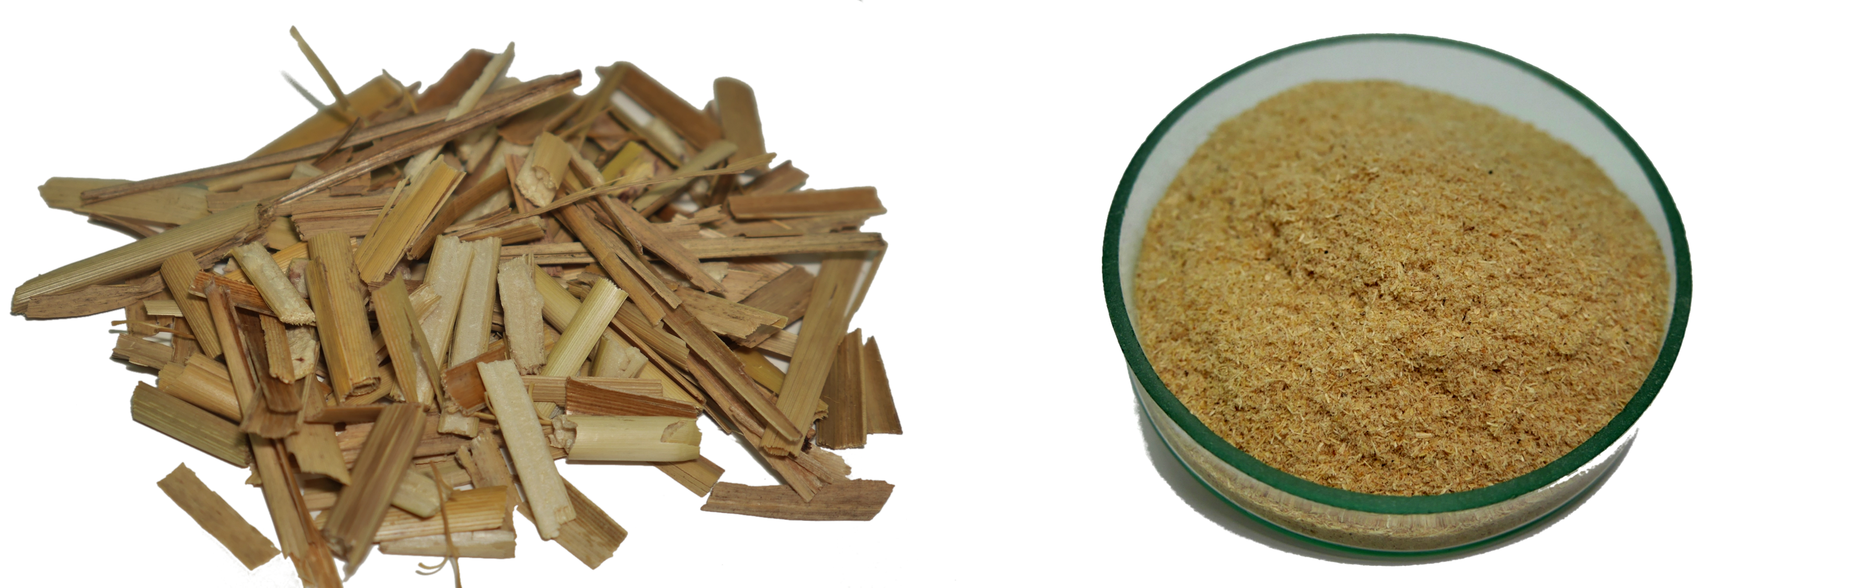
Figure 1. Raw wheat straw biomass (left) and biomass after preparation for laboratory analysis (right).

Prior to the pyrolysis test, the following properties were determined: ash content (Ash), volatile matter (VM), fixed carbon (FC), moisture content (Wª), carbon (C_{t}ª), hydrogen (H_{t}ª), oxygen (O_{t}ª), nitrogen (Nª), sulfur (S_{t}ª), and high heating value (HHV). Analyses were performed according to methods described elsewhere [33,40,41].
The samples were also subjected to ICP‒OES analysis to investigate how metal oxides and heavy metals change under different pyrolysis conditions. Wet chemical pressure digestion of the raw biomass material was required before elemental analysis by inductively coupled plasma spectrometry due to concerns about the loss of volatile components. In a Milestone Ethos One microwave digestion system (Srl, Italy), 0.3 g of sample and 10.2 cm³ of three separate acid solutions were placed in a Teflon vessel in the oven. The vessel was heated to 190 °C for 35 min three times, and each sample was digested three times; deionized water was used. Spectroscopic-grade nitric acid (65%), hydrofluoric acid (47–51%), and hydrogen peroxide (30%) were used (Sigma Aldrich). An iCAP 6500 Duo inductively coupled plasma optical emission spectrometer (Thermo Scientific, USA) was used to measure the As, Cd, Cu, Cr, Pb, Ni, and Zn contents. To calibrate the spectrometer, model solutions were prepared from single-element solutions with concentrations of 1,000 mg/dm³ provided by the SCP Science Company.

  - Pyrolysis-gas chromatography/mass spectrometry (Py-GC/MS)
Each sample was "dropped" into a Multi-Shot Pyrolyser EGA/PY-3030D for Py-GC/MS analysis (Frontier Laboratories Ltd, Fukushima Japan). The pyrolysis temperature was set to 500, 600, and 700 °C, while the GC oven temperature was increased at a rate of 5 °C per minute from 45 to 275 °C. The sample vapours created in the furnace were split (at a ratio of 1/50), a portion of it was transferred to a column at a flow rate of 1.91 mL/min and pressure of 27.3 kPa, and the remaining portion was vented. The vapours were separated using a Shimadzu QP-2010 Ultra Plus (Japan) gas chromatogram with a temperature-programmed capillary column and examined with a Shimadzu MS-QP2010SE mass spectrometer at 70 eV. A Phenomenex Zebron ZB-5 capillary column (consisting of a 5% diphenyl and 95% dimethylpolysiloxane stationary phase, a column length of 30 m, a column ID of 0.32 mm, and a thickness of 0.10 m) was used. The following settings were recommended for the mass spectrometer: ion source heater at 250 °C, interface temperature of 300 °C, vacuum at 10-5 Pa, m/z range of 45–300, and scan speed of 1428. Shimadzu (NIST17.0) postrun software was used to further evaluate the chromatograms and spectra obtained from each experiment.

  - Pyrolysis for biochar production
Three samples of various particle sizes, namely, 0.5–1, 1–2, and 2–3.15 mm, were subjected to pyrolysis under various temperatures between 500 and 700 °C, with steps of 100 °C. Pyrolysis tests were conducted at heating rates of 20, 25, and 30 °C/min and residence times of 5, 10, and 15 min using a TGA-701 LECO. In each pyrolysis test, a 1-g sample was placed in a ceramic crucible and pyrolysed in a nitrogen atmosphere. The 19 samples were prepared at the same time and analysed under the same pyrolysis conditions. The pyrolysis yields under varying conditions were calculated as the ratio between the mass of char obtained during pyrolysis and the mass of raw biomass using Equation (1):

$Y_{biochar}=\frac{m_{biochar}}{m_{raw_biomass}}∙100\%$,
where Y_{biochar} is the mass yield of biochar [%]; m_{biochar} is the mass of biochar [g]; and m_{raw_biomass} is the mass of raw biomass [g].

  - Fourier transform infrared spectroscopy (FTIR)
The raw biomass and the produced biochar samples were analysed via DRIFTS spectra on a Bruker Tensor 27 spectrometer equipped with a DTGS (deuterated triglycine sulfate) detector and an adaptor to enable diffuse reflectance measurements. After the samples were dried and ground to a particle size of less than 0.2 mm, 0.7 mg of sample and 300 mg of potassium bromide (KBr) powder were mixed and blended for 2–3 min in an agate mortar. In the first step, pure KBr was applied to measure the background at a resolution of 4 cm⁻¹, with 128 total scans at room temperature under a N₂ atmosphere. Subsequently, the prepared sample was placed in a diffuse reflectance sample cup (13 mm). Each sample was placed in a ceramic cup, and the surface was flattened with a spatula. Diffuse reflectance was analysed at a resolution of 4 cm⁻¹, with 128 total scans at room temperature under an N₂ atmosphere. Each sample was analysed in triplicate, and the results were averaged. The DRIFTS spectra were presented as Kubelka-Munk functions due to their direct proportionality to absorbance.
  - N₂ porosimetry
The porous structure of the biochar was characterized by nitrogen adsorption at 77 K. Prior to this analysis, the samples were outgassed under vacuum at 200 °C for at least 24 h to obtain a residual pressure below 50 mTorr; to record the adsorption isotherms, a 3-Flex instrument, Micromeritics, USA, was used. All samples were analysed in triplicate. The pore characteristics of the studied materials were analysed for three pore size ranges: micropores with pore sizes less than 2 nm, mesopores with pore diameters between 2 and 50 nm, and macropores with diameters larger than 50 nm. The following porosity and pore size distribution parameters were evaluated: volume and percentage ratio of micro, meso- and macropores, total volumes of pores, S_{BET} (Brunauer‒Emmett‒Teller (BET) equation), and pore size. The nitrogen adsorption and desorption isotherms were determined in the relative pressure range p/p_{o} = 0.01 to 0.96, allowing for the determination of micropore, mesopore, and total pore volumes. The specific pore area S_{BET} was determined from the Brunauer‒Emmett‒Teller (BET) equation. The total pore volume was calculated from Gurvitch's law based on the amount of adsorbed gas at a relative pressure p/po = 0.96 [42]. The average pore width (d_{avarage}) was determined using the following equation: d_{avarage} = 4VT/SBET [43].
  - Design of pyrolysis experiments and data analysis
The 2^{k} factorial designs were selected as the method of experimental design (DOE). The factorial designs required several experiments equal to 2^{k}, where k is the number of variables changed during the study. Each variable had two levels in these cases, coded as 1 and +1. The variables could be quantitative or qualitative; the detailed terms and conditions of the experiments are presented in Table 1. Four variables were used during this study: the thermal conversion temperature, biomass size studied, heating rate, and sample residence time at the final temperature. For this reason, the number of possible experiments was limited, and a 2⁴ factorial design was selected, requiring a total of 19 experiments (16 from 2^{k} and 3 in the centre).
Table 1. Experimental matrix of the 2⁴ factorial design with one central point.
Parameters/levels | Symbols
 | Coding  classical experimental design | X₁  pyrolysis temperature [ °C] | X₂  sample particle (grain) size [mm] | X₃  heating rate  [ °C/min] | X₄  residence time  [min]
Low | -1 | 500 | 0.5–1.0 | 20 | 5
High | +1 | 700 | 2.0–3.15 | 30 | 15
Centre | 0 | 600 | 1.0–2.0 | 25 | 10

The factorial design is suitable for estimating interactions among the studied variables. Consequently, with 16 experiments (with three repetitions following the surface morphology analysis), it was possible to estimate one constant term, four linear terms, six two-term interactions, and four quadratic term interactions. Mathematically, this model can be described by Equation (2):
Y = b₀ + b₁X₁ + b₂X₂ + b₃X₃ + b₄X₄ + b₁₂X₁X₂ + b₁₃X₁X₃ + b₁₄X₁X₄ + b₂₃X₂X₃ + b₂₄X₂X₄+ b₃₄X₃X₄ + b₁₁X₁² + b₂₂X₂² + b₃₃X₃² + b₄₄X₄²
All variable effects that could influence the studied biochar parameters were analysed using multivariate analysis of variance, more precisely, two-way ANOVA. This analysis is frequently used to assess the influences of several factors (independent variables) on one or more dependent variable(s); Equation (3) is as follows:
$y_{ijk}=μ+α_{i}+β_{j}+γ_{ij}+ε_{ijk}$,
where μ is the overall mean of the tested population, α_{i} and β_{j} are the main effects of individual factors, γ_{ij is} the interaction among factors, and ε_{ijk} is the experimental error.
This analysis assumes (as a null hypothesis) that all independent variable levels equally affect the trait being measured (the dependent variable). An alternative hypothesis assumes that at least one variable affects the trait more significantly than the others. For each independent variable, hypotheses were posed separately. Furthermore, the interaction between the independent variables can be understood as the combined effect (not decomposable into the separate factor effects α and β) of the two independent variables on the dependent variable (continuous) studied.
Within the developed experimental plan, optimization of the process using the data obtained consists of finding a local or global maximum for the parameter under study. The situation becomes more complex if, during optimization, several parameters that characterize the product need to be considered; in the discussed example, this is biochar. An additional complication occurs when the product or process parameters of interest are inversely proportional, that is, the minimum value for parameter x₁ is the desired feature, and for parameter x₂, the desired feature is its maximum value. In this case, a good solution is the use of the so-called “utility function” [44]. Several possible utility functions can be used, for example, linear utility, voiceover-IP utility, threshold utility, real-time, rate-adaptive, and stepwise functions [45]. This study focuses on the use of a linear utility function, which can be expressed with Equation (4) [46]:
$$f\left(d\left(g\right)\right)=\frac{\sum_{i=1}^{M}{w_{i}d_{i}}}{\sum_{i=1}^{M}{w_{i}}}$$
The overall utility function f(d(g) is a weighted average of the d individual utility functions, weighted by user-specified weights, w, where M is the number of response variables and w is the user-specified weight applied for determining the significance and sign of a given parameter, i.e., whether the value of the variable will be minimized or maximized during optimization.
- Results
  - Chemical analysis
Pyrolysis, as mentioned previously, is the thermal decomposition of organic fractions such as lignin, cellulose, and hemicellulose (in the case of biomass). The solid fraction is characterized by significantly higher values of the energy parameters, such as the high heating value (HHV). Table 2 shows the different parameters evaluated. The most valuable parameters from an energetic point of view are the concentrations of carbon and hydrogen, which are primarily responsible for the energy stored in the materials studied. Ash, oxygen and nitrogen are ballast in terms of energy.

Table 2. Proximate and ultimate analyses of the raw wheat straw biomass and the biochar obtained under various pyrolysis conditions.
Analysis | Ash | VM | FC | Wª | C_{t}ª | H_{t}ª | O_{t}ª | Nª | S_{t}ª | HHV
Unit | wt. % |  |  |  |  |  |  |  |  | MJ/kg
Straw biomass | 4.78 | 70.50 | 18.19 | 6.53 | 43.80 | 5.48 | 38.69 | 0.62 | 0.10 | 17.52
Straw biochar at 500 °C | 14.83 | 23.69 | 57.85 | 3.63 | 65.50 | 3.51 | 11.03 | 1.29 | 0.21 | 25.07
Straw biochar at 700 °C | 16.93 | 6.99 | 74.87 | 1.21 | 69.02 | 1.92 | 9.51 | 1.18 | 0.23 | 25.61

As seen in Table 2, as the pyrolysis temperature is increased, the degree of biomass conversion to biochar increases. As a result, the quantity of ash and carbon in the biochar increases, while the amount of volatile matter, which includes moisture in the biomass material as well as hydrogen, oxygen, and nitrogen, decreases. These results are consistent with those reported in other studies [47,48]. Pyrolysis at 500 °C increased the inorganic (mineral) fraction by more than 300% (over 350% at 700 °C) while decreasing volatile matter by 66 and 90 %_{m/m}, respectively. An increase in the carbon content and a decrease in the oxygen content of the biochar by 69.02% m/m and 9.51 %_{m/m}, respectively, resulted in 143 and 146% increases in the combustion heat values at 500 and 700 °C, respectively.
This trend was also reflected in the quantities of ash (Table 3) and trace elements (Table 4). The increased elemental content was due to thermal degradation of the biomass, which resulted in greater concentrations of compounds in the biochar. The ash content of the tested sample varied slightly between 0.8 and 1.2, depending on the analyser. Both the percentage and chemical composition of ash from biomass and the materials derived from it vary (often to a significant degree) depending on the type of biomass used. Biomass of agricultural origin, which includes wheat straw, is often characterized by a high ash content dominated by SiO₂. This is also the case in this study. In contrast to the chemical composition of oxides, the concentration of heavy metals is more dependent on the origin of the biomass and the purity of the soil on which the biomass grew and the surrounding environment. Some plants are hyperaccumulators and have a greater capacity to absorb specific elements from the environment, but wheat straw is not one of them.

Table 3. Ash composition of raw wheat straw biomass and biochar obtained under various thermal pyrolysis conditions.
Analysis | Straw biomass | Straw biochar at 500 °C | Straw biochar at 700 °C
 | % m/m (ash)
P₂O₅ | 3.2 | 2.9 | 4.3
SiO₂ | 58.0 | 52.1 | 54.2
TiO₂ | 0.10 | 0.10 | 0.12
Mn₃O₄ | 0.60 | 0.79 | 0.79
BaO | 0.05 | 0.07 | 0.05
Na₂O | 0.20 | 0.28 | 0.26
MgO | 3.7 | 3.8 | 4.0
SrO | 0.05 | 0.07 | 0.07
CaO | 8.6 | 9.9 | 7.8
Al₂O₃ | 1.1 | 1.2 | 1.0
Fe₂O₃ | 0.60 | 0.55 | 0.83
SO₂ | 2.3 | 2.4 | 3.2
K₂O | 11.1 | 15.4 | 12.9
The concentration of trace elements changed by 2.05 to 2.88 times for straw biochar obtained at 500 °C and 2.09 to 2.76 times for straw biochar obtained at 700 °C.
Table 4. Trace element composition of raw wheat straw biomass and biochar obtained under various thermal pyrolysis conditions.
Analysis | Straw biomass | Straw biochar at 500 °C | Straw biochar at 700 °C
 | mg/kg (dry)
Mercury (Hg) | 0.004 | 0.011 | 0.011
Vanadium (V) | 0.524 | 1.291 | 1.336
Lead (Pb) | 0.653 | 1.448 | 1.409
Nickel (Ni) | 0.910 | 1.974 | 2.063
Molybdenum (Mo) | 0.278 | 0.793 | 0.590
Coper (Cu) | 3.00 | 6.667 | 7.693
Manganese (Mn) | 58.200 | 125.877 | 139.654
Cobalt (Co) | 0.259 | 0.543 | 0.679
Cadmium (Cd) | 0.962 | 2.610 | 2.441
Zinc (Zn) | 5.635 | 15.059 | 14.156
Chromium (Cr) | 1.805 | 4.963 | 4.891
Arsenic (As) | 0.174 | 0.477 | 0.401
Antimuonium (Sb) | 0.036 | 0.081 | 0.088
In this study, Py-GC/MS analysis of the examined straw biomass was performed at the same temperature range assumed in the DOE. As shown in Fig. 2, raising the pyrolysis temperature caused changes in the qualitative and quantitative composition of the volatile matter. Table 5 shows the most distinctive components detected after pyrolysis at various temperatures.
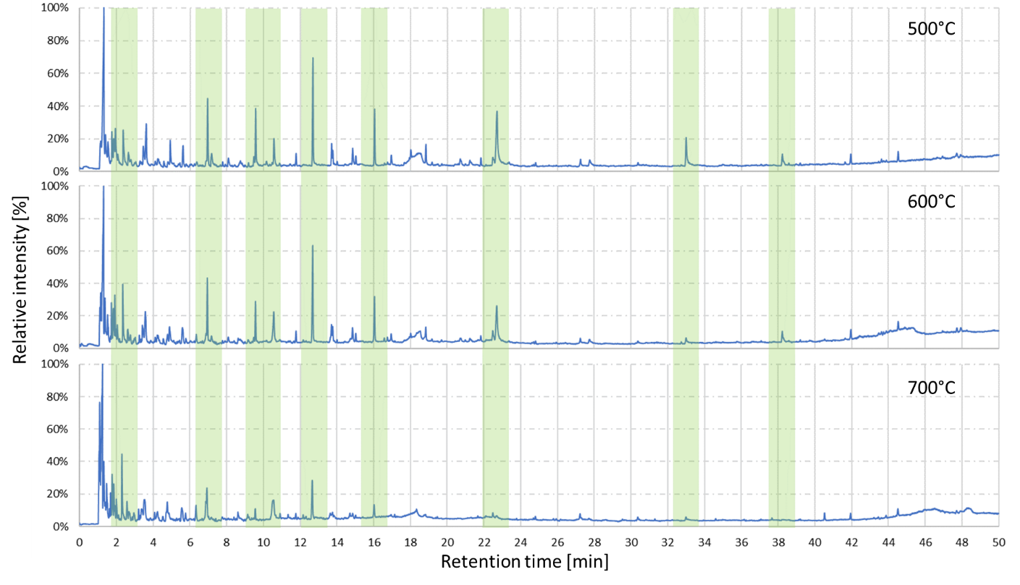
Figure 2. Pyrograms of the straw biomass obtained at 500, 600 and 700 °C.

The number of chemical compounds detected and their concentrations (as a percentage of the total area) varied with pyrolysis temperature. The most significant increases were detected in 2-methyl-3-buten-1-ol and 2,3-dihydrobenzofuran, which increased from 3.7% (600 °C) to 7.4% (700 °C) and from 2.4% (500 °C) to 4.8% (700 °C), respectively. At the same time, creosol and isoeugenol showed the greatest declines, falling from 3.8% (500 °C) to 0.8% (700 °C) and from 3.8% (500 °C) to 1.1% (700 °C), respectively. All of these factors are closely related to the thermal decomposition of biomass building blocks such as cellulose, hemicellulose and lignin. Similar results have been reported in other studies [49]. The raw data were published in the repository [50].
In addition to proximate and ultimate studies, FTIR was used to examine the raw wheat straw biomass and biochar samples generated under various pyrolysis settings. Table 6 shows the adsorption bands that correspond to the chemical groups identified in the raw wheat straw biomass and biochar generated by pyrolysis at 500 and 700 °C. Comparisons of different pyrolysis temperatures for the wheat straw biomass (Fig. 3) revealed that the alcoholic, phenolic, and H-bonded hydroxyl groups (wavenumbers 3200-3700 cm⁻¹) demonstrated greater resistance to degradation at increasing temperatures than the CH₃ and CH₂ groups (symmetric and asymmetric stretch) between wavenumbers 2840 and 2960 cm⁻¹.
Table 5. Trace element composition of raw wheat straw biomass and biochar obtained under various thermal pyrolysis conditions.
Retention time [min] | Name | Area [%]
 |  | 500 °C | 600 °C | 700 °C
1.1 | 2-Methyl-3-buten-1-ol | - | 3.7 | 7.4
1.3 | 1,2-Dimethylhydrazine | 18.8 | 16.5 | 18.2
1.7 | 1-Penten-3-one | - | 3.2 | 3.4
1.9 | Propanal | 3.5 | - | -
2.4 | Furfural | 3.0 | 5.0 | 5.6
2.7 | p-Xylene | - | - | 1.4
3.0 | Styrene | - | - | 1.5
3.4 | 5-(Hydroxymethyl)furfural | 1.8 | 2.1 | 2.2
4.8 | Phenol | - | 1.1 | 3.1
7.0 | Phenol, 2-methoxy- | 4.3 | 5.3 | 4.3
9.6 | Creosol | 3.8 | 2.4 | 0.7
10.5 | 2,3-Dihydrobenzofuran | 2.4 | 3.9 | 4.8
12.7 | p-Vinylguaiacol | 7.4 | 7.4 | 3.7
13.8 | Eugenol | 1.0 | 1.2 | 0.9
14.9 | Vanillin | 1.5 | 1.0 | -
16.0 | Isoeugenol | 3.8 | 3.4 | 1.1
22.7 | Coniferyl aldehyde | 7.9 | 1.1 | -
- not detected

Furthermore, aromatic C, aliphatic CH₃, and CH₂ groups associated with lignin
(1400-1500 cm⁻¹) proved to be more robust than aromatic components connected with aldehydes and ketones (wavenumber 1600-1700 cm⁻¹). An increase in temperature to 700 °C resulted in a significant drop in the concentration of functional groups, particularly in the alcoholic, phenolic, and H-bonded hydroxyl groups, as well as for CH₃ and CH₂ groups, leading to condensed aromatic structures [51], similar to results from another study that investigated differences among various biomass samples via FTIR spectroscopy for pyrolysis temperatures ranging from 100 to 700 °C. Moreover, because progressive pyrolysis causes carbonate structures to become more aromatic, the absorbance band corresponding to the vibration of aromatic rings (1580 cm⁻¹) grew substantially.
Table 6. Absorption band – chemical groups observed in the tested materials.
IR frequency, cm⁻¹ (±10 cm⁻¹) | Characteristic vibrations and functionality
3420 | O–H stretching of H-bonded hydroxyl groups
2840–2960 | CH₃, CH₂ symmetric and asymmetric stretch
1735 | C=O stretch, aldehyde, ketone, carboxylic acids
1580, 1510 | Aromatic, stretch
1435 | Combination of CH₂ scissoring and asymmetric CH₃ stretching
1225 | C-O-C asymmetric
1158 | Skeletal vibration involving CH₃ branch of propylene
1080 | Ring vibration
880 | Isolated hydrogen
815 | 2 adjacent hydrogens
780 | 3 adjacent hydrogens
750 | 5 adjacent hydrogens
730 | Ring vibrations

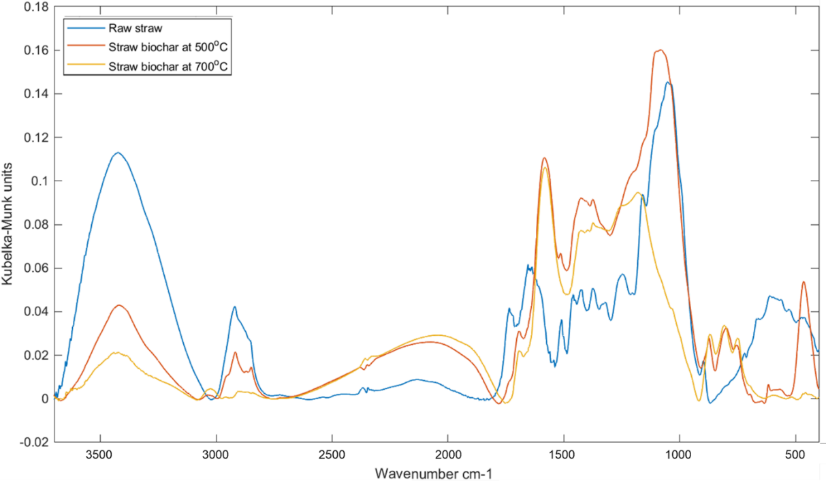
Figure 3. FTIR spectra of raw wheat straw biomass and biochar obtained via pyrolysis at 500 and 700 °C.
The nitrogen adsorption and desorption isotherms of the biochar samples processed at 700 °C with various temperature increments and residence times are shown in Fig. 4. We found growth in the curves for increasing relative pressures from 0.01 to 0.96, and these may be categorized as type II isotherms with hysteresis loops, which are typical of adsorbents that are categorized as microporous according to UPAC classifications. In most cases, the microporous characteristics of the biochars produced were validated by the data that showed a larger proportion for the microporous fraction, as shown in Fig. 5. By converting the quantity of adsorbed nitrogen at p/p₀ = 0.01 per liquid volume of adsorbate, the volume of the micropores was estimated. At p/p₀ = 0.96, the volume of mesopores was calculated by subtracting the volume of micropores from the quantity of adsorbate adsorbed (which reflects the volume of micro- and mesopores). The total pore volume was calculated using the quantity of adsorbed nitrogen at 0.99 relative pressure. The surface area of each carbon was calculated using the standard BET equation and a multilayer adsorption model. Because of the predominance of micropores in the biochars, the surface area was measured using a Rouquerol BET diagram in accordance with ISO 9277:2010. Depending on the preparation parameters, the biochars presented as examples (Fig. 6) had underdeveloped specific surface areas at lower temperatures (e.g., 500 °C), with a surface area of 50-100 m²/g; for higher temperatures (e.g., 700 °C), a specific surface area of approximately 400 m²/g was observed. Fig. 6 shows the best parameters for generating biochar for absorbent applications: 700 °C, 20 °C/min heating rate, and 5 min residence time. The highest temperature and most rapid heating rate, as well as the associated amount of volatile substances given off during the degradation of the biomass material, cause microcracks that remain in the final material as pores of varying sizes. Their size can depend on many factors, ranging from process variables to the characteristic properties of the biomass material or the type of biomass.

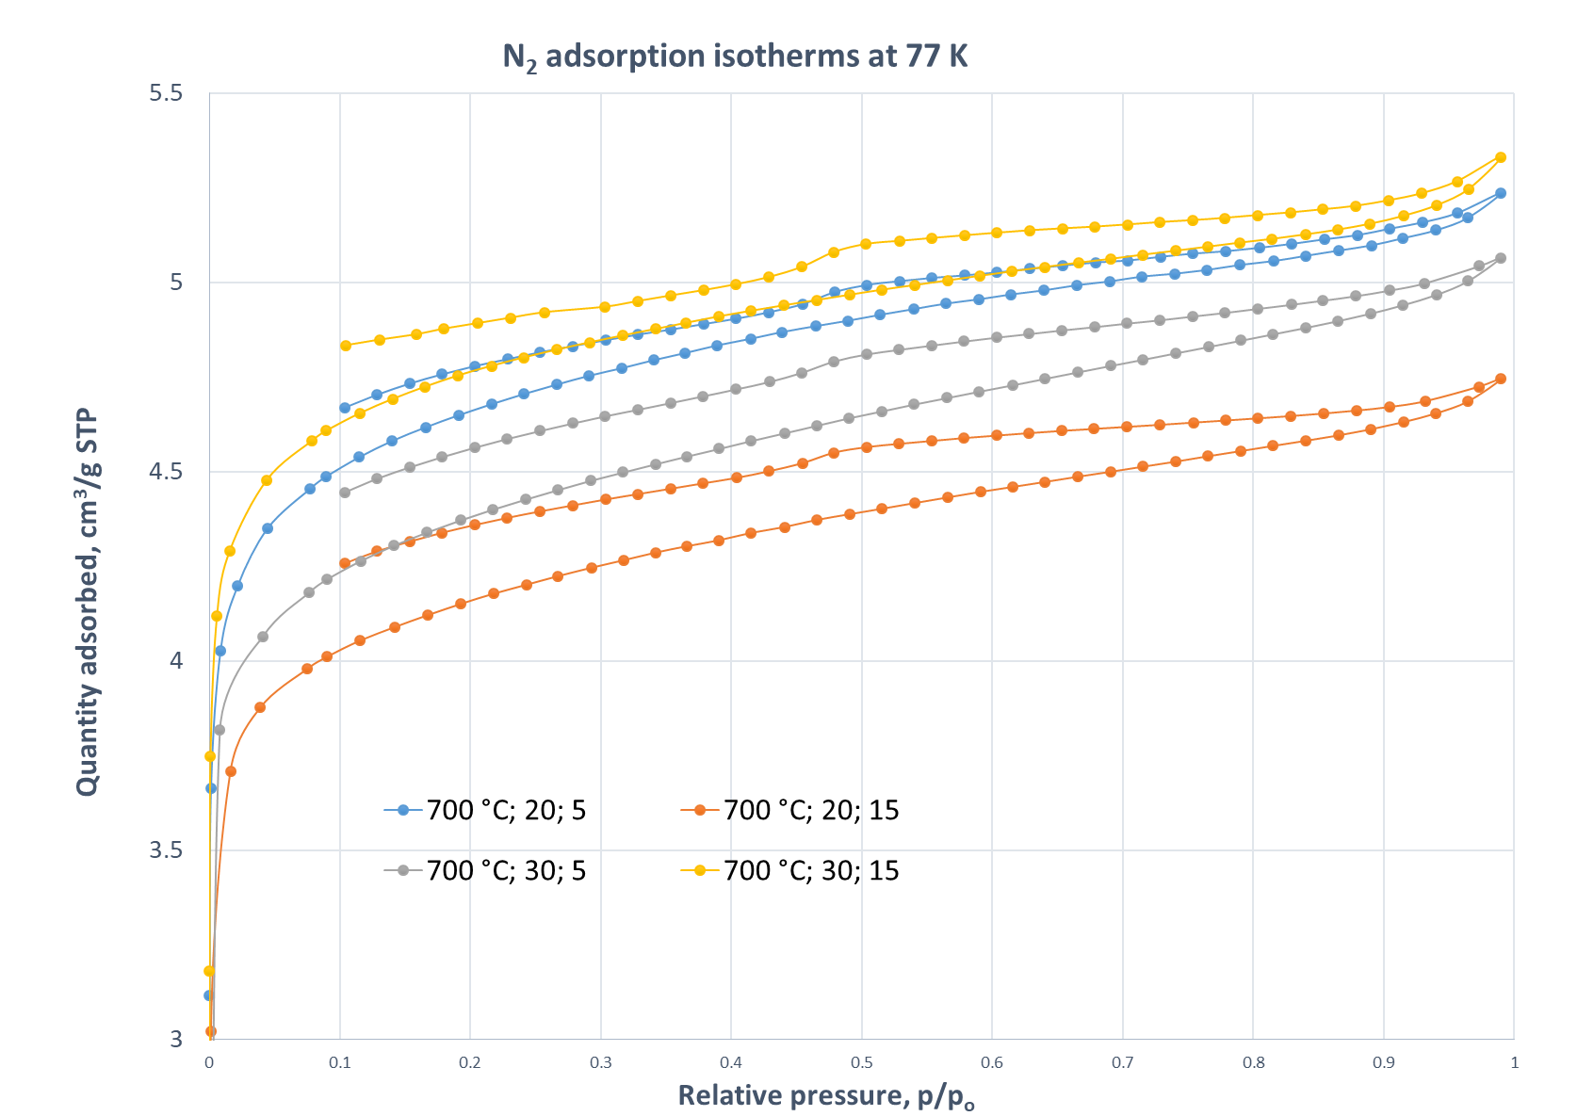
Figure 4. Isotherms of adsorption and desorption of N₂ at 77 K for some biochar samples.

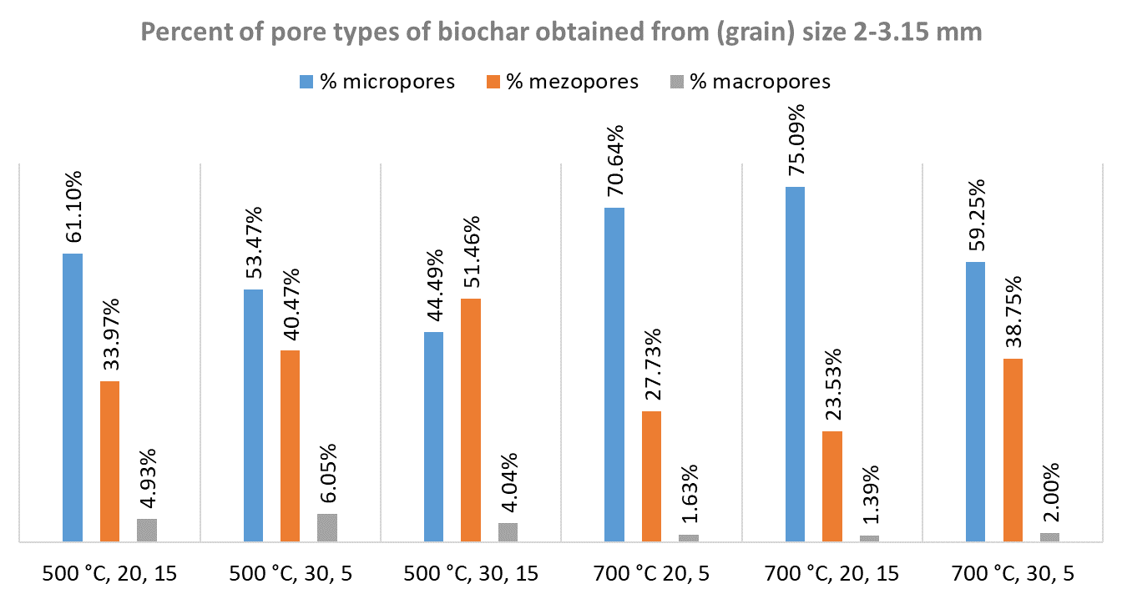
Figure 5. Percentage distribution of pores divided into micro, meso-, and macropores for selected biochar samples.
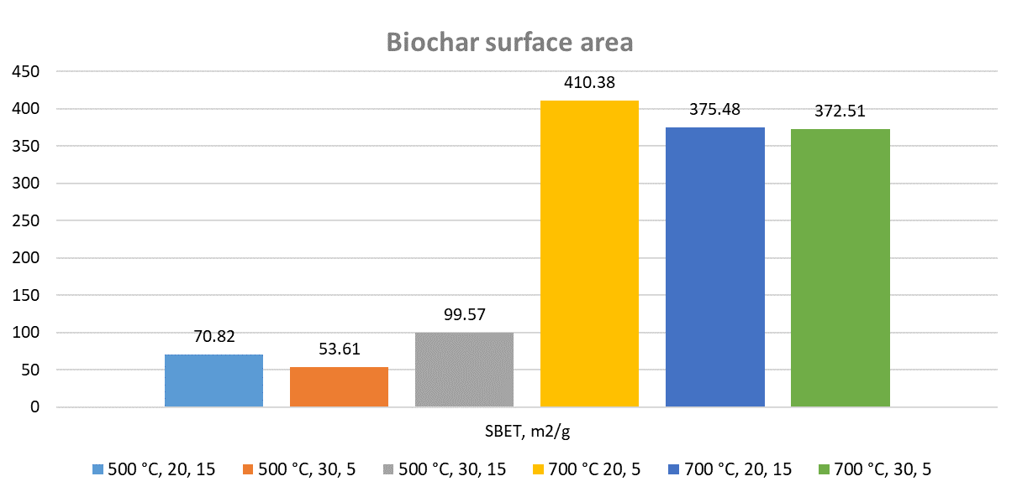
Figure 6. Specific surface areas of selected biochar samples.
The data collected enabled studies to be performed to establish the evaluated variables that had the most statistically significant impact on the obtained results.
  - Data analysis
As mentioned previously, the main objective of this study was to determine the interrelationships among selected pyrolysis parameters, such as pyrolysis temperature (T), heating rate (HR), residence time (RT), material grain size (G), and their interactions, which have a statistically significant effect on the surface morphology of biochar and its yield. The first two variables were chosen because they are most commonly studied in the academic literature. The third variable, residence time, is also studied in terms of its impact on the properties of biochars, although usually as a secondary variable after temperature, and only rarely in conjunction with the two previously mentioned. The fourth variable was chosen due to its impact on, among other things, the energy intensity of the comminution process and the time consumption of the fraction separation process, and hence on the overall cost-effectiveness of the pyrolysis process. For this, ANOVA was applied. We noted a statistically significant effect for almost all variables studied, except for the volume of macropores (Fig. 7). This may be related to the fact that macropores are pores whose size exceeds 50 nm, and their formation is dependent not only on the thermal conversion conditions but also on the micro- and mesopores formed during the process. Micro- (≤2 nm) and mesopores (2–50 nm) [52] are more influenced by parameters such as the following:
- the pyrolysis temperature, in which an increase in temperature corresponds to an increase in the amount of organic matter degraded and thus the emission of volatile compounds, which form a porous layer by penetrating the structure of the formed biochar,
- the heating rate, which influences the release dynamics of volatile components and thus the total pore volume and mesopore volume,
- the residence time, which influences pore formation and can affect both total pore volume and mesopore volume, as well as average pore size,
- the degree of biomass fineness, which has an impact on pore size when analysing the porosity of biomass carbonates.

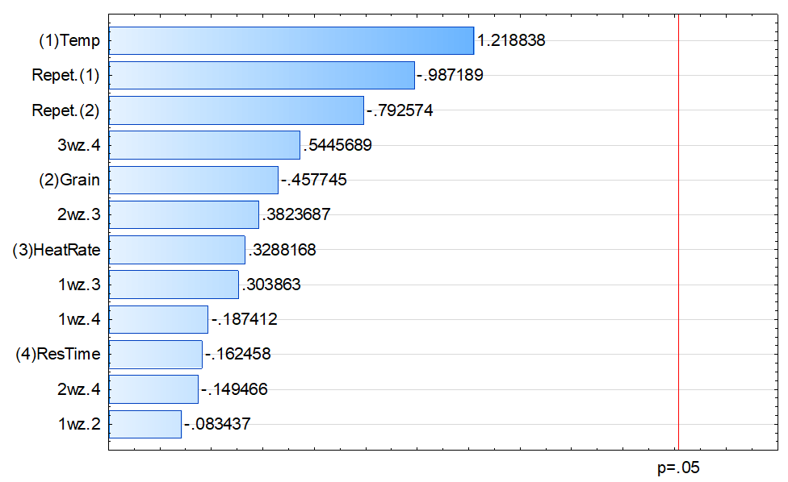
Figure 7. Pareto chart showing the effects of process conditions on macropore volume (V_{macro}) in wheat straw biochar.
Only pyrolysis temperature had a significant impact on the sum of the volumes of micro- and mesopores (Σ_{Vmicro+Vmacro}), volume of micropores (V_{micro}), BET surface area (S_{BET}), and percentage of macropores (%_{macro}) (Fig. 8). For the other cases, the values of the analysed dependent variables affected more than two process parameters.
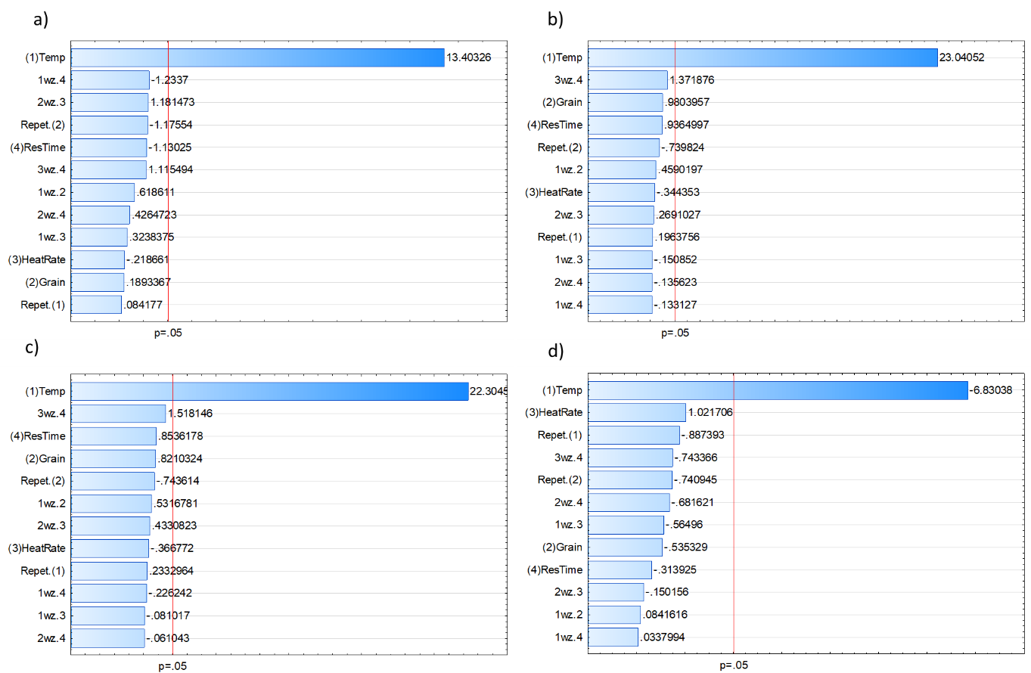
Figure 8. Pareto diagrams showing the effects of process conditions on (a) the sum of the volumes of micro- and mesopores (Σ_{Vmicro+Vmacro}), (b) volume of micropores (V_{micro}), (c) BET surface area (S_{BET}), and (d) percentage of macropores (%_{macro}) in the obtained wheat straw biochar.
For biochar yield, pyrolysis temperature (T) and heating rate (HR) had a statistically significant effect, whereas for mesopore volume, we observed a statistically significant effect of temperature (T) and interactions between heating rate (HR) and residence time (RT) (Fig. 9a, b). Similar results were observed for the total pore volume (t_{Vpores}) (Fig. 9c). For the ratio of mesopore volume to total pore volume (V_{mes}/V_{t}), four variables had statistically significant effects, namely, pyrolysis temperature (T), grain size (G), residence time (RT), and interactions between grain size and heating rate. However, the interaction effect was not statistically significant, with a p value of 0.051 and a cut-off value of 0.050 (Fig. 10). A similar result was observed for micro- and macropore percentages, which were mainly influenced by temperature (T), grain size (G), and residence time (RT) (Fig. 10b, c).
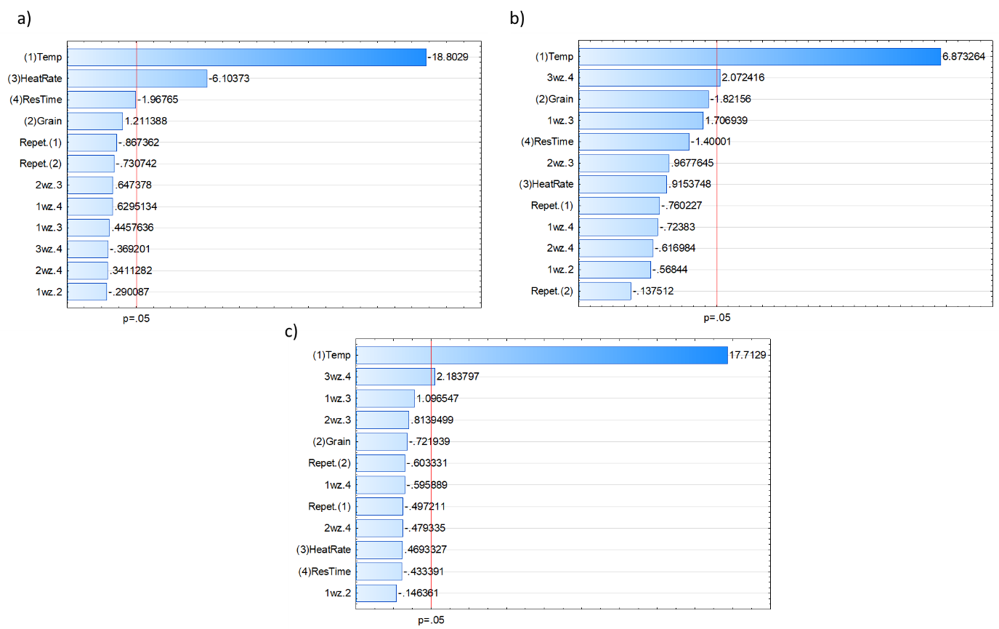
Figure 9. Pareto diagrams showing the effects of process conditions on (a) biochar yield, (b) mesopore volume (V_{meso}), and (c) total pore volume (t_{Vpores}) of wheat straw biochar.

The main influences of pyrolysis temperature and heating rate on the quality parameters of the obtained biochars can be related to the biochemical composition of the wheat straw biomass used for the study. This biomass was characterized by a fairly homogeneous content of both cellulose and hemicellulose, which was confirmed by thermogravimetric data [33]. The fairly uniform quantitative distribution of both cellulose and hemicellulose results in their thermal distribution being concentrated in the pyrolysis temperature range of 250-350 °C. This reduces the influence of variables such as the heating rate (due to the narrow temperature range for the main pyrolysis step of the biomass under investigation) and the holding time at the final set temperature (due to the absence or small amount of further transformations that could take place in the obtained biochar).
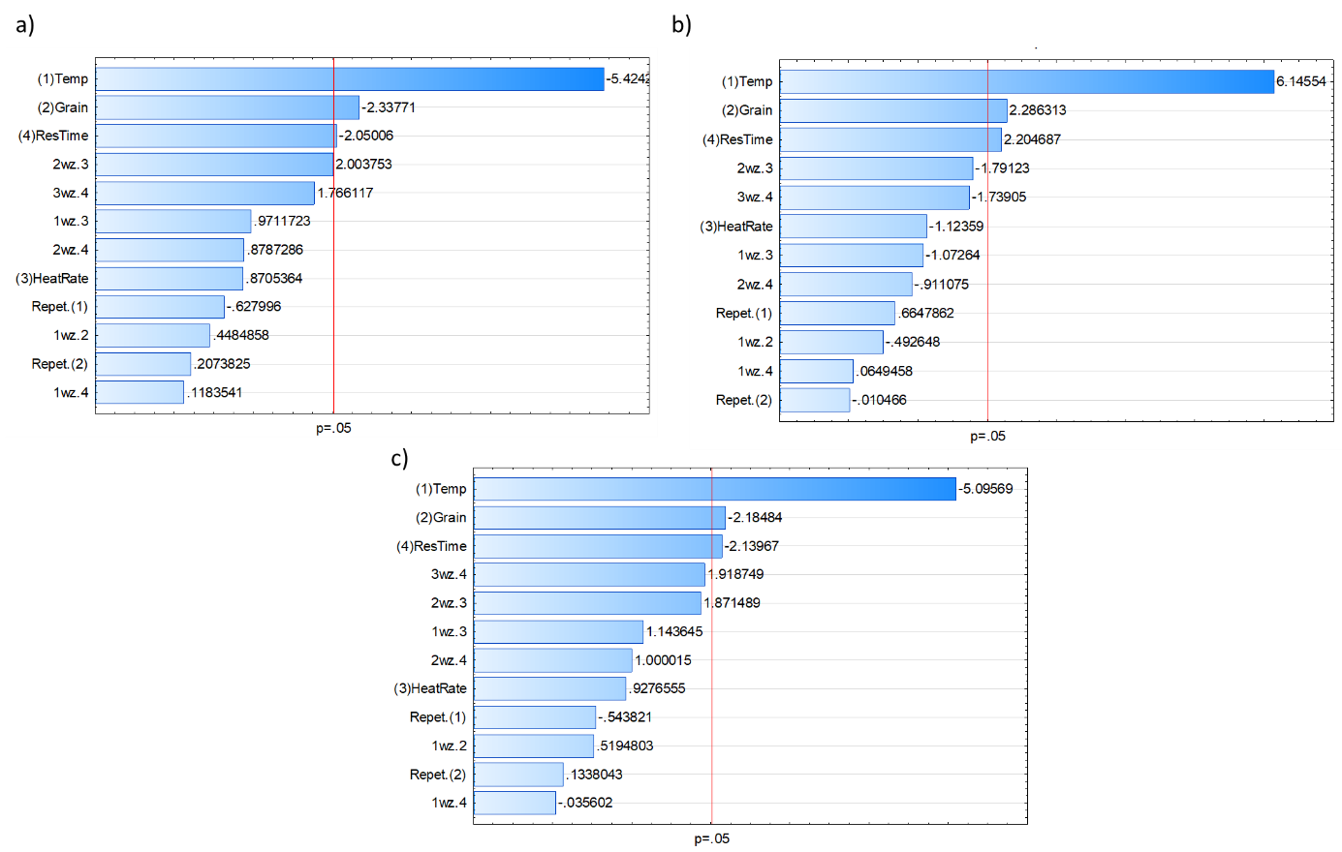
Figure 10. Pareto diagrams showing the effects of process conditions on the (a) ratio of the volume of mesopores and total pores (V_{mes}/V_{t}) and the percentage of micro(b) and mesopores (c) in wheat straw biochar.
For the average pore diameter (D), we observed significant interactive effects between grain size and the heating rate and between the heating rate and holding time (Fig. 11).
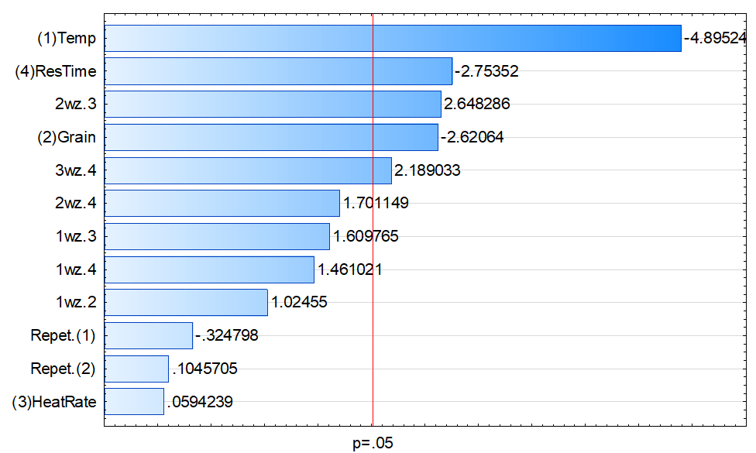
Figure 11. Pareto graph showing the effects of process conditions on the average pore diameter (D) in the obtained wheat straw biochar.
An important result of the present study is the positive effect of the interaction of two variables, namely, the heating rate and the residence time of a sample at a given final pyrolysis temperature. This interaction may, in many cases, allow one to increase the following quality parameters of the obtained biochar by preparing a suspension:
- mesopore volume (V_{meso}),
- total pore volume (t_{Vpores}),
- average pore diameter (D).

  - Optimization
Although straw is not ideal for the preparation of biochar with high surface areas, by optimizing the pyrolysis process, satisfactory results can be obtained. Generally, depending on the type of material and the temperature conditions, the surface area of S_{BET} varies from 26.3 [53] to 280 cm² [54]. After activation, an S_{BET} value of 246 cm² was obtained using steam at 800 °C, and an S_{BET} value 490 cm² was obtained using CO₂ at 700 °C. Other researchers also obtained similar S_{BET} values [55–57] and reported similar S_{BET} values for biochar obtained from catalytic pyrolysis and after activation [58,59]. Another investigation [60] that utilized palm kernel shell (PKS) wastes treated with microwave pyrolysis yielded an S_{BET} value that was 140 m²/g greater than the optimum value obtained in the current study, although the biomass material used was notably different from straw.
Optimal biochar parameters could be obtained by optimizing the pyrolysis conditions and biomass fragmentation using appropriate fractions. Figures 12 and 13 present the so-called “surfaces of the utility function”, which, as mentioned earlier, is a function that defines the total utility of all parameters that are significant from the optimization point of view. To put it another way, the ideal solution must be the greatest ballpark value for each parameter that was tried. It is common practice to anticipate the highest possible (maximum) values for some of the parameters being tested while simultaneously desiring the lowest possible (minimum) values for other parameters. The outcomes of the studies that were conducted on the sorption properties of the carbonates that were investigated and were utilised for the DOE analysis were shared in the repository [61].
In Figures 12 and 13, the contours correspond to the percentage of coverage of all conditions assumed in the optimization. The first assumption was to maximize all studied variables listed in Table 6, and the second assumption was to maximize all studied variables except biochar yield. The local maximum of the response surface plot in the presented figure was approximately at a 0.50 level, which means that approximately 50% of the studied variables obtained maximum values at a specific point corresponding to a specific process condition.
Figure 12. Response surface plotted against the utility function assuming maximum biochar yield.

Figure 13. Response surface plotted against the utility function assuming maximization of all parameters except biochar yield and percentage and volume of macropores.
Figures S.1 and S.2 in the supplemental materials illustrate the two optimization strategies presented in this study for the response surface method. The first approach maximises all of the investigated carbonate quality parameters (S.1). In the second case, all of the quality parameters of the biochar are maximized, except for the biochar production yield and the percentage and volume of macropores (S.2). This approach was selected to show under what conditions it is possible to obtain a biochar with the highest possible BET surface area and the greatest number of micro- and mesopores. The algorithm optimises the conditions by taking into account the observed and assumed boundary conditions, which are the utility functions for the individual quality parameters tested.
Whenever optimization is performed, the response function takes into consideration which parameters should have the highest possible values and which should have the lowest possible values. This method makes it possible to select process conditions, e.g., those corresponding to the maximization of all analysed parameters (Fig. 12), which yield biochar with an S_{BET} surface area of 325.20 cm². However, if we maximise all parameters except biochar yield and percentage and volume of macropores (Fig. 13; from 25.313% to 24.513%), we can obtain an increase in surface area of more than 24% to approximately 400 cm².
In the present study, the highest S_{BET} surface area of 400 cm² (Table 7) was obtained at a pyrolysis temperature of 700 °C, a grain size of 0.5–1.0 mm, a heating rate of 20 °C/min, and a residence time of 5 min without activation; thus, we obtained a slightly lower S_{BET} surface area than those reported in studies with CO₂ activation. The optimum conditions obtained at 650 °C were calculated by estimating the response surface function based on data measured at 600 and 700 °C. However, it should be noted that these values were calculated and not validated by additional pyrolysis conducted under controlled conditions.

Table 7. Optimal pyrolysis conditions calculated by assuming maximum and minimum biochar yields.
 | Unit | Optimal pyrolysis conditions with the assumption of maximization of biochar yield and char properties |  | Optimal pyrolysis conditions with the assumption of minimization of biochar yield and maximization of char properties
Y_{char} | [%] | Temperature – 650 °C  Grain size – 0.5–1.0 mm  Heating rate – 20 °C/min  Residence time – 5 min | 25.313 | Temperature – 700 °C  Grain size – 0.5–1.0 mm  Heating rate – 20 °C/min  Residence time – 5 min | 24.513
Σ_{Vmicro+Vmacro} | [cm³/g] |  | 0.178 |  | 0.212
V_{micro} |  |  | 0.109 |  | 0.136
V_{meso} |  |  | 0.064 |  | 0.073
V_{macro} |  |  | 0.004 |  | 0.004
V_{t} |  |  | 0.177 |  | 0.213
V_{mes}/V_{t} | - |  | 0.438 |  | 0.386
S_{BET} | [m²/g] |  | 325.20 |  | 400.00
D | [Å] |  | 2.562 |  | 2.336
%_{micro} | [%] |  | 0.556 |  | 0.609
%_{meso} |  |  | 0.421 |  | 0.375
%_{macro} |  |  | 0.023 |  | 0.016

In addition to knowing the optimum pyrolysis process conditions to obtain biochar with the highest surface area before activation, it is possible to determine which variables influence this process and how. Temperature had the most significant influence on the parameters studied. However, the effect was not always positive. Setting aside efficiency considerations for preparing biochars (this parameter will always be inversely correlated with temperature), temperature had a negative effect on parameters such as macropore percentage (% macro), the ratio of the volumes of mesopores and total pores (V_{mes}/V_{t}), mesopore percentage (%_{meso}), and average pore diameter (D). The values of these parameters decrease with increasing pyrolysis temperature. A similar negative effect was exerted by the heating rate and the residence time at a given temperature on the ratio of the volumes of mesopores and total pores (V_{mes}/V_{t}), mesopore percentage (%_{meso}), and average pore diameter (D). The average pore diameter was also influenced by the fraction used. Although the heating rate or residence time alone and the fraction size, in the case of average pore diameter, had a negative impact on the parameters characterizing the cathode, the interaction between them in the case of average pore diameter had a positive effect, which may offset the effects of the individual variables. For example, for the average pore diameter, the effect of fraction size was estimated to be 2.62, and the effect of the interaction of fraction size and heating rate was estimated to be 2.65. Moreover, for micropore volume (V_{micro}) and total pore volume (t_{Vpores}), there was a positive interaction between variables that did not have significant influences, such as the heating rate and holding time at a given temperature.
This technique can be applied to a wide range of thermal conversion processes for biomass, wastes, and their mixes. It may also be used to generate biomass biochars with specifications required for various purposes, e.g., for the introduction of elements to allow for CO₂ sequestration in soils and for the binding of noxious emissions. Other process variables that can be analysed in this manner include the strength of the microwave source used during microwave pyrolysis or microwave-assisted torrefaction (where process parameters affect the properties of, for example, the solid and liquid products), [62,63], the pressure or vacuum, [64], the type and amount of hydroxides used as an additive to develop the surface, and the composition of the biomass itself.

- Conclusions
To verify the research questions posed in the first stage of this study, pyrolysis was performed on wheat straw biomass with three particle sizes (0.5–1.0, 2.0–3.15, 1.0–2.0 mm). Various pyrolysis tests were conducted in a nitrogen environment at temperatures between 500 and 700 °C, heating rates between 20 and 30 °C/min, and residence periods between 5 and 15 minutes. The application of the design of experiments (DOE) and analysis of variance (ANOVA) allowed us to examine the impact of four process variables and their interactions on the properties of biochars generated from the pyrolysis of low-quality biomass such as straw. These experiments and analyses were performed in accordance with the objectives of the study. This work examined the influence of interactions between the principal process variables of biomass pyrolysis and the variables themselves. In contrast to what was previously believed, the effects of process conditions on the examined biochar variables related to surface growth were minor. The impacts varied based on the investigated parameter and were characterized by nonlinearity, which could be important information for the development of acceptable surface features in such materials.
Data analysis clarified which process variables and their probable interactions have a statistically significant impact on biochar quality criteria. These interactions consist of the following:
- interactions between the heating rate (HR) and residence time (RT), which impact the mesopore volume (V_{meso}) and total pore volume (t_{Vpores}) of wheat straw biochar
- interactions between grain size (G) and heating rate (HR), which impact the ratio of the volume of mesopores to total pores (V_{mes}/V_{t})
- interactions between the heating rate (HR) and residence time (RT) and between the grain size (G) and heating rate (HR), which impact the average pore diameter (D).
The research that was carried out demonstrated that it is feasible to produce quite satisfactory results even when employing low-quality agricultural biomass (straw), as was the case in the reported example, provided that careful preparation of experimental settings is carried out. The best results for the sorption characteristics of biochars are obtained at 650 °C and 700 °C, assuming maximisation of the amount of biochar or its minimisation, depending on the assumed objectives, and maximisation of the sorption parameters of the biochars. The remaining pyrolysis parameters were the same for both temperatures: grain size 0.5-1.0 mm; heating rate 20 °C/min; residence time 5 min. Depending on the requirements for biochar, our outcomes can be used to design biochar for specific applications, even from biomass of low quality.

Acknowledgements
This research was supported by the Faculty of Energy and Environmental Engineering, Silesian University of Technology (statutory research), Poland, and BRISK2, which has received funding from Horizon 2020’s Research and Innovation Programme under grant agreement number 731101.

References
[1] Kan T, Strezov V, Evans TJ. Lignocellulosic biomass pyrolysis: A review of product properties and effects of pyrolysis parameters. Renewable and Sustainable Energy Reviews 2016;57:1126–40. https://doi.org/10.1016/J.RSER.2015.12.185.
[2] Leng L, Huang H. An overview of the effect of pyrolysis process parameters on biochar stability. Bioresour Technol 2018;270:627–42. https://doi.org/10.1016/J.BIORTECH.2018.09.030.
[3] Ma J, Kong W, Di W, Zhang Z, Wang Z, Feng S, et al. Synergistic effect of bulking agents and biodegradation on the pyrolysis of biodried products derived from municipal organic wastes: Product distribution and biochar physicochemical characteristics. Energy 2022;248:123512. https://doi.org/10.1016/J.ENERGY.2022.123512.
[4] Johannes Lehmann SJ. Biochar for Environmental Management. 2nd Editio. Routledge; 2015. https://doi.org/10.4324/9780203762264.
[5] Phan AN, Ryu C, Sharifi VN, Swithenbank J. Characterisation of slow pyrolysis products from segregated wastes for energy production. J Anal Appl Pyrolysis 2008;81:65–71. https://doi.org/10.1016/J.JAAP.2007.09.001.
[6] Goyal HB, Seal D, Saxena RC. Bio-fuels from thermochemical conversion of renewable resources: A review. Renewable and Sustainable Energy Reviews 2008;12:504–17. https://doi.org/10.1016/J.RSER.2006.07.014.
[7] Poskart A, Skrzyniarz M, Sajdak M, Zajemska M, Skibiński A. Management of Lignocellulosic Waste towards Energy Recovery by Pyrolysis in the Framework of Circular Economy Strategy. Energies 2021, Vol 14, Page 5864 2021;14:5864. https://doi.org/10.3390/EN14185864.
[8] Ong HC, Chen WH, Singh Y, Gan YY, Chen CY, Show PL. A state-of-the-art review on thermochemical conversion of biomass for biofuel production: A TG-FTIR approach. Energy Convers Manag 2020;209:112634. https://doi.org/10.1016/J.ENCONMAN.2020.112634.
[9] Kan T, Strezov V, Evans TJ. Lignocellulosic biomass pyrolysis: A review of product properties and effects of pyrolysis parameters. Renewable and Sustainable Energy Reviews 2016;57:1126–40. https://doi.org/10.1016/J.RSER.2015.12.185.
[10] Sajdak MM. Optimization frameworks in resource management and process engineering. Plastics to Energy: Fuel, Chemicals, and Sustainability Implications, Elsevier; 2018, p. 425–42. https://doi.org/10.1016/B978-0-12-813140-4.00017-0.
[11] Gałko G, Rejdak M, Tercki D, Bogacka M, Sajdak M. Evaluation of the applicability of polymeric materials to BTEX and fine product transformation by catalytic and non-catalytic pyrolysis as a part of the closed loop material economy. J Anal Appl Pyrolysis 2021;154. https://doi.org/10.1016/j.jaap.2021.105017.
[12] Basu P. Pyrolysis. Biomass Gasification, Pyrolysis and Torrefaction 2013:147–76. https://doi.org/10.1016/B978-0-12-396488-5.00005-8.
[13] Bridgwater A. Fast pyrolysis of biomass for the production of liquids. Biomass Combustion Science, Technology and Engineering 2013:130–71. https://doi.org/10.1533/9780857097439.2.130.
[14] Pattiya A. Fast pyrolysis. Direct Thermochemical Liquefaction for Energy Applications 2018:3–28. https://doi.org/10.1016/B978-0-08-101029-7.00001-1.
[15] Liu Z, Hughes M, Tong Y, Zhou J, Kreutter W, Lopez HC, et al. Paper mill sludge biochar to enhance energy recovery from pyrolysis: A comprehensive evaluation and comparison. Energy 2022;239:121925. https://doi.org/10.1016/J.ENERGY.2021.121925.
[16] Liu W-J, Jiang H, Yu H-Q. Emerging applications of biochar-based materials for energy storage and conversion. Energy Environ Sci 2019;12:1751–79. https://doi.org/10.1039/C9EE00206E.
[17] Xie Y, Xiao J, Liu Q, Wang X, Liu J, Wu P, et al. Highly efficient utilization of walnut shell biochar through a facile designed portable direct carbon solid oxide fuel cell stack. Energy 2021;227:120456. https://doi.org/10.1016/J.ENERGY.2021.120456.
[18] Atinafu DG, Wi S, Yun BY, Kim S. Engineering biochar with multiwalled carbon nanotube for efficient phase change material encapsulation and thermal energy storage. Energy 2021;216:119294. https://doi.org/10.1016/J.ENERGY.2020.119294.
[19] Atinafu DG, Wi S, Yun BY, Kim S. Engineering biochar with multiwalled carbon nanotube for efficient phase change material encapsulation and thermal energy storage. Energy 2021;216:119294. https://doi.org/10.1016/J.ENERGY.2020.119294.
[20] Leng L, Xu X, Wei L, Fan L, Huang H, Li J, et al. Biochar stability assessment by incubation and modelling: Methods, drawbacks and recommendations. Science of The Total Environment 2019;664:11–23. https://doi.org/10.1016/J.SCITOTENV.2019.01.298.
[21] Leng L, Huang H, Li H, Li J, Zhou W. Biochar stability assessment methods: A review. Science of The Total Environment 2019;647:210–22. https://doi.org/10.1016/J.SCITOTENV.2018.07.402.
[22] Guo M, Song W, Tian J. Biochar-Facilitated Soil Remediation: Mechanisms and Efficacy Variations. Front Environ Sci 2020;8:183. https://doi.org/10.3389/FENVS.2020.521512/BIBTEX.
[23] Das SK, Ghosh GK. Hydrogel-biochar composite for agricultural applications and controlled release fertilizer: A step towards pollution free environment. Energy 2022;242:122977. https://doi.org/10.1016/J.ENERGY.2021.122977.
[24] Liu H, Ye C, Xu Y, Wang Q. Effect of activation conditions and iron loading content on the catalytic cracking of toluene by biochar. Energy 2022;247:123409. https://doi.org/10.1016/J.ENERGY.2022.123409.
[25] Ahmad M, Rajapaksha AU, Lim JE, Zhang M, Bolan N, Mohan D, et al. Biochar as a sorbent for contaminant management in soil and water: a review. Chemosphere 2014;99:19–33. https://doi.org/10.1016/J.CHEMOSPHERE.2013.10.071.
[26] Song W, Guo M. Quality variations of poultry litter biochar generated at different pyrolysis temperatures. J Anal Appl Pyrolysis 2012;94:138–45. https://doi.org/10.1016/J.JAAP.2011.11.018.
[27] Ghorbani M, Asadi H, Abrishamkesh S. Effects of rice husk biochar on selected soil properties and nitrate leaching in loamy sand and clay soil. International Soil and Water Conservation Research 2019;7:258–65. https://doi.org/10.1016/J.ISWCR.2019.05.005.
[28] Chen Y, Zhang X, Chen W, Yang H, Chen H. The structure evolution of biochar from biomass pyrolysis and its correlation with gas pollutant adsorption performance. Bioresour Technol 2017;246:101–9. https://doi.org/10.1016/J.BIORTECH.2017.08.138.
[29] Pariyar P, Kumari K, Jain MK, Jadhao PS. Evaluation of change in biochar properties derived from different feedstock and pyrolysis temperature for environmental and agricultural application. Science of The Total Environment 2020;713:136433. https://doi.org/10.1016/J.SCITOTENV.2019.136433.
[30] Weber K, Quicker P. Properties of biochar. Fuel 2018;217:240–61. https://doi.org/10.1016/J.FUEL.2017.12.054.
[31] Sajdak M, Stelmach S, Kotyczka-Morańska M, Plis A. Application of chemometric methods to evaluate the origin of solid fuels subjected to thermal conversion. J Anal Appl Pyrolysis 2015;113. https://doi.org/10.1016/j.jaap.2014.10.005.
[32] Xiao X, Chen B, Chen Z, Zhu L, Schnoor JL. Insight into Multiple and Multilevel Structures of Biochars and Their Potential Environmental Applications: A Critical Review. Environ Sci Technol 2018;52:5027–47. https://doi.org/10.1021/ACS.EST.7B06487.
[33] Sajdak M, Słowik K. Use of plastic waste as a fuel in the co-pyrolysis of biomass: Part II. Variance analysis of the co-pyrolysis process. J Anal Appl Pyrolysis 2014;109:152–8. https://doi.org/10.1016/j.jaap.2014.07.001.
[34] Lehmann J, Joseph S. Physical Properties of Biochar. Biochar for Environmental Management: Science and Technology 2012:45–64. https://doi.org/10.4324/9781849770552-9.
[35] Sajdak M, Muzyka R, Hrabak J, Rózycki G. Biomass, biochar and hard coal: Data mining application to elemental composition and high heating values prediction. J Anal Appl Pyrolysis 2013;104:153–60. https://doi.org/10.1016/J.JAAP.2013.08.009.
[36] Clemente JS, Beauchemin S, Thibault Y, MacKinnon T, Smith D. Differentiating Inorganics in Biochars Produced at Commercial Scale Using Principal Component Analysis. ACS Omega 2018;3:6931–44. https://doi.org/10.1021/ACSOMEGA.8B00523.
[37] Dai Z, Brookes PC, He Y, Xu J. Increased Agronomic and Environmental Value Provided by Biochars with Varied Physiochemical Properties Derived from Swine Manure Blended with Rice Straw. J Agric Food Chem 2014;62:10623–31. https://doi.org/10.1021/JF504106V.
[38] Lian F, Xing B. Black Carbon (Biochar) In Water/Soil Environments: Molecular Structure, Sorption, Stability, and Potential Risk. Environ Sci Technol 2017;51:13517–32. https://doi.org/10.1021/ACS.EST.7B02528.
[39] Hassan M, Liu Y, Naidu R, Parikh SJ, Du J, Qi F, et al. Influences of feedstock sources and pyrolysis temperature on the properties of biochar and functionality as adsorbents: A meta-analysis. Science of The Total Environment 2020;744:140714. https://doi.org/10.1016/J.SCITOTENV.2020.140714.
[40] Sajdak M, Muzyka R, Hrabak J, Rózycki G. Biomass, biochar and hard coal: Data mining application to elemental composition and high heating values prediction. J Anal Appl Pyrolysis 2013;104:153–60. https://doi.org/10.1016/j.jaap.2013.08.009.
[41] Sajdak M, Muzyka R. Use of plastic waste as a fuel in the co-pyrolysis of biomass. Part I: The effect of the addition of plastic waste on the process and products. J Anal Appl Pyrolysis 2014;107:267–75. https://doi.org/10.1016/j.jaap.2014.03.011.
[42] ISO - ISO 9277:2010 - Determination of the specific surface area of solids by gas adsorption — BET method 2010.
[43] Barrett EP, Joyner LG, Halenda PP. The Determination of Pore Volume and Area Distributions in Porous Substances. I. Computations from Nitrogen Isotherms. J Am Chem Soc 1951;73:373–80. https://doi.org/10.1021/JA01145A126.
[44] Saxena S, Pinjari AR, Bhat CR. Multiple discrete-continuous choice models with additively separable utility functions and linear utility on outside good: Model properties and characterization of demand functions. Transportation Research Part B: Methodological 2022;155:526–57. https://doi.org/10.1016/J.TRB.2021.11.011.
[45] Wang WH, Palaniswami M, Low SH. Application-oriented flow control: Fundamentals, algorithms and fairness. IEEE/ACM Transactions on Networking 2006;14:1282–91. https://doi.org/10.1109/TNET.2006.886318.
[46] Pavlov YP, Andreev RD. Preferences, Utility Function, and Control Design of Complex Cultivation Process. Decision Control, Management, and Support in Adaptive and Complex Systems 2013:174–98. https://doi.org/10.4018/978-1-4666-2967-7.CH009.
[47] Phyllis2. Database for (Treated) Biomass, Algae, Feedstocks for Biogas Production and Biochar 2012. https://phyllis.nl/ (accessed December 5, 2019).
[48] Lazaroiu G, Pop E, Negreanu G, Pisa I, Mihaescu L, Bondrea A, et al. Biomass combustion with hydrogen injection for energy applications. Energy 2017;127:351–7. https://doi.org/10.1016/J.ENERGY.2017.03.133.
[49] Merckel RD, Heydenrych MD, Sithole BB. Pyrolysis oil composition and catalytic activity estimated by cumulative mass analysis using Py-GC/MS EGA-MS. Energy 2021;219:119428. https://doi.org/10.1016/J.ENERGY.2020.119428.
[50] Sajdak M. Py-GC-MS of wheat straw. Mendeley Data 2022;1. https://doi.org/10.17632/PWPF26J8B3.1.
[51] Keiluweit M, Nico PS, Johnson M, Kleber M. Dynamic molecular structure of plant biomass-derived black carbon (biochar). Environ Sci Technol 2010;44:1247–53. https://doi.org/10.1021/ES9031419/SUPPL_FILE/ES9031419_SI_001.PDF.
[52] Fukumori Y, Takeuchi H, Ando Y. Structural Control of Nanoparticles. Nanoparticle Technology Handbook 2018:49–107. https://doi.org/10.1016/B978-0-444-64110-6.00002-0.
[53] Kołtowski M, Hilber I, Bucheli TD, Oleszczuk P. Effect of steam activated biochar application to industrially contaminated soils on bioavailability of polycyclic aromatic hydrocarbons and ecotoxicity of soils. Science of The Total Environment 2016;566–567:1023–31. https://doi.org/10.1016/J.SCITOTENV.2016.05.114.
[54] Yun CH, Park YH, Park CR. Effects of pre-carbonization on porosity development of activated carbons from rice straw. Carbon N Y 2001;39:559–67. https://doi.org/10.1016/S0008-6223(00)00163-9.
[55] Wu B, Cheng G, Jiao K, Shi W, Wang C, Xu H. Mycoextraction by Clitocybe maxima combined with metal immobilization by biochar and activated carbon in an aged soil. Science of The Total Environment 2016;562:732–9. https://doi.org/10.1016/J.SCITOTENV.2016.04.079.
[56] Tan G, Sun W, Xu Y, Wang H, Xu N. Sorption of mercury (II) and atrazine by biochar, modified biochars and biochar based activated carbon in aqueous solution. Bioresour Technol 2016;211:727–35. https://doi.org/10.1016/J.BIORTECH.2016.03.147.
[57] Liu Y, Song Y, Ran C, Siyal AA, Chtaeva P, Dai J, et al. Pyrolysis of furfural residue in a bubbling fluidized bed reactor: Biochar characterization and analysis. Energy 2020;211:118966. https://doi.org/10.1016/J.ENERGY.2020.118966.
[58] Chang C, Liu Z, Li P, Wang X, Song J, Fang S, et al. Study on products characteristics from catalytic fast pyrolysis of biomass based on the effects of modified biochars. Energy 2021;229:120818. https://doi.org/10.1016/J.ENERGY.2021.120818.
[59] Zhang L, Yao Z, Zhao L, Li Z, Yi W, Kang K, et al. Synthesis and characterization of different activated biochar catalysts for removal of biomass pyrolysis tar. Energy 2021;232:120927. https://doi.org/10.1016/J.ENERGY.2021.120927.
[60] Lam SS, Yek PNY, Ok YS, Chong CC, Liew RK, Tsang DCW, et al. Engineering pyrolysis biochar via single-step microwave steam activation for hazardous landfill leachate treatment. J Hazard Mater 2020;390:121649. https://doi.org/10.1016/J.JHAZMAT.2019.121649.
[61] Sajdak M. Porosity and pore size distribution of biochar from straw biomass - data for DOE 2022;1. https://doi.org/10.17632/96R5RC8HR9.1.
[62] Lam SS, Tsang YF, Yek PNY, Liew RK, Osman MS, Peng W, et al. Co-processing of oil palm waste and waste oil via microwave co-torrefaction: A waste reduction approach for producing solid fuel product with improved properties. Process Safety and Environmental Protection 2019;128:30–5. https://doi.org/10.1016/J.PSEP.2019.05.034.
[63] Yek PNY, Chen X, Peng W, Liew RK, Cheng CK, Sonne C, et al. Microwave co-torrefaction of waste oil and biomass pellets for simultaneous recovery of waste and co-firing fuel. Renewable and Sustainable Energy Reviews 2021;152:111699. https://doi.org/10.1016/J.RSER.2021.111699.
[64] Liew RK, Chai C, Yek PNY, Phang XY, Chong MY, Nam WL, et al. Innovative production of highly porous carbon for industrial effluent remediation via microwave vacuum pyrolysis plus sodium-potassium hydroxide mixture activation. J Clean Prod 2019;208:1436–45. https://doi.org/10.1016/J.JCLEPRO.2018.10.214.

