Mitigation of self-phase modulation
by sinusoidally time varying phase

F. Audo,¹ S. Boscolo,² and C. Finot ¹
¹ Laboratoire Interdisciplinaire CARNOT de Bourgogne, UMR 6303 CNRS-Université de Bourgogne Franche-Comté, Dijon, France
² Aston Institute of Photonic Technologies, School of Engineering and Applied Science, Aston University, Birmingham B4 7ET, United Kingdom
Author e-mail address: christophe.finot@u-bourgogne.fr

Abstract: We report on our experimental and theoretical results on the use of a sinusoidally time varying phase to suppress undesirable self-phase modulation of optical pulses propagating in fiber-optic systems.
OCIS codes: (060.4370) Nonlinear optics, fibers; (060.5060) Phase modulation

1. Introduction
The propagation of intense ultra-short optical pulses in a Kerr medium such as an optical fiber still remains a critical issue for the performance of many optical systems such as beam delivery, optical communication or pulse amplification systems. This is because the self-phase modulation (SPM) of the propagating pulse usually causes a broadening of the pulse spectrum that is typically accompanied by an oscillatory structure covering the entire frequency range. Several strategies have been proposed and successfully deployed to counteract the deleterious effects of SPM in fibre-optic systems. These include spatial or temporal scaling to reduce the impact of nonlinearity via the use of very large mode area fibres or chirped pulse amplification. A different class of approaches relies on the exploitation of the peculiar properties of parabolic shaped pulses and self-similar evolution, the use of other types of pre-shaped input pulses, and the compensation of nonlinear phase shifts with third-order dispersion. However, none of these last techniques preserves the pulse temporal duration.
A simple technique to compensate the nonlinear phase due to SPM and related spectrum broadening of nanosecond or picosecond optical pulses consists in using an electro-optic phase modulator to impart the opposite phase to the pulses. This method, which emulates the use of a material with a negative nonlinear index of refraction, has proved successful in fibre-optic and free-space optical telecommunication applications using phase-shift keying systems and in the generation of high-peak-power nanosecond pulses [1, 2].
In this paper, we present proof-of-principle experimental results obtained with Gaussian-shaped input pulses [3]. Further, we present an in-depth characterization of the SPM-mitigation method based on numerical simulation of the governing equation. We assess the effects of the initial pulse shape and duration on the effectiveness of the technique and highlight the differences between pre- and post-propagation compensation schemes [4].

2. Experimental proof of concept
Using the setup sketched in Fig. 1(a), we have recently experimentally demonstrated that for 120-ps Gaussian shaped input pulses, the use of a simple sinusoidal drive signal for the phase modulator with appropriate amplitude and frequency is sufficient to reduce the nonlinear spectrum broadening to a large degree, and to significantly enhance the spectral quality of the pulses while their temporal duration remains unaffected.

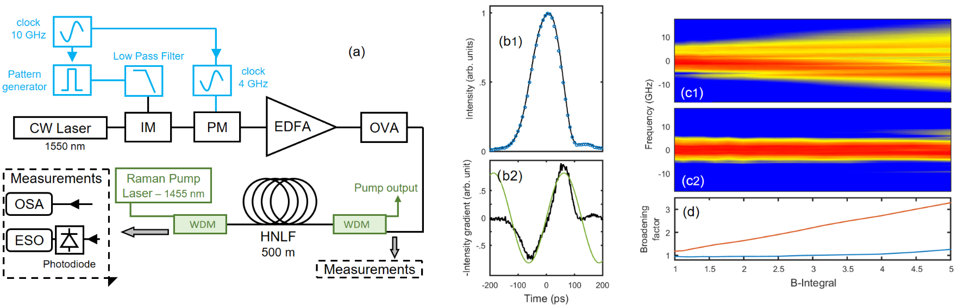
Fig. 2 (a) Experimental setup. (b)-(d) Experimental results: (b1) Temporal intensity profiles of the input pulse (black) and the input pulse with phase compensation (blue circles). (b2) Opposite temporal intensity gradient of the input pulse (black) and sinusoidal fit (green). (c) Evolution of the frequency spectrum with the accumulated B-integral without (subplot 1) and with (subplot 2) phase compensation. (d) Evolution of the rms spectrum broadening factor with the B-integral without (red) and with (blue) phase correction.
The experimental results are summarized in Fig. 1(b)-(d). While in the absence of phase correction we observe progressive expansion of the output spectrum from the fiber with increasing values of the accumulated B-integral, accompanied by the development of ripple and asymmetry, the use of a corrective phase modulation maintains an output spectrum that is only marginally affected. The benefits afforded by the phase correction method are also apparent when comparing the evolution of the rms spectral width with the accumulated B-integral between the two configurations [Fig. 1(d)].
3. Impact of initial pulse characteristics
Our experimental results are fully in line with the results of numerical simulation of the nonlinear Schrödinger equation shown in Fig. 2. We also derive an exact closed formula for the rms spectral width of an initially Gaussian pulse after undergoing SPM and with the corrective phase applied, which confirms the substantial reduction of the SPM-induced spectrum broadening attainable with the phase compensation. Further, we assess the impact of the initial pulse shape and duration on the effectiveness of the compensation technique. We show that for hyperbolic secant pulses, optimization of the parameters of the modulating sinusoid through a scan of the amplitude-frequency space outperforms the parameter choice based on simple analytic guidelines. By varying the initial pulse duration across an order of magnitude, we highlight the significant differences in performance between pre- and post-propagation compensation schemes, and show that remarkable SPM mitigation is attainable even in the presence of non-negligible fiber dispersion.

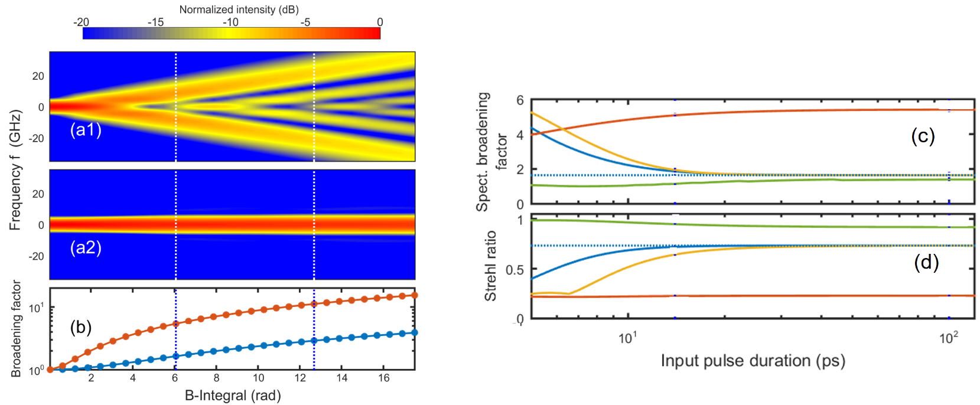
Fig. 2 (a) Numerically computed evolution of the spectrum of an initial 100 ps Gaussian pulse with the accumulated B-integral, before (subplot 1) and after (subplot 2) phase compensation. (b) Evolution of the rms spectral broadening factor. The results obtained without and with phase correction are plotted with red and blue lines, respectively. The circles represent analytical predictions. Evolutions of: (c) the rms spectral broadening factor and (d) the Strehl ratio of an initial Gaussian pulse with the input pulse duration. The accumulated B-integral is 2π. The results obtained without phase modulation, with the phase modulation chosen based on design rules applied as a post-compensation, with the phase modulation chosen based on design rules and applied as a pre-compensation, and with the optimized phase modulation applied as a post-compensation are plotted with red, blue, yellow and green lines, respectively. The dotted blue lines represent the results obtained in a quasi-pure nonlinear regime.

Our experimental and numerical results confirm the new exciting practical applications that can be developed based on the combination of SPM and a simple temporal phase modulation of the pulses [5, 6].

[1] C. Xu, L. Mollenauer, and X. Liu, "Compensation of nonlinear self-phase modulation with phase modulators," Electron. Lett. 38, 1578-1579 (2002).
[2] T. Ulmer, J. M. Roth, J. R. Minch, J. Chang, J. D. Moores, G. Nowak, and F. G. Walther, "Mitigation of Self-Phase Modulation in High-Peak-Power Lasercom Systems," in Lasers Congress 2016 (ASSL, LSC, LAC), OSA Technical Digest (online) (Optical Society of America, 2016), LW3B.6.
[3] F. Audo, S. Boscolo, J. Fatome, B. Kibler, and C. Finot, "Nonlinear spectrum broadening cancellation by sinusoidal phase modulation," Opt. Lett. 42, 2902-2905 (2017).
[4] S. Boscolo, F. Audo, and C. Finot, "Impact of initial pulse characteristics on the mitigation of self-phase modulation by sinusoidally time varying phase," Opt. Quant. Electron 50, 62 (2018).
[5] S. Boscolo, L. K. Mouradian, and C. Finot, "Enhanced nonlinear spectral compression in fibre by external sinusoidal phase modulation," J. Opt. 18, 105504 (2016).
[6] F. Audo and C. Finot, "Extinction ratio enhancement by sinusoidal phase modulation and nonlinear spectral focusing," Laser Physics 27, 115401 (2017).

