**Managing Risk in Strategic Sourcing: A Cross-Sectional and Multi-National Case Study**

Martin Kotula1, William Ho2, Srinivas Talluri2, 3, Prasanta Dey1, and Xin Ma4

*1Aston University*

*2The University of Melbourne*

*3Michigan State University*

*4Monash University*

**Abstract –** While risk management in supply chains is continuing to receive significant attention in the extant literature, research on risk aspects relating to strategic sourcing across various industry sectors from a multi-national perspective is scant. Based on 20 case companies in the construction and electronics sectors in Germany and the United Kingdom (UK), this paper undertakes a comparative evaluation of strategic sourcing risk management practices. We find that risk management has not been adopted fully across industries and countries from a strategic sourcing perspective and that differences exist with respect to risk factors considered, methods adopted to analyse risk, and impact on business performance. Our research presents several significant and useful insights for managing risks in strategic sourcing.

***Key words:***Strategic sourcing, risk management, construction, electronics manufacturing, Germany, United Kingdom

**1. BACKGROUND**

Increasingly, firms are pursuing long-term relationships with their suppliers for strategic items with a view to soliciting insights for new product development and resolving various operational issues. Strategic sourcing not only reduces the purchasing and manufacturing costs significantly, but also contributes to product quality, product innovation, firm’s flexibilities, and supply chain agility (Dey et al., 2015).

As supply chains become more complex and globalized, firms to a higher degree are dependent on their suppliers. This also entails a number of unexpected negative events, which makes strategic sourcing more critical compared to the past. For instance, the earthquake, tsunami, and the subsequent nuclear crisis that occurred in Japan in 2011 caused Toyota’s production to drop by 40,000 vehicles, costing $72 million in profits per day (Pettit et al., 2013). The catastrophic Thailand flooding of October 2011 affected the supply chains of computer manufacturers across the world and Japanese automotive companies that had plants in Thailand (Chopra and Sodhi, 2014). All these risks have a direct impact on strategic sourcing decisions. Therefore, it is necessary to consider risk factors along with cost and quality factors while making strategic sourcing decisions.

Recently, supply chain risk management (SCRM) has received significant attention in academic research. Ho et al. (2015) reveal that there is a continuous growth in the number of academic articles focusing on SCRM in the period of 2003-2013. Supply chain risks can be divided into two categories – macro risks and micro risks (Ho et al., 2015). Macro risks refer to adverse and relatively rare external events or situations which might have negative impact on companies, such as natural risks (e.g., earthquakes, weather related disasters) and man-made risks (e.g., war and terrorism, and political instability). On the other hand, micro risks refer to recurrent events originated directly from internal activities of companies and/or relationships within partners in the entire supply chain, including demand risk, manufacturing risk, supply risk, information risk, transportation risk, and financial risk. Among these seven types of supply chain risks, supply risk is the most widely studied risk type (Ho et al., 2015). Specifically, most of the researchers studied the supplier assessment and mitigation problems with risk considerations. Although there is a significant amount of research in the domain of supply risk, risk consideration in strategic sourcing is limited. To the best of our knowledge, there is no study that empirically analyzes cross-sectional and multi-national cases of risk management in strategic sourcing. The knowledge on critical risk factors in strategic sourcing, sector and country specific practices, and methods that help develop and adapt tailored risk management strategies and approaches would prove to be of significant value to practicing managers.

Based on practitioner reports and academic literature, firms recognize the importance of strategic sourcing, but often fail to incorporate risk management into strategic sourcing initiatives. For example, 53% of the interviewed firms in Australia spent AUD$50 million or more per year on sourcing from suppliers, but 61% of the interviewed firms only spent AUD$250,000 or less per year on supplier risk management (PwC, 2013). Besides, it is also the case that many firms are unprepared for risks and lack the real implementation of risk management methods even when their supply chains are exposed to various types of risks. For instance, Zsidisin et al. (2000) reveal that only 33% of companies studied in their research performed a formal risk assessment or used contingency plans during sourcing. Blackhurst et al. (2005) identify that only 5-25% of Fortune 500 companies were prepared to handle crisis or disruptions.

The primary goal of this paper is to understand whether risk management can enhance the effectiveness of strategic sourcing. Although strategic sourcing has benefits, it can be a risky endeavour due to various external and internal factors – such as political, environmental, contractual, logistical and economic constraints. This paper intends to contribute to this knowledge gap by answering the following three research questions: 1) to what extent companies face strategic sourcing risk and what is its impact on business performance 2) what are the critical strategic sourcing risk factors and 3) what methods do companies adopt to manage sourcing risks. This study takes both cross-sectional and multi-national perspectives through comparative analysis of construction and electronics manufacturing sectors in Germany and the UK. The answers to these questions will enable organizations to develop their risk management system specific to industry and geographical location in order to make their strategic sourcing more effective.

The remainder of the paper is organized as follows. Section 2 discusses the research methodology. Section 3 demonstrates the results and findings. Section 4 presents the managerial implications and section 5 concludes the paper.

**2. RESEARCH METHODOLOGY**

This research undertakes 20 qualitative case studies within construction and electronics manufacturing companies in Germany and the UK. We have followed the case protocol based on Eisenhardt (1989) and Yin (2009). The company selection was based on a stratified sampling approach. The brief description of the companies is enclosed in Appendix 1. Companies’ revenues range from 37 million to 8 billion Euros and reflect professionals with 17 years of experience in the sourcing domain on average (see Table 1). Small organizations were not considered due to their revenues, spend, organizational capabilities and fewer supplier relationships, which may have limited the number of potential risks.

The country selection is primarily based on the fact that there is limited research in qualitative cross-country evaluation of strategic sourcing risk management practices in Germany and the UK. Also, Germany (No. 4) and the UK (No. 5) are within the world largest economies and dominant in Europe (World-Bank, 2015), therefore the expected findings should be significant and generalizable. Furthermore, Germany is in central Europe, known as transit country, and has strong export quota, whereas the UK is on an island and is therefore exposed to supply chain risks.

The construction and electronics manufacturing sectors were selected for this research. The construction sector is highly dependent on tight scheduling and budget, and it utilizes a network planning structure instead of an assembly line approach. Typically, the spend distribution is high and often reaches millions of Euros, which leads to a higher bargain power of buyers. The electronics manufacturing sector is highly exposed to global business environment, including Asian markets, and has to cope with global sourcing, cultural varieties, and lean supply chains. The electronic component crisis led to significant risks for organizations in this sector, whereby the lead times for certain parts increased from a few days to months. In addition, the product life cycles became shorter and the electronic components changed frequently, which led to an additional risk exposure in single sourcing strategies and product design. Therefore, due to the varied characteristics of both sectors, we need to adopt different strategies to manage strategic sourcing in construction and electronics industries. Additionally, different countries have unique socio-economic and political landscape which calls for unique approach to managing risks in strategic sourcing.

Table 1: Company and interviewee characteristics

|  |  |  |  |  |
| --- | --- | --- | --- | --- |
|  | n | Minimum | Maximum | Average |
| Revenue | 19 | 37 Mil. € | 8,123 Mil. € | 1,594 Mil. € |
|  |  |  |  |  |
| Employees | 16 | 265 | 58,312 | 6,595 |
|  |  |  |  |  |
| Interviewees |  |  |  |  |
| Experience in current  position (years) | 16 | 2 years | 29 years | 8.5 years |
| Experience in sourcing in sum (years) | 13 | 3 years | 36 years | 17.7 years |

The research reveals the answers to research questions on importance of risk management in strategic sourcing, specific risk factors that affect strategic sourcing, and methods that could be adopted to manage risks in strategic sourcing for industry sectors and countries (see Figure 1). Through case studies using interview protocol and document reviews within 20 organizations in two countries (Germany and the UK) and two sectors (construction and electronics) data was collected and analyzed.

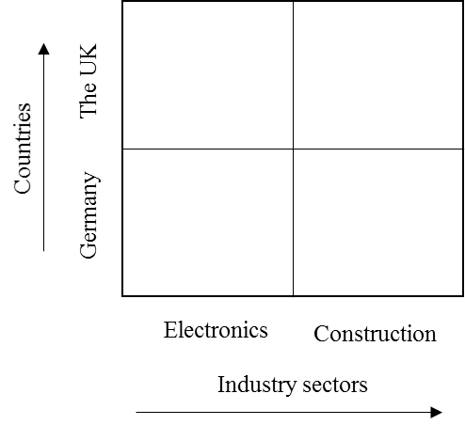Figure 1: Research framework.

**2.1. Data collection**

This research is based on in-depth semi-structured interviews, which is an adequate process to address the research questions (Yin, 2003). An interview protocol was developed in line with the research questions (see Appendix 2). Furthermore, to increase validity, a structured questionnaire was used at the end of the interview to collect information on relevant criteria and their prioritization. The interview protocol and the questionnaire were pre-tested and peer-reviewed by three researchers and one practitioner within the sourcing and procurement discipline. The feedback was incorporated into the final protocol and questionnaire. The main interviewees were from the sourcing functions or in some cases with additional experts based on availability. Only in few construction companies, a function for sourcing and procurement was non-existing; though the commercial department took the interview responsible for the spending. Surprisingly, we noticed different reporting lines by industry of the interviewed persons. In construction industries, the sourcing function is likely reporting to the chief executive officer (CEO) domain, whereas the electronics industries mainly report to the chief financial officer (CFO) (see Figure 2).

Figure 2: Reporting hierarchies.

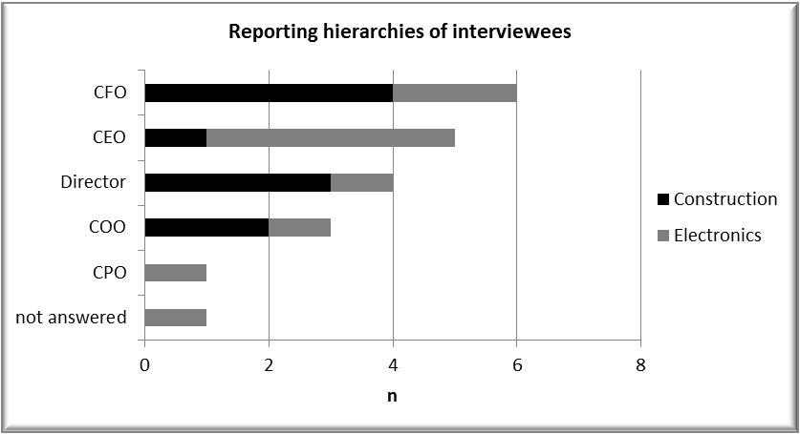

All the interviews were conducted face-to-face between September 2011 and November 2012. With one exception, nineteen interviews were audio recorded with direct documentation of the spoken words with special agreements on confidentiality. The interviewees’ entire answers were used for analysis purposes and coding in NVivo 9 ©. Despite the pure interviews, companies also showed their applied tools and methods to provide evidence. Corporate strategies and revenue data were derived from public available data. Furthermore, other public available data such as brochures or through the internet available information was used.

**2.2. Data analysis**

The empirical analysis is mainly based on an iterative and inductive process of reading, coding, and interpretation as well as re-evaluation of the transcribed interview notes of 20 case studies (Miles and Huberman, 1994; Yin, 2009). Each case study was analyzed by the leading researcher using open and axial coding. In this step, the leading researcher manually assigned codes, categories or clusters for each of the interviews. For organizational codes, attribute fields were used in NVivo. In addition, categories were used in accordance to the research framework. Each case study coding was reviewed by one independent researcher, where the coding and the transcript were peer reviewed. In addition, to further justify qualitative answers, the questionnaire was used to verify the spoken words with a written selection of criteria (e.g., criteria/factors to be selected). Finally, the data were used for cross-case analysis and pattern matching as well as grouping and frequency analysis. Overall, there was high confidence of the spoken words during the interviews and the written questionnaire answers.

To ensure high level of reliability, we differentiate in construct, internal, external validity (Yin, 2009). The construct validity is ensured by having multiple sources for cross-case analysis and a chain of evidence by transcripts as well as shown data and documents during the interviews. Furthermore, the interview protocol has open-ended and closed questions as well as a questionnaire to verify validity and evidence of answers. Internal validity is ensured through pattern matching as well as explanation building from each of the cases. To ensure external validity, we used multiple cases in two industries and two countries as well as replication logic in each of the cases. For reliability, we used a database of all interviews, interview protocols as well as audio taping. The inter-coder reliability was conducted through code review by the research team rather than individually to avoid bias. Note that it was not system supported nor conducted statistically because there is no consensus in the academic literature on its evaluation and impact. Appendix 3 shows the code structure and hierarchy.

**3. RESEARCH FINDINGS**

This section addresses the three research questions based on the qualitative evaluation of 20 case studies in Germany and the UK. Appendix 4 summarizes the findings of the case studies.

**3.1. To what extent the case companies faced strategic sourcing risks and how the strategic sourcing risks impact business performance?**

Nine out of twenty companies stated that they faced significant risks by having a notable disturbance to the operational business in 2010/2011. Therefore, almost every second company was affected by a significant risk. The focus on these occurred risks, which had a significant impact to the company. In this context, there was no big difference from the country perspective nor from the industrial perspective. However, the key finding and difference is that companies are affected by different risks within an industry. We did not notice any country difference, and risks do not stop at a border. For example, there seems to be a higher likelihood that companies in construction are more exposed to supplier insolvency and companies in the electronics sector by supply security (see Figure 3). This can be of course argued, but to some degree it is obvious because construction projects are capital intensive, while electronics industries normally focus on just-in-time such that even a missing of low-cost parts can stop production. It could also be argued that UK faced a stronger economic downturn at this point in time, which could have led to higher bankruptcies. Nevertheless, suppliers’ bankruptcy is noted in every industry and in every country. In practice, it is relatively hard to measure because the creditworthiness scores are based on ex-post financial data. It is obvious that such risk is the most important factor in the framework nowadays.

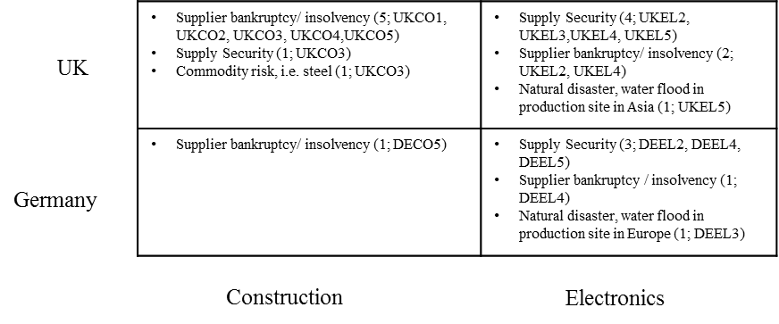Figure 3: Strategic sourcing risks faced.

Several companies claimed to be locked-in with a supplier due to technical specifications or single sourcing strategies. Those companies clearly indicated to move towards a dual supplier strategy for the critical parts because of the significant disturbance, which is in line with the findings from the literature (Yu et al., 2009). There is a risk exposure on supply security if single sourcing is applied (Yu et al., 2009).

UKEL5 underlines the need for changing specification and moving out of lock-in situations: *"So, in the long run, I think it’s going to have to come down to us holding higher stock levels on certain critical products. Alternatively, in long-term development we should consider these issues in looking at the design of our equipment at the top end at the concept stage, so we bring in a few options that allow us to get the product operating at the specification we want it while offering us a spectrum of critical components that could fill into it. So, we are de-risking it from a design stage; however, that will take a number of months and years."*

Another surprise in the analysis is the impact of natural disasters. UKEL5 was hit by a supplier in Thailand: *"Yes. We had a situation because of the Thai flooding where a large proportion of hard drive manufacturing is based in Thailand, Seagate, and this affected us in that we buy standard set specification PCs from Hewlett-Packard and they manufacture this in Bulgaria and that then is shipped into the UK to a reseller that final configures and ships into our division."* DEEL3 had similar flooding issue in Germany: *"The whole production site of our supplier was flooded and could not deliver."*

UKEL4 underlines the criticality: *"Again, the balance of power was moving towards the buyer and then the tsunami affected everybody in electronics and it affected in a number of ways and the companies those lots of – there was a lot of companies bought up very early, so created a false demand in the market… the knock on effect those factors that were affected, often the companies had alternative factories, but because people loaded the order book it filled up capacity very quickly, so prices went up, lead times extended. And we just, in the last month, started to see that now reduced."*

This research shows that there are only few materialized risks and those vary across country and industry. The findings are quite contrary to some literature proposing multi-criteria risks management tools (Ho et al., 2015), because basically the dominating risks were only two, which had significant impact. We also see that companies identify and try to manage multiple risks (see Figure 4), but at a company level the number of criteria is a dozen or less. Of course, there could be more risks managed and proposed, but in this research only a few risks materialized. When we consider the different strategies companies apply, it can be said that single sourcing leads to higher risk exposure, if a supplier does not deliver anymore. Albeit, supplier creditworthiness is a kind of a traditional criterion, we may see that it can be a constant risk. Some of the companies are using agencies such as Dun & Bradstreet for supplier creditworthiness rank, but the issue of these financial data is always ex-post based. The question is whether a sufficient algorithm can be used to forecast supplier bankruptcy in the future. Besides, we see supply continuity as one of the key risks in the electronics sector, which is more impactful to a just-in-time production than in a large construction project. Nevertheless, we notice that such risk also appears in the construction sector.

Risk events can have a significant impact on companies’ business performance, if a manufacturing process is disrupted or if the ordered goods are not delivered due to supply risks. The impacts vary across the industries and geographical location. From the case studies, seven out of twenty companies confirmed that an appropriate risk management in case a risk materializes, will influence business performance and can even allow the company to win new customers or market share; though to outperform against peers (see Figure 4). Two companies said, it has no impact. The remaining eleven companies had no serious risk event.

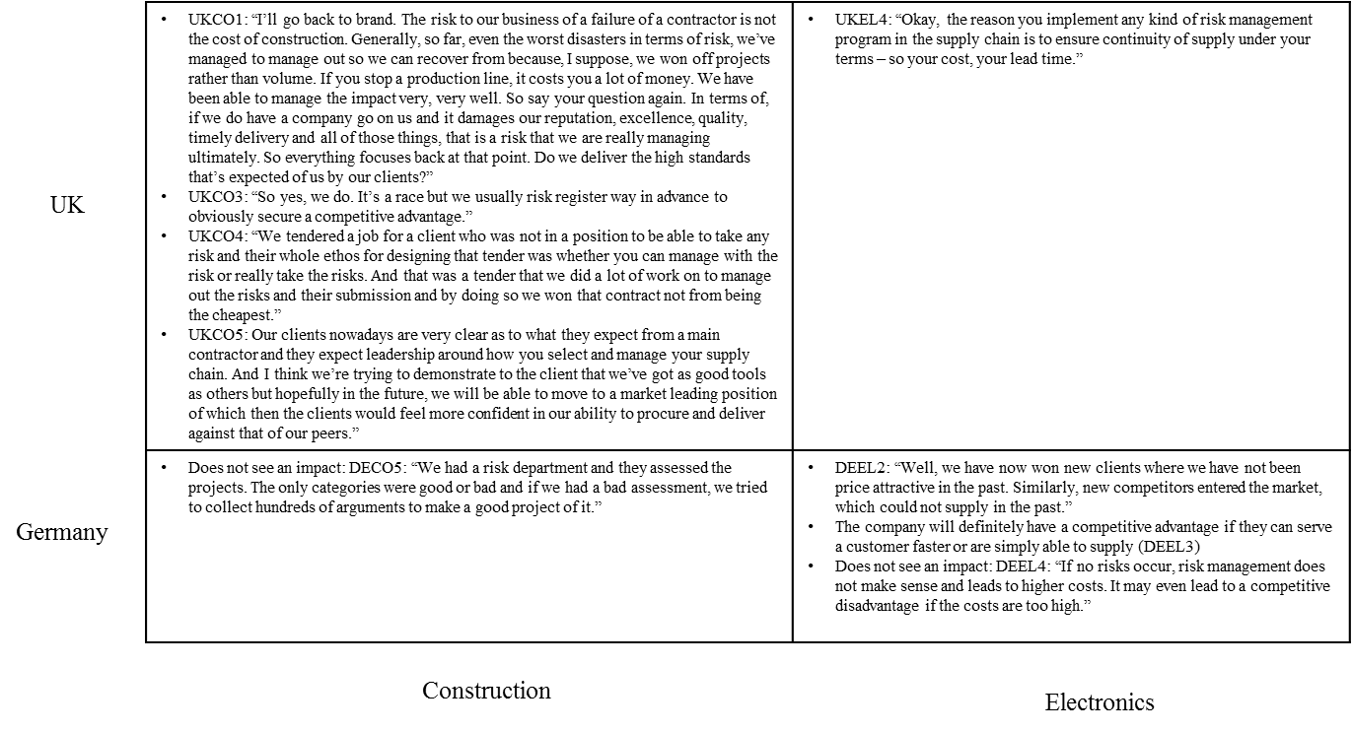Figure 4: Impact of risks on business performance.

Our research shows that an appropriate risk management can have an impact on business performance. Generally, companies confirmed to gain additional market share if a competitor was unable to deliver due to supply security or bankruptcy risks. The impact of supply capabilities, especially in a kind of a market shock situation, such as the allocation of electronic parts, leads to a competitive advantage and increases the revenue of the company. On the other hand, we also identified cases which faced similar risks such as bankruptcy or supply security, but did not face a significant disruption of their business. In this context, some had an established risk management, which may have prevented them but there have also been companies without appropriate practices without major disturbance.

**3.2. What are the critical strategic sourcing risk factors?**

Although companies considered several risk criteria in their supplier evaluation process, it became very clear that the key focus was suppliers’ creditworthiness, followed by quality, supplier capabilities, and supply continuity, as shown in Figure 5. In some selective cases, the companies focus on price (commodity), country risks, or the “end of product lifecycle” risks, when a supplier changes technology more frequently and the manufacturers cannot keep up with the speed of technological change, as well as the risk for know-how spying.

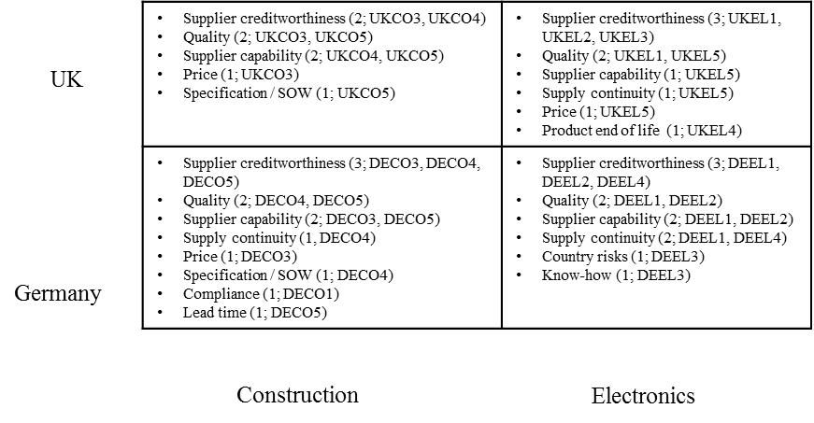Figure 5: Critical risk factors considered in the strategic supplier selection.

This qualitative evaluation from interviews shows that applied risk management practices in strategic sourcing primarily focus on suppliers’ creditworthiness. Although the factor is important and companies want to make sure their supplier has a solid financial performance before being selected, the measurement and controlling are challenging. The reason is the momentum picture of financial information in a balance sheet or cash-flow statement. Although companies use external service providers, such as Dun & Bradstreet, for providing financial metrics or credit-worthiness, the provided information is not real-time.

If we reflect what companies tend to consider as important risk management criteria (see 3.2) and compare these to the real materialized risks (see 3.1), there is a clear misalignment. Although supplier bankruptcy, natural disaster, and supply security have been dominating any companies in this research, they are not the main factors in their eyes. For example, supplier bankruptcy (Figure 3) hit every UK construction company and supply security affected four UK electronics companies, but only two see this in construction as a critical factor as well as one in the UK electronics sector. The same applies for Germany, where in electronics the dominating risk was supply security, only one company believes this is a critical factor. Therefore, companies should align and adjust their risk framework with materialized risks. We may conclude that the risk management practices and criteria are still emerging. In this context, we see that emerging risks are only partially covered in a risk framework and more importantly are not part of the interviewees’ beliefs to be important. Although risks should be minimized by selecting a strategic supplier, we see that there is no guarantee in practice. It may be due to the fact that supplier bankruptcy or supply security are really hard to predict. Therefore, and more importantly, we argue to have appropriate mitigation plans for all critical suppliers.

There are slight variations of risk factors that are being considered in construction and electronics industries in Germany and the UK. Construction companies emphasize on specifications compliance and lead time, whereas electronics companies concern with country specific risk (e.g., political and environmental) and product end of life related issues. German companies are more concerned with materials specification compared to the UK companies. On the contrary, the UK companies emphasize on life cycle aspect of products.

**3.3. To what extent the case companies adopt risk management methods/tools?**

Out of twenty cases, only ten companies had a formalized risk management, which was either managed on a corporate level or, particularly, in sourcing. In an ideal world, this approach would be based on an IT system and established across different departments. The findings of the interviews uncover variations in how risk management programmes are established. Especially, there is a country specific difference in construction sector, where no single company in Germany does use risk management programmes in strategic sourcing compared with its UK peers, where almost every company have risk management established (see Figure 6). Considering the materialized risk by only one company in Germany, the impact of risk management can be debatable. On the contrary, the impact and significance of risks faced in the electronics sector is an indicator for higher risks by industry, but if companies apply risk management in practice, it actually does not prevent them from risk occurrence. However, the adoption of risk management practices in the electronics sector is more likely than in construction and it is more likely in German electronics than in UK.

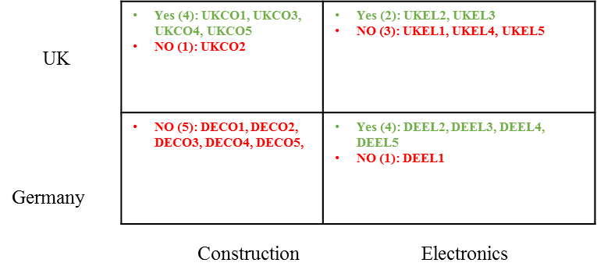**Figure 6:** Companies with established risk management programmes.

The applied risk management methods and tools vary across industries and countries. Specifically, six UK companies and four German companies apply a risk management programme. Furthermore, we see a more holistic and more variety of tools being adopted in the UK based construction industry compared with only few companies in UK’s electronics sector (see Figure 7). In addition, the electronics sector in Germany applies several risk management tools. The dominating tool is a risk matrix, which is unique to each of the company and mainly used in Microsoft Excel ®. The second dominating tool is an IT system/software, such as ERP.

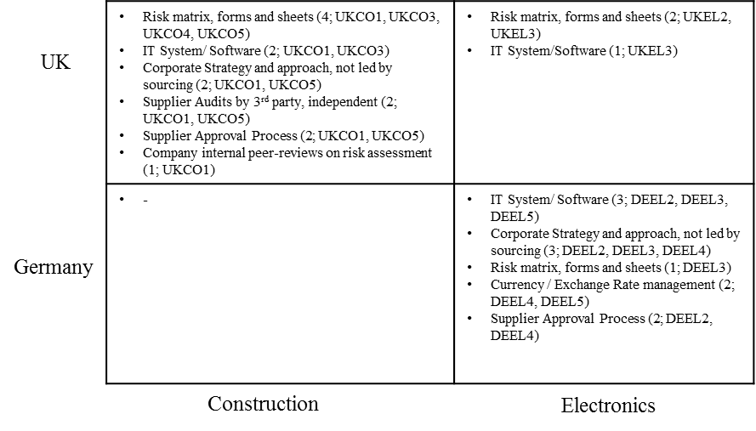Figure 7: Applied risk management methods/tools.

DEEL2 explains: *"We manage our potential risks, such as supplier performance or quality in SAP (ERP)."* DEEL3 states: *"For all our financial risks we are using a checklist, which we developed. There are about 20 criteria, ranging from financial credit-worthiness, Dun & Bradstreet information, but also on-time deliveries, changes in delivery lead times, etc. This is fully recorded in SAP (ERP)."* A different approach is applied at DEEL5, which uses a developed Microsoft Access database to capture and assess risks, where the company also collaborates with an insurance company to assess risks such as fires. More formalized and in different steps, UKEL3 executed a system-based risk management: *"Well, quite simply, when we talk about supplier risk, you know, I'd kind of break that down into two segments that we have. Financial risk on a supplier level. At a company high level here, we have, you know, a monthly supplier risk analysis, which is done in cooperation with a D&B (Dun & Bradstreet) tool, and this influences directly in that any supplier above a certain risk is immediately analyzed in detail to see how critical that supply is to our business, and what contingencies that we can put in place to mitigate against the risk. So anyone of high risk and beyond has a full, detailed risk analysis done on the supplier and looks to put in place some mitigation."* Each construction project has its own risk characteristics, meaning UKCO4 tries to assess each package. Furthermore, the company tries to pass the risk through the supply base. *“It’s when we look to procure the package, there will be […] when we tender a job there will be a risk analysis done, a risk register taken for that project which will transfer itself to a risk contingency within the contract. That is occasionally broken down onto a package-by-package basis, but not always. But it would not be […] so risk is – we try to identify the risk in relation to a certain package before placing that package and within the package it will either be placed on a lump-sum basis again to try and mitigate risk on that,”* states UKCO4.

Furthermore, companies have established and centralized risk management programmes, of which sourcing functions are a part. In many cases, these are central and corporate risks, such as currency, export, IT security, or fire risks. Five companies use centralized strategies to manage risks. DEEL2 has one centralized reporting system, headed by the CFO, and to which each department autonomously reports risks. Equally, DEEL3 uses a group-wide system that also covers sales topics such as increasing competition or market downturns. In this context, the sourcing function has a sub-system (DEEL3). DEEL5 refers to the automotive certification ISO TS 16949: *“It is a requirement by many OEM to comply with these standards and, therefore, the whole company acts accordingly.”*

*“Therefore, risk strategies are project-specific and so, yes, we have a centralized strategy, but they are project-specific,”* points out UKCO1. UKCO5 has an entire department established for managing risks: *“There’s a whole risk department in the company, but what they’re doing is looking at project risk and financial risk from a company point of view.”*

The remaining approaches include a supplier approval process, where companies specifically use a standardized process to qualify and assess suppliers. Two companies use external auditing services for suppliers; the currency management is handled centrally by the treasury departments. Finally, one company has established a peer-review process within risk management from site to corporate level; this means that risks were assessed by two independent individuals.

Although one company (DEEL4) has a formalized risk management practice and faced some risks, the CPO is very critical of the effort being taken to manage the programme and does not see risk management as a competitive advantage: *“If no risks occur, risk management does not make sense and leads to higher costs. It may even lead to a competitive disadvantage if the costs are too high.”* Therefore, a clear trade-off must be taken in how to effectively manage risks in sourcing. For the remaining companies, the reasons for not having a risk management programme are different. DECO1 does not use any kind of risk tools either in the group or sourcing, and DECO2 argues that the group heterogeneity does not allow for a standardized approach or tool. DECO5 is enjoying strong growth, and therefore the structures and capacity do not allow them to establish a structured approach. *“There is a very rough concept established, but not really a regular monitoring. It is a kind of business continuity, if we have a fire in the production,”* states DECO4. Similarly, UKEL1 states it has business continuity plans - especially in the IT and server landscape, but has no such a plan in sourcing. UKEL2 believes that risk management does not add significant value, and therefore, it is not established. UKEL4 has plans to implement a risk management programme next year, but this has not started yet and the capacity is still lacking. Finally, UKEL5 was working on a concept but had not implemented a programme: “*But from a risk management, myself and my colleagues we are working on this at the moment and we are crafting a check list for a framework where we are taking all the supply base, grading them on what is the likely failure points, whether it’s geographically, whether it’s the market, whether it’s down to technology.”*

DECO3 has an informal approach on a project level, and DEEL1 looks at risks informally and occasionally, but with no tool or approach systematized: *“We look on business continuity, have two independent production sites for instance. When it comes to sourcing, we focus on dual sourcing and went through a programme where we had to qualify new suppliers.”* When asked if they have a risk management programme, UKCO2 states: *“No, I guess we probably don’t. We do a lot of the risk analysis, it’s done at tender stage for individual projects.”*

Considering the research findings from Zsidisin et al. (2000), only three out of nine companies performed a risk management assessment, while Blackhurst et al. (2005) identified that only 5-25% of Fortune 500 companies were prepared to handle crisis or disruptions. The findings of this research project show a slight improvement, but this is still lagging behind what is expected, despite the possibility that companies are trading off between risks and benefit (Chopra and Sodhi, 2004). Although Khan and Burnes (2007) argue that the SCRM is not well perceived, Rossetti and Choi (2005) remind us of the risks of close collaborations and dependencies. As global sourcing continues to increase and companies focus on reducing costs, the risk exposure increases (Wagner and Bode, 2006).

To increase the resilience of companies, an established risk management and continuity programme is recommended by the literature to manage risks in strategic sourcing. In practice, there are so few companies using strategic tools to manage risks according to our research findings. The companies apply the risk tools with a strong focus on financial metrics from Dun & Bradstreet or operational risks.

In summary, the applied approaches are extremely operational and do not reflect the strategic risks from long-term supply decisions. There are risks from single sourcing and single specification, but also from complex supply chains and lean management. Therefore, when managing risks in strategic sourcing, companies need to take a long-term perspective, assess the sourcing spend portfolio, and identify the risks to cash-flow and revenue streams.

**4. MANAGERIAL IMPLICATIONS**

This study aims to explore the role of risk management in strategic sourcing through examining whether risk management enhances effectiveness of strategic sourcing using the following three questions: To what extent companies face strategic sourcing risk and what are their impact on business performance; what are the critical risk factors for strategic sourcing; and what methods do the companies adopt to manage these risks. The research findings provide meaningful managerial implications for organizations.

First, the study reveals that close to 50% of the businesses experience significant risks in strategic sourcing. Close to 40% of businesses agreed that if risks are materialized, these would affect business performance substantially. Our research also shows that an appropriate risk management can have an impact on business performance. Specifically, companies would gain additional market share if a competitor was unable to deliver due to supply security or bankruptcy risks. Therefore, organizations should develop and implement their country and industry specific strategic sourcing risk management framework.

Second, we reveal that companies in construction are more exposed to supplier insolvency and companies in the electronics sector by supply security. Supplier bankruptcy is a common risk factor for any industry and country, and this risk has serious impact on entire business performance of case companies as these companies have adopted single sourcing strategies. However, it is very difficult to measure because the creditworthiness scores are based on ex-post financial data. Therefore, organizations should manage those critical risks, particularly supplier bankruptcy, in a proactive and real-time manner.

Third, this study uncovers some key materialized risks, which are limited to supplier insolvency, supply security, natural disaster, and commodity price risks. To increase the effectiveness of strategic sourcing risk management approaches, organizations should consider a more holistic list of risks that would affect their supply chain resilience and sustainability, including macro risk, demand risk, manufacturing risk, supply risk, information risk, transportation risk, and financial risk (Ho et al., 2015)

Fourth, this research shows a misalignment between the critical risk factors (i.e., types of risks affecting companies most) and the strategic sourcing risk management criteria (i.e., risk criteria for evaluating strategic suppliers). Although supplier bankruptcy, natural disaster, and supply security have been dominating any companies in this research, these critical risk factors are not the main risk criteria for evaluating strategic suppliers. Instead, companies considered several risk criteria in their supplier evaluation process, including suppliers’ creditworthiness, quality, supplier capabilities, and supply continuity. Therefore, organizations should align and adjust their risk framework with materialized risks.

Fifth, our research finds that only ten out of twenty companies had a formalized risk management. The adoption of risk management practices in the electronics sector is more likely than in construction and it is more likely in German electronics than in UK. Comparing with the findings from Zsidisin et al. (2000) as well as Blackhurst et al. (2005), the findings of this research show a slight improvement. But, the adoption of integrated strategic sourcing risk management practices is still less than expected because companies are increasingly exposed to a variety of supply chain risks in todays’ volatile business environment.

Sixth, the applied risk management approaches are extremely operational and do not reflect the strategic risks from long-term supply decisions. The companies apply the risk tools with a strong focus on financial metrics from Dun & Bradstreet or operational risks. Specifically, the dominating tool is a risk matrix mainly used in Microsoft Excel ®, followed by an IT system/software, such as ERP. To increase the resilience of companies, organizations should establish a better and integrated SCRM process to identify, assess, mitigate, and monitor both strategic and operational risks in strategic sourcing.

**5. CONCLUSIONS**

This paper applies a multiple case study approach to understand and compare the strategic sourcing risk management practices across the construction and electronics manufacturing sectors in Germany and the UK. There are several research findings that help fill the knowledge gaps in the literature. Our findings show that companies are exposed to risks, which, in the worst case, affect their business performance. Therefore, there is a necessity of incorporating risk management in strategic sourcing. Also, we find that companies are mainly exposed to supplier insolvency and supply security risks. However, companies do not manage supply risks appropriately. Specifically, companies tend to focus more on supplier bankruptcies than supply security when evaluating and selecting new suppliers. Companies are strongly recommended to align their strategic sourcing risk management practices better with the key materialized risks. Furthermore, we find that there is limited risk types considered in practice. Companies should also consider other supply risk factors identified in the literature proactively. Last, but not least, we find that single sourcing or single specification is a key driver for higher risk exposure, especially in cases of supplier bankruptcies and supply shortages. Therefore, companies should move towards a dual supplier strategy for the critical parts to avoid any significant disturbance.

The major claim against the qualitative findings is typically based on personal biases and peculiarity, which is particularly the case if there is only one interviewee participating within one organization. However, there is always a risk of interviewee bias, which cannot be excluded. The researcher has to believe in the interviewees’ responses and that the research design findings are validated with different questions and through examining the overall situation. Besides, the research design was based on questions with a high degree of subjectivity, which supports the qualitative study and the research objective of a deep understanding of how companies adopt and execute strategic sourcing risk management.

There are several possibilities for extending knowledge in the area of strategic sourcing risk management. First, this study could be extended by considering additional sectors (e.g., service industry) and countries (e.g., developing or low cost countries) to examine if there is a difference on the types of risks faced. Second, the knowledge could be extended by quantitatively evaluating the benefits and costs of strategic sourcing risk management practices. For example, scholars could apply a multiple case study approach to analyze and benchmark the payoffs or losses between those companies implementing strategic sourcing risk management practices and those not implementing in the same sector while exposing to similar risk types. Third, a risk management framework in strategic sourcing could be developed for industry and country specific use.

Appendix 1: Nature of business and companies

|  |  |  |  |  |
| --- | --- | --- | --- | --- |
| **DECO1** | **DECO2** | **DECO3** | **DECO4** | **DECO5** |
| The company is a large enterprise and serves public and industrial clients with project development, turnkey solutions, real estate management and facility management combined with services. The markets served vary from power, infrastructure or operations of infrastructure projects with financial management. | The company has broad offerings: building, turnkey solutions, civil engineering, underground construction, building renovation or pre-casting of elements. Furthermore, the company offers real estate services. | The primary business of the company is the services, product and turnkey solution provision with a focus on interior fit-out, facade construction and insulation engineering. The product range covers facade, steel, glass ceilings and industrial scaffolding. | The company serves private clients with prefabricated houses. The house can be selected from standards or references or can be custom-made. The company produces around 700 houses per year. | The company develops large projects for industrial clients. Primary activities are: project development, project management, general contracting and construction services. Furthermore, the company manages the properties, the facility, assets, centre and park houses. The company is general contractor for clients or develops and operates own properties |
| **DEEL1** | **DEEL2** | **DEEL3** | **DEEL4** | **DEEL5** |
| The company is a one of the competent solution providers for automation, installation, drive and control systems technology. The company produces electronic motors and drives, and automation systems based on its own engineering. | The company is a competent solution provider for automation, installation, drive and control systems technology. It serves all industries from automotive and aerospace to consumer goods. | The company is a global company with multiple sites and is one of the leaders in diagnosis and measuring systems for rotating components across industries. | The company is a solution provider in communication and radio control systems covering engineering, equipment and support across multiple industries. | The company provides the global automation markets and is a leading developer and manufacturer of electrical equipment such as sensor, barrier, fieldbus technique and positioning systems. |
| **UKCO1** | **UKCO2** | **UKCO3** | **UKCO4** | **UKCO5** |
| The company’s core competency is in construction and construction consulting with integrated services across the full property and infrastructure life cycle. Despite the construction delivery, the company offers consulting services in project, facility and cost management. | The company has several offerings in the area of construction of buildings and infrastructure. The offering covers design, construction through project finance and lifetime asset management. Furthermore, it offers services in facility management, energy and infrastructure. | The company is the leading UK construction and regeneration group in the public and private sectors. The offerings range from construction and infrastructure projects, through investments, urban regeneration, fit-out restructuring projects and affordable housing. | The Group provides a broad range of services. They offer construction, development, energy, IT and management services across a variety of sectors. The company further specializes in care, student accommodation, residential, education, hotels and leisure. | The company is an international group, which operates as an integrated services provider around the globe. They offer the whole construction life cycle starting with development, investment management, project management & construction, and asset & property management for property and infrastructure. |
| **UKEL1** | **UKEL2** | **UKEL3** | **UKEL4** | **UKEL5** |
| The Group is the leading company in electrical test equipment. The company designs, manufactures and serves low and high-voltage markets, as well as the solar market. | The company designs and manufactures portable electric test and measuring equipment for high and low voltage. Although the company has a global footprint, the organizational structure is local to meet local customer requirements. | The company is a world leader in providing measurement and sophisticated communications and data solutions for gas, electricity and water customers. | The company is an integrated electronic manufacturing service provider of custom-made solutions for cable looms, cabinets and boxes. Furthermore, the company offers a range of services, from electronic component sourcing to supply chain management. | The company is a leading provider of high-technology tools and systems for research and industry. The company serves all industries, from agriculture to chemical and textiles. |

Appendix 2: Extract interview protocol

**Supply Risk Management**

1. How do recent supply risks **influence your corporate strategy in 2010/2011**?
2. Do you have an implemented a risk management programme in your company?

Yes ❑ 1 No ❑ 2

1. If **YES:**
   1. How do you **identify potential risks**?  
       [Could you please make an example, how you normally execute that process?]
   2. When it comes to the assessment of risks: What are the applied **criteria**?
   3. What kind of risks do you manage **actively and preventive**?   
       [internal, external, economical, quality, supplier]
   4. How **do you monitor** the identified and assessed risks?
   5. What kind of **tools** do you use?
      1. Do you have a special IT system for risk management?

Yes ❑ 1 No ❑ 2

1. If **NO:**   
   "What **are the reasons for not implementing** a risk management programme?"

Over the last months some serious events happened such as financial crisis, volcano ash, or the nuclear accident, which lead to disruptions in the supply chain.

1. Did you have **some serious risk events** with significant impact to your business in 2010/2011?

Yes ❑ 1 No ❑ 2

1. If **YES:**
   1. Could you please give **two examples, how those events affected   
       your company**?
   2. How can the risk management lead to enhanced business performance?   
       [Did the company perform better having a risk management than competitors?]
2. If we focus purely on strategic sourcing: What are the **dominating “must-have” risk factors to be used in a preventive risk management** portfolio?

Appendix 3: Code structure and hierarchy

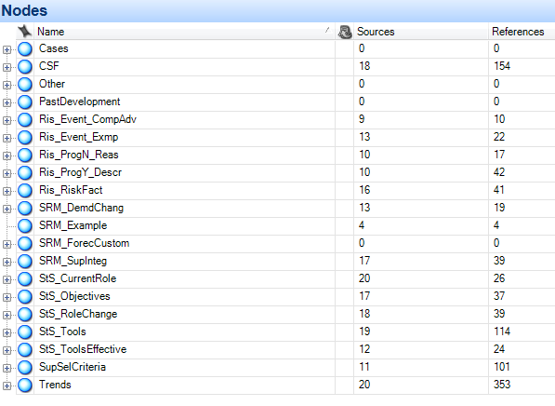

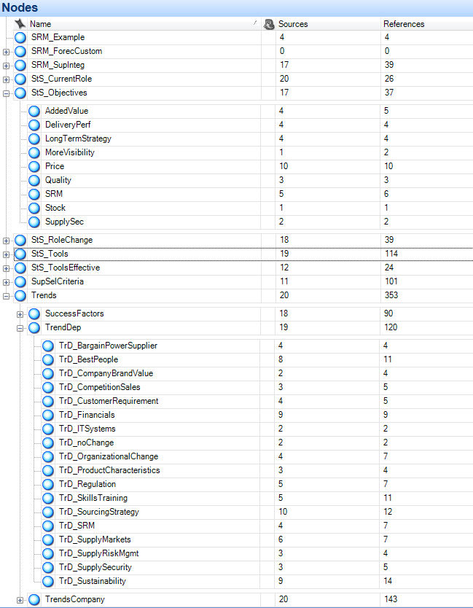

Appendix 4: Summary of case findings



**REFERENCES**

Blackhurst, J., Craighead, C.W., Elkins, D., and Handfield, R.B. 2005. “An Empirically Derived Agenda of Critical Research Issues for Managing Supply-chain Disruptions,” *International Journal of Production Research* 43 (19): 4067–81.

Chopra, S., and Sodhi, M.S. 2004. “Managing Risk to Avoid Supply Chain Breakdown.” *MIT Sloan Management Review* 46 (1): 53–61.

Chopra, S., and Sodhi, M.S. 2014. “Reducing the Risk of Supply Chain Disruptions.” *MIT Sloan Management Review* 55 (3): 73–80.

Dey, P.K., Bhattacharya, A., and Ho, W. 2015. “Strategic Supplier Performance Evaluation: A Case-based Action Research of a UK Manufacturing Organisation.” *International Journal of Production Economics* 166: 192–214.

Eisenhardt, K.M. 1989. “Building Theories from Case Study Research.” *The Academy of Management Review* 14 (4): 532–50.

Ho, W., Zheng, T., Yildiz, H., and Talluri, S. 2015. “Supply Chain Risk Management: A Literature Review.” *International Journal of Production Research* 53 (16): 5031–69.

Khan, O., and Burnes, B. 2007. “Risk and Supply Chain Management: Creating a Research Agenda.” *The International Journal of Logistics Management* 18 (2): 197–216.

Miles, M.B., and Huberman, A.M. 1994. *Qualitative Data Analysis: An expanded Sourcebook,* 2nd Edition. London, U.K.: Sage Publication.

Pettit, T.J., Croxton, K.L., and Fiksel, J. 2013. “Ensuring Supply Chain Resilience: Development and Implementation of an Assessment Tool.” *Journal of Business Logistics* 34 (1): 46–76.

PwC, *PwC’s Supplier Risk Management Study 2013*, https://www.pwc.com.au/assurance/assets/supplier-risk-management-study-27nov13.pdf, 2013.

Rossetti, C., and Choi, T.Y. 2005. “On the Dark Side of Strategic Sourcing: Experiences from the Aerospace Industry.” *The Academy of Management Executive*19 (1): 46–60.

Wagner, S.M., and Bode, C. 2006. “An Empirical Investigation into Supply Chain Vulnerability.” *Journal of Purchasing and Supply Management* 12 (6): 301–12.

World-Bank. *GDP 2015*. http://databank.worldbank.org/data/download/GDP.pdf.

Yin, R.K. 2009. *Case Study Research*. 4th Edition. London, UK: Sage Publication.

Yu, H., Zeng, A.Z., and Zhao, L. 2009. “Single or Dual Sourcing: Decision-making in the Presence of Supply Chain Disruption Risks.” *Omega* 37 (4): 788–800.

Zsidisin, G.A., Panelli, A., and Upton, R. 2000. “Purchasing Organization Involvement in Risk Assessments, Contingency Plans, and Risk Management: An Exploratory Study.” *Supply Chain Management: An International Journal* 5 (4): 187–97.