Chemically Synthesized Gold and Silver Particles
Absorbing in the Near-IR Spectral Range
Yu. A. Razumova, N. A. Toropov, and T. A. Vartanyan
We propose methods for creating spherical gold particles of submicron size and silver rod-like particles with transverse dimensions of ~10 nm and an aspect ratio of 1:10. Factors determining the frequency of plasmon resonances are considered, reagents are selected, and their ratios for obtaining prolate silver particles are determined. An optimal concentration of the surfactant is determined for creating most elongated silver particles. A shift of the plasmon absorption toward the near-IR range of the spectrum is obtained.

INTRODUCTION
Nanoparticles of noble metals exhibit plasmon resonances due to oscillations of free electrons. The frequency of these oscillations depends on the material, the geometric parameters of nanoparticles, and the dielectric permittivity of the surrounding medium [1]. At present, the most common plasmon materials are alkali and noble metals [2, 3]. Particles of these metals usually have intense absorption bands in the ultraviolet and visible ranges of the spectrum. At the same time, the properties of these structures, which manifest themselves in a strong localization of electric fields and, as a result, in the modification of the optical properties of different organic and biological molecules, as well as quantum dots placed near them, may serve as a basis for the observation of new phenomena in the infrared range. These properties involve the enhancement of absorption, the possibility of observing giant Raman scattering, the modification of the rates of radiative and nonradiative transitions in molecules and quantum dots, etc. [4–8]. To move to the infrared range, the optical properties of new plasmon materials are being actively investigated at present times. In particular, it has been proposed to use colloidal quantum dots based on metal chalcogenides with a disturbed stoichiometric ratio [9, 10]. However, the huge interest in the near-infrared range is caused not only by the possibility of observing basic laws, but also by solving a number of applied problems. First, since many biotissues have transparency windows in the near-infrared range of the spectrum, noble-metal nanoparticles can be used in biomedical problems. Second, the main telecommunication wavelengths lie in the near-infrared range of the spectrum, which, in turn, is determined by the transparency windows of quartz fiber-optic communication lines. Plasmon effects would improve the characteristics of optoelectronic devices. However, quantum dots with plasmon resonances in the near-IR range that are currently available can hardly be used to solve these problems, since they may negatively affect living organisms and their composition and properties are unstable. Therefore, the objective of this work was to develop methods for the synthesis of nanoparticles from noble metals, plasmon resonances of which would be shifted to the red range of the spectrum with respect to resonances of spherical particles in an aqueous medium.

THEORETICAL BACKGROUND, MATERIALS, AND METHODS
As a theoretical background, we propose to consider the well-known model of nanoparticles in the shape of a nanosphere placed in a quasistationary electric field [1]. Plasmon oscillations arising in these particles can have three mutually orthogonal modes. However, in the model of a sphere, these modes are triply degenerate; therefore, for the case of rather small (~10 nm) silver particles in vacuum, we can calculate the corresponding plasmon resonance wavelength using the optical constants from [11]. In the case of a single silver particle in a vacuum, it is smaller than 400 nm. In addition to the geometrical characteristics of the particle, the dielectric permittivity of the surrounding medium has a significant effect on the frequency of plasmons [1]. In the case of aqueous solutions, the frequency of plasmon oscillations of spherical silver particles with a diameter of ~10 nm corresponds to 405–410 nm. Correspondingly, upon contact with a medium with a higher real part of the dielectric permittivity, e.g., with gallium arsenide, the wavelength will be large [12].
In the model of a particle in the shape of a prolate spheroid, one can show that the frequency of plasmon oscillations corresponding to the major semiaxis of the spheroid decreases. Thus, if strongly prolate particles are used, e.g., with a 1:10 aspect ratio between the semiaxes, the wavelength of corresponding plasmon resonances is almost 1000 nm [1]. We note that dipole plasmon oscillations in silver and gold particles are excited upon interaction with light if the particle size is smaller than half the light wavelength. If the wavelength becomes comparable with the particle size, quadrupole oscillations can be observed [1, 13], as well as, potentially, oscillations of higher orders.
In this work, the frequency of plasmon resonances is varied by changing the geometry of particles. In the first case, we synthesized colloidal solutions of spherical gold particles of submicron sizes, while, in the second case, we synthesized silver particles in the shape of prolate spheroids.
To create both solutions, we used the method of indirect growth of seeds, in which two main components are mixed. The first component is a seed solution containing gold or silver nanoparticles with a size of 1–10 nm in the nucleation stage. The second component of the mixture ensures the further growth of larger particles in the case of gold, or anisotropic growth conditions in the case of silver rods.
Gold particles were formed from a seed solution prepared on the basis of gold chloride (HAuCl4) in a volume of 5 mL (at a concentration of 0.5 mmol/L). To ensure the nucleation of particles in the seed solution, we used a cetyltrimethylammonium bromide (CTAB) surfactant, which was dissolved in 5 mL of deionized water in an ultrasonic bath (at a concentration of 25 mmol/L), and 0.6 mL of sodium boron hydride (10 mmol/L), which was added being cooled to 0°C. To grow particles, 25 μm of the seed solution were added to a preprepared growth solution. The growth solution was prepared as follows: 10 mL of CTAB (30 mmol/L) were actively mixed with 0.25 mL of silver nitrate (4 mmol/L), and 5 mL of HAuCl4 (1 mmol/L) were added to them. After thorough stirring, 70 μL of ascorbic acid (0.8 mol/L) were added. As soon as the seed solution was added, the growth solution was maintained at room temperature for 30 min without stirring. The obtained colloidal solutions were examined in cells by absorption spectroscopy in the wavelength range of 200–900 nm, and, also, were deposited on semiconductor gallium arsenide substrates and studied by scanning electron microscopy (Zeiss Merlin) in the electron backscattering regime.
To synthesize silver nanorods, two approaches were tested. The first of them, following [14], uses a binary mixture of surfactants in the growth solution, the second approach uses only CTAB. In both cases, the seed solution consisted of silver nitrate (20 mL with a concentration of 0.25 mmol/L), which was reduced by sodium citrate (0.25 mmol), and sodiumboron hydride. In our experiments, we found that the seed solution becomes matured after maintaining at room temperature for 2 h. After maintaining for 5 h, the seed solution becomes unusable, since the particles pass into a stable phase and cease to grow.
In the first approach (in the case of a two-component mixture), the growth solution consisted of CTAB mixed with benzyl dimethyl hexadecyl ammonium chloride (BDAC). To these substances, silver nitrate, alkaline solution, and ascorbic acid were added. Prolate particles were also grown without stirring the seed and growth solutions. Despite the data available in the literature on the synthesis of nanorods using a similar technique [14], the optical density spectra showed a large fraction of round-shaped particles with a maximum at 420 nm and a weakly pronounced shoulder in the spectrum at a wavelength of 500 nm. In this case, a change in the ratio between the surfactants in favor of CTAB resulted in an increase in the optical density of the long-wavelength maximum of the spectrum. Thus, we showed that CTAB is the key reagent for the formation of nanorods, and, in the second approach, only this compound was used.

RESULTS AND DISCUSSION
Figure 1 shows the absorption spectrum of a solution of synthesized gold particles. The spectrum exhibits a wide band of the plasmon absorption of gold nanoparticles. The image of gold nanoparticles deposited on a gallium arsenide substrate is also shown. The image was obtained with a scanning electron microscope. The diameter of synthesized particles reaches 380 nm. It should be noted that, upon precipitation onto a substrate, particles aggregate into larger clusters. Since the solutions were sonicated prior to the measurement of the absorption spectra, we assume that the concentration of such agglomerates in them is extremely low and they contribute insignificantly to the spectrum. Nevertheless, it should be noted that the wing of the plasmon absorption extends to 700 nm.
Our experiments on creation of silver nanoparticles showed that, when the seed solution was added to the growth solution that contained only one surfactant, CTAB (10 mL with 73 mg of dry matter) and silver nitrate (0.5 mL, 100 mmol/L), ascorbic acid, and NaOH (0.1 mL, 1 mol/L), the spectrum of the resulting solution significantly changed compared to the seed solution consisting of small silver particles (Fig. 2). When CTAB was used, along with a typical maximum at 420 nm, the spectrum also exhibited a maximum of the optical density at 650 nm, which indicates the formation of nanorods and the excitation of transverse and longitudinal plasmonic modes, respectively.
We also examined solutions with lower and higher concentrations of CTAB. The spectra of particles grown in them were similar to the spectra of the seed solution, but were more broadened. Alternatively, such solutions led to a shift of the plasmon resonance band toward smaller wavelengths. As an example, Fig. 2 shows the absorption spectrum of a colloid that was prepared with CTAB containing 143 mg of dry matter in the growth solution.
Using a scanning electron microscope, we verified the obtained results. The SEM image clearly shows silver nanorods. It should be noted that they are not uniform in size, which causes a large width of the opticaldensity spectrum. Their aspect ratio reaches 1:10.

CONCLUSIONS
Therefore, in this work, we demonstrated the possibility of synthesis of gold and silver nanoparticles with plasmon resonances, which are shifted to the redrange of the spectrum compared to spherical particles. For silver, we showed that the use of only one surfactant, CTAB, is optimal from the point of view of creating particles absorbing in the near-infrared range. We determined the optimal concentration of the surfactant in the growth solution. It is obvious that an increase in the aspect ratio of prolate particles is possible provided that the concentrations of the remaining components and the synthesis conditions are optimized, which we plan to do in the future.

- Kelly K.L., Coronado E., Zhao L., Schatz G.C. // J. Phys. Chem. 2003. V.107. №3. P.668. doi 10.1021/jp026731y
- Drampyan R., Leonov N., Vartanyan T. // Journal of Modern Optics. 2016, V.63. №14. P. 1347. doi 10.1080/09500340.2016.1145747
- Toropov N.A., Leonov N.B., Vartanyan T.A. // Physica Status Solidi (B) Basic Research. 2017. Article in Press. doi 10.1002/pssb.201700174
- Rai V.N., Srivastava A.K., Mucherjee C., Deb S.K. // Appl. Opt. 2012. V. 51. P. 2606. doi 10.1364/AO.51.002606
- Kamalieva A.N., Toropov N.A., Vartanyan T.A. // Int. J. Nanotechnology. 2016. V.13. № 8/9. P. 642. doi 10.1504/IJNT.2016.079667
- Kamalieva A., Toropov N., Reznik I., Vartanyan T. // Opt. Quant. Electron. 2016. V. 48. № 12. P. 562. doi 10.1007/s11082-016-0841-2
- Nabiullina R.D., Starovoĭtov A.A., Toropov N.A. // J. Opt. Technol. 2017. V. 84. P. 453. doi 10.1364/JOT.84.000453
- Toropov N.A., Starovoytov A.A., Leonov N.B., Kaliteevskaya E.N., Vartanyan T.A. // Proc. SPIE. 2013. V. 8766. P. 87660Q. doi 10.1117/12.2017137
- Luther J.M., Jain P.K., Ewers T., Alivisatos A.P. // Nat. Mater. 2011. V. 10. P. 361–366. doi10.1038/nmat3004
- Balitskii O.A., Sytnyk M., Stangl J., Primetzhofer D., Groiss H., Heiss W. // ACS Appl. Mater. Interfaces. 2014. V. 6. P. 17770–17775. doi 10.1021/am504296y
- Johnson P.B., Christy R.W. // Phys. Rev. B. 1972. V. 6. P. 4370. doi 10.1103/PhysRevB.6.4370
- Kosarev A., Chaldyshev V., Toropov N., Gladskikh I., Gladskikh P., Baryshnikova K., Preobrazhenskiy V., Putyato M., Semyagin B., Vartanyan T. // Proc. SPIE. 2017. V. 10346. P. 1034613. doi: 10.1117/12.2272994
- Toropov N.A., Gladskikh I.A., Parfenov P.S., Vartanyan T.A. // Opt. Quant. Electron. 2017. V. 49. № 4. P. 154. doi 10.1007/s11082-017-0996-5
- Shajari D., Bahari A., Gill P., Mohseni M. // Opt. Mater. 2017. V. 64. P. 376. doi 10.1016/j.optmat.2017.01.004
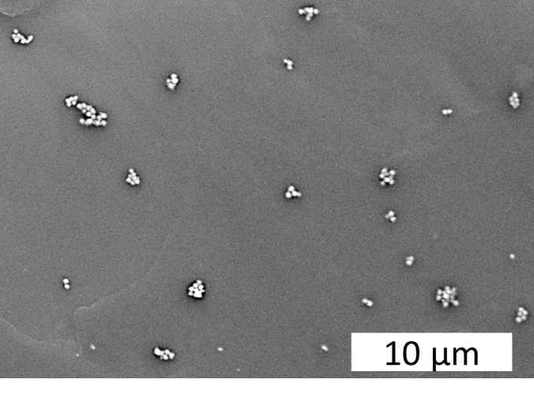
Fig. 1. Absorption spectrum of a colloidal solution of synthesized gold particles and their SEM image.

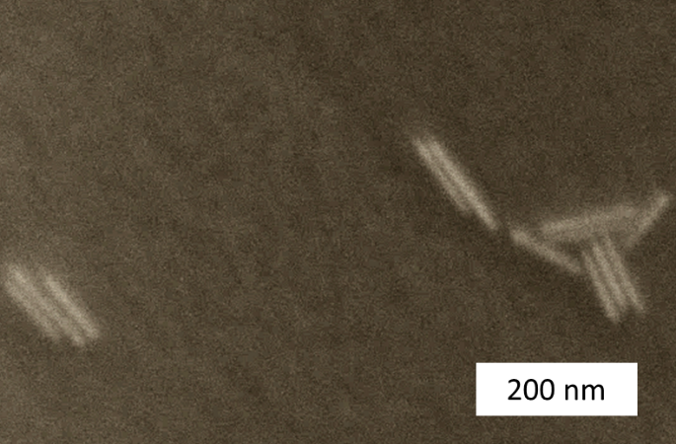
Fig. 2. Absorption spectra of (1) a seed solution and (2) a colloidal solution of nanorods with a CTAB content of 73 mg in a growth solution and (3) with a CTAB content of 143 mg. On the right, a SEM image of rods (73 mg CTAB) on gallium arsenide is presented.

