Electrochemical Impedance Spectroscopy State of Charge Measurement for Batteries using Power Converter Modulation

Shady Gadoue1, Kuan-Wen Chen2, Paul Mitcheson2, Vladimir Yufit3, Nigel Brandon3

1 School of Engineering and Applied Science, Aston University, Birmingham, United Kingdom

2Department of Electrical and Electronic Engineering, Imperial College London, United Kingdom

3Department of Earth Science and Engineering, Imperial College London, United Kingdom

E-mail: [s.gadoue@aston.ac.uk](mailto:s.gadoue@aston.ac.uk)

***Abstract*—** **This paper will demonstrate the concept of a new, low-cost, on-line technique for monitoring battery state of health (SOH) and state of charge (SOC) using electrochemical impedance spectroscopy (EIS). A particular focus will be electric vehicles (EVs), where the SOC accuracy over existing battery management systems (BMS) will improve range prediction accuracy, although the proposed technique is also applicable to other electrochemical energy storage devices. While currently there exist few methods to measure the battery state of charge online, these methods are generally categorized as “indirect” methods which are prone to errors due to environmental changes and require additional hardware/costs for implementation.** **In this paper the EIS excitation signal will be generated by the system’s *existing* power converter without requiring extra hardware but only requires software upgrade. The main objective of the proposed method is to minimize the impact on the main operation of the power converter in the system.**

***Keywords—State of charge, Batteries, Energy Storage, Electric Vehicles.***

# Introduction

With the advance of new chemical manufacturing processes, different types of new rechargeable batteries are being produced. Over the last two decades the development of Li-ion batteries has been continuing to demonstrate its advantages over conventional batteries. These advantages include high energy density, low self-discharge rate, no memory effect, low maintenance requirement, no scheduled cycling required and availability for a variety of voltages. Among the Li-ion battery family, lithium-ion iron phosphate (LFP) battery stands out from the crowd and is currently one of the most widely used secondary batteries power source. It becomes a mature technology that has several advantages which made it a suitable power source especially for electric vehicles (EVs) applications. These advantages include: relatively high energy density, low self-discharging rate, maintenance free, and it can be fast-charged just under an hour.

Existing battery management systems (BMS), especially those employed in EV applications, rely on several techniques to estimate state of charge and health. The simplest use Coulomb counting [1] in combination with look up tables of battery performance from previous testing. Knowledge of battery discharge rates, temperature and cycling history is also used to inform the SOC prediction and adaptive state estimation is used in more advanced systems [2, 3]. A disadvantage of these time domain techniques is that they are all subject to drift inaccuracy over time, meaning accuracy is reduced at the most critical point in use – when the battery is degrading. More complicated estimation techniques have been also proposed such as extended Kalman filter (EKF ) [4]

In contrast, Electrochemical Impedance Spectroscopy (EIS) is a powerful laboratory tool to identify battery state of charge (SOC) and state of health (SOH) [5, 6]. EIS measurements are obtained by applying small AC voltage or current perturbations at the battery terminals at different frequencies in order to measure the battery impedance as a function of frequency. This data can then be interpreted to determine the status of the battery [5]. Impedance measurement can be also used for fault detection and analysis in battery packs [7]. Advantages of EIS over methods employed in traditional BMS are tolerance to integrator drift, improved, non-invasive insight into battery degradation processes, and computationally efficient calculation [5]. Improved battery status accuracy is of significant interest in EVs as it will allow improved range estimation and lower range anxiety. Even though the state of charge (SOC) for EV battery could be measured and determined currently by using the EIS technique, nevertheless this is usually constrained to laboratory environments with bulky, sensitive and expensive equipment.

A fundamental requirement for measuring the EIS is to generate the required current or voltage perturbation signal. In the laboratory, a galvanostat (or potentiostat) is used as a signal source which, combined with an accurate voltage (or current) amplitude and phase measurement is used as the basis for generating the impedance data. However, these instruments are large, expensive and unsuitable for vehicle integration [6]. For on-line use, the circuitry connected to the battery pack must be capable of generating current perturbations at across a range of frequencies and amplitudes. This could be achieved using dedicated circuitry, although it is desirable to be able to utilize this technique without the need for the dedicated hardware. This will keep weight down and mean minimal modifications for vehicle manufacturers to implement the scheme.

Previous research [6] has shown that a low cost version of such a system can be realized, for EV applications, using power electronic converters as the signal source and with carefully calibrated measurement circuitry and signal processing to accurately determine the battery impedance. This research has established the basic techniques but limitations including effect on EV performance, torque pulsations and relevant motor drive system have not been considered. Furthermore, the proposed method has been tested on BLDC motor drive system which is not one of the most common motor drive employed for existing EVs.

This paper proposes a novel technique for monitoring the condition of battery health and state of charge in EVs using the *already existing* vehicle motor drivetrain through software modifications only. The focus will be on PMSM drives which are currently the most commonly employed electric drive system for vehicle power train. This paper shows that injecting a perturbation signal on the d-axis current command of the PMSM drive, as the vehicle power train, will create an appropriate perturbation signal for the EIS system that can be then used for impedance measurement and hence SOC monitoring for the battery connected to the PMSM drive. Simulation results confirm the feasibility of the proposed strategy which is further verified by a comparison with laboratory experimental data of the EIS system within a wide range of frequencies.

# Battery Impedance Measurement

Electrochemical Impedance Spectroscopy (EIS) is a standard and powerful tool in electrochemistry to diagnose the reactions occurring within batteries in order to characterize the chemical process in terms of electrical measurements. It is generally achieved by applying a small perturbation signal (a sine wave voltage at one particular frequency for instance) across the two terminals of the battery, and the current response is measured to compute the impedance of the battery at that particular frequency. The process is repeated for a number of different frequencies to compute the frequency response of the battery, following that a Nyquist Plot can be obtained for analyzing the battery SOC. Fig. 1 shows a typical Nyquist Plot for LFP after the EIS measurement has taken within a frequency range of 0.1Hz-5kHz [5]. This method is a simple, non-invasive and cost-effective means to gain insights into the internal properties of the battery.

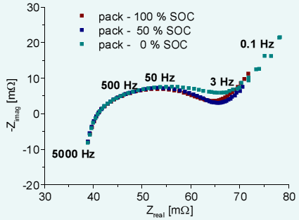

Fig.1 EIS measurements of a 4-cell pack at open circuit voltage

Following the EIS measurement, an equivalent circuit model (ECM) is employed to model the LFP battery (Fig. 2) and for parameter fitting to get a clear relationship with SOC [5].

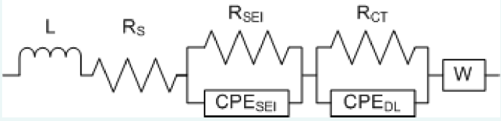

Fig. 2 Equivalent circuit LFP model for fitting EIS data [5]

Since it has been previously reported that one of the battery parameter-constant phase elements relating to double layer capacitance behaves “monotonically” with battery SOC [5], this parameter could serve as an indication for battery SOC measurement online. Fig. 3 [5] demonstrates the relationship between single battery SOC against double layer capacitance under laboratory conditions when using a potentiostat and frequency spectrum analyzer.

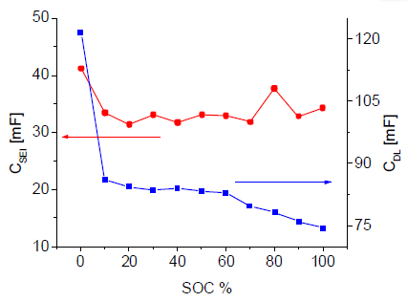

Fig. 3 Double layer capacitance variation against single battery SOC [5]

# PMSM Drive System and Control

PMSM drives have been commonly employed for EV applications, such as the power drivetrain used in Nissan Leaf or Renault Zoe EVs. Field oriented control (FOC) is the standard control technique applied for PMSM drives. The main objective of FOC is to completely decouple flux and torque producing current components.

The general electrical torque expression for PMSM can be expressed as:

 (1)

where and are the stator *d* and *q* winding flux linkages. The expressions for the stator *d* and *q* winding flux linkages using FOC can be expressed as follows respectively:

 (2)

 (3)

Hence by controlling *ids* to be zero:

 (4)

And hence the motor torque is controlled by controlling *iqs*. A block diagram of the FOC system is shown in Fig. 4.



Fig. 4 FOC block diagram for PMSM drive system

# The Proposed Method

The main objective of this research is to propose a novel efficient online method for battery SOC monitoring in EV applications using novel strategies in motor control by making *almost no changes* to the existing vehicle hardware. Instead, the existing vehicle motor controller will be used as source of excitation for battery impedance online measurement with the aim of minimizing the impact on vehicle performance. The proposed condition monitoring technique is based on EIS and relies on a FOC PMSM drive employed in most modern electric and hybrid vehicles drives powertrain. The EIS technique requires the battery to be excited at different frequencies (normally by drawing a small AC current from the battery, at a variable frequency, set by the algorithm). This small excitation signal allows the battery impedance to be determined as a function of frequency and the impedance/frequency data can then be interpreted to generate battery SOC and SOH.

Different from existing techniques, the AC perturbation signal is proposed to be injected, for the first time, on the stator *d*-axis current demand of the electric drive FOC system to produce the required perturbation in the dc link current connecting the battery to the inverter-fed machine. The *d*-axis stator current in a FOC PMSM drive system is responsible for the motor magnetization and is usually kept constant below rated speed and is usually zero for PMSM drives. Signal processing algorithms will be employed to analyze the battery current and voltage waveforms and consequently to generate the frequency-dependent battery impedance curves which will be used to identify the battery state of charge (SOC) online. The block diagram of the proposed condition monitoring technique is shown in Fig. 5.

# Simulation Results And Discussions

To prove the concept of the proposed SOC online monitoring technique, the FOC system of a PMSM vehicle drive controller, shown in Fig. 4, has been developed in Matlab-Simulink. A dynamic model of the PMSM has been employed. The equivalent circuit model of the LFP battery in Fig. 2 is used to model the battery connected to the dc link of the PMSM drive system. The parameters of the PMSM used in this study are given in Table I. The system has been simulated with a small signal injected on the *d*-axis of the stator current demand at a frequency range of 20 Hz to 4 kHz starting at 0.2 sec. Simulation results are shown in Figs. 6-7 for the drive system performance (Motor speed and torque) at injection frequencies of 66 Hz and 1.23 kHz respectively. It can be shown that a perturbation signal, with similar frequency, is produced on the dc link current (battery current) waveform as shown in the frequency spectra of both filtered battery voltage and current in Figs. 6-7. This perturbation signal will be the excitation signal required by the EIS to generate the required perturbation in the battery voltage. It can be noticed that the signal injection has little effect on the motor drive performance speed and torque waveforms which makes this technique suitable for online EIS.



Fig. 5 Proposed SOC monitoring technique

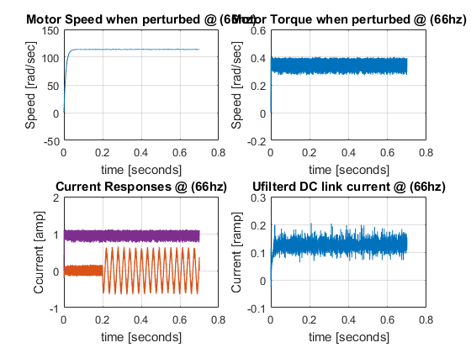

ids

Motor Torque (N.m)

Current (A)

Current (A)

Speed (rad/s)

Motor Torque

Motor Speed

*d-q* Motor Currents

*iqs*

DC Link Current

(a)

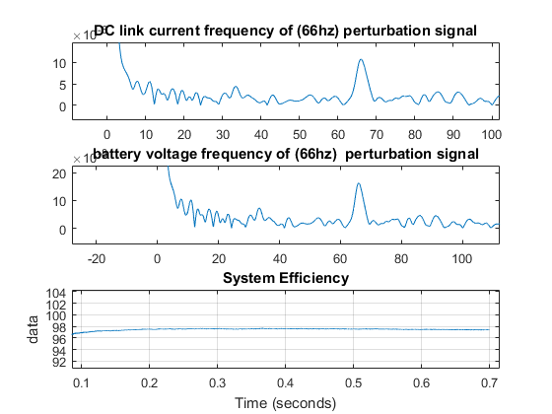

Battery Current

×10-5

Battery Voltage

×10-7



Frequency (Hz)

(b)

Fig. 6 Simulation results of the proposed technique using PMSM drive at injection frequency of 66 Hz (a) Motor drive performance (b) FFT of filtered battery current and voltage

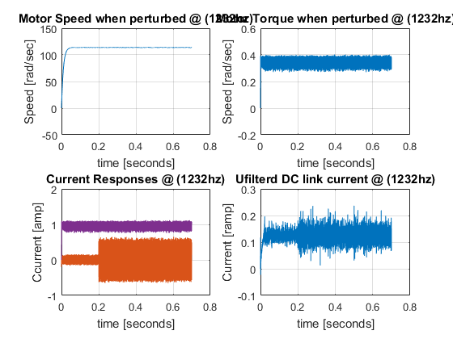

*iqs*

Motor Torque (N.m)

Current (A)

Current (A)

Speed (rad/s)

Motor Speed

Motor Torque

*d-q* Motor Currents

ids

DC Link Current

Z

(a)

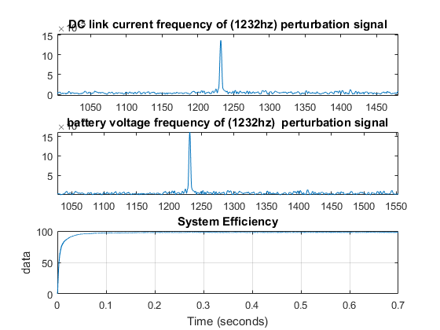

×10-5

Battery Current

Battery Voltage



×10-7

Frequency (Hz)

(b)

Fig. 7 Simulation results of the proposed technique using PMSM drive at injection frequency of 1.23 kHz (a) Motor drive performance (b) FFT of filtered battery current and voltage

To verify the feasibility of the proposed method the signal injection at the *d*-axis stator current (within a frequency range of 20 Hz to 4 kHz) has been repeated for different SOC (this can be adjusted by changing the relevant parameters of the equivalent circuit model in Fig. 2). At each frequency, the FFT of both filtered battery current and voltage is carried out and the corresponding battery impedance value is calculated. Hence the battery impedance graphs at different SOC and frequency can be obtained. The acquired impedance graphs are compared with those obtained from experimental data [5] for the same battery. Figs. 8-11 show a close agreement between the battery impedance graphs obtained from the proposed method and the experimental data for 100%, 80%, 60% and 40% SOC. This proves the proposed method ability to be used for online measurement of battery impedance and hence battery SOC using existing hardware without the need of any extra circuitry for excitation while the battery voltage measurement can be obtained from the existing BMS system.

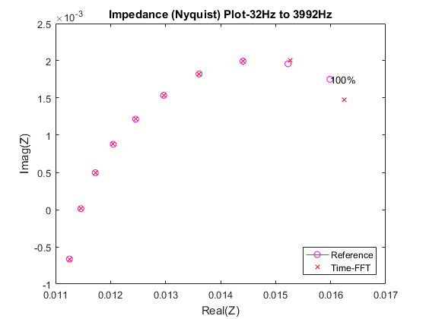Fig. 8 Simulation Impedance plot (cross) vs. experimental data (dot) when battery is at 100% SOC

32 Hz

4 kHz

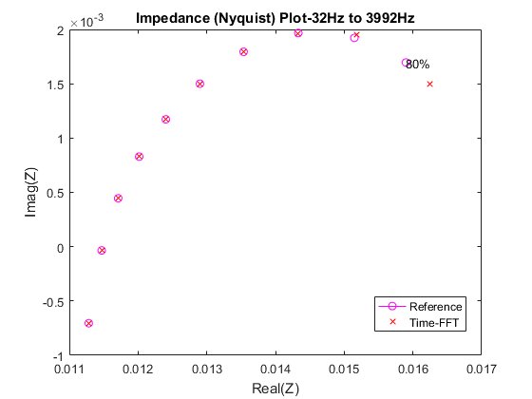Fig. 9 Simulation Impedance plot (cross) vs. experimental data (dot) when battery is at 80% SOC

4 kHz

32 Hz

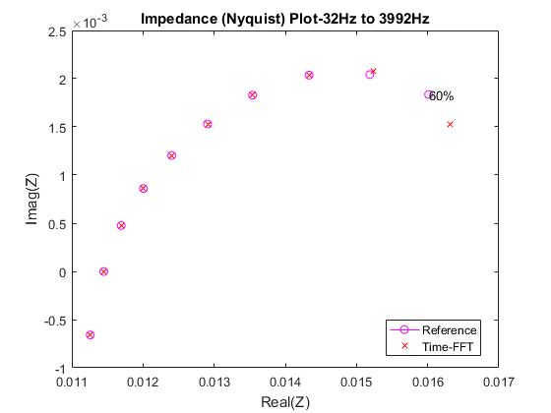

4 kHz

32 Hz

Fig. 10 Simulation Impedance plot (cross) vs. experimental data (dot) when battery is at 60% SOC

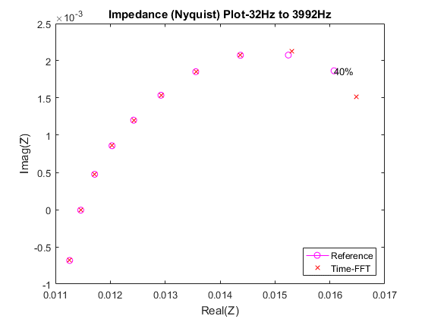 Fig. 11 Simulation Impedance plot (cross) vs. experimental data (dot) when battery is at 40% SOC

32 Hz

4 kHz

|  |  |
| --- | --- |
| Table I  PMSM Parameters | |
|  | 3.55 ohms |
|  | 13.3 mH |
|  | 8 mH |
|  | 8 mH |
| Pole pairs | 4 pairs |
| Rated power | 400W |
| Rated speed | 3000 rpm |
| Flux linkages (by magnets) | 0.05996 V.s |

# Conclusions

This paper presented a novel method for online monitoring of battery SOC using EIS techniques. The proposed method can be also applied to other electrochemical energy storage devices. A particular focus was given to batteries for EV applications. The existing vehicle PMSM motor drive controller is proposed to be used as the source of the excitation signal required by the EIS to generate the impedance plots of the battery and hence determine the SOC. Simulation results show that by injecting a small AC signal on the d-axis current demand of the PMSM FOC drive system an appropriate excitation signal with same frequency is generated on the battery terminals with little effect on the vehicle motor drive performance. The impedance plots of the battery can be obtained by using signal processing techniques. The simulation results are compared with experimental data and close agreement between the two sets have been achieved.

Nonetheless, further investigations and experimental works are still needed in order to check the feasibility of the technique since currently EMI, DC-link noise and other real-life experimental factors are not taken into account.

# references

[1] E. Meissner and G. Richter, “Battery monitoring and electrical energy management: Precondition for future vehicle electric power systems,” *J. Power Sources*, vol. 116, no. 1/2, pp. 79–98, Jul. 2003.

[2] G. Plett, “Extended kalman filtering for battery management systems of LiPB-based HEV battery packs, Part 1: Background,” *J. Power Sources*, vol. 134, no. 2, pp. 252–261, Aug. 2004.

[3] D. V. Do, C. Forgez, K. El Kadri Benkara and G. Friedrich, "Impedance Observer for a Li-Ion Battery Using Kalman Filter," in *IEEE Transactions on Vehicular Technology*, vol. 58, no. 8, pp. 3930-3937, Oct. 2009.

[4] G. Plett, “Extended kalman filtering for battery management systems of LiPB-based HEV battery packs, Part 1: Background,” *J. Power Sources*, vol. 134, no. 2, pp. 252–261, Aug. 2004.

[5] D. A. Howey, V. Yufit, P. D. Mitcheson, G. J. Offer and N. P. Brandon, "Impedance measurement for advanced battery management systems," *Electric Vehicle Symposium and Exhibition (EVS27), 2013 World*, Barcelona, 2013, pp. 1-7.

[6] D. A. Howey, P. D. Mitcheson, V. Yufit, G. J. Offer and N. P. Brandon, "Online Measurement of Battery Impedance Using Motor Controller Excitation," in *IEEE Transactions on Vehicular Technology*, vol. 63, no. 6, pp. 2557-2566, July 2014.

[7] G. J. Offer, V. Yufit, D. A. Howey, et al., Fault analysis in battery module design forelectric and hybrid vehicles*, J. Power Sources*, 206:383–392, 2012.