Post-print of: Micron volume 43, issues 2–3, February 2012, pages 215–222

An international round-robin calibration protocol for nanoindentation measurements

M. Cabibbo (a), P. Ricci (a), R. Cecchini (b), Z. Rymuza (c), J. Sullivan (d), S. Dub (e), S. Cohen (f)
a Dipartimento di Ingegneria Industriale e Scienze Matematiche, Università Politecnica delle Marche, Via Brecce Bianche, 60131 Ancona, Italy
b Instituto de Ciencia de Materiales de Sevilla, (CSIC, Universidad de Sevilla), Avenida Américo Vespucio 49, 41092 Sevilla, Spain
c Politechnika Warszawska (WUT – Warsaw University of Technology), Institute of Micromechanics and Photonics, ul. Sw.A. Boboli 8, 02-525 Warsaw, Poland
d Aston University, Aston Triangle, Birmingham, B4 7ET, United Kingdom
e Institute for Superhard Materials of the National Academy of Sciences of Ukraine, Avtozavodskaya str. 2, 04074, Kiev, Ukraine
f Weizmann Institute of Science, Rehovot, Israel

Abstract
Nanoindentation has become a common technique for measuring the hardness and elastic–plastic properties of materials, including coatings and thin films. In recent years, different nanoindenter instruments have been commercialised and used for this purpose. Each instrument is equipped with its own analysis software for the derivation of the hardness and reduced Young's modulus from the raw data. These data are mostly analysed through the Oliver and Pharr method. In all cases, the calibration of compliance and area function is mandatory. The present work illustrates and describes a calibration procedure and an approach to raw data analysis carried out for six different nanoindentation instruments through several round-robin experiments. Three different indenters were used, Berkovich, cube corner, spherical, and three standardised reference samples were chosen, hard fused quartz, soft polycarbonate, and sapphire. It was clearly shown that the use of these common procedures consistently limited the hardness and reduced the Young's modulus data spread compared to the same measurements performed using instrument-specific procedures. The following recommendations for nanoindentation calibration must be followed: (a) use only sharp indenters, (b) set an upper cut-off value for the penetration depth below which measurements must be considered unreliable, (c) perform nanoindentation measurements with limited thermal drift, (d) ensure that the load–displacement curves are as smooth as possible, (e) perform stiffness measurements specific to each instrument/indenter couple, (f) use Fq and Sa as calibration reference samples for stiffness and area function determination, (g) use a function, rather than a single value, for the stiffness and (h) adopt a unique protocol and software for raw data analysis in order to limit the data spread related to the instruments (i.e. the level of drift or noise, defects of a given probe) and to make the H and Er data intercomparable.
Keywords
Nanoindentation; Calibration; Round-robin; Hardness; Young's modulus
1. Introduction
Nanoindentation is a relatively new technique for the measurement of hardness, reduced Young's modulus, and strain rate sensitivity when small penetration depths and measurement volume are required (Fisher-Cripps, 2000, Elmustafa and Stone, 2003a, Elmustafa and Stone, 2003b and Zhang et al., 1996). However, to date, little attention has been paid to the data spread that the use of different instruments, calibration and analysis procedures might introduce. Further work on standardisation is therefore needed.
Hardness is defined as the resistance of a solid material to indentation by another harder material. The hardness test actually measures the resistance strength of the material under loading by a virtually undeformable indenter. This measurement is usually performed through the evaluation of the contact area between the two materials. It is affected by surface roughness, and the microstructure features of the sample, such as grain structure, interfaces, precipitates and so forth (Guidoni et al., 2009, Berke et al., 2010 and Tam et al., 2009). The operation becomes complicated when measuring a thin film which has been deposited on a substrate. In this case, the contribution of the substrate may disturb the hardness evaluation of the thin film, as the indenter penetration starts to interact with the substrate-coating contact surfaces (Fisher-Cripps, 2000, Elmustafa and Stone, 2003a, Elmustafa and Stone, 2003b, Pharr, 1998, Franco et al., 2004, Doerner and Nix, 1986, Elmustafa and Stone, 2003a and Elmustafa and Stone, 2003b). This implies a dependence of the hardness measurement on the volume of the interacting material. Thereafter, in some circumstances, the hardness analysis through continuum mechanics in the nanoscale range may no longer be possible (Elmustafa and Stone, 2003a and Elmustafa and Stone, 2003b).
Sharp triangular pyramids, such as Berkovich, or cube corner indenters are generally used when the smallest possible length scale is needed. Other tips, such as spherical ones, may also be used, particularly when it is necessary to acquire information about the elastic behaviour of thin films (Fisher-Cripps, 2000, Pharr, 1998 and Bell et al., 1992). This is because the contact of the indenter with the sample surface is elastic when the load is low and becomes elastic–plastic as the load rises, allowing the sample yield strength to be evaluated (Pharr, 1998). Sharp tips and spherical indenters suffer, respectively, from sharpness, and spherical geometry imperfections. This geometrical aspect leads to measurement inaccuracy which can affect the nanoindentation evaluations if they are not properly performed and calibrated. The indenter penetration depths may be as little as 20 nm with very limited contact areas. Thus the accuracy of the tip radii and the spherical geometry are of the utmost importance (Pharr, 1998 and Franco et al., 2004).
For hard and superhard coatings, the plastic deformation generated by the load–depth curve is quite small, due to the shallow penetration depth of the tip. Thus, even small accuracy errors in displacement measurements are likely to affect the goodness of the hardness data. The preliminary calibration stage is therefore crucial for the reliability of nanoindentation measurements. Nowadays, several different nanoindentation instruments are commercialised and used within the scientific community. Each instrument requires specific calibration procedures to be followed in order to extract the Young's modulus and hardness from the recorded raw data. Although the instrument hardware varies, the Oliver and Pharr approach (Joslin and Oliver, 1990 and Oliver and Pharr, 1992) is generally the reference method for data analysis. The ISO/FDIS 14577-1 standard (ISO/FDIS 14577-1, 2002) accepts the Oliver and Pharr method (Oliver and Pharr, 1992) for the hardness and Young's modulus evaluation through nanoindentation. This standard is indeed an attempt to give guidelines for the reproducibility and direct comparability of nanoindentation results (ISO/FDIS, 2002 and Herrmann et al., 2000). The standard primarily addresses the indentation of bulk materials. At European level a draft standard, addressing the case of indentation of coatings, has been prepared by the Committee CEN TC184-WG5 and the INDICOAT project (DESIRED, 2000, Draft of CEN TC 184; INDICOAT, 2001). These standards also define an indentation depth limit of 200 nm for nano-range measurements. Analyses of the nanoindentation method readily show that the geometry of the indenter tip is almost always an important source of measurement inaccuracies. Another reason for the non-intercomparability of the raw data and nanoindentation hardness measurements, when using different instruments, is the adoption of different calibration procedures and protocols. The different calibration protocols are strictly related to the variety of raw data software analysis applications, available on the market. In fact, each nanoindentation instrument requires specific skills and step-by-step calibration procedures to be followed in order to extract the Young's modulus and the hardness values from the raw data. To date, very few works have been published on this critical issue (Lee et al., 2003, Perry et al., 1988, Jacobs et al., 2003 and Jennett and Owen-Jones, 2002). Of these four published works, three (Perry et al., 1988, Jacobs et al., 2003 and Jennett and Owen-Jones, 2002) are dedicated to micro- and nano-scratch calibration procedures applied to hard TiN and DLC coatings through round-robin experiments. Recently, only the work by Lee et al. (2003) has focused on an international round-robin experiment to evaluate the consistency and intercompatibility of hardness measurements among different nanoindentation instruments. Their work focuses on tests on coated samples of hardness ranging between 15 and 35 GPa, and provides recommendations for guaranteeing hardness measurement consistency.
The current paper deals with and presents an international round-robin calibration protocol applied to different nanoindentation instruments for the measurement of the hardness and the reduced Young's modulus of different, hard and soft, samples using three different indenters: Berkovich, cube corner, and spherical. The use of a common calibration protocol for different instruments was aimed at evaluating, minimising, and overcoming the statistical data spread, which has been observed to affect nanoindentation measurements when two or more datasets, coming from multiple instruments, are compared. The reported round-robin experiments were conducted within the framework of a European funded project (Nanoindent NMP3-CA-2008-218659).
2. Method
The common calibration and analysis procedures (protocol, described below) that were followed for different nanoindentation instruments are based on the Oliver and Pharr method (Oliver and Pharr, 1992 and ISO/FDIS, 2002). Therefore, hardness and reduced Young's modulus are obtained after a complete cycle of indenter loading–unloading, using the Oliver and Pharr equations for hardness, H, and Young's modulus, Er, determination (Pharr et al., 1992).
The international round-robin was aimed at calibrating the machine compliance (Cm) and the area function, and therefore at calibrating the measurements of H and Er for the different instruments used, and with different indenters. The major steps in these experiments were: (a) definition and distribution of identical reference samples, (b) definition of a common measurement protocol, (c) definition of a common analysis protocol and (d) data analysis using the common protocol.
The consistency and goodness of the protocol were tested by comparing the data spread obtained using this procedure with that obtained through the instrument default procedure. The raw data were acquired using common reference samples for all the different nanoindentation instruments. The data spread evaluation also served as a means for the identification of sources of misalignment, yielding possible further advantages of the protocol used here.
The commercially available reference samples were: fused quartz (Fq: Er = 72 GPa, ν = 0.17) as a hard material, sapphire (Sa: Er = 410 GPa, ν = 0.234) for its high Young's modulus, polycarbonate (Pc: Er = 3.3 GPa, ν = 0.37) as a soft material. These samples were circulated among partners and all the results obtained, using the common protocol with different instruments, were sent to the partner labelled as Hys-U in the following table, which includes all the partners, their nanoindentation instruments and the available indenters (Table 1). Three different indenters were used: Berkovich, B, cube corner, cc, and spherical, Sp.
The common measurement protocol consisted of two parts: process 1 and process 2. Process 1 dealt with the calibration of both the stiffness (inverse of compliance) and the area functions for each available instrument and indenter. Process 2 was aimed at establishing a common procedure to be followed, on the basis of process 1, for the measurement of H and Er on the common reference samples. Measurements in process 1 were carried out on Fq and Sa for all the three indenters with a trapezoid-shaped function having tload = 20 s, thold = 10 s, tunload = 20 s (Fig. 1a). The maximum load was in the range 100–10,000 μN, for the low range, and between 10 and 100 mN, for the high range. In Process 2, H and Er were measured on Fq and Pc, with load functions as described in Fig. 1(b), for the Fq, and 1(c), for the Pc. The H and Er values on Fq were measured using a cyclic load function consisting of 10 steps at tload = 10 s, thold = 10 s, tunload = 3 s. The 10 steps were scaled to 10% load increment, one after the other, up to the maximum load. At the end of the cycle, the tip was unloaded to 10% of the maximum load for a 120 s dwelling time. The maximum load was 2 mN and 10 mN, for instruments using low loads and 20 mN and 100 mN, for instruments using higher loads. The H and Er on Pc were measured using a single cycle load function with tload = 20 s, thold = 60 s, tunload = 3 s to 10% of the maximum load, followed by a final holding time of 60 s. The maximum load was 0.1, 1 and 10 mN for instruments using low loads and 1, 10, 100 mN, for instruments using higher loads. All the measurements in process 2 were repeated 10 times per each maximum load (Fig. 1).
To compare the data and to evaluate the intercompatibility of the different instruments, the 10 data sets obtained for each instrument, probe and load, were averaged. The analyses of Process 2 yield the H and Er values as a function of the contact depth, hc, for each probe, instrument and maximum load on both Fq and Pc. Raw data were analysed using a common software application (ASMEC Indent Analyser, website: www.asmec.de). All the measurements were analysed using the same software parameters. Specifically, the default values for the fitting range of the unloading curve were set to 98% and 40% of the maximum force; the zero point correction and thermal drift correction were fixed automatically. The goodness of the calibration procedure was evaluated in terms of the alignment of the measurement of H and Er obtained by partners using different instruments and probes, as different probes are expected to produce a systematic difference.
All the data were collected and analysed by the UNIVPM partner (acronym: Hys-U, see Tab. 1) using dedicated software (ASMEC Indent Analyser, website: www.asmec.de).
3. Results and discussion
3.1. Process 1: calibration of stiffness (inverse of compliance) and area function
After having determined the instrument/indenter stiffness function, the area function was calculated using the data recorded during process 1, for each indenter, on the Fq and Sa samples. Fig. 2 shows a representative example of stiffness as a function of the load, F. It was found that, even for the same instrument, the stiffness of different indenters varies remarkably. This clearly justifies the need for performing separate stiffness measurements for each instrument and for each indenter. The range of load (and therefore depth) over which the calibration was performed depended on the maximum load force available for the different instruments (e.g. 10 mN for Hys-U, and a maximum limit of 100 mN set for MTS). These data also confirm the importance and utility of using both Sa and Fq in the stiffness calibration process. Another key aspect of the common analysis software is the adoption of a stiffness function, rather than a single stiffness value for the area function analysis (as suggested in instrument manuals). This allows variations in the stiffness value for different loads. As regards the area function, the observed curve differences are due to the shape and curvature radius of the indenter. These area functions were used for the evaluation of H and Er in process 2. Fig. 2(b) gives an example of the reported area function differences.
The ASMEC Indent Analyser software was also used to obtain the indenter tip curvature radius and the curvature of the spherical indenter (Table 2). This is an important parameter, as it is known that measurements become unreliable as the contact depth approaches the indenter curvature radius. In fact, in some instrument manuals the rule of thumb is to keep contact depth above one-third of the probe radius. The indenter radius has to be taken into consideration when H and Er are measured. In some cases a cut-off value of penetration depth below which measurements are considered unreliable has to be taken into account. Some of the values reported in Table 2 are rather suspect, as they are too small. This is probably due to the poor quality of some of the measurements, which were responsible for the unreliability of the calibration measurements and a possible misevaluation of the indenter curvature radii. In this regard, Fig. 3 shows an example of a poor quality dataset, recorded with an Hys-T, and the same dataset obtained by Hys-U showing a much better load–unload curve quality. The stiffness and area function calibration values, obtained in process 1, were used for calibration process 2.
3.2. Process 2: hardness (H) and reduced Young's modulus (Er) measurement and analysis
The calibration processes were used by all partners (with the sole exception of ASMEC/UNAT which only took part in process 1) to evaluate the hardness, H, and reduced Young's modulus, Er, of hard, Fq, and soft, Sa, reference samples. Measurements on these samples were first performed following the common protocol, and then using the data analysis tool available for each instrument. To compare the data and then evaluate the goodness and reproducibility of the different instrument data, a set of 10 measurements was averaged for each partner, each available indenter, and specific instrument maximum load.
In order to avoid tip rounding effects on the measurements, the calculation of these average values was carried out after having defined a penetration depth, hc, cut-off limit. Therefore, only H and Er values with hc > R/10 and hc > R/3 (R, indenter curvature radius) for B and cc, respectively, were used. No cut-off limit was used for Sp probes. These values were compared in order to evaluate the intercomparability of the different instruments used after having followed the common calibration procedures. The results of this comparison are reported in Fig. 4 and Fig. 5. The goodness of the calibration procedure was evaluated in terms of the spread of H and Er obtained by partners using different instruments and indenters. In the case of the Berkovich indenter, the data converged to a common value of H = 8.2, 0.16 GPa, and Er = 68, 3.4 GPa, for the hard Fq and soft Pc samples, respectively. In the case of the cube corner indenter, the data converged to a common value of H = 8.2, 0.17 GPa, and Er = 71, 3.3 GPa, for the hard Fq and soft Sa samples, respectively. These values were quite close, even if affected by a slight underestimation, to the expected values of H = 9.25, 0.16 GPa, and Er = 69.6, 3.3 GPa, for Fq and Pc, respectively. As regards the spherical indenter, the hardness values were slightly different compared to the results obtained using the two former indenters. Hardness was 6.0, 0.21 GPa, and Er = 69, 3.3 GPa, for the hard Fq and soft Sa samples, respectively. The reason why these data showed a better estimation and a lower standard deviation of the Young's modulus lies in the calibration procedure of the ASMEC Indent Analyser which is based on the Er calibration.
Fig. 4 also reports the sets of data obtained using the existing standards for the instruments. In particular, ISM performed measurements and analyses using Agilent software and a Berkovich indenter; while UNIVPM used Hysitron software with Berkovich and cube-corner indenters. The figure shows that the scatter of data is lower when using the common protocol with respect to the evaluation of the raw data with instrument specific analysis procedures. It is worth pointing out that another difference consisted in the determination of the zero-point, which was done by extrapolating several data points in the ASMEC software application, thus allowing for a non-ideal touch.

The main differences between most instrument software applications/protocols and the common analysis protocol (ASMEC Indent Analyser), presented here, is the use of both Fq and Sa as reference samples, and the adoption of a function for the stiffness, rather than using only Fq and a single value, which is currently the most commonly used instrument default prescription for calibration procedures.
For all the indenters the errors were smaller in the Er measurements compared to H, and they were roughly the same for soft and hard reference samples (slightly higher for the soft samples). The smallest error spreads were found with the Berkovich indenter, and the largest with the spherical one ( Fig. 4 and Fig. 5). It is also important to note that the dispersion of the results obtained without adopting the common protocol (either for measurements or analysis) was larger than when the protocol was followed. This effect can be clearly seen in the case of the Berkovich and the cube-corner indenters. As regards the spherical indenter, this effect was not so clear since only a few partners used instruments equipped with this type of tip.
The collection and direct comparison of data from different types of nanoindentation instruments using a common analysis procedure for the same materials, is quite unique, as, to the authors’ knowledge, it has been done in very few cases before (Lee et al., 2003, Perry et al., 1988, Jacobs et al., 2003 and Jennett and Owen-Jones, 2002). The importance and utility of the results obtained with this protocol are twofold. On the one hand, it can be used to interpret the data spread in nano-mechanical testing (namely for H and Er measurements). The data spread is not due to the different ways of performing the calibration of the area function and stiffness, to the type of reference samples used, to the way of performing the measurements of H and Er, to the tested sample, nor to the way of analysing the results, as all these parameters were fixed for all the partners. Therefore, in the first approximation, the spread obtained can be attributed to intrinsic instrument differences (e.g. the level of drift, instrument noise), superimposed on the statistical spread due to random variations (e.g. operator accuracy). On the other hand, this protocol can also be used as a starting point to compare this calibration procedure to other existing calibrations, suggested by the different nano-mechanics companies. As can be seen from Fig. 4, the use of different instrument manual protocols for calibration, measurement or data analysis, has a clear effect on the results. This new protocol is also intended to be a preliminary attempt to establish a unique means of calibration for all existing nanoindentation instruments. Indeed, the authors believe that there is still room for improvement to further reduce the spread of the results presented here. In this respect, the present protocol needs some modification concerning its application to the spherical indenter, as shown in Fig. 4 and Fig. 5, where hardness data averaged to a lower value, on Fq, and a slightly higher value, on Pc, compared to the results obtained using the sharper tips. Moreover, the data acquired using the spherical indenter suffer from a considerably coarser standard deviation. Some possible improvements are likely to concern the type of load curves used for H and Er measurements. In fact it was noticed that the drift rate of some instruments was large in comparison to the duration of the measurement, which is likely to cause a drift variation during the measurement and hence the risk of applying a wrong correction coefficient in the analysis stage. One solution would be the use of separate load–unload curves rather than one load curve with multiple load–unload cycles.
4. Concluding remarks
A new protocol for calibration and data analyses of hardness and reduced Young's modulus of hard and soft samples was drawn up and successfully tested by six different partners using six different nanoindentation instruments (Hysitron UBI and Triboscope, Micro Materials, Agilent G200, UNAT-ASMEC, and MTS XP). This protocol is conceived and designed to become the reference calibration procedure to be followed by users of different nanoindentation instruments. Three different diamond indenters, Berkovich, cube-corner and spherical, were used on common reference samples: a hard fused quartz, a soft sapphire and a highly elastic polycarbonate.
A comparison of the results obtained by the different instruments was performed in order to estimate the spread of results in common nano-mechanical testing. These results were used to identify the major sources of data spread strictly related to the different instruments. It was shown that the adoption of a function, rather than a simple value, for the stiffness improves the calibration accuracy. The hardness and reduced Young's modulus data spread was considerably lowered when this calibration protocol was applied, compared to the instrument-specific calibration procedures.
To obtain sound and intercomparable hardness and Young's modulus data for different nanoindentation instruments, the following precautions and recommendation must be followed: (a) use only sharp indenters (Berkovich and cube-corner) and spherical indenters of well known curvature radius, (b) as measurements becomes unreliable when the contact depth approaches the tip curvature radius a cut-off value of penetration depth, below which measurements are considered unreliable, should be chosen, (c) perform nanoindentation measurements with limited thermal drift. When the drift is too large or unstable during indentation it will introduce wrong corrections to the raw data resulting in the misevaluation of H and Er, (d) since load–displacement curves with very poor reproducibility lead to large uncertainty in the probe calibration, curves must be as smooth as possible, (e) perform stiffness measurements specific to each instrument/indenter couple since, even for the same instrument, the stiffness function of different indenters is remarkably different, (f) use both Fq and Sa, rather than only Fq, as calibration reference samples for stiffness and area function evaluation, (g) greatly improve the accuracy of the calibration procedure by using a function, rather than a single value, for the stiffness and (h) using different analysis software and/or different software analysis settings (e.g. the use or not of zero point correction, the use of different orders for the fitting functions) may yield different results.
The adoption of a unique protocol and software for raw data analysis was shown to greatly limit the data spread related to the instruments (i.e. level of drift or noise, defects of a given probe) and to make the H and Er data intercomparable.
Acknowledgments
This work was carried out within the framework of the FP7-funded NANOINDENT (NMP3-CA-2008-218659) project entitled Creating and disseminating novel nanomechanical characterisation techniques and standards. All the authors acknowledge the European Commission for having funded this research activity. The authors also wish to thank Dr. Thomas Chudoba, ASMEC, for allowing the use of their data and for the fruitful discussions.
References
Bell et al., 1992
T.J. Bell, J.S. Field, M.V. Swain
Size-dependent hardness in annealed and work hardened a-brass and aluminum polycrystalline materials using activation volume analysis
Thin Solid Films, 220 (1992), pp. 289–294

Berke et al., 2010
P. Berke, F. El Houdaigui, T.J. Massart
Coupled friction and roughness surface effects in shallow spherical nanoindentation
Wear, 268 (2010), pp. 223–232

Elmustafa and Stone, 2003a
A.A. Elmustafa, D.S. Stone
Stacking fault energy and dynamic recovery: do they impact the indentation size effect?
Mater. Sci. Eng., A358 (2003), pp. 1–8

Fisher-Cripps, 2000
A.C. Fisher-Cripps
A review of analysis methods for sub-micron indentation testing
Vacuum, 58 (2000), pp. 569–585

Franco et al., 2004
A.R. Franco, G. Pintaúde, A. Sinatora, C.E. Pinedo, A.P. Tschiptschin
The use of a Vickers indenter in depth sensing indentation for measuring elastic modulus and Vickers hardness
Mater. Res., 7 (2004), pp. 483–491

Guidoni et al., 2009
G.M. Guidoni, M.V. Swain, I. Jäger
Wear behaviour of dental enamel at the nanoscale with a sharp and blunt indenter tip
Wear, 266 (2009), pp. 60–68

DESIRED, 2000
DESIRED, 2000. European project, EC contract G6RD-CT2000-00418: Certified Reference Materials for DepthmSensing Indentation Instruments & Draft of CEN TC184: Advanced Technical Ceramics, WG5: Methods of Test for Ceramic Coatings, WI 121-132: Determination of Hardness and Young's Modulus by Depth Sensing Indentation.

Doerner and Nix, 1986
M.F. Doerner, W.D. Nix
A method for interpreting the data from depth-sensing indentation instruments
J. Mater. Res., 1 (1986), pp. 601–609

Elmustafa and Stone, 2003b
A.A. Elmustafa, D.S. Stone
Size-dependent hardness in annealed and work hardened a-brass and aluminum polycrystalline materials using activation volume analysis
Mater. Lett., 57 (2003), pp. 1072–1078

Herrmann et al., 2000
K. Herrmann, N.M. Jennett, W. Wegener, J. Meneve, K. Hasche, R. Seemann
Progress in determination of the area function of indenters used for nanoindentation
Thin Solid Films, 377–378 (2000), pp. 394–400

INDICOAT, 2001
INDICOAT Contract SMT4-CT98/2249, 2001. European Commission – Standards, Measurements and Testing Programme (SMT). Determination of hardness and modulus of thin films and coatings by nanoindentation.

ISO/FDIS, 2002
ISO/FDIS 14577-1, 2002. Metallic materials – instrumented indentation test for hardness and material parameter for Standardization, ISO Central Secretariat, 1211, Geneve, Switzerland.

Jacobs et al., 2003
R. Jacobs, J. Meneve, G. Dyson, D.G. Teer, N.M. Jennett, P. Harris, J. von Stebut, C. Comte, P. Feuchter, A. Cavaleiro, H. Ronkainen, K. Holmberg, U. Beck, G. Reiners, C.D. Ingelbrecht
A certified reference material for the scratch test
Surf. Coat. Technol., 174–175 (2003), pp. 1008–1013

Jennett and Owen-Jones, 2002
N.M. Jennett, S. Owen-Jones
NPL Measurement Good Practice Guide No. 54 ‘The Scratch Test: Calibration, Validation and the Use of a Certified Reference Material’
NPL Materials Centre (2002)

Joslin and Oliver, 1990
D.L. Joslin, W.C. Oliver
A new method for analyzing data from continuous depth-sensing microindentation tests
J. Mater. Res., 5 (1990), pp. 123–126

Lee et al., 2003
K.W. Lee, Y.W. Chung, C.Y. Chan, I. Bello, S.T. Lee, A. Karimi, J. Patscheider, M.P. Delplancke-Ogletree, D. Yang, B. Boyce, T. Buchheit
An international round-robin experiment to evaluate the consistency of nanoindentation hardness measurements of thin films
Surf. Coat. Technol., 168 (2003), pp. 57–61

Oliver and Pharr, 1992
W.C. Oliver, G.M. Pharr
An improved technique for determining hardness and elastic modulus using load and displacement sensing indentation experiments
J. Mater. Res., 7 (1992), pp. 1564–1583

Perry et al., 1988
A.J. Perry, J. Valli, P.A. Steinmann
Adhesion scratch testing: a round-robin experiment
Surf. Coat. Technol., 36 (1988), pp. 559–575

Pharr, 1998
G.M. Pharr
Measurement of mechanical properties by ultra-low load indentation
Mater. Sci. Eng., A253 (1998), pp. 151–159

Pharr et al., 1992
G.M. Pharr, W.C. Oliver, F.R. Brotzen
On the generality of the relationship among contact stiffness, contact area, and elastic modulus during indentation
J. Mater. Res., 7 (1992), pp. 613–617

Tam et al., 2009
E. Tam, M.S. Lhernould, P. Lambert, A. Delchambre, M.P. Delplancke-Ogletree
Electrostatic forces in micromanipulation: experimental characterization and simulation including roughness
Appl. Surf. Sci., 255 (2009), pp. 7898–7904
Zhang et al., 1996
K. Zhang, E. Soderlung, A.E. Giannakopoulos, D.J. Rowcliffe
Controlled indentation: a general approach to determine mechanical properties of brittle materials
Acta Mater., 44 (1996), pp. 1127–1141

Figure captions

Figure 1. Load functions of process 1 (a), process 2 on fused quartz (Fq) (b), and process 2 on polycarbonate (Pc) (c).
Figure 2. Stiffness, S, (a) and square root of the area function, A, (b) vs. indenter penetration force, F, for the Berkovich indenter and in the low load function range.
Figure 3. Force vs. displacement plots using the Berkovich indenter on sapphire (Sa) according to protocol process 1. Example of data obtained by Hys-U (a) and data obtained by Hys-T (b). The bad quality of the curves can be noticed in the case of Hys-T measurements (b), which ultimately invalidates the reliability of the calibration measurements and the evaluation of the indenter curvature radius.
Figure 4. Results of process 2 of the calibration protocol on fused quartz, Fq. H as a function of maximum load for the different instruments used with Berkovich (a), cube-corner (c) and spherical (e) indenters; Er as a function of maximum load for the different instruments used with Berkovich (b), cube-corner (d) and spherical (f) indenters. Data obtained using the procedures and instrument software for Hysitron (Hys-U) and Agilent (Agil) are also reported as bright solid square data points. Mean values and related standard deviation are also shown.
Figure 5. Results of process 2 of the calibration protocol on polycarbonate, Pc. H as a function of maximum load for the different instruments used with Berkovich (a), cube-corner (c) and spherical (e) indenters; Er as a function of maximum load for the different instruments used with Berkovich (b), cube-corner (d) and spherical (f) indenters. Mean values and related standard deviation are also reported.

Table 1
Table 1. Nanoindentation instruments used by the six different partners with their acronyms.
Instrument | Institute | Acronyms
Hysitron UBI | Università Politecnica delle Marche (UNIVPM) | Hys-U
Hysitron Triboscope | Politechnika Warszawska (WUT) | Hys-T
Micro Materials | Aston University (AU) | MM
Agilent Nanoindenter G200 | V. Bakul Institute for Superhard Materials of the National Academy of Sciences of Ukraine (ISM) | Agil
UNAT | ASMEC GmbH (ASMEC) | UNAT
MTS Nanoindenter XP | Weizmann Institute of Science (WIS) | MTS

Table 2
Table 2. Indenter curvature radii measured by the different partners (indicated by their acronyms) each for the available diamond indenters: B (Berkovich), cc (cube-corner), Sp (spherical).
Instrument | Acronyms | Indenter | Curvature radius [μm]
Hysitron UBI | Hys-U | B | 0.63
 |  | cc | 0.44
Hysitron Triboscope | Hys-T | B | 0.19
 |  | cc | 0.31
 |  | Sp | 0.22
Micro Materials | MM | B | 0.31
 |  | cc | 0.21
 |  | Sp | 2.1
Agilent Nanoindenter G200 | Agil | B | 0.28
UNAT | UNAT | B | 0.18
 |  | Sp | 0.27
MTS Nanoindenter XP | MTS | B | 0.29
 |  | cc | 0.06
 |  | Sp | 1.1

Figure 1
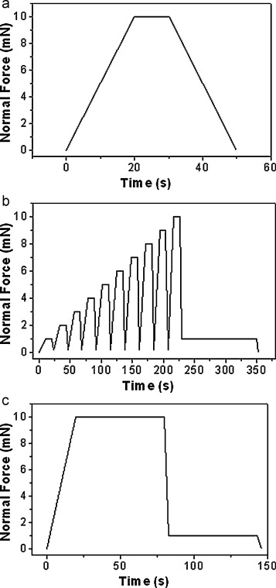

Figure 2
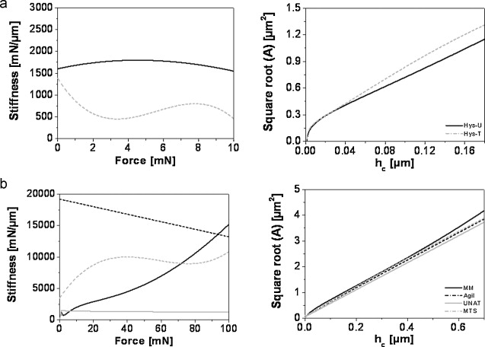

Figure 3

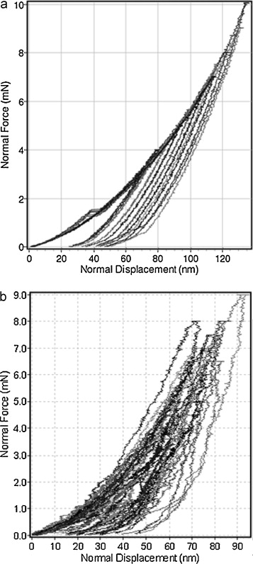

Figure 4
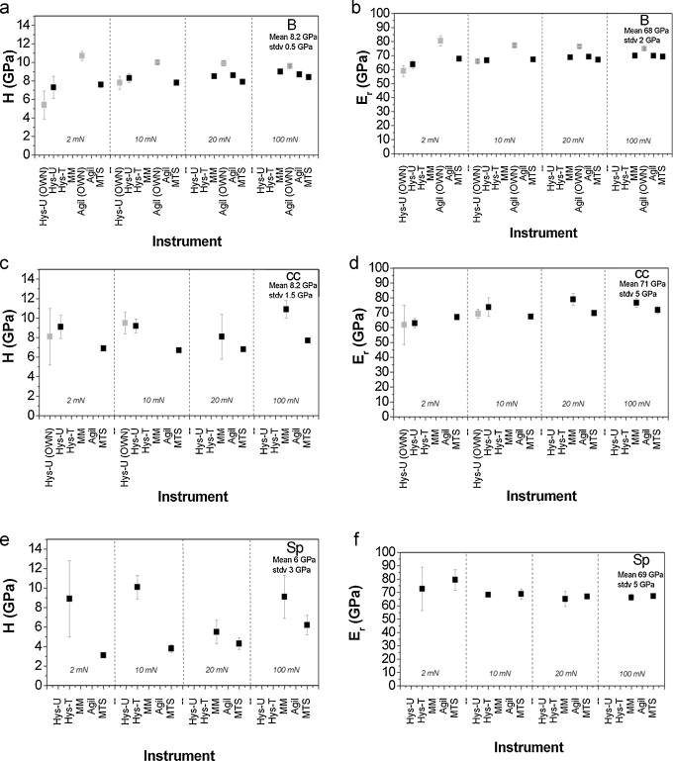

Figure 5
