A SENSITIVITY STUDY ON THE HUMAN CRYSTALLINE LENS USING FINITE ELEMENT ANALYSIS
*Benjamin. J. Coldrick¹, J. G. Swadener¹, Leon. N. Davies²
¹Biomedical Engineering Research Group, Aston University, Birmingham, B4 7ET
²Ophthalmic Research Group, Aston University, Birmingham, B4 7ET

*coldricb@aston.ac.uk
Key Words: structure, biomechanics, finite element analysis

ABSTRACT
Finite element analysis is a useful tool in understanding how the accommodation system of the eye works. Further to simpler FEA models that have been used hitherto, this paper describes a sensitivity study which aims to understand which parameters of the crystalline lens are key to developing an accurate model of the accommodation system. A number of lens models were created, allowing the mechanical properties, internal structure and outer geometry to be varied. These models were then spun about their axes, and the deformations determined. The results showed the mechanical properties are the critical parameters, with the internal structure secondary. Further research is needed to fully understand how the internal structure and properties interact to affect lens deformation.

INTRODUCTION
A fundamental attribute of human vision is the ability to change focus, so that objects both near and far can be seen. In the young eye, this ability is controlled by the accommodation system, where humans are able to change focus due to the crystalline lens changing shape (Figure 1). For distance vision, the lens assumes the relaxed position, where it is in the lowest power form. This is achieved by relaxation of the ciliary muscle, which, in turn, pulls the zonular fibres that surround the equator of the lens, flattening the lens [1]. For the lens to form its most powerful shape, for near vision, the ciliary muscle contracts, causing the zonular fibres to relax. This causes the lens to change shape as the capsule, which surrounds the lens, applies an inwards pressure on the lens [1]. Although accommodative ability is present in the young human eye, the amplitude of the response declines with age. Consequently, by approximately 50-55 years of age, the lens is no longer able to be formed into is most powerful form, resulting in the loss of ability to focus on near objects; this condition is known as presbyopia.[1]
Iris
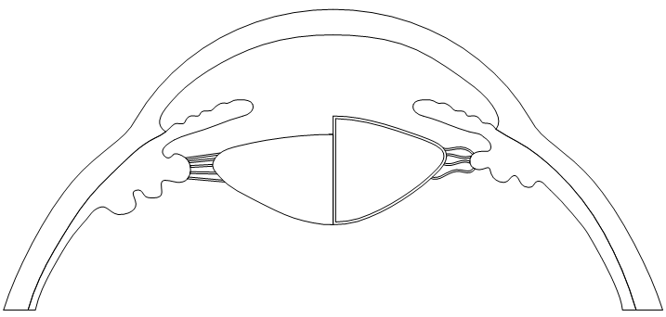
Cornea
Contracted ciliary muscle
Lens in most powerful shape
Relaxed zonules
Taunt zonules
Relaxed ciliary muscle
Lens in least powerful shape
Figure 1: Schematic of eye showing accommodation stages, the left hand side represents the lens in its low power form
Given the ubiquity of presbyopia, it is important to understand why it develops so that potential preventative and therapeutic techniques can be developed. Although functional near vision can be achieved with simple methods such as spectacles or contact lenses, or more advanced methods such as intraocular lenses, these are not ideal. The ideal method of treating presbyopia would be to restore the dynamic change in power that a young lens can achieve, therefore restoring the full range of near and far vision [2].
Finite element analysis has been used in a number of previous studies to analyse the accommodation system [3-6]. While some approaches differ, many similarities occur either in the model geometry or the model mechanical properties. The current study will explore these models to lay the groundwork for a more detailed FEA model of the accommodation system.

2. METHOD
A sensitivity study was designed, which would allow a range of lenticular parameters to be varied, enabling the key parameters that affect lens deformation to be analysed. The method chosen to model the lens deformation was a lens spinning test; this has been used on both cadaver eyes [7] and in a previous FEA model [8]. It has been established that a spinning speed of 107.4 rad/s can result in lens deformations that approximate the degree of deformation that an in-vivo lens undergoes during accommodation [7].
The key parameters analysed were the lens shape (its surface curvature and thickness), the internal structure of the lens and the mechanical properties. Each of these parameters has been shown to change with age [9, 10]. As presbyopia affects adults after the age of 50 years; three age groups were chosen that should show the changes that occur in the lens between the ages of 20, 40 and 60 years.
An existing lens modelling method [11] was adapted to create the lens outline, using measured in-vivo data [12] for defining the accommodated lens shapes.
Three internal structure models were modelled, each with a different number of internal shells as shown in Figure 2. The first, a two shell model, was based on the assumption that the lens can be modelled as having a nucleus and cortex only. The second, a four shell model based on in-vivo [12] and in-vitro [13] work which showed the lens could be segmented further. The final model was a 10 shell model based on mechanical properties found through in-vitro dynamic mechanical analysis (DMA) [10].
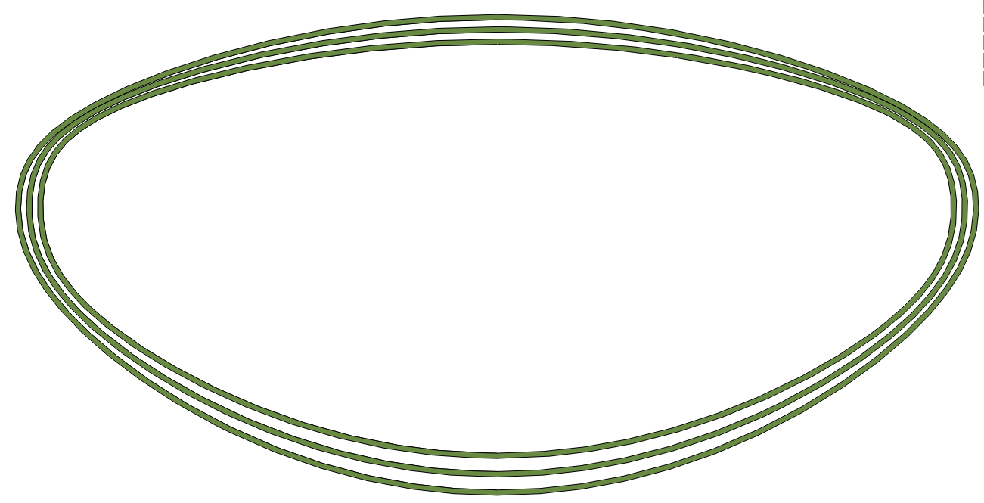
C
B
D
A
Figure 2: A, B and C show the different internal structure models, D shows the three age outlines, with the youngest lens model on the inside and the oldest on the outside
The final parameter is the elastic modulus of the lens, values were obtained from the DMA work that the 10 shell models were based on, for 20, 40 and 60 year old lenses. The lens is assumed to have a possions ratio of 0.49[8]. The final property needed was the density, which is assumed to be 105 kg/m³ [8].
The program used for the analysis was ANSYS® (Academic Research, Release 14.0). The study was a static study with large deformations. Quadrilateral elements (PLANE183) were used with axi-symmetry enabled. The lens was fixed at the posterior lens surface.

3. RESULTS
To analyse the deformations of the lens models, the change in thickness and lens power was calculated. The power was calculated using the thick lens formula, where the radius of curvature of the lens surfaces was calculated using a circle fitting algorithm. The axial thickness change was calculated across the centre of the lens.
Figure 3 shows that the largest contributor to lens deformation is the mechanical property age. The properties associated with a young lens show a large power change upon being spun, while properties associated with an old lens show no power change. When the mechanical properties remain constant, altering the geometry only has an impact on a lens with young mechancail properites. For an older lens, changing the shape has no effect.
B
A
D
4. DISCUSSION
Figure 3: Graph A shows the power change with only mechanical property variation, Graph B shows the Power change with only geometry variation, Graphs C & D show the power and thickness change with only internal structure variation
C
The principal aim of this work was to understand which parameters have the most impact on human crystalline lens deformations, as they will be the parameters which will need careful consideration when building a complete model of the accommodation system. However, a secondary aim was to explore which parameters of the lens could be manipulated to restore accommodative ability to an old eye.
Figure 3 illustrates that the mechanical properties have the largest impact on lens deformation; using the properties of a young lens gives a much larger power change than can be achieved with properties derived from an older lens. Figure 3 (C&D) shows that the internal structure model does not have as large an impact on lens power, but the effects are not easy to predict, shown by the difference in trend of the thickness change. This indicates that further work is needed to fully understand how the number of shells influences shape change. The outer lens shape has little effect other than when the mechanical properties from a 20 year old lens are used. However, further work is needed to take into account the influence of the capsule on these deformations.
From these results, further research into mechanical property variation would be prudent, as it can be seen that altering the mechanical properties gives the largest change in power, indicating that it will be key in restoring accommodative ability to older eyes. A complete lens model, including the capsule, can then be developed, which can then be implemented into a FEA model of the accommodation system. Using this model, predictions can be made about what changes within the accommodation system to cause the loss of accommodative ability with age.

5. CONCLUSION
As a first step in developing a complex FEA model, understanding what the key parameters are that affect lens deformation is essential. This study has shown the importance of the mechanical properties, as well as that further research is needed to understand how the internal structure affects lens deformation; it has also shown that outer lens geometry is not as important in analysing lens deformation.
6. REFERENCES
1. Sheppard, A.L., et al., Accommodating intraocular lenses: a review of design concepts, usage and assessment methods. Clinical and Experimental Optometry, 2010. 93(6): p. 441-452.
2. Glasser, A., Restoration of accommodation: surgical options for correction of presbyopia. Clinical and Experimental Optometry, 2008. 91(3): p. 279-295.
3. Burd, H.J., S.J. Judge, and J.A. Cross, Numerical modelling of the accommodating lens. Vision Res, 2002. 42(18): p. 2235-251.
4. Ljubimova, D., A. Eriksson, and S. Bauer, Aspects of eye accommodation evaluated by finite elements. Biomechanics and Modeling in Mechanobiology, 2008. 7(2): p. 139-150.
5. Weeber, H.A. and R.G.L. Van Der Heijde, Internal deformation of the human crystalline lens during accommodation. Acta Ophthalmologica, 2008. 86(6): p. 642-647.
6. Abolmaali, A., R.A. Schachar, and T. Le, Sensitivity study of human crystalline lens accommodation. Computer Methods and Programs in Biomedicine, 2007. 85(1): p. 77-90.
7. Fisher, R.F., The elastic constants of the human lens. J Physiol, 1971. 212(1): p. 147-80.
8. Burd, H.J., G.S. Wilde, and S.J. Judge, An improved spinning lens test to determine the stiffness of the human lens. Experimental Eye Research, 2011. 92(1): p. 28-39.
9. Charman, W.N., The eye in focus: accommodation and presbyopia. Clin Exp Optom, 2008. 91(3): p. 207-25.
10. Weeber, H.A., et al., Stiffness gradient in the crystalline lens. Graefes Arch Clin Exp Ophthalmol, 2007. 245(9): p. 1357-66.
11. Giovanzana, S. and S. Talu, Mathematical models for the shape analysis of human crystalline lens. Journal of Modern Optics, 2011: p. 1-9.
12. Dubbelman, M., et al., Changes in the internal structure of the human crystalline lens with age and accommodation. Vision Res, 2003. 43(22): p. 2363-75.
13. Taylor, V.L., et al., Morphology of the normal human lens. Investigative Ophthalmology & Visual Science, 1996. 37(7): p. 1396-1410.

