**Testing the impact of an educational intervention designed to promote ocular health among people with Age-related macular degeneration**

Running head: Nutritional intervention for people with AMD

Dr Rebekah Stevens, Dr Richard Cooke & Dr Hannah Bartlett

Aston University

Corresponding author: Rebekah Stevens, [stevensr@aston.ac.uk](mailto:stevensr@aston.ac.uk)

Keywords: AMD, Nutrition education, diet, intervention

Declaration of conflicting interest

The authors report no conflicts of interest and have no proprietary interest in any of the materials mentioned in this article.

Acknowledgements and funding

This work was funded by The College of Optometrists (grant number 60294).

Abstract

*Purpose*: Research has shown that individuals affected by Age-related macular degeneration (AMD) do not always consume foods or supplements known to be beneficial for ocular health. This study tested the effectiveness of an educational intervention designed to promote healthy eating and nutritional supplementation in this group.

*Methods:* One-hundred individuals with AMD completed baseline measures of several variables: confidence that diet affects AMD; motivation to engage in health protective behaviours; knowledge about which nutrients are beneficial; intake of kale, spinach and eggs. Participants were allocated to either intervention or control conditions. Intervention participants received a leaflet and prompt card that contained advice regarding dietary modification and supplementation. Control participants received a leaflet created by the Royal College of Optometrists. A follow-up questionnaire, measuring the same variables assessed at baseline was administered two weeks later.

*Results* At follow-up, significant condition x time interactions were found for confidence that diet affects AMD (F(1,92) = 4.54, p < 0.05), motivation to talk to an eye professional about supplementation (F(1,92) = 4.53, p = 0.036), motivation to eat eggs (F(1,92) = 12.67, p =0.001), and egg intake (F(1,92) = 11.97, p = 0.001). In each case, intervention participants scored higher than control participants.

*Conclusions* Receiving an educational intervention increased participants’ confidence that diet affects AMD, motivation to engage in health protective behaviours, and egg intake. This intervention could be easily incorporated into current clinical practice delivered by either optometrists or opthamologists.

Introduction

Age-related macular degeneration (AMD) is the leading cause of visual impairment in the developed world (*Opinions and circumstances of visually impaired people in Great Britain: Report based on over 1000 interviews.*, 2006; RNIB, 2010). One way to slow the progression of AMD is by increasing consumption of the carotenoids lutein and zeaxanthin (L+Z), by either eating foods high in L+Z (kale, spinach, or eggs) or taking nutritional supplements such as the AREDS2 formula. However, research shows that AMD patients are often unclear about what foods or supplements they should eat (Stevens, Bartlett, Walsh, & Cooke, 2014) and also report not receiving advice from their ophthalmologist or optometrist regarding nutrition or supplements.

In a recent study 4, it was found that participants with AMD failed to consume the recommended 10 mg amount of the beneficial carotenoids (L+Z). AMD-affected participants in this study consumed only 1.4 mg L&Z per day (Stevens, Bartlett, & Cooke, 2015). In addition, only 25 out of 158 participants ate kale which is considered to be one of the most lutein rich vegetables. One explanation for these results is that they primarily eat food they enjoy and are used to, which are not typically high in (L+Z) (Stevens et al., 2014). Therefore, interventions are needed to change eating habits. It is essential to design effective materials to communicate appropriate dietary and supplementation advice for AMD patients. In addition to boosting individuals’ knowledge of advice, it is also important to change two other variables: self-efficacy and motivation.

Self efficacy is a measure of the confidence that a person has in their ability to perform a behaviour9. Increasing self-efficacy has been shown to provide individuals with the confidence to overcome barriers (Bandura, 1997). Evaluating self-efficacy using scales gives researchers an idea of whether a subject is likely to accomplish a task in the future, and has been used with success in previous studies (Stevens, Bartlett, & Cooke, 2017; Turner, Nicholson, & Sanders, 2011). In the present study, we wanted to increase individuals’ self-efficacy that changing their diet can slow the progression of their AMD.

Another variable that is important to change to promote behaviour change is motivation to perform behaviour. Several models of human behaviour, such as Bandura’s Social Cognitive Theory (1986)(Cahill, 1987), Rogers’ Protection Motivation Theory (1983)(Rogers, 1983) and Ajzen’s (1991)(Ajzen, 1991) Theory of Planned Behaviour, all converge on the idea that motivation is a first step to behaviour change and that you must increase motivation *before* you change behaviour. In the present study, we wanted to increase individuals’ motivation to engage in protective activities such as increasing their consumption of kale, spinach and eggs, as well as consulting with their eye care professional about supplementation. Ultimately, increasing motivation should lead to behaviour change in the form of increased intake of kale, spinach and/or eggs.

The aim of this study was to develop a novel educational intervention to promote healthy eating and nutritional supplementation among AMD patients. Such a tool has the potential to impact the lives of thousands of patients with AMD, and carers of patients with AMD, helping them to navigate the confusing messages that are currently communicated about nutrition, supplementation and eye health.

A successful educational intervention would lead to the following outcomes at follow-up:

1. Participants feeling more confident that changing their diet will slow the progression of their AMD*.*
2. Participants feeling motivated to engage in eye health protective behaviours, such as eating foods high in (L+Z) or asking their eye professional if they would benefit from taking an AREDS2 nutritional supplement.
3. Participants understanding that the most (L+Z) rich foods are spinach, kale and eggs, and how much 10 mg constitutes.
4. Participants increasing their consumption of foods high in (L+Z) or start taking supplements.

Methods

*Ethical approval*

The procedures followed for focus groups and the intervention study were in accordance with the ethical standards of the Aston University Ethics Committee on human experimentation that conform to the Declaration of Helsinki 1975, revised Hong Kong 1989; application number 949.

*Literature search to inform development of the intervention*

A systematic literature search for studies evaluating the effectiveness of nutritional educational interventions delivered to AMD patients was carried out to August 2016 using the following electronic databases: PubMed, Web of Knowledge, The Cochrane Library, Optics Infobase, Ovid Journals, PsycArticles, National Center for Biotechnology Information (NCBI) databases, and Wiley Online Library.

Key words used were:

“effectiveness*” AND “Nutritional* education” or “nutritional* intervention” AND “elderly” OR “older adults” OR “seniors”

This search identified no previous studies on this topic, so an additional systematic literature search for studies evaluating the effectiveness of nutritional educational interventions for older adults with other health issues was performed to identify best practice for this population.

One study (Sahyoun, Pratt, & Anderson, 2004) that reported positive outcomes had nutrition messages that were limited to key nutrients or one/two simple messages to reduce cognitive demands and facilitate effective decision-making. Interventions that were successful were practical or targeted to specific needs (e.g. lowering sodium in hypertension). In general, behavioural changes were often successful if participants were at risk of, or suffering from, a health condition; more serious conditions and symptoms were more motivating (Sahyoun et al., 2004). There was also a greater likelihood of the intervention having a positive outcome if there was face-to-face interaction between participants and health professionals (Gilden, Hendryx, Clar, Casia, & Singh, 1992; Glasgow et al., 1992; van den Arend, Stolk, Rutten, & Schrijvers, 2000).

Research has shown that people are able to cope with 7±2 new concepts at one time and so new concepts need to be introduced gradually (Miller, 1994). The main concepts that we need participants to understand are (i) that (L+Z) are the most beneficial nutrients for the prevention of progression of AMD, (ii) they need to be obtained in the diet, (iii) the most (L+Z) rich foods are spinach, kale and eggs, (iv) the AREDS2 formula is the only clinically proven supplement, and (v) the AREDS2 formula has only been found to be beneficial when the disease is at a certain stage(Chew et al., 2013).

*Focus Groups*

Due to a lack of research identified via the systematic literature searches, it was decided to conduct two focus groups with members of Macular Society support groups to inform the intervention by gaining the perspective of AMD patients. Both focus groups took place in February 2016. Participants were asked where they had received nutritional information from, if they felt they had enough information about nutrition, in which format they would like to receive nutritional advice, and if they would like extra advice such as recipes, alerts or prompts. Most participants commented they would like to receive nutrition advice verbally from a qualified eye professional, and then a simplified leaflet or handout which summarised the key points the professional spoke about to refer back to later. A summarised transcript of the focus groups is included in **Appendix one**.

*Intervention design*

Since the majority of focus group participants said that they would like nutritional advice to come from an eye care professional in the first instance, RS and HB (both qualified optometrists) spoke to participants and gave specific nutritional advice in terms that were easy for patients to understand. To back up topics that were discussed, a leaflet (see **figure one**) was created that could be folded into thirds – this was designed in the same style as Macular Society documents: large font size (14/16 where possible), limited italics and underling, and high contrast primary colours. A prompt card was also created that a patient could keep in a wallet or purse in order to take the card to their eye-care appointments and be reminded of questions they might want to ask their eye-care professional (see **Appendix two**). Participants in the control condition were given a leaflet created by the Royal College of Optometrists (<https://www.college-optometrists.org/membership/free-patient-resources/patient-leaflets.html>).

*Figure one inserted here.*

*Outcome Measures*

The primary outcome measure in this study was an individual’s confidence (self-efficacy) that changing their diet can slow the progession of their AMD. The secondary outcomes measured in this study were (i) motivation to engage in health protective behaviours, (ii) knowledge about AMD, and (iii) intake of three foods high in L+Z: kale; spinach; eggs.

A 13 item survey, created using the software Bristol Online Surveys (University of Bristol, 8-10 Berkeley Square, Bristol BS8 1HH, UK), was used to assess participants’ baseline scores on the outcome measures (see **Appendix three**). Confidence was measured using a single item: Participants rated their confidence that nutrition could slow down the progression of AMD out of 100 (in 10 increment steps). Motivation to engage in five health protectitve behaviours (To eat a diet incorporating kale daily; To eat a diet incorporating spinach daily; To eat a diet incorporating eggs daily; To ask my ophthalmologist or optometrist whether I would benefit from nutritional supplementation; To take a supplement daily if recommended to me from an eye professional) were also measured on a 100 point scale (in 10 increment steps). Knowledge was measured by asking participants which of four possible options were the most lutein rich. The choices were a) spinach, kale and eggs, b) cabbage, lettuce and mango, c) kale strawberries and blueberries, and d) eggs, cheese and milk. Participants were also asked to report their intake of spinach, kale and eggs in the last week.

In previous research, AMD patients were not eating the required number of calories for their age and gender (Stevens et al., 2014), or the foods that would be most beneficial for their condition. Therefore, in addition, participants were asked to report all the sources they had received nutritional information from, and they were also asked to view four photograph scenarios of a typical day of food in increasing calorie amounts (1200, 1500, 2000, 2500 calories – calculated using MyFitnessPal; see **appendix four** for photographs) and pick which of the four they felt was the appropriate amount of food to eat per day for them. The food contents were:

1. 1200 calories: two eggs, two slices of wholemeal toast, one bowl of tomato soup, 1 slice of ciabatta bread, two sausages, seven oven chips, two spoonfuls of peas, one spoonful of carrots, three cauliflower florets, small Yorkshire pudding, a strawberry fat free yoghurt and a banana.
2. 1500 calories: As above plus an extra sausage, gravy, a tablespoon of butter and another seven oven chips.
3. 2000 calories: As above plus a glass of full fat milk, an apple, a slice of ham, three chocolate biscuits.
4. 2500 calories: As above plus a glass of orange juice, an extra slice of wholemeal bread, three tomatoes, and 50g of cheddar cheese.

*Intervention delivery*

Individuals with AMD were recruited via the Macular Society roadshows (49), research database (41) or support meetings (10) from May to October 2016. Participants at the roadshows were allocated into an intervention or a control group by whether they were approached by the first author (intervention) or the third author (control), and participants recruited from the database and support meetings were allocated into the groups alternatively according to when they contacted the first author.

Participants in the intervention group were given nutritional advice face-to-face at the Macular Society Roadshow (or via a recorded video of RS and HB online for those recruited via the database and support meetings), and given the prompt card and leaflet to take away (or mailed, for database or support meeting participants). Participants in the control group received current patient advice leaflet from the College of Optometrists**.**

A follow up questionnaire was administered over the telephone 2-3 weeks later to determine if there were any changes in the outcome variables. The follow up questionnaire was identical to the initial survey apart from the removal of the diet picture question, which could not be delivered via a telephone call, plus the inclusion of a question asking participants to rate the leaflet they received from 1 (extremely unhelpful) to 10 (extremely beneficial).

Results

*Sample characteristics*

Sample size calculations indicated 100 participants should be recruited in total (with 10% attrition factored in) in order to ensure 80% power at the 95% significance level to change the participants’ confidence that eating nutritients would slow the progression of their AMD. One-hundred and three participants were recruited. Three participants withdrew leaving 100 participants - 49 were allocated to the intervention group and 51 to the control group; allocation was not random, due to restrictions on how volunteers were approached. Instead, allocation was on the basis of initiating contact with either the first author (intervention) or third author (control). The average age of the participants was 76.47 ± 8.75 years. Ninety-seven participant were White British, one was Irish, one Australian, and one Iranian. 26 participants were male, and 74 were female. 94 participants completed the follow-up survey.

Of the four food scenarios, designed to measure participants calorie intake, 53 participants chose 1200 calories, 20 participants chose 1500 calories, 15 participants chose 2000 calories and eight participants chose 2500 calories.

When asked what the sources participants had received information about nutrition and AMD from were, 70 cited the Macular Society, 36 cited their ophthalmologist, 19 cited their optometrist, 16 cited friends as a source of information, eight cited the RNIB, four participants said that they had received no information from any sources and two cited their GP.

Sixty-three participants initially reported taking nutritional supplements for AMD. Five participants were unable to remember the brand, but the others reported various brands: Ocuvite – 7 participants, Macushield – 16, Visionace – 1, Viteyes – 10, ICaps – 3, Preservision – 3, Sight Support – 1, Nutrof – 2, Lutigold- 1, Lutein 10mg – 3, Lutein 20mg – 4, AREDS2 – 1, Boots own eye supplements – 1, Retinex – 2, Maculeh - 3. Only 14 participants were taking an AREDS2 formula. At the follow up survey, 68 participants reported taking nutritional supplements; five participants in the intervention group that had previously not taken any supplements reported that they had started an AREDS2 formulation after consulting their optometrist. Three participants in the intervention group had switched from Macushield to Maculeh (similar to the AREDS 2 formula).

*Statistical analysis*

Statistical software IBM SPSS was used to perform all statistical analyses. Chi square tests showed no significant differences between those that completed the two surveys in gender, ethnicity, and age. An independent groups t-test also showed one significant difference between the control or invention group – the control group consumed more kale at baseline (t (92) = -2.202, p < 0.001) = . This suggests that participants who remained in the study were broadly similar, apart from their initial kale consumption. Two factor Analysis of Variance (ANOVA) with group (intervention vs. control) and time (baseline, follow-up) as factors were used to analyse differences in self-efficacy, motivation, behaviour and knowledge levels.

*Primary Outcome – Did the intervention increase confidence?*

Table 1 displays the results of the two factor ANOVA testing the hypothesis that receiving the intervention would change confidence. Results show that there was a main effect of time (F (1,92) = 13.9, p < 0.01), meaning that both groups scored higher for confidence at follow-up. However, this main effect was qualified by a significant condition x time interaction (F (1,92) = 4.54, p < 0.05). Inspection of the means in Table 1 shows that while there was a large increase in self-efficacy in the intervention condition over time (M = 61.3 at baseline; M = 74.7 at follow-up), there was only a small increase in self-efficacy in the control group over time (M = 61.9 at baseline; M = 65.5 at follow-up). Paired groups t-tests confirm that the change in self-efficacy was significant for the intervention condition (t (45) = 3.56, p = 0.001) while the change in self-efficacy was not significant for the control condition. This means that the intervention leaflet changed self-efficacy more compared to the control leaflet.

*Secondary outcome – was there a change in motivation to perform eye protective behaviours?*

There were main effects of time for 4/5 motivation items: A (i.e., eating kale daily; F (1,92) = 6.78, p = 0.001), C (i.e., eating eggs daily; F (1,92) = 10.32, p = 0.002), D (i.e., speaking to a professional about supplementation; F (1,92) = 19.15, p <0.001) and E (i.e., taking a supplement if advised to do so by an eye care professional; F (1,92) = 6.82, p < 0.05). Scores were higher for each item at follow-up compared to baseline. This was also the case for the remaining motivation item, B (asking about eating spinach daily) although this difference was not significant.

Two of these main effects were qualified by group x time interactions. For Item C, F (1,92) = 12.67, p =0.001). Inspection of means in Table 1 shows that while there there was an increase in motivation to eat eggs daily in the intervention condition over time (M = 43.5 at baseline; M = 61.5 at follow-up) there was a *decrease* in motivation to eat eggs daily in the control condition over time (M = 52.7 at baseline; M = 51.8 at follow-up). Paired groups t-tests confirm that the change in motivation to eat eggs daily was significant for the intervention condition (t (46) = 4.19, p < 0.001) and that the change in motivation to eat eggs daily was not significant for the control condition. This means that the intervention leaflet was more effective at changing motivation to eat eggs daily compared to the control leaflet.

For item D, (F (1,92) = 4.53, p = 0.036). Examination of the means in Table 1 shows that the change in motivation to talk to an eye professional about supplementation was greater in the intervention condition (M = 53.0 at baseline; M = 80.8 at follow-up) compared to the control condition (M = 60.2 at baseline; M = 69.8 at follow-up). The change for the intervention

**Table 1.** Differences in Study variables across condition, time and group x time interaction.

|  |  |  |  |  |  |  |  |  |  |
| --- | --- | --- | --- | --- | --- | --- | --- | --- | --- |
| Variable | Time | Control (N = 48 ) | Intervention (N = 46) | Condition | | Time | | Condition x Time | |
|  |  | M (SD) | M (SD) |  | |  | |  | |
| Self-efficacy | T1 | 61.9 (3.57) | 61.3 (3.65) | 0.94 | | 13.9*** | | 4.54* | |
|  | T2 | 65.5 (.23) | 74.7 (3.48) |  | |  | |  | |
| Motivation A | T1 | 32.1 (4.44) | 24.1 (4.53) | 0.27 | | 6.78* | | 3.26 | |
|  | T2 | 34.3 (4.5) | 36.2 (4.6) |  | |  | |  | |
| Motivation B | T1 | 40.0 (4.45) | 36.9 (4.54) | 0.001 | | 3.14 | | 1.46 | |
|  | T2 | 41.6 (4.5) | 45.2 (4.6) |  | |  | |  | |
| Motivation C | T1 | 52.7 (4.43) | 43.3 (4.52) | 0.001 | | 10.32** | | 12.67** | |
|  | T2 | 51.8 (4.03) | 61.5 (4.11) |  | |  | |  | |
| Motivation D | T1 | 60.2 (5.89) | 53.0 (6.01) | 0.09 | 19.1*** | | 4.53* | |
|  | T2 | 69.8 (5.0) | 80.8 (5.06) |  | |  | |  | |
| Motivation E | T1 | 85.6 (4.71) | 76.7 (4.80) | 1.28 | | 6.82* | | 1.31 | |
|  | T2 | 90.0 (3.07) | 87.9 (3.14) |  | |  | |  | |
| Spinach | T1 | 1.13 (.18) | 0.66 (.18) | 1.16 | | 9.15** | | 2.10 | |
|  | T2 | 1.31 (.23) | 1.20 (.24) |  | |  | |  | |
| Kale | T1 | 1.06 (.21) | 0.41 (.21) | 4.18* | | 3.92 | | 0.00 | |
|  | T2 | 1.31 (.26) | 0.67 (.27) |  | |  | |  | |
| Eggs | T1 | 2.92 (.34) | 2.50 (.34) | 0.39 | | 7.26** | | 11.97** | |
|  | T2 | 2.77 (.27) | 3.67 (.27) |  | |  | |  | |
| Food knowledge | T1 | 1.31 (.07) | 1.44 (.07) | 0.68 | | 27.4*** | | 1.73 | |
|  | T2 | 1.10 (.04) | 1.09 (.04) |  | |  | |  | |

Note. Motivation A = To eat a diet incorporating kale daily; Motivation B = To eat a diet incorporating spinach daily; Motivation C = To eat a diet incorporating eggs daily; Motivation D = To ask my opthamologist or optometrist whether I would benefit from nutritional supplementation; Motivation E = To take a supplement daily if recommended to me from an eye professional. *p < .05, **p < .01, ***p < .001

condition was significant, paired groups t-test (t (45) = 4.41, p < 0.001), the change for the control condition was not significant.

*Secondary outcome – was there a change in knowledge?*

When asked which of the food options were the most lutein rich, 34 participants initially chose the correct food choice of spinach, kale and eggs. 56 participants chose kale, strawberries and blueberries, two participants chose cabbage, lettuce and mango and two participants chose eggs, cheese and milk. In the follow-up survey, 83 participants chose the correct food group choice, with only 11 participants choosing kale, strawberries and blueberries. There was a main effect of time (F (1,92) = 27.44, p <0.001) but no group effect or group interaction.

*Secondary outcome – was there a change in consumption of foods high in L+Z?*

For kale intake, there was a main effect of group (F (1,92) = 3.92, p <0.5). Table 1 shows that participants in the control condition ate more kale, however an independent t-test of the baseline data showed that the control group consumed significantly more kale than the intervention group in the first instance (t (92) = -2.20, p <0.001). The were main effects of time for spinach (F (1,92) = 9.15, p = 0.003) and egg intake (F (1,92) = 7.26, p = 0.008). Intake of both spinach and eggs was higher at follow-up. Finally, there was also a group x time interaction for egg intake (F (1,92) = 11.97, p = 0.001). Mean egg intake was higher at follow-up in the intervention condition (M = 3.67) compared to the control group (M= 2.77). This indicates that receiving the intervention leaflet encouraged participants to eat more eggs compared to receiving the control leaflet.

*How did participants rate the usefulness of the two leaflets?*

Participants were asked to rate the leaflet that they received (either the intervention leaflet or the College of Optometrists leaflet) for its usefulness. Participants in the control group that received the College of Optometrists leaflet gave it an average score of 5.77 out of a possible 10. Participants in the intervention group that received the created leaflet and prompt card gave them a mean score of 7.54. An independent samples t-test revealed that this was a significant difference (t (92) = 4.181, p <0.001).

**Discussion**

This study tested the effectiveness of a novel educational intervention designed to increase confidence that nutrition can slow the progression of AMD. The intervention was also evaluated in terms of its impact on motivation to engage in eye protective behaviours, such as eating kale, spinach, and eggs, plus motivation to speak to an eye professional about supplementation, and, to improve knowledge about nutrtients. It was hoped that changing these factors would lead to increased intake of the three nutrient rich foods. Results show that the intervention condition significantly improved their confidence at follow-up, while there was no significant change in confidence in the control condition. The intervention condition also significantly increased their motivation to eat eggs daily and talk to an eye professional about supplementation; these changes were not found in the control condition. All participants increased their motivation to eat kale, motivation to take a nutritional supplement, and improved their knowledge. Finally, In terms of eating more foods high in L+Z, results showed that while control participants ate more kale overall, intervention participants ate more eggs after receiving the intervention and both groups increased their spinach intake at follow-up.

The results clearly show that receiving the educational intervention—a leaflet and prompt card—had beneficial effects for people with AMD, not only to back up verbal advice given by an eye-care practitioner, but also to give them the power to find out about the stage of their condition and whether they would benefit from an AREDS2 supplement. Asked at the end of the study to rate the usefulness of the intervention materials, participants gave it a significantly higher rating than the control leaflet, designed by the College of Optometrists.

Beyond the results for primary and secondary outcomes, when confronted with a photograph of a day’s amount of food, the majority of participants picked amounts of food that are very low in calories. This has been found in a previous study by the authors (Stevens et al., 2015), where the authors hypothesised that this may be due to participants not being able to fully see their plate of food. Visually impaired people may be at risk of malnutrition if they are unable to eat an appropriate amount of food.

Participants reported receiving information primarily from the Macular Society, which is unsurprising as this was the method of recruitment. However, not many participants reported receiving information from their optometrist, indicating that either this was not done (contrary to Lawrenson et al’s study) or patients cannot remember receiving it. It may be that the guidelines that optometrists follow are not explicit enough in when and what nutritional advice to recommend to patients with AMD. The intervention group scored the educational materials (leaflet and prompt card) to be more beneficial than the control group (College of Optometrists patient information booklet).

*Recommendations*

Patients with AMD appear to respond well to face-to-face nutrition advice given by an eye-care professional. This needs to be backed up with small target-driven educational materials that specifically define what a patient can do to improve their condition. A smaller card that can be carried around gives patients the independence to find out more about their condition, and whether they would benefit from an AREDS2 formula. It is recommended that all patients with AMD receive nutritional advice in this manner – face-to-face advice, delivered at a later date than the visit where the patient is told their diagnosis (it is likely that a patient will not remember much advice at this time as they are processing the news of their diagnosis) together with our specially designed leaflet and prompt card.

Optometrists are uniquely placed to give nutritional advice to patients as they are easily accessible both clinically and geographically, and if ophthalmologists refer patients back to their optometrists after the diagnosis to receive the advice, patients would be at their most receptive and this would relieve some burden from busy ophthalmology departments. All optometrists need to be providing the same advice to patients (spinach, kale, eggs and supplementation) so that patients are not confused by conflicting guidance. The designed leaflet and prompt card will provide this consistency, and can be easily incorporated into any current clinical protocol. Both patients and practitioners would see a benefit.

References

Ajzen, I. (1991). The theory of planned behavior*,* 179.

Bandura, A. (1997). *Self-efficacy : the exercise of control*: New York : W.H. Freeman, c1997.

Cahill, S. E. (1987). Social foundations of thought and action: a social cognitive theory. *Contemporary Sociology*, 12.

Chew, E. Y., Clemons, T. E., SanGiovanni, J. P., Danis, R., Ferris, F. L., Elman, M., . . . Sperduto, R. (2013). Lutein plus Zeaxanthin and Omega-3 Fatty Acids for Age-Related Macular Degeneration The Age-Related Eye Disease Study 2 (AREDS2) Randomized Clinical Trial. *Jama-Journal Of The American Medical Association, 309*(19), 2005-2015.

Gilden, J. L., Hendryx, M. S., Clar, S., Casia, C., & Singh, S. P. (1992). Diabetes support groups improve health-care of older diabetic-patients. *Journal Of The American Geriatrics Society, 40*(2), 147-150.

Glasgow, R. E., Toobert, D. J., Hampson, S. E., Brown, J. E., Lewinsohn, P. M., & Donnelly, J. (1992). Improving self-care among older patients with type II diabetes: the "Sixty Something..." Study. *Patient Education And Counseling, 19*(1), 61-74.

Miller, G. A. (1994). The magical number seven, plus or minus two: some limits on our capacity for processing information. 1956. *Psychological Review, 101*(2), 343-352.

Network 100 Scotland*.* (2006)*. Opinions and circumstances of visually impaired people in Great Britain: Report based on over 1000 interviews*. Retrieved from https://www.rnib.org.uk/sites/default/files/Network_1000_Opinions.doc

RNIB. (2010). Age Related Macular Degeneration. Retrieved from <http://www.rnib.org.uk/eyehealth/eyeconditions/conditionsac/pages/amd.aspx>

Rogers, R. W. (1983). cognitive and physiological processes in fear appeals and attitude change: a revised theory of protection motivation. In (pp. 153-176). New York: Guildford Press: Social Pyschophysiology: A source book.

Sahyoun, N. R., Pratt, C. A., & Anderson, A. (2004). Research: perspective in practice: Evaluation of nutrition education interventions for older adults: a proposed framework. *Journal of the American Dietetic Association, 104*, 58-69. doi:10.1016/j.jada.2003.10.013

Stevens, R., Bartlett, H., & Cooke, R. (2015). Original article: Dietary analysis and nutritional behaviour in people with and without age-related macular disease. *Clinical Nutrition ESPEN*. doi:10.1016/j.clnesp.2015.03.080

Stevens, R., Bartlett, H., & Cooke, R. (2017). Evaluation of a clinical decision making aid for nutrition advice in age-related macular degeneration. *British Journal of Visual Impairment, 35*(2).

Stevens, R., Bartlett, H. E., Walsh, R., & Cooke, R. (2014). Age-related macular degeneration patients' awareness of nutritional factors. *British Journal of Visual Impairment, 32*(2), 77-93.

Turner, K. M. T., Nicholson, J. M., & Sanders, M. R. (2011). The Role of Practitioner Self-Efficacy, Training, Program and Workplace Factors on the Implementation of an Evidence-Based Parenting Intervention in Primary Care. *Journal of Primary Prevention, 32*(2), 95-112.

van den Arend, I. J. M., Stolk, R. P., Rutten, G., & Schrijvers, G. J. P. (2000). Education integrated into structured general practice care for Type 2 diabetic patients results in sustained improvement of disease knowledge and self-care. *Diabetic Medicine, 17*(3), 190-197.

**Appendix One**

Focus group results

A total of 17 participants aged over 55 with AMD participated in the focus groups. Shortened transcripts have been summarised in the quotations from participants below:

Where have you had nutritional education from?

Participants were asked where or who had provided nutritional advice to them. The majority of participants responded that they had read advice from the Macular Society, but only two participants had advice from eye-care professionals.

*“We have had someone from UK healthy eating come and speak to us at this support group”*

*“No one from hospital has given any nutritional advice to me”*

*“I belong to the MS and I read what they send me.”*

*“I went to a very good privately owned optician who told me I had dry AMD and he told me red wine and kale and any dark green vegetables and something else, and that was many years ago. Now, he was ill and he retired and subsequently I came here and joined the MS and that’s where I get the information from now”*

*“There is the MS leaflet that we can read”*

*“Mr S (*a local ophthalmologist*) from the hospital recommended I have Macushield every day”*

*“My doctor won’t prescribe anything, and yet some doctors will prescribe. They don’t know much about it”*

*“My GP said it hasn’t been proved”*

Would you like nutritional information from the macular society or prefer from an eye professional?

Participants were asked where they would like nutritional information from. All participants responded that they would like information to come directly from eye professionals and that they felt that they could implicitly trust what they were advised to do by them.

*“I want advice early on when I got diagnosed from my eye doctor”*

*“I want advice to come from hospitals or GP. My GP does not have a clue about my condition. “*

*“I want to see an ophthalmologist face to face and he or she gave me something to take away there and then”*

*“It doesn’t have to be the ophthalmologist – he has all these patients sitting there waiting in this big long corridor. All you want is somebody – it could be a nurse, it could be anybody – it could be the caretaker!”*

*“An optician can do it”*

Would it be helpful to have a visual aid to help know how much nutrients to have?

Participants were asked if they would find a physical object such as a cup or measuring jug useful for making sure they had enough lutein or zeaxanthin for that day. The majority of participants felt that they were unlikely to use anything physical.

*“Black lettering would be good on the side”*

*“The talking newspapers bring out gadgets on the market. A talking measuring (missing word) was brought out recently for £30. My family bought it for me. It’s in a gadget cupboard and I never use it”*

*“It would need to be quite big. I don’t think I’ve got room”*

Would you like this information in a leaflet?

Participants were asked what format they would like to receive nutritional information in. First, a leaflet was discussed. All participants felt that a leaflet, if big enough, can be very useful for reminding patients of the salient points that an eye-care professional might have discussed.

*“Yes, if its big enough”*

*“I like large print information”*

*“The only problem I have with leaflets is the information goes out of date very quickly. This MS one is from 2014 – and it doesn’t say anything about eggs. How do we keep up to date with new advice that comes out?”*

Would you like this information in a video?

Secondly, an audio/visual format was discussed. The majority of participants felt that they would like something that could be on a DVD or format they could watch or listen to at home, but not something that they would have to find on the internet. Many participants expressed that the internet was too complicated for those with visual impairment.

*“I prefer something audio”*

*“A DVD would be good”*

*“The internet is not good – I can’t see anything.”*

*“I can’t use computers”*

*“On the MS website you can click a button and it will read it out to you”*

*“This would be good for people who are newly diagnosed with a mild form. If they had something pictorial it might help those people. Like a video that said ‘this much’, ‘this much’. It’s not going to help people who are further down the road because they can’t see.”*

*“The MS do send you a DVD when you join, so they could include it in that package”*

*“If you can’t get online these days, you are at a disadvantage – that’s where all the information is”*

Would you like daily reminders to take your supplements/ nutrients?

Participants were asked whether having a prompt service such as an SMS or phone call to remind them about nutrition would be useful. All participants responded that they would find it irritating and unhelpful.

*“It would annoy me.”*

*“I do things automatically – I don’t need to be reminded”*

*“You know what’s going to do you good. You enjoy it all in moderation .You don’t need reminding about that”*

Would you like recipes sent to you?

Finally, participants were asked whether having recipes with spinach, kale and eggs would be helpful and whether recipes should be handed out at eye appointments or sent out in the post. All participants found recipes helpful and had experience of using recipes from the Macular Society. The majority of participants felt that having recipes given out wasn’t a priority, as the Macular Society already provides a fantastic range of recipes.

*“The MS has recipes with kale in. It’s very strong and it needs to be with something else”*

**Appendix two** – Prompt card

 

**Nutrition and supplementation advice for people with AMD**

**Don’t forget to ask your eye professional:**

**1. Do I have drusen at my macula?**

**2. Are my drusen larger than my central retinal artery?**

**3. In my other eye, do I have drusen larger than the central retinal artery, or geographic atrophy not involving the central macula?**

**4. Do I have geographic atrophy at the macular or wet AMD in both eyes?**

 

**If your eye professional answered ‘yes’ to questions 1-3 overleaf, and you are aged over 50 years, then an AREDS 2 supplement would be beneficial.**

**If your eye care professional answers yes to question 4, then you**

**are not likely to benefit from taking an AREDS 2**

**supplement. Please ask about local support groups in your area.**

**Appendix three** – Survey One.



**Nutrition advice for people with, or at risk of, AMD**

**Welcome!**

Thank you for taking the time to complete this survey. This survey aims to explore how people with age-related macular degeneration (AMD) feel about nutrition and nutritional information.  
  
Survey responses are anonymous, and it will take approximately 15 minutes to complete.

**Consent**

The following questions are to make sure you understand your rights concerning this study. The answers you provide in this survey are anonymous, but in order to view your answers, we ask you to provide a 6 digit code to identify each individual survey.

1. I confirm that I have read and have understood the information for the above study and have had the opportunity to ask questions.

Yes

1. I understand that my participation is voluntary and that I am free to withdraw at any time, without giving any reason, without my legal rights being affected.

Yes

**3.**  I agree to take part in the above study.

Yes

**4.**  Please tell us the first three letters of your Mother's maiden name ……………………………………..

Please tell us the last three digits of your telephone number ………………………………………...….

Please tell us your date of birth

…………………………………

Please provide a contact phone number and a time for us to contact you…………………………………………………………………………..

**Information about you**

**5.**  How old are you? ……………………………

**6.**  Would you describe yourself as...

Male Female

**7.**  Please state your ethnic background  *(Optional)……………………………….*

**Nutritional knowledge**

**8.** Where have you received information about nutrition from? Tick, or respond ‘yes’, to all that apply.

Ophthalmologist…………………...

Macular Society…………………………….

Media such as newspapers /TV/ magazines /websites……………………

Optometrist………………………...

RNIB…………………………………..

Friends……………………………..

Have not received any information……………………………………..

**9**. Please indicate on the scale how confident you are that nutrition can help slow the progression of AMD:

|  |  |  |  |  |  |  |  |  |  |  |
| --- | --- | --- | --- | --- | --- | --- | --- | --- | --- | --- |
| **Select your level of confidence from 0 – no confidence, to 100 – highly confident** | | | | | | | | | | |
| **0** | **10** | **20** | **30** | **40** | **50** | **60** | **70** | **80** | **90** | **100** |
|  |  |  |  |  |  |  |  |  |  |  |

**10**. Which of the following options is recommended by eye professionals to help slow the progression of AMD? Tick only **one**.

a) spinach, kale and eggs………………………………

b) cabbage, lettuce and mango………………………..

c) kale, strawberries and blueberries………………….

d) eggs, cheese and milk……………………………….

**11**. Do you currently take any nutritional supplements? Tick only **one**

Yes ………….

No ……….....

**11i**. If yes, please state which supplements you take, and how often

------------------------------------------------------------------------------------------------

**Scenarios**

**12**. Please look at the following four diet scenarios (photographs) and choose **ONE** of the options that you feel contains approximately the right number of calories for **you.** Please tick **one.**

A __________________ B______________________

C___________________ D______________________

**Food portions**

Please indicate how many portions of the following foods you have eaten in the last week:

Spinach (1 portion is one handful)…………

Kale (1 portion is one handful)………………

Eggs (1 portion is one egg)….………………

**Motivation**

**13.**  Please select an option for each row of the table to indicate the degree of motivation you feel for each of the following statements

|  |  |  |  |  |  |  |  |  |  |  |  |
| --- | --- | --- | --- | --- | --- | --- | --- | --- | --- | --- | --- |
|  | **Select your level of motivation from 0 - no motivation, to 100 - highly motivated** | | | | | | | | | | |
|  | **0** | **10** | **20** | **30** | **40** | **50** | **60** | **70** | **80** | **90** | **100** |
| **a.** To eat a diet incorporating kale daily |  |  |  |  |  |  |  |  |  |  |  |
| **b.** To eat a diet incorporating spinach daily |  |  |  |  |  |  |  |  |  |  |  |
| **c.** To eat a diet incorporating eggs daily |  |  |  |  |  |  |  |  |  |  |  |
| **d.** To ask my ophthalmologist or optometrist whether I would benefit from nutritional supplementation |  |  |  |  |  |  |  |  |  |  |  |
| **e.** To take a supplement daily if recommended to me from an eye professional |  |  |  |  |  |  |  |  |  |  |  |

**Appendix Four** – Photograph A 1200 calories

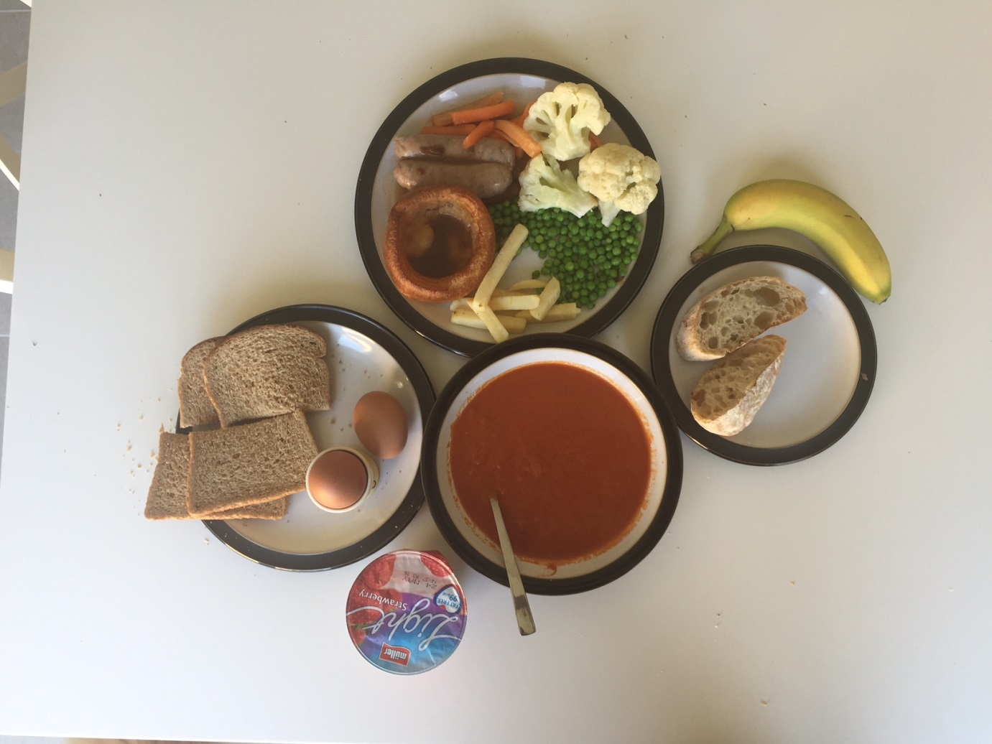

Photograph B 1500 calories

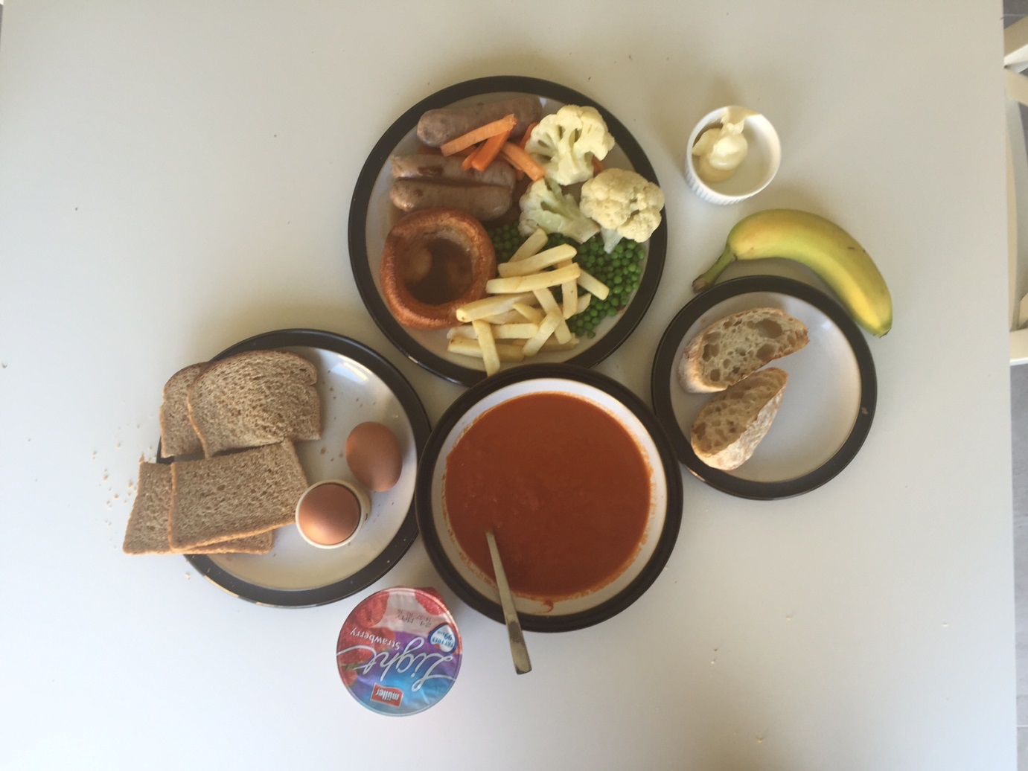

Photograph C 2000 calories

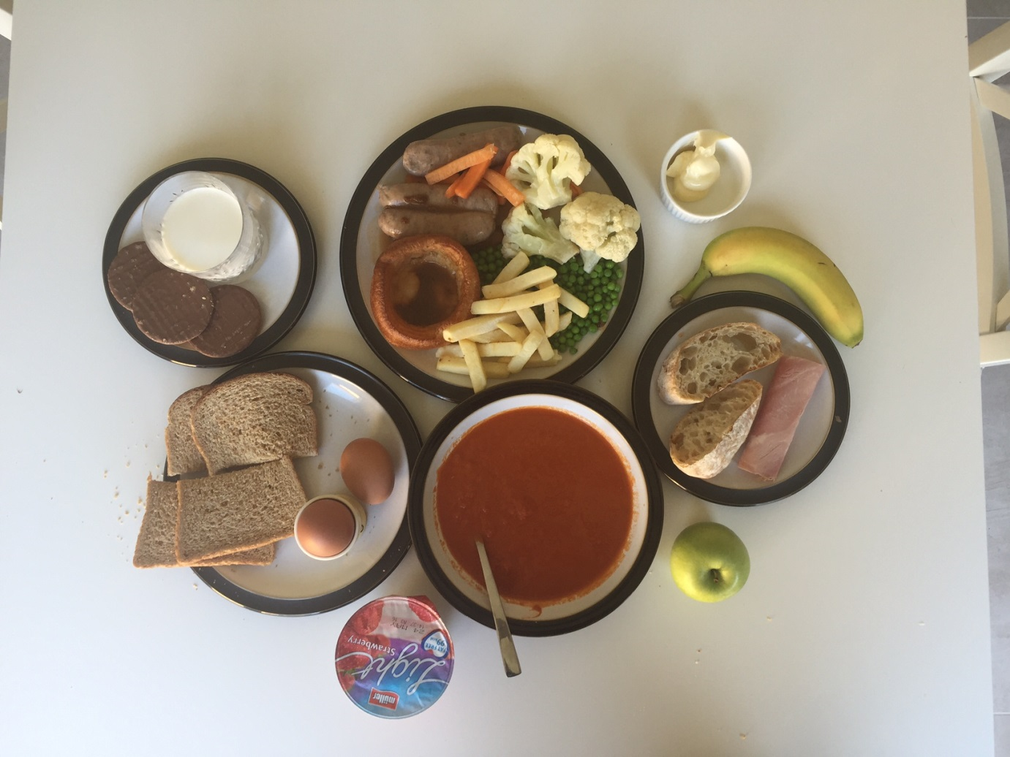

Photograph D 2500 calories

