**Coherent random lasing controlled by Brownian motion of the active scatterer**

Shuofeng Liang1, Leicheng Yin1, ZhenZhen Zhang1, Jiangying Xia2, Kang Xie2, Gang Zou1, Zhijia Hu2,3† and Qijin Zhang1*

1 University of Science and Technology of China, Hefei, Anhui 230026, P. R. China

2 School of Instrument Science and Opto-electronic Engineering, Hefei University of Technology, Hefei, Anhui 230009, China

3 Aston Institute of Photonic Technologies, Aston University, Birmingham B4 7ET, UK

E-mail: zhijiahu@hfut.edu.cn

E-mail: zqjm@ustc.edu.cn

**Abstract.** Stability of scattering loop is fundamental for coherent random lasing in a dynamic scattering system. In this work, Fluorescence of DPP is scattered to produce RL and we realize the transition from incoherent RL to coherent RL by controlling Brownian motion of the scatterers (dimer aggregates of DPP) and the stability of scattering loop. To produce coherent random lasers, the loop needs to maintain a stable state within the loop-stable time, which can be determined through controlled Brownian motion of scatterers in the scattering system. The result shows that the loop-stable time is within 5.83×10-5 s to 1.61×10-4 s based on the transition from coherent to incoherent random lasing. The time range could be tuned by finely controlling the viscosity of the solution. This work not only develops a method to predict the loop-stable time, but also develops the study between Brownian motion and random lasers, which opens the road to a variety of novel interdisciplinary investigations, involving modern statistical mechanics and disordered photonics.

**Keywords:** Random lasing, Laser materials, Multiple scattering, Brownian motion

**1. Introduction**

Random laser (RL) is a non-conventional laser, whose feedback mechanism is based on disorder-induced light scattering [1]. Based on the feedback mechanisms, random lasers are classified into two categories: random lasers (RLs) with incoherent (or non-resonant) feedback, also called incoherent RLs, were firstly discovered in TiO2 colloidal solution [2]; RLs with coherent (or resonant) feedback, also called coherent RLs, were firstly discovered in ZnO powders and polycrystalline thin film [3, 4]. The difference between incoherent RLs and coherent RLs is a basic issue on optically active disordered media, and realize the transition from incoherent RLs to coherent RLs is helpful to understand the interplay of phase-coherent multiple scattering and ampliﬁcation of radiation [5, 6].

There has been some works on the transition between incoherent RLs and coherent RLs. In 2000, Cao et al observed the transition from incoherent RL (ampliﬁed spontaneous emission) to coherent RL by continuously varying the amount of scattering in an active random medium [7]. Liu et al got spotted and disordered scatters by utilizing holographic technique, then pumped two different random lasings: incoherent random lasing via ns laser, coherent random lasing via ps laser [8]. Lopez et al demonstrated that random lasers (RLs) may be prepared in two distinct regimes by the selection of the number of activated modes through controlling the shape of the pump [9]. Recently, Consoli et al observed the RL transition from resonant to non-resonant operation regimes with spatially localized feedback, in which the coherent feedback was thought to come from a closed loop path and is dependent on the density of active scatterers [10]. The loop serves as a laser resonator, when the ampliﬁcation of such a loop path exceeds the loss, laser oscillation could occur in the regime. In this work, the transition comes ture by controlling Brownian motion of scatterers.

Random lasing in a variety of systems has been extensively researched such as in colloidal solution [11-13], quantum dot [14], cold atom [15], π-conjugated polymer films [16], liquid crystal [17-19], nanoparticles [20-22], nanowires [23-25] and turbulence [26, 27]. Different from other systems, colloidal solution has close relationship with Brownian motion. It is well known that the movement of particles in solution follows the law of Brownian motion [28]. Letokhov predicted that the Brownian motion of the scattering particles leads to a random variation (wandering) of the photon frequency due to the Doppler eﬀect of the scattering particles [9]. Genack and Drake experimentally conﬁrmed this prediction 26 years later [29]. Cao et al also found the frequencies of the lasing modes are diﬀerent for each pump pulse as the random cavities constantly changed their conﬁgurations due to the Brownian motion of ZnO nanoparticles (NPs) in solution [30]. The above works show the eﬀect of the Brownian motion of NPs on random lasing in colloidal solution. To our knowledge, there is little work on RLs under changing Brownian motion.

Brownian motion can be easily changed by surrounding temperature (T), the systems viscosity (K) and the radius of particles (P) [28]. Considering the small sliding interval and the possible solubility of dye molecules when T changes, it is here just changing the viscosity of the scattering solution by adding diﬀerent amounts of polymer, which would results a changing in Brownian motion of scatterers. V. Folli et al have found that RLs can be aﬀected and controlled by the status of the motion of the granular materials [31], this work demonstrated that RLs are sensitive to the speciﬁc grain distribution, however, one question is still remained: how does the dynamic distribution of scatterers aﬀect the RL emission?

In our previous work, aggregates of N, N-di [3-(isobutyl polyhedral oligomeric silsesquioxanes) propyl] perylene diimide (DPP) were used as active scatterers in solvents like CS2 (carbon disulﬁde) to boost coherent random lasing [35, 40]. Chemical combination of perylene diimide (PDI) and polyhedral oligomeric silsesquioxanes (POSS) at a mole ratio of 1:2 makes DPPs aggregates work as active scatterers in a random system [33, 34], the distance of POSS NPs is known to be 1.2 nm by simple calculation from its chemical structure, which is far smaller than the emission wavelength λ=584 nm ($d≪λ$), so the molecular meets the scattering and ampliﬁcation condition to boost the appearance of random lasers. In this work, PS (polystyrene) is used to change viscosity of DPP solution in CS2. With increasing the amounts of PS, the viscosity increases, therefore, Brownian motion of DPP aggregates is gradually conﬁned, the emission spectra was found to have a change.

**2. Experimental Parts**

**2.1. Chemicals and materials**

The molecular structure of DPP is shown in Fig.1 (a). This molecule was prepared according to the reported procedure [32]. The commercial PS was bought from Shanghai Aladdin Bio-Chem Technology Co., LTD. CS2 was bought from Sinopharm Chemical Reagent Co., Ltd. Samples for RL measurement were prepared as follows. Firstly, six solution samples in CS2 from P1 to P6 were prepared with DPP concentration of 10-3 M and polymer concentration of 0wt%, 5wt%, 10wt%, 15wt%, 20wt%, 25wt% for P1 to P6, respectively. And then, each solution sample was encapsulated in glass tubes with the inner (outer) diameter is 200 µm (300 µm) by the method reported before [35].



**Fig.1** (a) Chemical structure of DPP molecule. (b) Schematic illustration of the experimental setup for detection of RL.

**2.2. Measurements**

Refractive index (RI) of solution samples was determined on an Abbe refractometer WZS-I and steady shear viscosity of the samples was measured on an AR-G2 Rheometer made in the USA. In RL measurement, 532 nm output of a Q-switched Nd:YAG laser (pulse duration 10 ns, repetition rate 10 Hz) was used to pump the sample with an f=10 cm focus lens. The pump pulse energy was controlled by a Glan prism. The emitted light was collected by a ﬁber spectrometer (QE65Pro, ocean optics, resolution 0.4 nm, integration time 100 ms).

RL measurements were performed by using the experimental set-up illustrated schematically in Fig. 1 (b). A 532 nm pulse laser source was used to pump samples (solution) in a glass tube with the laser direction perpendicular to the direction of the length of the tube and a ﬁber probe of a ﬁber spectrometer was kept close to the pump region on the tube and perpendicular to both the direction.

**3. Results and discussion**

The emission spectra of all samples at diﬀerent pump energy are shown in Fig.2, and dependence of the intensity and linewidth of the main peaks in the emission spectra of samples on diﬀerent pump energies are shown in Fig.3. For sample P1-P4, when PS concentration is lower than 15wt%, with the increase of the pump energy, multiple sharp peaks can be observed in the spectra. Typically, such a set of sharp features indicates coherent random lasing [36, 37]. For sample P5-P6, when PS concentration is more than 20wt%, with the increase of the pump energy, a wider dull emission peak appears instead of narrow multiple sharp peaks, thus incoherent RL is produced in high concentration samples [38, 39].Fig.4 (a) shows the contrast between all samples and Fig.4 (b) shows the power Fourier transform (PFT) of the corresponding emission spectra in Fig.4 (a). The cavity path length (*Lc*) can be obtained through the power Fourier transform (PFT) analysis and will be furtherly discussed below.

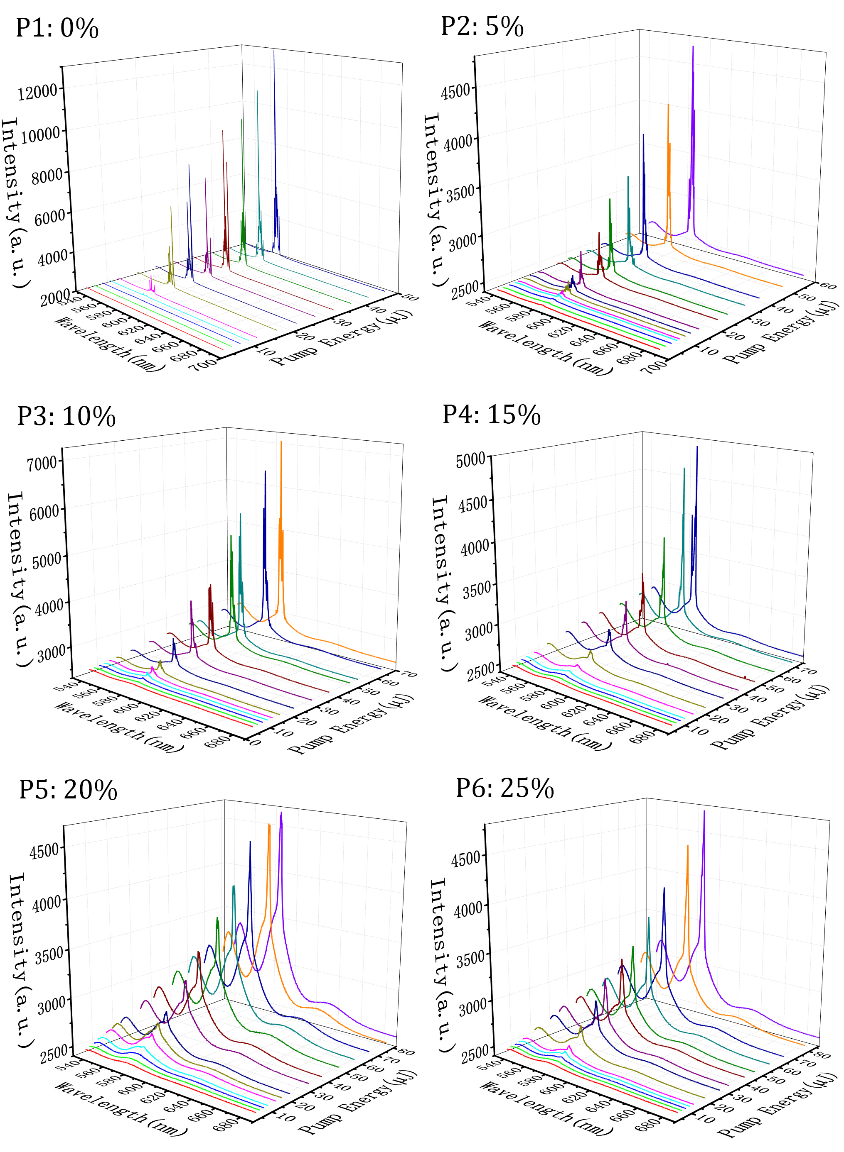

**Fig.2** Evolution of emission spectra of sample P1-P6 (from left to right, up to bottom) at diﬀerent pump energies.

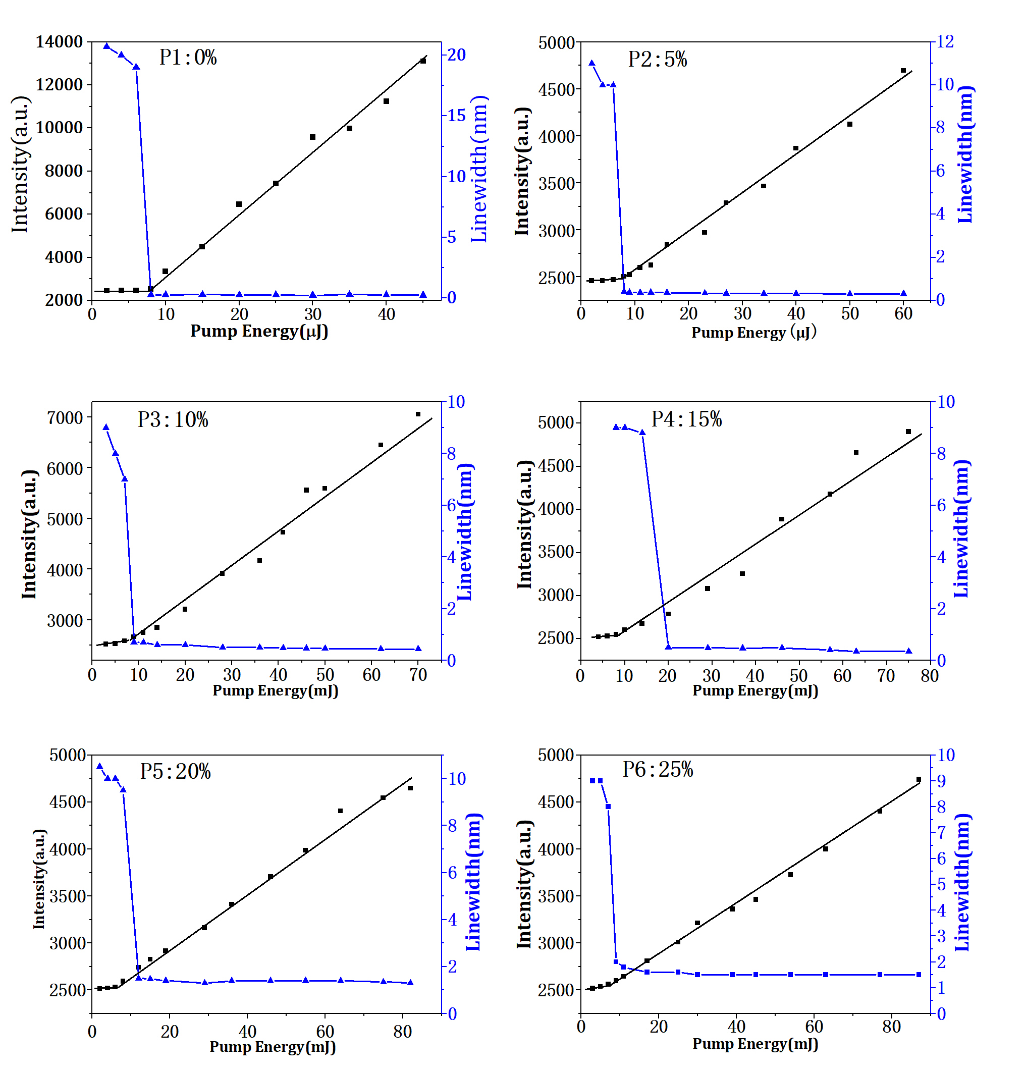

**Fig.3** Dependence of the intensity (black square) and linewidth (blue triangle) of the main peaks of the emission spectra of sample P1-P6 (from left to right, up to bottom) on diﬀerent pump energies, respectively.

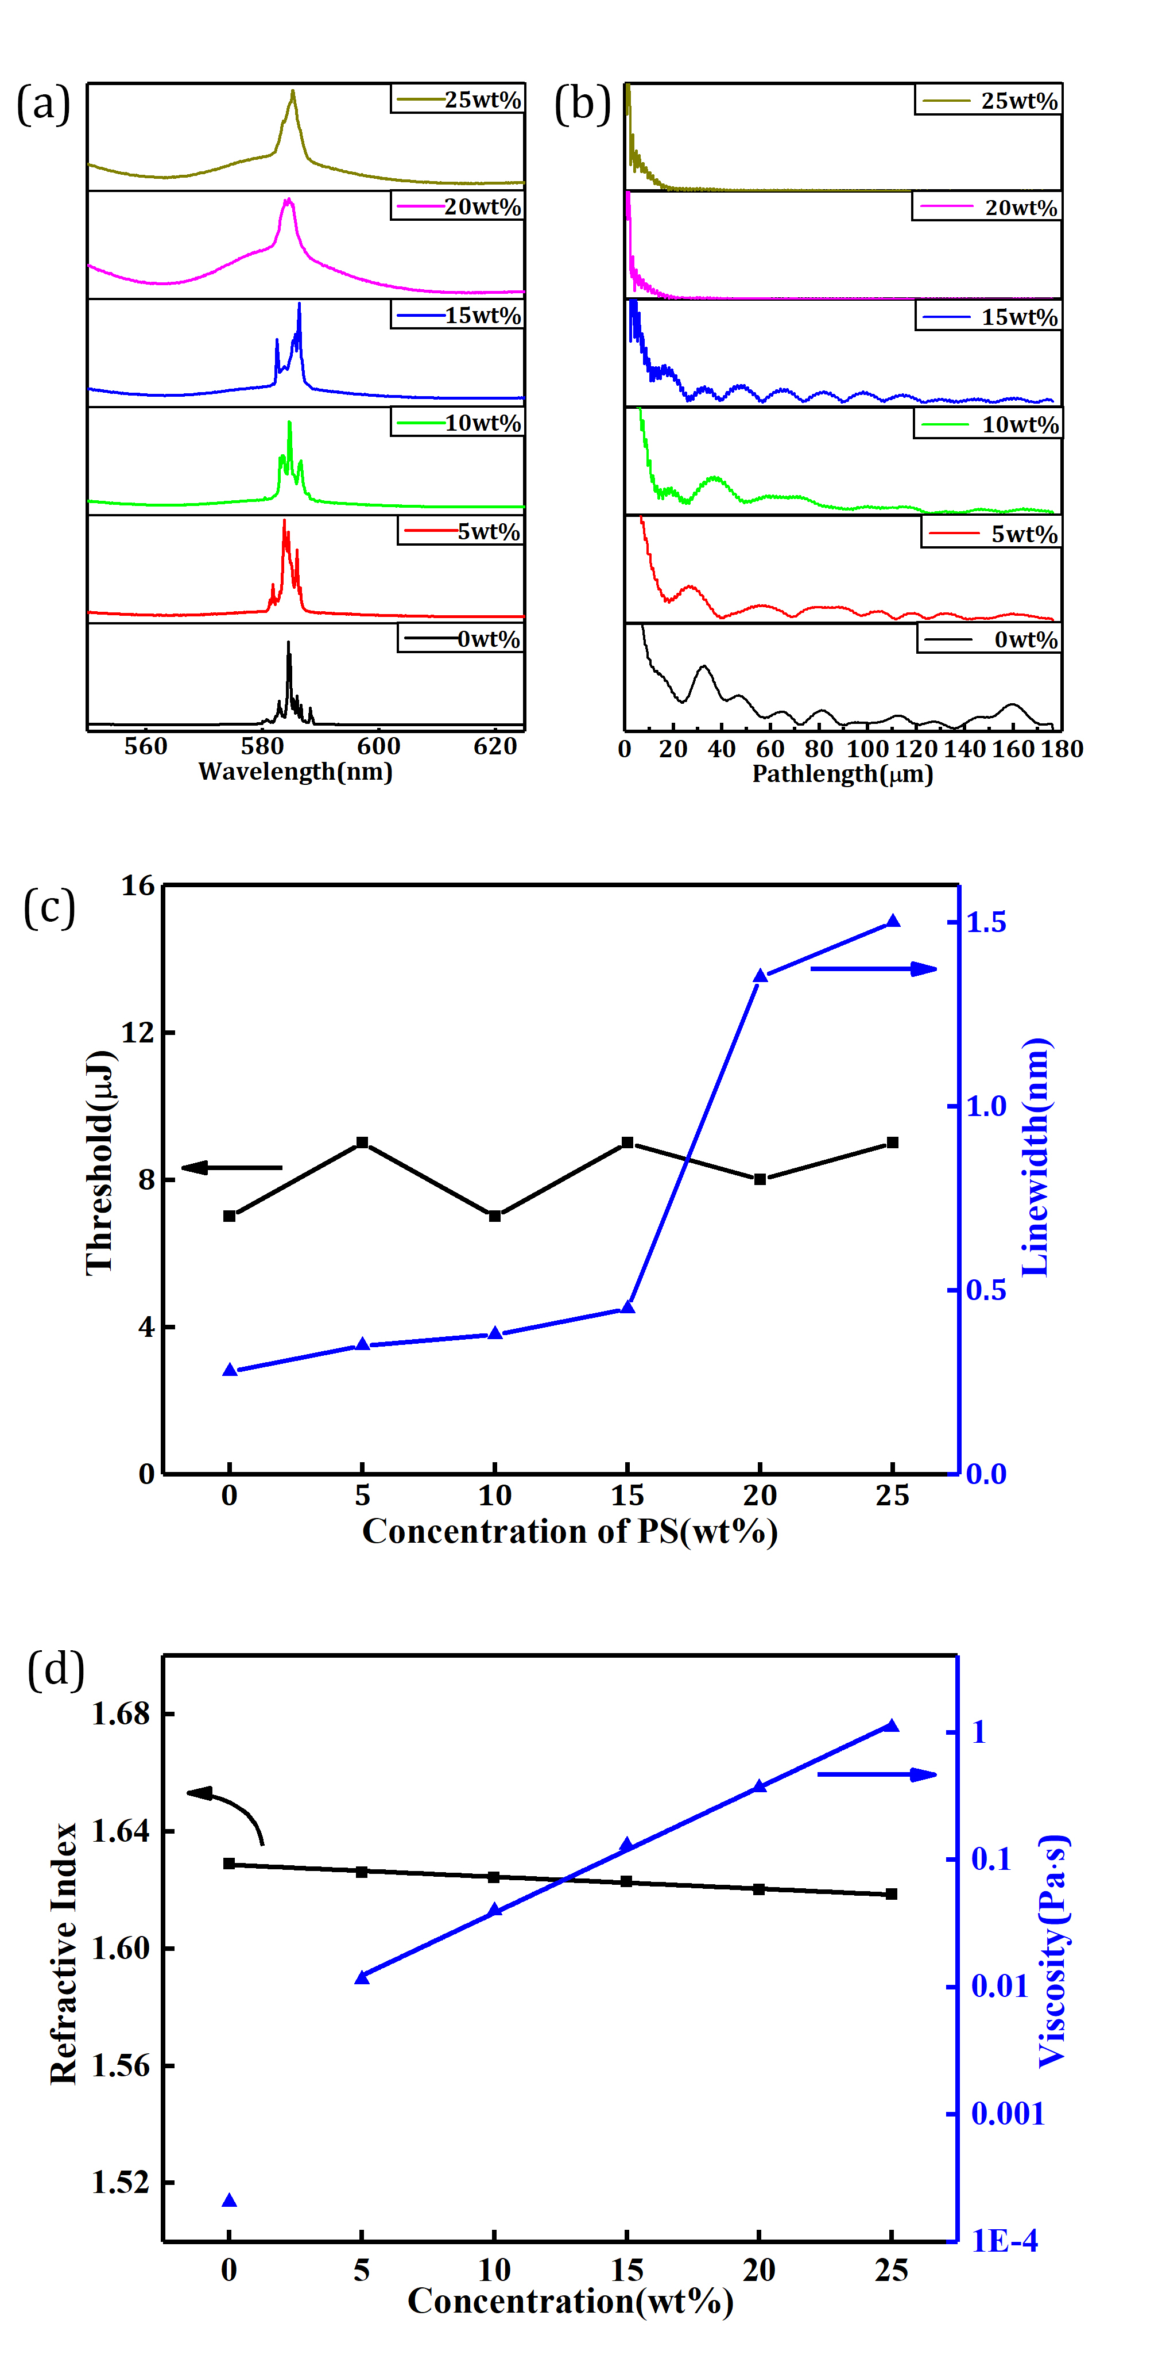

**Fig.4** (a) Emission spectra of solution samples with a series of PS concentration under pump energies above the thresholds. (b) The power Fourier transform (PFT) of the corresponding emission spectra shown in (a). (c) Relationship between threshold as well as linewidth and PS concentration of samples P1 to P6. (d) Relationship between refractive index as well as viscosity and concentration of PS of all the samples.

These experimental results show that coherence of random lasing could be transformed via changing the concentration of PS. Thresholds and linewidths of RLs obtained from Fig.3 are shown in Fig.4 (c). At low concentration of PS, the threshold is lower and linewidth is narrower than that of samples with high PS concentration. Especially, at about 15wt%, there is distinct transition in linewidth from 0.3 nm to 1.5 nm, which implies that there is a regime transition from coherent random lasing at low PS concentration to incoherent random lasing at high PS concentration. There are possibly two factors responsible to the transition. One is the refractive index (RI) of the solution. From results shown in Fig. 4 (d), it is seen that RI of P1 is 1.6290 and RI of P6 is 1.6185, the change of RI along with PS concentration changing is about 0.01. In our previous work, it was found that such small change in RI does not prohibit boosting of random lasing from the solution [40]. Another factor is the viscosity of the solution. It is well known that Brownian motion of molecules in a solution is greatly aﬀected by viscosity (K) of the solution, which can be theoretically treated for a small particle movement in one-dimensional system as following [28]:

$λ_{x}=\sqrt{t}\sqrt{\frac{RT}{N}\frac{1}{3πKP}}$ (1)

λx means the value of the displacement of the particle in the direction of X-axis in time t, R is the universal gas constant, T is temperature, N is Avogadros number, K is coeﬃcient of viscosity, P is the radius of the sphere. Based on this model, all the factors, t, T, R, N and P, are the same when PS concentration changes. K becomes an only factor deserved to be considered in our system along with increase of PS concentration. Therefore, in our system Eq.1 can be changed into:

$t_{x}=Kλ_{x}^{2}C$ (2)

in which constant $C=3πNP/RT$

From Eq.2 it is easily seen that the time (tx) for the ﬁxed λx between DPP aggregates is directly proportional to the viscosity (K) of the solution, which is proportional to the PS concentration in the solution as shown in Fig.4 (d).

During random lasing, Brownian motion of scatterers makes scatterers’ position be in a dynamic equilibrium, and hence a loop for coherent resonance is in a dynamic equilibrium, too. The cavity path length (*Lc*) can be obtained through the power Fourier transform (PFT) analysis of Fig.4 (a), a well-defined laser cavity yields peaks at *pm* in the PFT atlas and *pm* meets the formula: $p_{m}=mnL_{c}/π$, where m is the order of the Fourier harmonic, n is the refractive index of the gain medium, and *Lc* is the cavity path length [41]. It is showed in Fig.4 (d) that n is 1.6290, 1.6260, 1.6243, 1.6229, 1.6202, 1.6185 for sample P1 to P6, respectively, the first sharp peak in the PFT spectra (i.e., the fundamental Fourier component m=1) gives that *Lc* values for sample P1 to P4 are approximately equal to 63.2μm, 50.3μm, 36.4μm and 29.6μm, this result shows that the RL of sample with lower viscosity has higher coherence. As we know, the close loop consists of the scattereers, but Brownian motion could change the position of scatterers and then have an impact on the stability of the loop. On the one hand, in order to produce coherent random lasing, the scattering loop needs to keep stable for coherent resonances within the loop-stable time (ts). On the other hand, with certain concentration, there is a dynamic average distance between DPP aggregates in solution and a corresponding average time (tm) for the aggregates to cover the distance. The diﬀerence between ts and tm will determine if the loop is restored for coherent RLs under Brownian motion. If tm < ts, the loop restores and coherent RL produce. If tm ≥ ts, the loop is not stable enough for RL resonance because scatterers around cannot occupy the vacancies left by the original scatterers in the loop and the loop is destroyed at that moment. The schematic model is depicted in Fig.5. From Fig.5 (a) it is seen that the loop (sample P1) keeps unchanged even the scatterers (black) constituting of the loop are not the original scatterers (orange). However, in Fig.5 (b), the loop (sample P6) can’t restore because Brownian motion of the scatterers is slowed by the viscosity medium. The analysis on the model above implies that there exists a loop-stable time for coherent RLs. However, no experimental method reported before to demonstrate and determine the loop-stable time.



**Fig.5** Schematic illustration between RL action and dynamic distribution of active scatterers in (a) sample P1 and (b) sample P6 with diﬀerent viscosity.

The above qualitative analysis can be used to predict the loop-stable time for coherent RL through experimental data obtained in this work. Average distance between two scatterers (λx) can be calculated in terms of concentration and volume of each solution sample and tm can be obtained through Eq.2. Calculation results for solutions with various viscosities are shown in Table I.

**Table I**. tm of scatterers in Brownian motion calculated through Eq.2a

|  |  |  |  |  |  |  |
| --- | --- | --- | --- | --- | --- | --- |
| Sample | 1 | 2 | 3 | 4 | 5 | 6 |
| RL | coherent | | | | incoherent | |
| PS (wt%) | 0 | 5 | 10 | 15 | 20 | 25 |
| Viscosity(Pa•s) | 0.00036 | 0.01836 | 0.06197 | 0.19728 | 0.54591 | 1.58789 |
| *tm* (s) | 1.06×10-7 | 5.43×10-6 | 1.83×10-5 | 5.83×10-5 | 1.61×10-4 | 4.69×10-4 |

a Samples with diﬀerent PS concentration. Concentration of DPP is 1.00×10−3 M and corresponding distance between dimer aggregates of DPP [35, 40] (λm) is 14.9 nm.

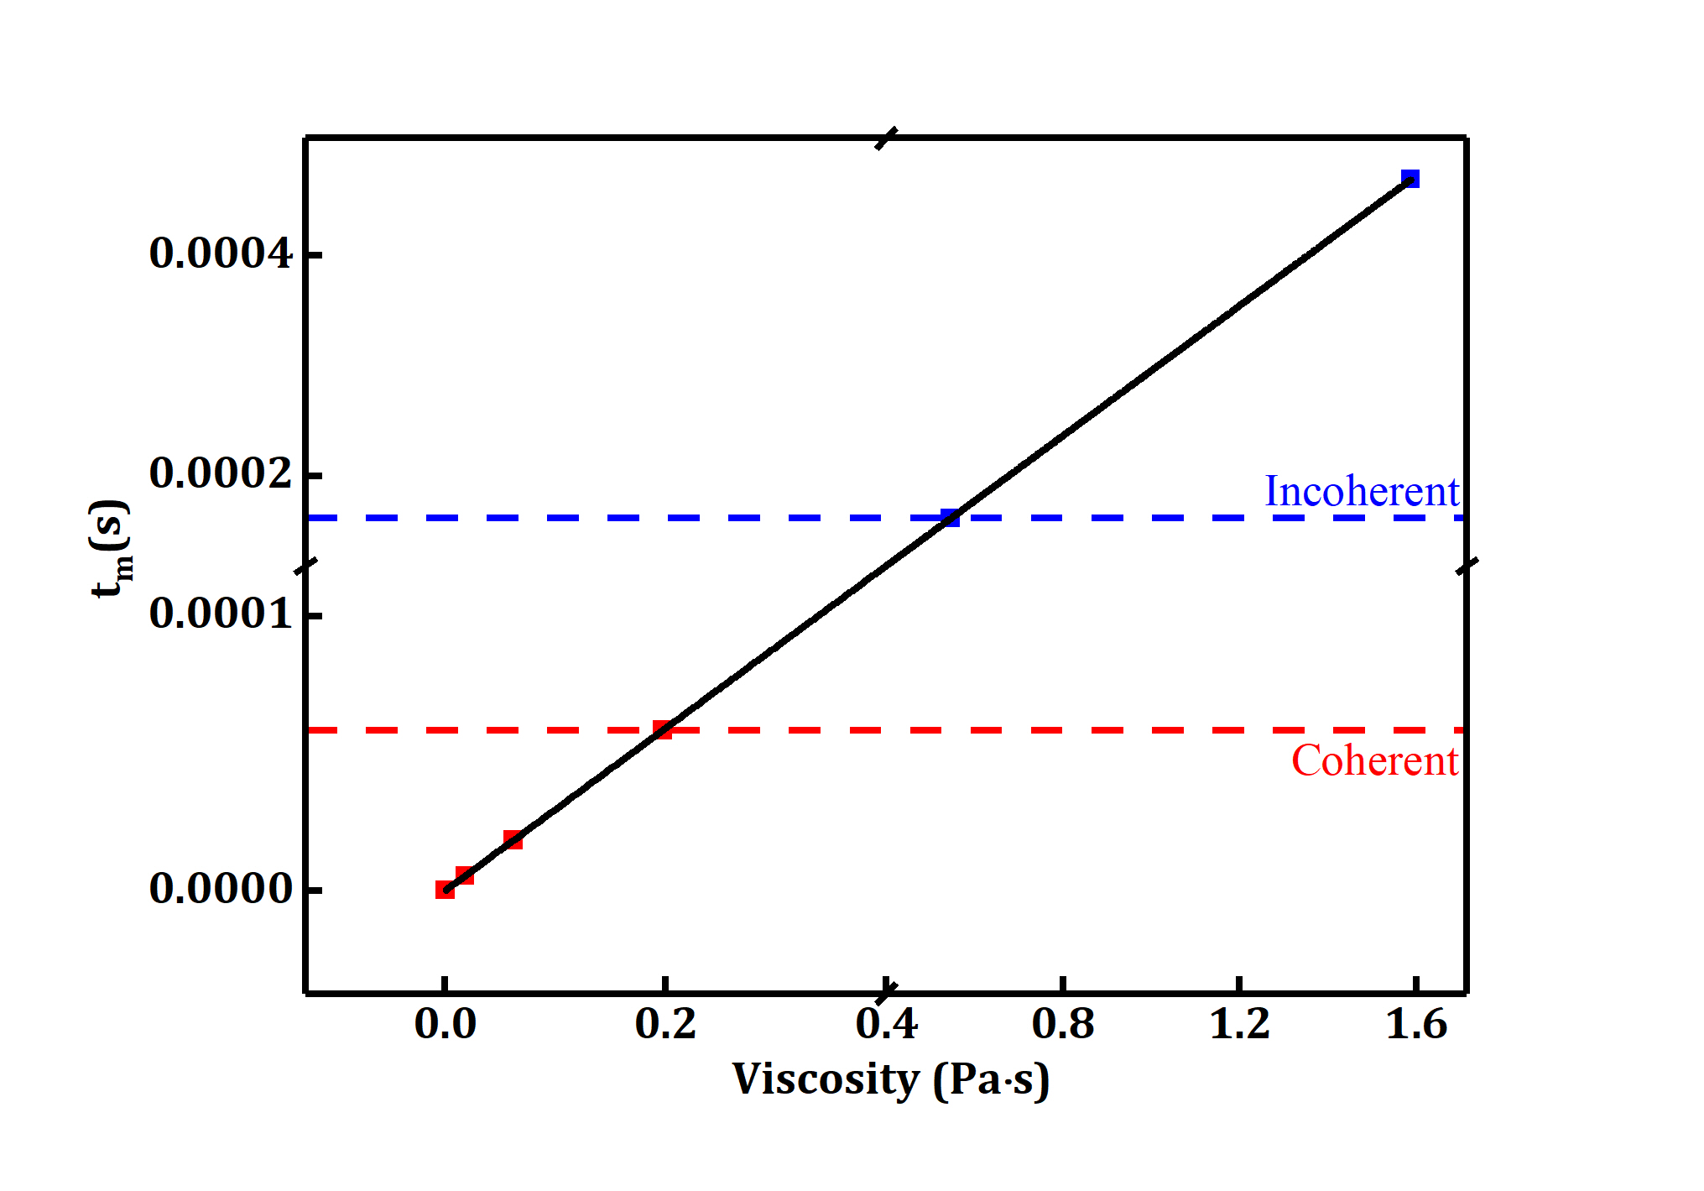

**Fig.6** Relationship between viscosity and motion time. Different time sections lead to diﬀerent types of RL.

Taking coherence properties of each RLs (P1 to P6) shown in Fig.4a into consideration, relationship between tm and the viscosity shown in Fig.6 can be divided into two regime: above tm = 1.61×10−4 s (sample P5), incoherent RLs come up from the active scatterers (DPP) solution; below tm = 5.83×10−5 s (sample P4), coherent RLs come up from the DPP solution. From this result, it can be easily deduced that the loop-stable time lies between these two values. This is the ﬁrst quantitative demonstration of the loop-stable time in a solution RLs system, although coherent RLs and incoherent RLs have already been observed, respectively, in such a system. It is worth pointing out that time range between the two regimes is about 10 ms, which could be further narrowed by ﬁnely operating the experiment, because this time interval is directly dependent on the solution viscosity used in the experiments.

**4. Conclusion**

In conclusion, it is found in this work that there is a transition from coherent RL to incoherent RL along with the increasing of systems viscosity. The loop-stable time for coherent RL is proposed and conﬁrmed based on the transition, which is located in the time range from 5.83×10−5 s to 1.61×10−4 s. The time range can be further narrowed by ﬁnely tuning viscosity of the solution, which means that the accuracy of the loop-stable time is controlled by Brownian motion in a dynamic scattering system. This work performs a new way to realize the transition from incoherent RLs to coherent RLs, which is valuable for the study of coherent random lasers.

**Acknowledgements**

This work was supported by National Natural Science Foundation of China (NSFC) (51673178, 51273186, 21574120, 11574070 and 11404087); Basic Research Fund for the Central Universities (WK2060200012); Science and Technological Fund of Anhui Province for Outstanding Youth (1608085J01), Fundamental Research Funds for the Central Universities, China Postdoctoral Science Foundation (2015M571918, 2017T100442), European Union’s Horizon 2020 research and innovation programme under the Marie Skłodowska-Curie grant agreement (744817). Fundamental Research Funds for the Central Universities (JZ2017HGTB0187).

References

[1]. Wiersma D S, van Albada M P and Lagendijk A 1995 Random laser? *Nature* 373

[2]. Lawandy N M et al 1994 Laser action in strongly scattering media *Nature* 368 436

[3]. Cao H et al 1998 Ultraviolet lasing in resonators formed by scattering in semiconductor polycrystalline films *Appl. Phys. Lett.* 73 3656

[4]. Cao H et al 1999 Random laser action in semiconductor powder *Phys. Rev. Lett.* 82 2278

[5]. Letokhov V S 1968 Generation of light by a scattering medium with negative resonance absorption *Sov. Phys. JETP* 26 835

[6]. Sebbah P and Vanneste C 2002 Random laser in the localized regime *Phys. Rev. B* 66 144202

[7]. Cao H et al 2000 Transition from amplified spontaneous emission to laser action in strongly scattering media *Phys. Rev. E* 61 1985

[8]. Zhai T et al 2010 Pulse-duration-dependent and temperature-tunable random lasing in a weakly scattering structure formed by speckles *Phys. Rev. A* 82 023824

[9]. Leonetti M, Claudio C, and Lopez C 2011 The mode-locking transition of random lasers *Nature Photon.* 5 615

[10]. Consoli A and López C 2017 Lasing optical cavities based on macroscopic scattering elements *Sci. Rep.* 7 40141

[11]. Wang Y et al 2016 Bright single-mode random laser from a concentrated solution of π-conjugated polymers *Opt. Lett.* 41 269

[12]. Brito-Silva A M et al 2010 Random laser action in dye solutions containing Stöber silica nanoparticles *J. Appl. Phys.* 108 033508

[13]. Kumar B et al 2013 Random laser action with nanostructures in a dye solution *J. Laser Appl.* 25 042012.

[14]. Chen Y et al 2011Colloidal quantum dot random laser *Opt. Express* 19 2996

[15]. Guerin W et al 2010 Towards a random laser with cold atoms *J. Opt.* 12 024002

[16]. Tulek A, Polson R C and Vardeny Z V 2010 Naturally occurring resonators in random lasing of π-conjugated polymer films *Nature Phys.* 6 303

[17]. Ferjani S et al 2008 Random lasing in freely suspended dye-doped nematic liquid crystals *Opt. Lett.* 33 557

[18]. Ye L et al 2017 Study on the polarization of random lasers from dye-doped nematic liquid crystals *Nanoscale Res. Lett.* 12 27

[19]. Ye L et al 2013 Thermally tunable random laser in dye-doped liquid crystals *J. Mod. Opt.* 60 1607

[20]. Jimenez-Villar E et al 2013 Novel core–shell (TiO 2@ Silica) nanoparticles for scattering medium in a random laser: higher efficiency, lower laser threshold and lower photodegradation *Nanoscale* 5 12512

[21]. Luan F et al 2015 Lasing in nanocomposite random media *Nano Today* 10 168

[22]. Nakamura T , Tomohiro H and Sadao A 2011 Gold-nanoparticle-assisted random lasing from powdered GaN *Opt. Express* 19 467

[23]. Shi X et al 2013 High performance plasmonic random laser based on nanogaps in bimetallic porous nanowires *Appl. Phys. Lett.* 103 023504

[24]. Wang Z et al 2015 Single-excitation dual-color coherent lasing by tuning resonance energy transfer processes in porous structured nanowires *Nanoscale* 7 15091

[25]. Bashar S B et al 2016 An Sb-doped p-type ZnO nanowire based random laser diode *Nanotechnology* 27 065204

[26]. Picozzi A et al 2014 Optical wave turbulence: Towards a unified nonequilibrium thermodynamic formulation of statistical nonlinear optics *Phys. Rep.* 542 1

[27]. Turitsyna E G et al 2013 The laminar–turbulent transition in a fibre laser *Nature Photon.* 7 783

[28]. Einstein A 1956 *Investigations on the Theory of the Brownian Movement* Courier Corporation

[29]. Genack A Z and Drake J M 1994 Laser Physics-Scattering for Superradiation *Nature* 368 400

[30]. Cao H 2003 Lasing in random media *Waves random media* 13 R1

[31]. Folli V et al 2012 Shaken granular lasers *Phys. Rev. Lett.* 108 248002

[32]. Zhuang X et al 2010 A highly soluble polyhedral oligomeric silsesquioxane end-capped perylenediimide dye *New J. Chem.* 34 1120

[33]. Cerdán L et al 2010 Laser emission from mirrorless waveguides based on photosensitized polymers incorporating POSS *Opt. Express* 18 10247

[34]. Hu Z et al 2012 Coherent random fiber laser based on nanoparticles scattering in the extremely weakly scattering regime *Phys. Rev. Lett.* 109 253901

[35]. Yin L et al 2016 Coherent random lasing from nano-scale aggregates of hybrid molecules by enhanced near zone scattering *RSC Adv.* 6 85538

[36]. Wu X et al 2006 Random lasing in weakly scattering systems *Phys. Rev. A* 74 053812

[37]. Meng X et al 2009 Coherent random lasers in weakly scattering polymer films containing silver nanoparticles *Phys. Rev. A* 79 053817

[38]. Sznitko L et al 2014 Coherent–incoherent random lasing based on nano-rubbing induced cavities *Laser Phys. Lett.* 11 045801

[39]. Fotiadi A A 2010 Random lasers: An incoherent fibre laser *Nature Photon.* 4 204

[40]. Yin L et al 2016 Quantitative analysis of “Δ l= ls− lg” to coherent random lasing in solution systems with a series of solvents ordered by refractive index *RSC Adv.* 6 98066

[41]. Polson R C , Levina G and Vardeny Z V 2000 Spectral analysis of polymer microring lasers *Appl. Phys. Lett.* 76 3858